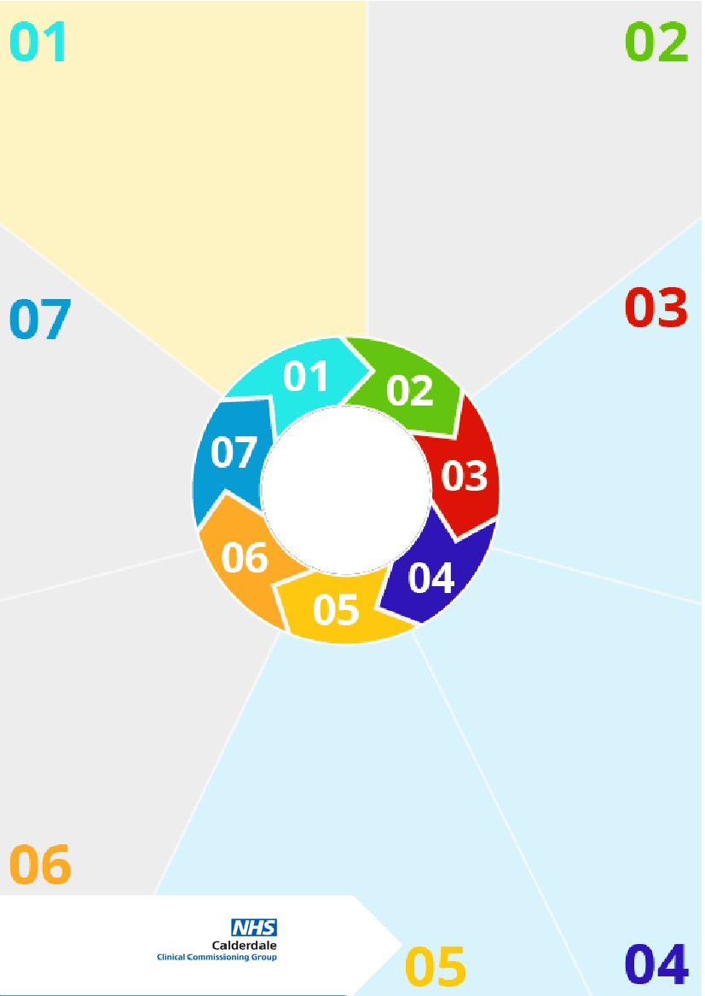
What is it ?
Contextual Safeguarding is an approach to understanding, and responding to, young people’s experiences of significant harm beyond their families. It recognises that the different relationships that young people form in their neighbourhoods, schools and online can feature violence and abuse. Parents and carers have less influence over these contexts, and young people’s experiences of extra-familial abuse can undermine parent-child relationships.
Why it matters ?

Traditional approaches to protecting children/young people from harm have focussed on the risk of violence and abuse from inside the home, and don’t always address the time that children/young people spend outside the home.
Questions to consider
Can the young people change their social conditions?
Can we assist with different activity choices?
Do we know local hotspots for young people?
Have we made local connections in the community?
Do parents have an awareness of the child’s peer group and hang outs?

Information

As children move from early childhood and into adolescence they spend increasing amounts of time socialising independently of their families. The nature of young people’s relationships, that they form in these settings, inform the extent to which they encounter protection or abuse.
7 Minute Briefing
Contextual safeguarding
For further info visit
What is Contextual Safeguarding?
A Contextual Safeguarding approach aims to disrupt harmful extra-familial contexts rather than move young people away from them. The approach seeks to identify the ways in which professionals, adults and young people can change the social conditions of environ-ments in which abuse has occurred.
What should we do?

These risks
Often manifest in extra-familial environments including schools, public spaces and online platforms are informed by peer norms and relationships.
Involves young people perpetrating, as well as experiencing harm.
Can present as the result of perceived ‘choices’ a young person has made.
What are the risks?
There are a wide range of potential risks where the prime cause of harm is outside of the family. This list isn’t exhaustive but includes: peer on peer abuse; exploitation and online abuse; missing episodes; gang involvement; radicalisation; trafficking and modern slavery.
Date Junel 2019


