**Calderdale Safeguarding Adults Board**

**Calderdale Safeguarding Children Partnership**

**‘A Day in the Life…’**

Making sense of an individual’s lived experience





**A Day in the Life …**

In order to fully understand how various experiences (including abuse and neglect) impacts on an individual, it is necessary to identify the associated risks, unmet needs and areas of resilience and therefore to understand what life is like for that person on a daily basis, in the evening, during the night, at weekends, during public holidays and when different people are involved in their care of them. In order to understand how the behaviours, attitude and parenting/caring style of the parent or carer contribute to the risks or unmet needs, it is also necessary to understand a day in their own life. One way of doing this is to work with the individual and the parent/carer (separately and together when it is safe to do so) using a tool, for example, a clock, to assist them to describe what is happening for them at different times of the day and night. The experience of a pre-verbal child, a child or adult with limited language skills or levels of understanding may need to be explored in different ways, for example, via, a pictorial timetable of their day (PECS –Pictorial Exchange Communication System), observations, specific questions with the carer about routine, mealtimes, bedtimes etc.



The purpose of ‘A Day in the Life’ of the individual is to establish an understanding of:

|  |  |
| --- | --- |
| **Morning routine and parental/carer involvement** | What is the individual’s or other’s responsibility for tasks, personal hygiene, dressing and availability of relevant equipment, clothes, availability of breakfast, preparation for nursery/school/day care/work etc., appropriate parental/carer supervision and support, mode of transport to nursery/school/day care/work etc. |
| **Out of the house** | Journey to and from nursery/school/day care/work; relationships with others; child’s/adult’s presentation e.g. tired, hungry; activities during the day; feelings associated with different people, places, activities; others’ expectations etc. |
| **Evening routines and parental/carer involvement** | Availability of parent/carer; availability of meals; individual’s responsibility for tasks, self-care, personal hygiene and availability of relevant equipment; appropriate parental/carer supervision; access to leisure activities, friends and resources; favourite past times, what happens? Who is in the house?, What are the arrangements for going to bed etc. |
| **Night time** | Where the individual sleeps; sleep patterns, disruptions; facilities etc. Who else is in the house? What do they do? Where do they sleep? |
| **Weekends and holidays** | What happens? Who is involved, meals, routines and explored as above etc. |

Open ended questions will facilitate greater insight, for example, ‘Tell me what usually happens on a school day/on a Saturday’. ‘How do you wake up?’ ‘What happens then?’ etc.

Asking if and how the child/adult would like their daily lived experience to change will provide additional information about their views and feelings.

The quality of attachment between the child/adult and the parent/carer should be observed along with analysis of the parent/carer and individual’s relationship.

The parent/carer should be invited to describe a day in their own life and how they perceive life for the individual from their perspective over a 24 hour period so that the clocks can be compared with the individual’s account and similarly with any professionals who have an understanding of family/support/ carer dynamics and lifestyle. By understanding the lives of both parent/carer and the individuals in a family, practitioners can then establish what needs to change and highlight discrepancies, gaps and areas of concern.

**Individual’s Perspective**

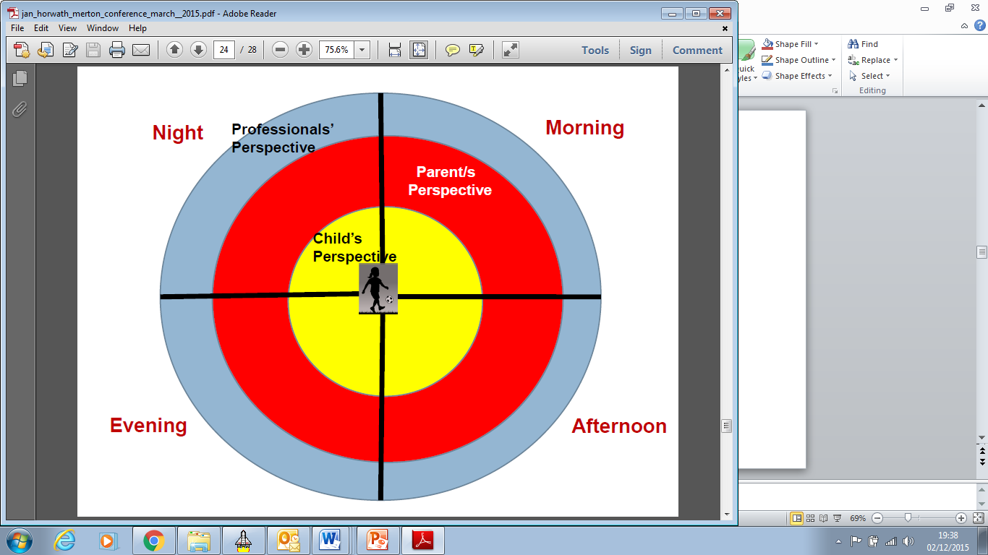

**Clocks used to gather and collate information regarding the daily lived experience of the individual and parent/carer.**

By understanding how the parent/carer views their own and the individual’s world, how they process and make sense of information, practitioners can assist parent/carers to better appreciate the needs of the individual. Being specific with parents/carers about the consequences of their behaviours on the daily experiences of the person and providing the parent/carer with information about the impact of chronic neglect and/or abuse on children and adults, they may begin to understand what needs to change.

**Analysing and making sense of the information**

There are various facets to understanding and assessing what the information means for the health and wellbeing of the person. The information gathered can be transferred into any assessment document and should be analysed in relation to:

1. The interaction between the individual’s strengths and difficulties

2. The interaction between the parents/carers strengths and difficulties

3. The interaction between family and environmental factors

4. The impact of the style and quality of parenting/caring on the individual’s health and development in terms of resilience and protective factors and vulnerability and risk factors

5. How family and environmental factors are directly impacting on parenting/caring and/or the individual.

The analysis should include:

* Identifying and exploring patterns within the individual and family’s life;
* Assessing the extent to which the parent/carer’s ability/capacity to change is linked with the individual’s developmental needs, pace of development and/or promotion of the individual’s health and well-being;
* Consideration of alternative explanations for what is happening;
* Consideration of what a day in the life of this person would look like if their needs were being met and risks removed;
* Making professional judgements based on research, specialist knowledge and theory in order to arrive at a conclusion.