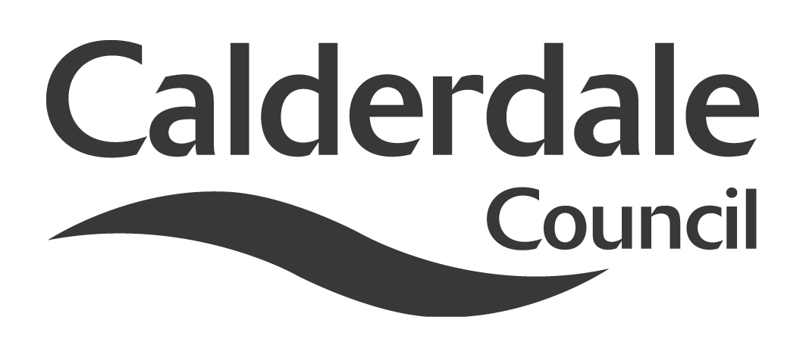
7

Report to Scrutiny Panel
Name of Scrutiny Panel | Economy & Environment Scrutiny Panel
Meeting Date | 15th December 2010
Subject | Work Plan
Wards Affected | All
Report of | Scrutiny Support Officer
Type of Item  (please tick✓ ) | Review existing policy
Type of Item  (please tick✓ ) | Development of new policy
Type of Item  (please tick✓ ) | Performance management (inc. financial)
Type of Item  (please tick✓ ) | Briefing (inc. potential areas for scrutiny) | √
Type of Item  (please tick✓ ) | Statutory consultation
Type of Item  (please tick✓ ) | Council request
Type of Item  (please tick✓ ) | Cabinet request
Type of Item  (please tick✓ ) | Member request for scrutiny (CCFA)

Why is it coming here?
For members to decide on future items for scrutiny

What are the key points?
As with all panel meetings, future items for scrutiny are discussed at the work plan part of the agenda. As part of the corporate governance process, regular performance reports should be considered by members to assist them in identifying appropriate items. Attached to this report are the latest Economy and Environment Directorate Reports on Revenue Monitoring and also Complaints and Compliments, for the benefit of members in work planning.

Possible courses of action
Members can choose to accept, reject, amend or revise the suggested work plan

Contact Officer
Steve Barnbrook, Scrutiny Support Officer 01422 393252

Should this report be exempt?
No

