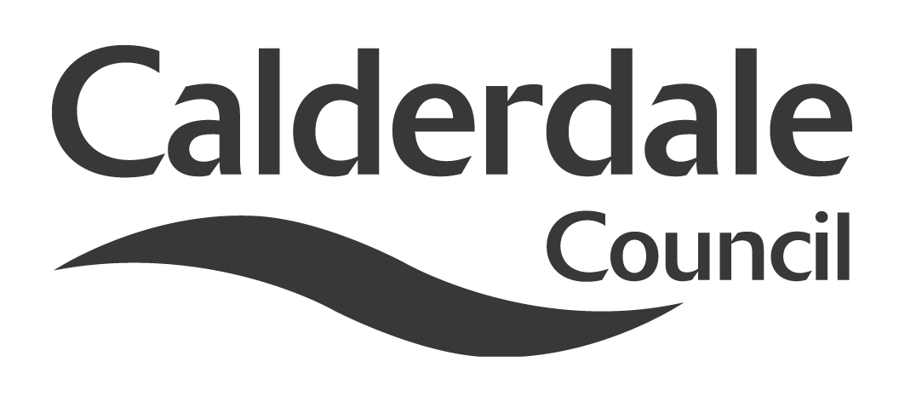
5

Report to Scrutiny Panel
Name of Scrutiny Panel | Economy & Environment Scrutiny Panel
Meeting Date | 15th December 2010
Subject | Towards A Low Carbon Future
Wards Affected | All
Report of | Scrutiny Support Officer
Type of Item  (please tick✓ ) | Review existing policy | √
Type of Item  (please tick✓ ) | Development of new policy | √
Type of Item  (please tick✓ ) | Performance management (inc. financial)
Type of Item  (please tick✓ ) | Briefing (inc. potential areas for scrutiny) | √
Type of Item  (please tick✓ ) | Statutory consultation
Type of Item  (please tick✓ ) | Council request
Type of Item  (please tick✓ ) | Cabinet request
Type of Item  (please tick✓ ) | Member request for scrutiny (CCFA)

Why is it coming here?
Members are in the process of undertaking a detailed review on carbon reduction in Calderdale and have decided to look at issuing an interim report. In addition, as part of the ongoing work, the panel have invited Professor Andy Gouldson of Leeds University to attend this meeting as part of their evidence gathering process. They also requested that the Assistant Chief Finance Officer be invited, to address questions around funding.

What are the key points?
This report outlines the progress to date of the work of the panel, along with other developments since the work began. It also gives a brief biography of Professor Gouldson.

Possible courses of action
The panel could make interim recommendations to Cabinet or Council, issue an interim report, agree further work, or elements of all of the above.

Contact Officer
Steve Barnbrook, Scrutiny Support Officer 01422 393252

Should this report be exempt?
No

Report to Scrutiny Panel
- Background

At its meeting of 13th October 2010, the panel agreed to a Terms of Reference for undertaking a detailed review of Carbon Reduction in Calderdale (appendix 1).

As part of the timetable of work for the review, it was agreed that the meeting of December 15th would look at forming possible interim recommendations.

- Main issues for Scrutiny

As part of this detailed review the panel, in whole or in part, have already undertaken a number of pieces of work.

At its meeting of 3rd November 2010, the panel examined some of the implications of the Comprehensive Spending Review on carbon reduction in Calderdale, particularly the changes to the Carbon Reduction Commitment Energy Efficiency Scheme (CRCEES). This scheme has essentially been changed from a trading opportunity to an emissions tariff, a move which could cost the Council as an organisation up to around £400,000.

Other areas covered at that meeting included the Renewable Heat Incentive Scheme, the Local Sustainable Transport Fund, Warm Front/Green Deal and The Green Investment Bank.

The panel also agreed to amend their terms of reference to accommodate the changes to CRCEES.

Councillors Pearson and Sutherland have attended a site visit, along with the Scrutiny Support Officer to the Alternative Technology Centre in Hebden Bridge and Gibson Mill at Hardcastle Craggs. The visit had been informative and looked at practical ways of reducing carbon emissions. The Alternative Technology Centre has worked with schools, carrying out individual audits.

Cabinet

Cabinet met on 15th November and agreed the following:

(a) approval be given to the 10:10 Action Plan including development with partners of “soft measures” to reduce carbon emissions across the local community;

(b) approval be given to the creation of an Invest to Save budget for energy efficiency initiatives within a value of £400k, subject to a business case agreed by the Head of Finance and the Director, Economy and Environment and in consultation with the Cabinet Member with responsibility for Economy and Environment;

(c) Cabinet recommends that funding is allocated to cover the annual purchase of carbon allowances under the mandatory CRC Energy Efficiency Scheme as part of the budget process for 2011/12;

(d) approval be given to the development of the Calderdale Climate Change Strategy; and

(e) a further report be submitted to Cabinet on progress on the 10:10 Action Plan and the Invest to Save initiative

Local Strategic Partnership Climate Change Group

This group met for the first time on 14th October, with members of scrutiny present, and agreed the following as its remit:

Agreed: The CCG would act as an overview group, providing expert input into the drafting of the strategy through practical development and providing feedback on documents.
Agreed: The members of the CCG would ensure that information flowed both ways in terms of other policies and plans that would support and impact on the strategy.
Agreed: That it would be better for the CCG, at this time, not to act as a formal ‘Advisory Group’ to the Cabinet.
Agreed: The CCG would remain distinct from Scrutiny with both ensuring that communication flowed between the groups.

Other issues

At the time this paper was written the Localism Bill had yet to be published. Amongst other things this is expected to include major changes to planning legislation which members may wish to consider as enabling tools.

Also underway at the time of writing is the 16th meeting of the United Nations Framework Convention on Climate Change in Cancun, Mexico.

Funding

Despite the changes to CRCEES, there are still a number of potential avenues for funding, including the following:

Green Investment Bank
Green Deal
ELENA (European Local Energy Assistance) – via Covenant of Mayors
IEE (Intelligent Energy Europe Programme)
ERDF (European Regional Development Fund)
JESSICA (Joint European Support for Sustainable Investment in City Areas)
Feed-in Tariffs
Renewable Heat Incentives
Local public-private partnerships

Also at the time of writing, Calderdale Council is awaiting the outcome of the Local Government Settlement for 2011-12, which will impact on funding.

- Consultation

Ongoing as part of the review.
- Further action and timescales

To be determined at this meeting.

- Options appraisal

n/a

- Conclusions

There is significant activity around carbon reduction at all levels, including globally. At a local level it is important that the work of scrutiny and other bodies, including the LSP, is complementary but discrete. The work that scrutiny is doing has already influence other activity. The outcomes of this meeting will help further shape that influence.

- Appendices

Detailed Review amended Terms of Reference.

- Background documents

Leeds City Region Green Infrastructure Strategy
Leeds City Region Low Carbon Framework
Climate Change Synthesis Report – The Forestry Commission
Local Government’s Offer on Climate Change – LGA
Low Carbon Budgets – briefings by LGIU and Friends of the Earth
Report of the Green Investment Bank Commission
Calderdale Local Development Framework
10:10 Initiative
Covenant of Mayors
Yorkshire Peat Partnership
LTP3
Energy Security and Green Economy Bill
Westminster Hall Debate – Onshore Wind Turbines
Annual Report on Fuel Poverty Statistics 2010 – DECC
EU Committee of the Regions Opinion Papers
Carbon Reduction Commitment Energy Efficiency Scheme (CRCEES)
Comprehensive Spending Review
2050 Pathways
Climate Change Act 2008
The UK Low Carbon Transition Plan

- Documents available for inspection at

Westgate House, Westgate, Halifax, HX1 1PS

