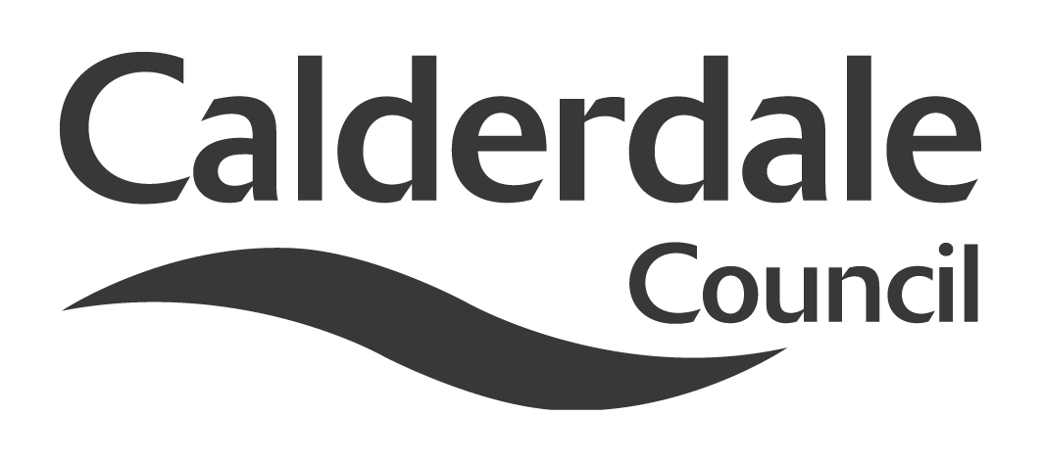
9

Report to Scrutiny Panel
Name of Scrutiny Panel | Use of Resources Scrutiny Panel
Meeting Date | 15th July 2010
Subject | Coalition Government Changes on Partnership Arrangements
Wards Affected | All
Report of | Scrutiny Support Officer
Type of Item  (please tick✓ ) | Review existing policy
Type of Item  (please tick✓ ) | Development of new policy
Type of Item  (please tick✓ ) | Performance management (inc. financial)
Type of Item  (please tick✓ ) | Briefing (inc. potential areas for scrutiny) | ✓
Type of Item  (please tick✓ ) | Statutory consultation
Type of Item  (please tick✓ ) | Council request
Type of Item  (please tick✓ ) | Cabinet request
Type of Item  (please tick✓ ) | Member request for scrutiny (CCFA)

Why is it coming here?
Panel requested an update on the current government position

What are the key points?
The report sets out current government thinking (as far as it is known) on Comprehensive Area Assessment, Local Area Agreements, Local Strategic Partnerships and regional issues.

Possible courses of action
Panel may wish to consider how the Council may wish to respond to the current Government position and the implications of some of these wide-ranging proposals. In particular, Panel may wish to consider how the Council’s overview and scrutiny function may wish to operate in a rapidly changing context.

Contact Officer
Steve Barnbrook, Scrutiny Support Officer 01422 393252

Should this report be exempt?
No

Report to Scrutiny Panel
- Background

In its document “The Coalition: our programme for government”, the new government identified a number of policy themes which would have an impact on strategic partnership working for local authorities across numerous areas of operation. This report seeks to update members on those policy themes, outlining what further detail is now available and assessing some of the implications arising from that detail.

- Main issues for Scrutiny

Since the publication of the coalition’s programme for government towards the end of May, a varied level of information has been coming from government departments, ministers and other sources regarding the detail of the programme. In some areas action has happened, in some it is planned, and in others there has been no further announcement.

The following are some of the key themes with regard to local authorities:

Comprehensive Area Assessment (CAA)

Across England, local services are monitored by separate watchdogs – the Audit Commission, Care Quality Commission, Her Majesty's Inspectorates of Constabulary, Prisons and Probation, and Ofsted. Comprehensive Area Assessment (CAA) brought the work of these watchdogs together.

It was announced on 25th June 2010 by the Secretary of State for Communities & Local Government, Eric Pickles, that CAA would be abolished with immediate affect.

Local Area Agreement

To date there has been no announcement on the future of the LAA

Local Strategic Partnership

Again, at the moment it is not clear what the future holds for LSPs

Regional Strategy

In a speech to the Local Government Association on 6th July, Eric Pickles announced that an order would be laid before Parliament on that day revoking Regional Strategies through Section 79 of the Local Democracy, Economic Development and Construction Act 2009.

Accompanying notes to the speech said the following:
“The abolition of regional strategies provides a clear signal of the importance attached to the development and application of local spatial plans, in the form of Local Development Framework Core Strategies and Development Plan Documents. Local plans drawn up with the help of the community will become the basis for local planning decisions, and future reform will make it easier for local councils to agree and amend local plans with their local community, in a way that maximises the involvement of neighbourhoods. The introduction of incentives to replace building targets will be a top priority for the new Government and take place early in the spending review.”

Total Place

It appears that “Total Place” may be a concept whose time has come. It is based on the principle of looking at total public spend in an area and assessing how that can be better spent by, amongst other things, cross-agency working and resource sharing.

It originated under the previous government from the Operational Efficiency Programme, which was launched by the Treasury back in July 2008 to look at achieving greater efficiency in a variety of cross-cutting areas.
This then led onto the Total Place initiative, based on a “whole area approach to public services”. 13 pilots were undertaken across the country – the nearest to us was in Bradford – and a final report published in March 2010.

In his speech to the LGA Conference on 6th July, Eric Pickles talked about the German concept of “Doppelspitze” or identical authority, “Where you have Chief Executives and elected leaders responsible for the same thing. It's both expensive and pointless.
Couldn't chief execs bring more to the table by working across boundaries, rather than replicating what the leader should be doing?”

He has also in the past welcomed examples whereby nearby local authorities share a chief executive, or an authority shares a chief executive with the local health authority.

At the same conference, Dame Margaret Eaton, Chair of the LGA, launched a paper entitled “Place-based budgets – the future governance of local public services”.

It argues that councils or groups of councils should be responsible to local voters and to Parliament for spending on frontline services under a new system of “placed-based budgeting”.
The report calls for local decision-makers to oversee economic regeneration, planning, housing and regeneration, home energy efficiency, managing flood and climate risks, adult skills, local transport, primary health care, policing and probation, and support into employment for the long-term unemployed and workless.

Proposals in the report include:
- Put councils at the heart of local economic development, allowing councils in each region to either replace the Regional Development Agencies (RDA) with local enterprise partnerships or retain existing regional arrangements, and abolish the boards of Primary Care Trusts and Strategic Health Authorities
- Devolve RDA, Homes and Communities Agency and Skills Funding Agency budgets to place-based budgets
- Devolve the budgets and commissioning of employment support and Job Centre Plus functions
- Transfer responsibility for many trunk roads (excluding motorways) from the Highways Agency to local government
- Create local accountability for offender management
We will need a formal response from the government on the proposals, set out in these keynote speeches.

Regional Development Agencies

Yorkshire Forward, along with the other Regional Development Agencies, will be abolished. There will not be a like-for-like replacement. The plan is for local authorities and business leaders to come together to form Local Enterprise Partnerships (LEPs), which would be expected to set out local economic priorities and provide strategic vision.

In a letter to local authority leaders and (unspecified) business leaders on 29th June 2010, Vince Cable (Business, Innovation & Skills) and Eric Pickles (Communities & Local Government) outlined some of their ideas on the role, governance and size of LEPs. It would appear that they expect LEPs to be at least sub-regional (or City Region) in size, although they could replicate existing RDA boundaries. They would be chaired by a business leader and would need to fund their own day-to-day running costs.

It is unclear what will happen to the funding currently going to RDAs. However, on 29th June Nick Clegg announced that there would be a “£1bn Regional Growth Fund to help areas and communities at risk of being particularly affected by public spending cuts. The fund, which will operate in 2011/2012 and 2012/2013 will help areas most dependent on public sector employment as the country makes the transition to private sector-led growth and prosperity. Both private bodies and public-private partnerships will be able to bid for funding by demonstrating that their proposal will bring in private investment and support sustainable increases in private sector jobs and growth in their area.”

Leeds City Region

Leeds City Region has already responded to the Government proposal on LEPs as follows:

“The Leeds City Region Partnership has welcomed the Government's invitation to support business and economic growth through local enterprise partnerships (LEPs).
In a joint letter to council and business leaders, the Government outlined its commitment to strengthen local economies by reforming the current system of sub-national economic development.
It noted that the role of local enterprise partnerships will be to encourage strong collaboration between local businesses and councils in order to create the right environment for economic growth.
The Leeds City Region Partnership will be developing its proposal drawing from work undertaken over the past six years in support of economic prosperity at a city region level. “

Where this will leave the Leeds City Region Employment & Skills Board, or whether that body would be the proposed LEP, is yet to be resolved.

Council Structure & Transparency

There will be a Decentralisation and Localism Bill commencing its progress in this session of Parliament. Although the full details are not yet known (other than what was outlined in the Queens Speech on May 25th) it will include requirements and powers such as:

- Councils to publish online all job vacancies
- Councils to publish online the job titles of every member of staff and the salaries and expenses of senior officials.
- Councils to publish online all spending over £500
- Abolish Standards Boards
- Allow councils to have Elected Mayor, Cabinet or Committee arrangements

What counts as a public body?

In its paper “Place-based budgets”, the LGA argues that the following are areas requiring some form of public service governance:

• where public money is being directly spent, strategic decision-making about what services are delivered and by whom, either through contracting or through holding public sector delivery bodies to account for outcomes

• where market mechanisms are operating and public money is following consumer
decisions – for example, through a per-pupil funding formula for schools -decision-making about the public sector’s regulatory role in ensuring the efficient functioning of the market, the fulfilment of public policy and securing redress for citizens.

Other Developments

The four Police Authorities and Forces of Yorkshire & the Humber commissioned Deloitte to look at “Delivering value for money through collaboration”. This report was completed in May 2010 and concluded, amongst other things, the following:

- The presumption is now that services should be delivered collaboratively unless the evidence suggests that it is less effective and efficient to do so.
- Through regional collaboration we believe a cost-base of £1.147bn across the four forces can be reduced by circa 9% over a 5-year period.

They identified significant challenges on the back of their recommendations for both scrutiny and delivery of functions.

- Consultation

N/A

- Further action and timescales

To be determined

- Options appraisal

None at this stage

- Conclusions

It is clear that the emphasis from national government is to greater localism, but at the same time greater collaborative working, both between public sector providers within a local authority area, and also across boundaries. There is also an emphasis on private sector being the engine for growth.

There are numerous challenges for Calderdale in the coming months, both financially and structurally. It has, however, a significant track record in partnership working and development.

- Appendices

None

- Background documents

“The Coalition – our programme for government”
Letter from DBIS and DCLG 29th June 2010 regarding Local Enterprise Partnerships
Deloitte – Briefing to the Police Authorities and Forces of Yorkshire & the Humber, May 2010
Local Government Association – “Place-based budgets – the future governance of local public services

- Documents available for inspection at

Westgate House, Westgate, Halifax, HX1 1PS

