Calderdale MBC |  | 11
Wards Affected | All | 11
Cabinet  12 February 2018 |  | 11
Calderdale Cares: Moving Forward on Health and Social Care
Report of the Chief Executive and Director of Public Health

- Purpose of the report
  - In the present climate of fiscal consolidation and growing demand, the government wants to see the integration of health and social care, in all areas of England, by 2020. In response, a range of contracting and organisational forms are emerging across England that sees the alignment of NHS commissioning and provision and integration of CCG functions in a local authority.

  - This paper proposes a realignment of community health services, primary care, public health and social care services for children and adults through Calderdale Cares.

  - Calderdale Cares is a place-based framework for Health and Social Care in Calderdale that is underpinned by strong collaboration across the statutory and community sector and where organisations work together and share resources to deliver holistic person-centred support at a local level.

  - As a leader on “place”, the Council is critical to developing a whole system approach where innovative integrated services focus on reduction in health inequalities, and the joint commissioning of preventative services deliver the most improvements to people’s health.

2. Need for a decision

2.1 Cabinet is asked to consider the approach to delivering health and social care integration by 2020 and reach a decision on whether to support it.

3. Recommendation
Cabinet is recommended:
  - To endorse, in principle, the approach to delivering a place-based integrated health and social care system that will enable neighbourhoods to develop at their own pace.

  - To endorse, in principle, the alignment of in-scope service budgets.

2. Where are we now?

  - There is already a successful history of collaboration across Calderdale organisations and their leadership via the Vanguard Programme and Health and Wellbeing Board. Therefore, we should continue to build on the willingness to take joint responsibility for population health and service improvement, whilst reflecting our commitment to having a shared responsibility for the health and care of local people through the triple aim of improved population health, quality of care and financial efficiency.

  - The Calderdale Health and Wellbeing Board are currently developing a place-based approach through the Single Plan for Calderdale. The plan outlines a collective vision of a sustainable health & care system for the people of Calderdale that delivers improved health outcomes, reduced health inequalities, greater independence and moves away from the current system that incentivises episodic and fragmented care.

  - Within the Council, work is currently underway to develop thinking around integration and to learn from other areas that are at various stages on this journey. Current learning suggests that:
- This is an organisational development, people process, as well as a structural process.
- The role of executive leaders and Elected Members in driving and sponsoring change is critical and needs to be visible throughout.
- Public, staff and stakeholders need to be engaged in co-design.
- The purchaser-provider split incentivises more, not better care.
- Areas must commit to redistributing resources from secondary to community and primary care.
- Integrated models should focus on the needs of the population in place.

  - If agreed, the Calderdale Cares proposals will be discussed with the CCG, CHFT, SWYPFT senior leaders. The Chief Executives of these three bodies will put a joint proposal to the meeting of the Health and Wellbeing Board on proposed models of delivery in support of delivering the Single Plan for Calderdale in early 2018.

3. Calderdale Cares Proposal

  - Calderdale Cares proposes a vision that remains consistent with public-sector values; but moves from a top-down approach that incentivises fragmented and episodic care, to a locally led whole population system where closely integrated services share resources and work to empower people to take greater ownership of their health and wellbeing in the community.

  - Previous public consultations have shown that Calderdale people have concerns about the availability of health and social care services and the quality of those services. Whilst others have felt unable to influence both major decisions about existing services and about their own needs.

  - Through a neighbourhood model, Calderdale Cares will introduce locally led integrated services that will continuously engage with the local community and improve outcomes in neighbourhoods through seamless health and social care pathways; shifting demand from more acute services to early intervention and preventative services based in the community; whilst giving Calderdale people a greater opportunity to influence decision making. Neighbourhoods are likely to cover a population of 30000-50000 people. The boundaries will be agreed between the Council and partner organisations.

For the people of Calderdale, this will mean:
      - Easier and faster access to a wider range of joined-up pathways of care where people tell their story once.
      - Better outcomes based on what is important to people.
      - Fewer trips to hospital as more services will be available in the community.
      - More advice and guidance to help people make the right choices and manage their own health.
      - Better access to local voluntary and community groups.
      - More involvement in the design of care services near where people live.
      - Support from community and voluntary services when people need them.

For our organisations, this will mean:
- Being part of developing new services that better meet the needs of local people.
- Sharing Risk
- Ongoing engagement and service co-design with service users and the general public
- Delivering integrated services focused on the local needs of individuals, their carers, and their families.
- Developing a flexible workforce aligned to changing patterns in skills and service demand.
- Working with partners to consistently address each of the wider determinants of health.

  - To achieve this we need to develop new forms of care to specific cohorts of our population through new organisational forms, such as an alliance model, that work through pooling resources and new forms of commissioning that are aligned with the outcomes set out in the Single Plan for Calderdale (See Appendix 1 -5).

  - Calderdale Cares will emphasise improving population health by bringing together multiple interventions across the system through an integrated model that prioritises prevention and addressing the wider determinants of health.

  - The neighbourhood model will provide the platform for delivering effective whole population-outcome based services; will ensure that our children have the best start in life; and that Calderdale people live well and age well. To achieve this, integration of health and social care provision will be based around GP practices and the proposed development of an Integrated Wellness Service.

  - The Integrated Wellness Service will serve as a holistic approach to addressing the wider determinants of health such as wellbeing, healthy lifestyles, welfare and work/learning skills (See Appendix 3 and 4).

  - Calderdale Cares will prioritise the integration of physical and mental health, embedding parity of esteem for physical and mental health conditions across the system and tackling both high rates of mental health conditions among people with long-term physical health problems and a lack of support for wider psychological aspects of physical health and illness.

  - A core component for delivering integrated prevention and population needs focused service is the interface between acute hospitals and community based services. Therefore, close effective working relationships between acute hospitals and community based services should be a priority for Calderdale Cares.

  - Public engagement and scrutiny will form an essential part of Calderdale Cares. We will seek the views of the People Scrutiny Board on the Calderdale Cares implementation programme.

We will analyse the wide range of community engagement events that have taken place, including the Council’s People’s Commission and CCG consultation on hospital and community health services reconfiguration to make sure that the implementation programme for Community Cares takes account of the views of citizens.
Each neighbourhood will be asked to make sure that citizen and service user engagement is central to its activities.

  - By 2020, the new care models will be fully assessed and operational; budgets will be aligned and a wide range of services jointly commissioned through Calderdale Cares.

4. Strategy
Stage 1
  - The Health and Wellbeing Board’s Single Plan for Calderdale is a collective agreement of strategic aims, outcomes, measures and values that informs Calderdale Cares. It enshrines a whole system approach, and places the Council at the forefront of a ‘place based’ approach that emphasises a shift toward locally-led and whole population focused community based support.

  - All partners will recognise the potential risks and challenges posed by this including recognition that both the CHFT and SWYPFT may require standardised operating procedures across their larger footprint.

  - A full review of borough wide community assets will be undertaken and will form the basis of future models of health and social care.

A scoping exercise will be undertaken, identifying which Council and health services should be aligned.t, this will include a risk analysis and proposals for mitigating those risks.

  - In order to reduce duplication and ensure best value for each £ spent, joint commissioning by the Council and the CCG will be undertaken by an enhanced Integrated Commissioning Executive. The broader focus will reflect the whole population outcomes approach to Calderdale Cares that will see the allocation of budgets to integrated services on the basis of local need.

  - A ‘neighbourhoods’ model will be established across the health and social care system as a basis for locality working. These areas should cover populations of roughly 50,000 and will manage whole population budgets.

  - After a 12-month period, a full review will measure the effectiveness of the new ways of working and identify improvements needed. This review will be considered by the Health and Wellbeing Board.

Stage 2
  - By 2020, Calderdale Cares will be established as an alliance committed to delivering integrated community health, primary care and social care services with defined outcomes and accountabilities.

  - In-scope services will be delivered through local neighbourhoods, all of which will have identified budgets to meet the health needs of their population.

  - Governance arrangements for joint commissioning and overseeing service provision will be fully established with continued strategic oversight by the Health and Wellbeing Board, with clear accountabilities for each aspect of delivery.

  - The enhanced Integrated Commissioning Executive will play a pivotal role in driving the continued integration process – removing the purchaser/provider split and commissioning the proposed alliance of providers, and regularly monitoring performance in line with pre-determined outcomes.

5. Operational
Stage 1
  - Implementation of a common vision for change that will guide the way we will operate, shape our values and behaviors and inform integrated decision making that remains engaged with wider conversations across the West Yorkshire footprint.

  - Delivery of a place-based person-centered approach to Health and Social Care against defined whole-population health outcomes, promoting people to live well and age well across the whole of Calderdale.

  - Development of effective measures of cost, quality and public satisfaction that link to the Single Plan for Calderdale and are fully deployed across each neighborhood.

  - Delivery of a strategy for supporting employees about how their day-to-day work will change and that encourage individuals and groups to take ownership for their new roles and responsibilities for delivery of an effective preventative/early intervention/self-management service that engenders a culture based on a shared vision and shared principles and lived out in the behaviours of leaders at all levels.

Stage 2
  - Delivery of a full system review after 12 months on effectiveness of Calderdale Cares, reviewing agreed measures and responding to recommendations.

6. Governance

Stage 1
  - There is no single model of good governance and our collective understanding of what constitutes a suitable arrangement will continue to develop over the coming months. Discussions have considered a number of options, and the favoured approach is detailed in Appendix 2. Governance arrangement will be introduced in 2018/19 in “shadow form” with a view to more formal arrangements being introduced from June 2019.

  - The Leadership Group (Council Leader and chief executives of Council, CCG, CHFT, SWYPFT) will meet to provide strategic leadership and to ensure productive partnership working.

  - The recently formed Single Plan for Calderdale Officer Group will oversee the implementation of decisions of the HWB and the Leadership Group and report to each meeting of the HWB.

  - Existing Governance will be reviewed and proposals developed for effective governance that will facilitate establishment of Calderdale Cares.

Stage 2
  - The Integrated Commissioning Executive will be enhanced, undertaking a broader strategic commissioning role. Its membership will include one Council Cabinet Member and will commission services that reflect the Calderdale Cares commitment to a whole population integrated system.

  - Neighbourhoods will have established mechanisms for engaging with Integrated Commissioning Services with representation from providers, cabinet, and the public

  - Governance will be reviewed and proposals prepared to make sure the right governance can be introduced to take forward the next stages of Calderdale Cares.
7. Finance
Stage 1
  - The Council, the CCG, CHFT and SWYPFT will immediately begin working together to adopt a shared approach to addressing the budget deficit across the whole system.
  - Work will begin to identify spend of social care, primary care services and community health with a view to aligning budgets.
Stage 2
  - Budgets will be pooled and transferred via ICE to deliver shared health and population outcomes through Calderdale Cares.

8. Next Steps
- Discuss the Cabinet position with the CCG and other health colleagues ensuring linkage with West Yorkshire HWB Chairs’ discussions from HWB’s Chair meetings and STP footprint.
- Develop a joint strategic outcomes agreement based on the “triple aim” of improved population health, quality of care and financial efficiency.
- Develop a value and behaviours statement to guide the work and as a basis for engaging with staff.
- Review governance arrangements to ensure effective delivery of integrated services.
- Create a project plan for the delivery place based neighbourhood model with details agreed timescales.
- Identify in-scope LA services for alignment with neighbourhood model.

Appendix 1. King’s Fund Place-based systems of care design principles.
- Define the population group and the system's boundaries
- Identify the right partners and services
- Develop a shared vision and objectives
- Develop an appropriate governance structure
- Identify the right leaders and develop a new form of leadership
- Agree how conflicts will be resolved
- Develop a sustainable financing model
- Create a dedicated team
- Develop a single set of measures

Source: https://www.kingsfund.org.uk/sites/default/files/field/field_publication_file/Place-based-systems-of-care-Kings-Fund-Nov-2015_0.pdf

Appendix 2 Potential Structure
KEY:
Proposed Elected Member Position =
Pooled Budget = £

These structures are based upon developments in other parts of the country

£
Council Cabinet
CCG

NEIGHBOURHOODS

Health and Wellbeing Board
Health and Social Care Planning Board
Health and Social Care Planning Board a joint CMBC/CCG commissioning team with pooled budget rooted in place commissions and monitors Calderdale Cares.
Health and Wellbeing Board Committee of key partners led by the Council (Chair) – joint strategic needs assessment and place based outcomes strategy for wellbeing system based on defined locality/data. Potential council delegated powers around commissioning/ visible commitment to public engagement.
Calderdale Cares Providers
Calderdale Cares Providers - joined up locality hub services within defined localities model.
Budget allocated through a ‘population health’ based approach targeting needs identified within localities, delivering services focused on prevention and wellbeing.

Appendix 3 Example of a potential Calderdale Cares Model and Patient Pathway
A population with multiple chronic conditions requires care to be provided in an integrated manner as opposed to supplying the predominantly episodic interventions of our fragmented system at present. This potential Calderdale Cares delivery model addresses these imbalances and General Practice takes overall responsibility for the care provided by other services.
Patients can access services via their local GP, a single point of access which ties into a multi-disciplinary team of professionals and services that are able to address needs quickly and efficiently.

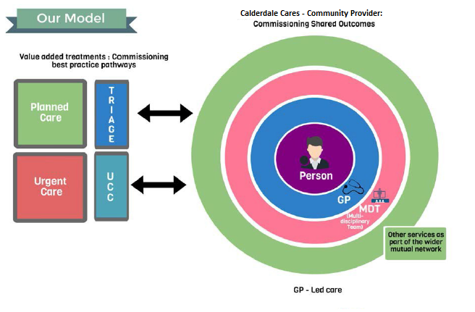
The services are summarised below that strive to improve access, continuity and coordination underpinned by more generic population health improvements, system and staff benefits and the empowerment of Calderdale communities.

ii.Rapid Access Services largely delivered on a locality basis and designed to respond to urgent care needs whilst identifying proactively potential onset or exacerbation of illness and ensuring an integrated approach to patient management within a community setting;

iii.On-going Care Services delivered at a GP level predominantly through multi-disciplinary teams (MDTs). These are delivered at scale on a locality through Local Access Hubs effectively forming a mutual network of care with a wider network of community based and voluntary sector services.

iv.High Care Need Services that operate as a ‘step up’ mechanism for the more vulnerable, complex care patients or patients with increasing acuity that require more enhanced condition management to prevent an admission to hospital and ‘stepping down’ to On-going Care Services.
v. Integrated Wellness Services which is predominantly focused on prevention and population health management would wrap around this model providing a range of services that address the wider determinants of health. (See Appendix 3).
(This model is based on the Dudley CCG approach).
Appendix 4 Integrated Wellness Service
An Integrated Wellness Service is defined as providing support to people to live well, by addressing the factors that influence their health and wellbeing and building their capability to be independent, resilient and maintain good wellbeing for themselves and those around them (Knowsley Council) .
It moves beyond focussing on single issues and takes a holistic and person-centred approach, addressing the psychosocial determinants of health behaviour. Source: Knowsley MBC
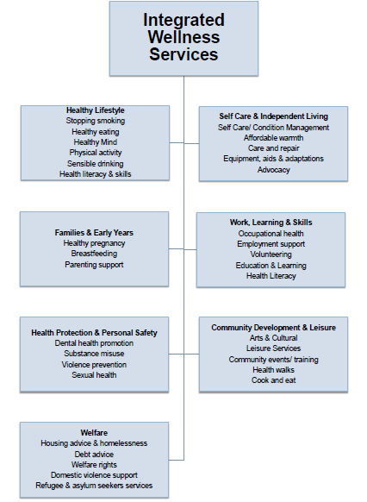
Knowsley Integrated Wellness Service: A Whole System Approach

•Single point of access ‘hub’.
•Holistic assessment of individuals.
•Hub triages clients based upon need and provides on-going support.
•Service supports community development and builds upon community assets.

Appendix 5. Potential Alliance Organisation Model
A review of the literature highlights a range of MCP models that could be explored – this paper presents a proposed alliance model based on the overview below:
Contractual Alliance Overview
• The four Providers remain separate legal entities, continue to directly employ their own staff but are bound together by an alliance agreement. In this option, the alliance would overlay existing contracts
• The Joint Commissioners and Providers come together in a contractual alliance to deliver MCP services under their existing contracts with the commissioners
• Decision making by the four Providers is delegated from each provider to their member(s) who sit on an Alliance Board and bind their organisation
• An overarching robust alliance arrangement which deals with risk and reward sharing is put in place
• Services are delivered by the individual members under their existing contracts
• The joint commissioners (Calderdale MBC/CCG) act as system integrators

Appendix 6. Ten lessons to support the development and implementation of new care models
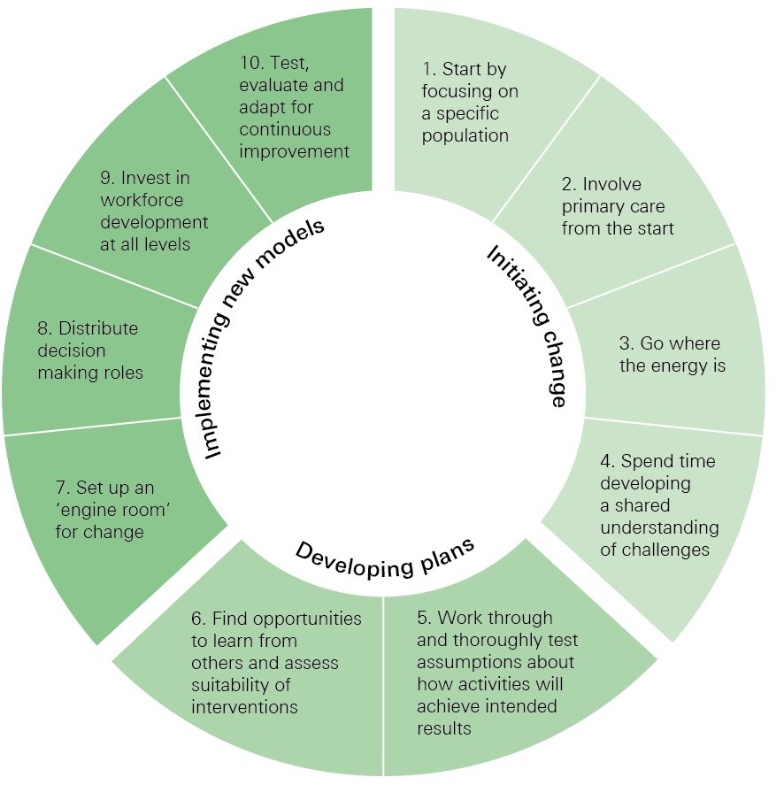
1. Start by focusing on a specific population
Focusing first on a specific cohort of the population gives teams experience of co-designing services with patients and using data to understand need.
2. Involve primary care from the start
Primary care plays an essential role in delivering coordinated care for patients, families and communities. General practitioners can offer significant insight into the needs of populations and where services can be developed.
3. Go where the energy is
Identifying individuals and teams who already have ideas for and commitment to change can help gain momentum locally.
4. Spend time developing a shared understanding of problems
Ensuring there is a shared understanding of the problems to be solved is a crucial factor in cross-team improvement work and requires that people are bought together at the beginning of any change initiative.
5. Work through and thoroughly test assumptions about how activities will achieve intended results
Developing logic models can help teams think through and articulate links between planned activities and outputs without rushing to implementation.
6. Find opportunities to learn from others and assess suitability of interventions
When looking at learning from elsewhere bring staff together to work through how to adapt the interventions for the local area.
7. Set up an ‘engine room’ for change
In the absence of formal organisational structures, it is important to put in place a central project team that includes project management, data analysis, communication and administrative expertise. This should include staff who have already worked in the local area to create confidence among stakeholders.
8. Distribute decision making roles
Ensure decision making roles are allocated across organisations and professional groups – not just at the most senior level.
9. Invest in workforce development at all levels
With the creation of new cross-organisational services, investment in developing people is crucial. This is necessary at all levels of the local system and requires a focus on individual skills, team development and training for those in leadership roles.
10. Test, evaluate and adapt for continuous improvement
Giving teams licence to experiment is crucial in order to understand the impact of changes and to help shape plans as they progress. It’s important to make sure the people and teams involved are given feedback and supported to alter plans when changes do not go as intended.

Department of Health and Department of Communities and Local Government, ‘Better Care Fund, Policy Framework 2016/17’, January 2016.
Calderdale People’s Commission, ‘Improving Health Together’ https://www.calderdale.gov.uk/v2/sites/default/files/improving-health-together-leaflet.pdf

