5



Report to Scrutiny Panel
Name of Scrutiny Panel | Economy and Environment
Meeting Date | 10 November 2016
Subject | 2nd Capital Programme Monitor 2016/17
Wards Affected | All
Report of | Group Director Economy and Environment
Type of Item  (please tick✓ ) | Review existing policy
Type of Item  (please tick✓ ) | Development of new policy
Type of Item  (please tick✓ ) | Performance management (inc. financial) | ✓
Type of Item  (please tick✓ ) | Briefing (inc. potential areas for scrutiny)
Type of Item  (please tick✓ ) | Statutory consultation
Type of Item  (please tick✓ ) | Council request
Type of Item  (please tick✓ ) | Cabinet request
Type of Item  (please tick✓ ) | Member request for scrutiny (CCFA)

Why is it coming here?
Under the Council’s financial procedures, directorates are required to report to Scrutiny Panel their overall capital monitoring position, and to report variances from the approved budget, together with the reasons for significant changes in service delivery.

What are the key points?
- This is the second capital monitor to be presented to Members in the current financial year which contains details of expenditure incurred for the period 01 April 2016 to 30 September 2016, together with the current forecasted outturn.

- It is anticipated at this stage in the financial year that £38.937m will be spent against the original forecast of £39.205m as detailed in Appendix 1 of this report.

- It should also be noted that in the main, expenditure incurred in 2016/17 will be financed by resources provided by the West Yorkshire Combined Authority (WYCA) for the Highways Capital Programme, the West Yorkshire Transport Fund programme, capital receipts, and the grant approved by the government to assist with recovery works following the Boxing Day floods.

Possible courses of action
Members are asked to note the content of the report.

Contact Officer
Paul Greenwood Tel :01422 393501

1 Background

  - This report is the second Capital Expenditure and Financing report to be presented to Scrutiny Panel in the current financial year, and it contains details of the relevant budgets and forecasts of expenditure for the year for the capital schemes managed by the directorate.

  - Appendix 1 attached to this report contains details of the budgets and forecasts for the relevant schemes for the year. Appendix 2 contains details of the overall budget of £96.299m that is currently in place for the relevant schemes for the financial years 2016/17 to 2018/19.

  - The overall capital programme for the directorate includes a budget of £24.974m to allow the Council and the Canal and River Trust (CRT) to deliver a number of schemes throughout the Borough, and further details relating to the various projects are contained in Appendix 3 attached to this report.

2 Main issues for Scrutiny Panel

2.1 Directorate Capital Schemes

2.1.1 In the current year there are several programmes of capital schemes being undertaken by most services of the directorate.

2.1.2 Highways & Engineering Service continue to deliver a suite of capital schemes within the Local Transport Plan (LTP) framework as well as delivering a number of projects in the ambitious Flood Recovery Programme utilising the £24.974m funding secured from the Department for Transport (DfT).

2.1.3 The West Yorkshire Plus Transport Fund Programme has received approval from the WYCA to incur expenditure in the region of £4.360m on the relevant schemes during 2016/17

2.1.4 Within the rest of the directorate, there are a number of services delivering programmes related to Flooding, Housing & Environment, Planning and the Corporate Projects associated with the council.

2.2 Summary of Current Expenditure, Forecasted Outturn and Variances By Service Areas

2.2.1 In the current financial year, Cabinet will receive Capital Programme financial monitoring/progress reports, with the next Capital monitor report to be presented to Cabinet on 14th November 2016. The reported position for Economy & Environment expenditure and the forecasted final outturn based on the September monitor review is summarised below for Members consideration:

Summary of September Financial Information by Service Areas

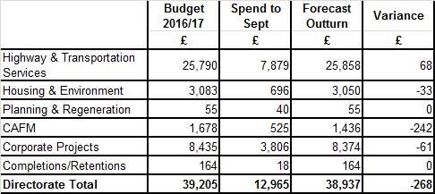

2.2.2 If all of the Council’s capital schemes are delivered by the end of the financial year in accordance with the current forecasts, expenditure in the region of £38.937m will be spent by 31 March 2017. Any slippage against the planned programme will be rolled forward to be delivered in the next financial year.

3 Programme Update in relation to schemes detailed in Appendix 1 & 2

3.1 Highways & Transportation Services - £25.790M

3.1.1 This service area reports a number of large Programmes which include Highway Maintenance, Integrated Transport, Street Lighting and the new Flooding Programme. At the end of September 2016, expenditure was £7.879m, equivalent to 31% of the approved budget of £25.790m.

3.1.2 The Carriageway Programme of works is progressing well with a number of schemes complete and expenditure for the year is forecast to exceed the budget of £2.994m. In terms of the major schemes, the A58 Stump Cross has been resurfaced during the last quarter and more than half of the principal road network schemes in the programme are now complete with evening work planned to ensuring industry and commerce are able to continue without too much disruption. The remainder are being programmed with the A629 Fountain Street due to commence shortly.

3.1.3 There is slippage in the Structural and the Street Lighting Programmes as resources have been targeted to some extent to deliver key areas of work within the Flood Recovery Programme.

It is, however, still anticipated that over 500 columns will be replaced in the current year and further work will be completed along Wakefield Road, Copley to upgrade the relevant lighting columns. Members of Scrutiny Panel are also reminded that the Council is looking to deliver a comprehensive street lighting replacement programme during the next 4 to 5 years, and the Council has recently advertised the tender to appoint a contractor to complete the relevant Asset Survey of the Council’s Street Lighting.

3.1.4 Various schemes are now being delivered as part of The Integrated Transport Programme with the Safer Road section of the programme introducing a number of 20MPH schemes. The Ovenden and Illingworth Areas have recently become operational and consultation on the Brighouse Area has recently been completed and implementation of the scheme will commence in the near future.

Within the Integrated Transport Programme there is a significant amount of funding allocated to the management of the road network within Calderdale which consists of signal upgrades and replacement works, the introduction of Variable Message Signs (VMS) and junction improvements. This area of the Programme accounts for 50% of the funding and relies heavily upon Leeds UTC delivering the works. Regular meetings are held with Leeds UTC to press the requirement to deliver schemes however resources are limited as they cover the whole of West Yorkshire. Recent discussions held with WYCA and the partner authorities have indicated that there is a willingness to share available resources within the districts to try and ensure that the Network Programme can be delivered.

3.1.5 For the Flood Investment plan it was anticipated earlier in the financial year that the whole of the budget of £1.342m would be spent in the current year however the latest forecast allows for expenditure of £430k. The schemes to be delivered in the current year from the Flood Risk Reduction Scheme (FRRS1 Programme) capital programme are as follows;

- Woodlands View
- Burnt Acres Wood
- Pinhill

3.1.6 Funding for the Flood Repairs Programme is ongoing with the Council, working with a number of partners including the Canal and Rivers Trust, drawing up a programme of works to be delivered during the next two years. The latest position in terms of service delivery as reported to the Department for Communities and Local Government in early October 2016 is detailed in Appendix 3 of this report.

At this point in the financial year it is anticipated that expenditure in the region of £18.576m will be spent by the end of the year by the Council and the CRT, but it is clear that the projection will change as schemes are prioritised, designed and implemented.

To date, work is continuing on the rebuilding of Elland Bridge and the scheme is on track to be opened in December 2016. The A646 at Fallingroyd, Hebden Bridge was reopened in October 2016. Works continue at Scout Road with the road to the school now re-opened. The remainder of work at the Scout Road site is ongoing with the Catch Fence being installed. Further design works are continuing in relation to the wall.

The bridge at Copley has been replaced with a temporary structure and design is continuing on a permanent structure.

Over 120 Scour Risk Assessments have been completed and schemes have evolved from this work. Some of these schemes are rated as ‘urgent’ priority and work has been commissioned for 6 of the most serious sites.

It is expected that the balance of funding of £6.394m will be required by the Council and the CRT to deliver the remaining schemes in the financial year 2017/18. It is worth noting that any slippage in expenditure will not impact on the overall funding available for the scheme as the grant provided by the DfT is not time limited.

3.2 Housing and Environment – £3.083M

3.2.1 At the end of September 2016 expenditure was £0.696M, equivalent to 23% of available resources, leaving a further £2.387M to be spent in the remaining months of the financial year. Comments in relation to the most significant schemes are as follows:

- Disabled Facilities Grant (£2.163M) - It is envisaged that the budget will be fully spent by the end of the year.
- Cluster of Empty Homes (£188k) - The budget has been earmarked in the current financial year to progress the compulsory purchase of an empty property and bring it back into use. Options for the housing assets in the Halifax Borough Market will also be investigated.
- Affordable Warmth (£400k) – The launch of the scheme has recently taken place with works expected to commence shortly following a report to Cabinet which outlined the loans available to facilitate private housing upgrades to ensure they are energy efficient. The loans are repayable and funding will be recycled to provide new loans to other home owners in the need of assistance to fund insulation and heating works to their homes. It is now anticipated that the budget will be fully utilised in the current year.
- Siddal Environmental Improvements (£156k) – Work is now complete and the final account from Amey LG is due to be received by the Council. It is anticipated that the scheme may realise a small underspend.
- New Street Developments (£45k) – Work on this project is due to be completed in the near future and the final accounts will be processed.

3.3 Regeneration - £55k

3.3.1 With a relatively minor budget of £55k and spend of £40k as at September 2016, equating to 74% of available finances, there are no reported concerns at this stage in relation to the delivery of the scheme for Boosting Businesses within the Borough.

3.4 CAFM - £1.678M

This programme of works consists of several projects as detailed below;

    - It is anticipated that £1.1m of the overall budget of £1.332m earmarked for Council’s Asset Management Programme will be spent in the current year. The most significant works are being carried out at the following premises;

- Lower Edge (roof repairs), Halifax Borough Market (gates refurbishment)
- Market Street (dry rot repairs)
- Mixenden Outdoor Centre (roof repairs)
- Victoria Theatre (phase 2 of 3 roof repairs)
- Todmorden Sports Centre (refurbishment of pool and boom)
- Queens Road Neighbourhood Centre (Phase 1 roof repairs)

    - A budget of £100k is set aside to meet the Council’s share of the refurbishment associated with the relocation of Iscal from Club Lane. The specification for the relevant work is currently being finalised and the tender process likely to commence in the near future.

    - The Council has recently had to resubmit the tender documentation for the completion of the work in relation to the Hebden Bridge Market relocation. Work is now expected to commence in January 2017 and be completed within an 8 week timescale.

3.5 Corporate Projects - £8.435m

3.5.1 West Yorkshire Plus Transport Fund - £2.760M

Members will note from Appendix 2 of this report that it is currently forecast that the Council will incur expenditure in the region of £32.3m during the next 3 years. It was initially projected in the 1st capital monitor that £4.1m would be spent in the current year but this is now expected to be in the region of £2.760m.

Members are aware that there are various phases to the overall programme, although the initial focus is on carrying out advanced work at on the Jubilee Road to Free School Lane scheme with contractors already on site. Work is also progressing on the compulsory purchase of land required to deliver the major part of the scheme at Salterhebble Hill.

Further work in relation to the Ainley Top to Jubilee Road phase will be carried out when the tenders for the delivery of professional services for Design and Build have been awarded.

Although work is also being undertaken to deliver other aspects of the programme, including the Station Gateway and Bradford to Brighouse/Huddersfield corridor, it is by no means certain how much of the revised budget will be spent in the current year.

3.5.2 Halifax Town Centre Office Strategy (HTCOS) - £4.063m

Also included under the umbrella of Corporate Projects are a further number of significant capital projects. Below is a brief update on the larger ongoing projects:

The refurbishment of Princess Buildings and new extension is currently subject to delay. Given the age and nature of the building (Grade 2 listed), there had been a significant number of variations, predominantly but not exclusively, structural in nature. These variations have increased the original budgets for the scheme, which is an integral part of the overall HTCOS programme budget.

Further work is also still due to be completed in relation to Mulcture House, Carlton Mill and Threeways, and the relevant contractors are due on site in respect of both Mulcture House and Carlton Mill in the final quarter of the year.

    - Document Archive Facility (£506k)

The Council has now agreed to relocate part of its document archive facility to the Springwood Business Park. The contractor is currently on site and the work is scheduled to be completed in December 2016 and the facility will be operational later in the financial year.

    - Revolving investment Fund (£654k)

The Council agreed in July 2013 to invest up to £1.632m in the Leeds City Region over a 3 year period. The payments of £654k made to date are the Council’s contribution to support housing developments on the outskirts of Leeds and Addingham.

  - Completions/Retentions

There are a number of schemes within the capital programme totalling £164k, as detailed in Appendix 1 of this report, where the Council is awaiting final accounts for various retentions. It is, however, forecast in the current year that all of the relevant costs will be incurred. The main schemes are as follows:
- Sowerby Bridge to Copley Valley
- Dudley Estate
- Decent Homes Programme
- Household Waste Sites – Halifax & Todmorden

4. Finance

4.1 Capital schemes within the Directorate are financed from the following capital resources:

- Borrowing/ Grants/Contributions/revenue and
- Council ‘pooled resources’ from property disposals

4.2 There are sufficient identified resources to fund the completion of the Directorate capital schemes within the Council’s Capital Programme.

4.3 Directorate Monitoring Arrangements

4.3.1 Progress on all Directorate capital schemes is regularly monitored by scheme Managers and action is taken to review programmes/phasing of schemes in order to ensure that costs are contained within budget.

5. Conclusions

5.1 The Directorate has an ambitious plan of capital investment programmes to complete during 2016/17, and progress is being made against a large proportion of these programmes. Subject to no contractual or weather delays managers are, in the main, confident of delivering their respective programmes.

5.2 The financial consequences of ongoing schemes have been reflected in the Council’s Capital Programme for 2016/17.

6 Background Documents

- Analysis and information provided by Scheme Managers and Head of Finance monitoring reports
- Financial Ledger

7 Documents available for inspection at:
Finance Services, 3rd Floor Westgate House, Westgate, Halifax.

For further information relating to this report, contact Paul Greenwood on 01422 393501.

Appendix 1
Directorate Specific Schemes and Rolling Programmes

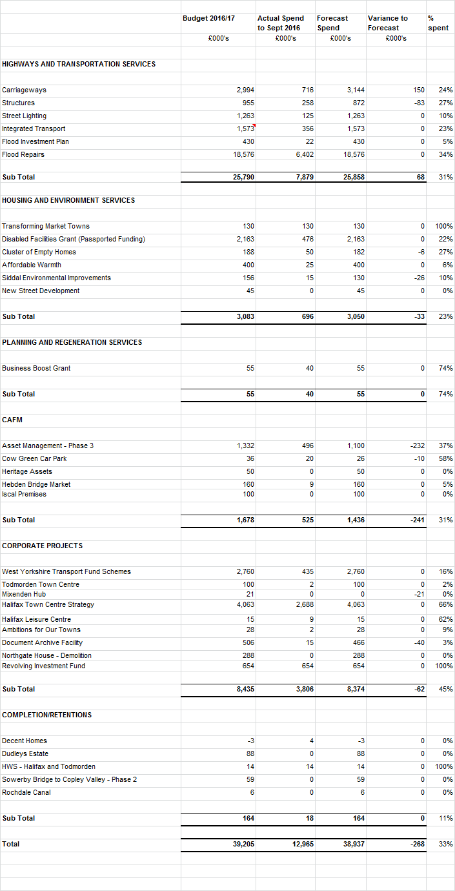

Appendix 2
Directorate Specific Schemes and Rolling Programmes Funding 2016/17 to 2018/19
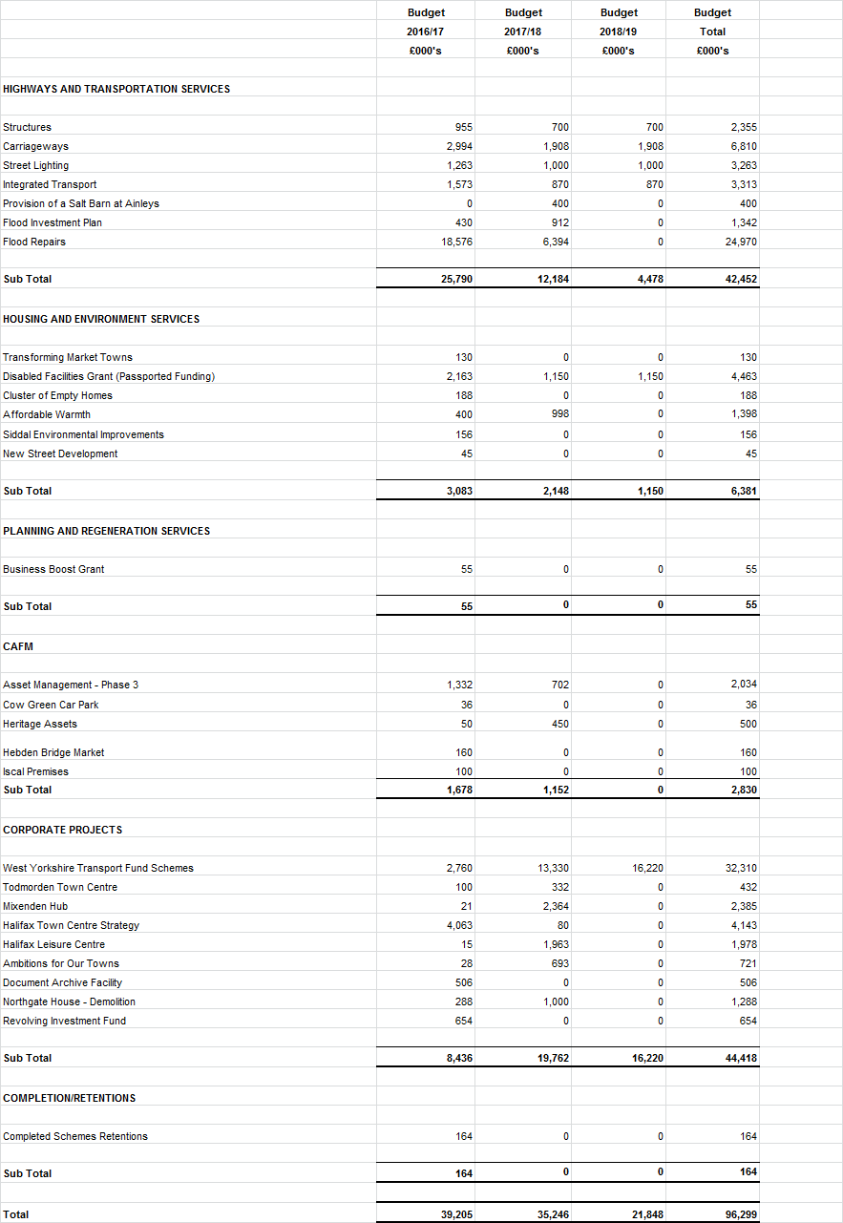

FLOODING REPAIR PROGRAMME 2016/17
APPENDIX 3

