


Agenda Item 9B
Report To: | Health and Wellbeing Board – 25th August 2016

Title of Report: | Better Care Fund (BCF) Quarterly report - First Quarter Performance Fund - 1 April 2016 to 30 June 2016
FOI Exemption Category: | Open
Responsible Officer: | Debbie Graham – Head of Service Improvement Calderdale CCG  Elaine James – Service Manager (Strategic Commissioning), Calderdale MBC
CCG Lead: | Dr Steven Cleasby
Report Author and Job Title: | Debbie Graham – Head of Service Improvement Calderdale CCG  Elaine James – Service Manager (Strategic Commissioning)
Executive Summary: | NHS England confirmed that the Calderdale BCF Plan has achieved Approved status on 2nd August 2016.  Every month the Better Care Fund Programme Board receives reports on the BCF programme, including progress on the performance of BCF Key Performance Indicators (see Appendix A). The Board considers actions to recover any underperformance and those actions which have been designed to mitigate any identified risks. The Board is currently chaired by the Director Adult Social Services, however following the departure of Bev Maybury to take up her new post with Bradford Council the Health and Well Being Board is asked to endorse the recommendation of the Programme Board that Dr Steven Cleasby assume the role of Chair of the BCF Programme Board.  The Health and Well Being Board is currently considering the future strategic arrangements for integrated commissioning in line with the requirements for the development of a local Sustainability and Transformation Plan and the requirement to integrate by 2020. It is envisaged by commissioners that the strength of the relationship and integrated operational commissioning practice developed through the BCF Programme will inform the approach towards Integrated Commissioning going forwards (see figure 1 below for the proposals in relation to refreshed local integrated commissioning governance).  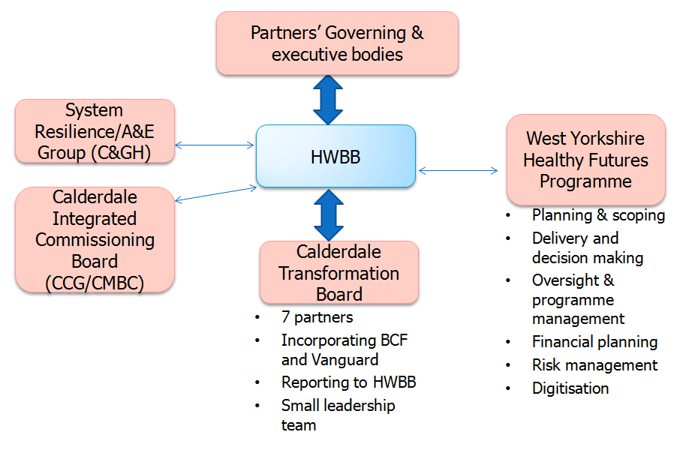  The Disabled Facilities Grant is included within the Better Care Fund. The mandated minimum budget for the DFG during 2015/16 was £1.090M. In keeping with spending review commitments the potential budget for 2016/17 is £2.063M. The revised DFG allocation has replaced the previous Adult Social Care Capital Grant which was included in the 2015/16 BCF and has been at the level of £513K per annum. The adult social care capital has historically been allocated by Capital Programme Working Group towards levering in significant additional capital to develop extra-care schemes, two schemes are under development currently – a 60 unit scheme in the Lower Valley and a 100 unit scheme in North Halifax. The capital grant has also been used to adapt properties into use including the vacant Heatherstones site which is now an integral part of the integrated intermediate care offer in Calderdale and supported accommodation for adults with learning disabilities and mental health needs in keeping with the Health and Well Being Board’s ambitions for Transforming Care. The current value of the DFG waiting list is £2.4M and the estimated costs of works to meet presenting demand is a further £1M which would bring the total cost of clearing the DFG during 2016/17to an estimated £3.4M. Clearly there are significant and competing cost pressures against the capital allocation within the BCF which is unringfenced. The recommendation of Officers to the Health & Well Being Board is that the DFG element within the BCF be released to Housing at the sustained level of the 2015/16 allocation whilst further work be undertaken by commissioners during September 2016 to consider the options for the balance to include all pressures outlined above for reporting back to the Health and Well Being Board in October 2016.  First quarter report 2016/17  The position reported at 30 June 2016  - Performance  The 2015/16 out turn position at the end of Quarter 1 was that the targets for improvement are all in line with planned trajectories (see Appendix A for dashboard of performance).  The 91 Day Metric is awaiting a validated return from CHFT.
Finance/Resource Implications: | The Better Care Fund in 2016/17 has a value of £15,790,766. The total value of the schemes in 2016/17 is £16,163,864, which is £373K more than the value of the mandated minimum value of the BCF Fund. Through Prudent financial management on the part of the BCF Programme Board a contingency reserve has been created of £1,194,000. The contingency is underwriting shared system risks including the in-built overspend to the fund. £821K is un-earmarked within the contingency reserve. Commissioners are undertaking service improvement and system redesign work to address the financial risks arising from the reported position.
Risk Assessment: | The Better Care Fund risk log comprises both Strategic and Operational Risks. All risks have a nominated lead officer. The Programme Board manages Strategic Risks and the Operational Risks are managed by its supporting Better Care Fund Operational Commissioning Group but with oversight from the Programme Board. Significant risks are migrated onto the CCG’s Corporate Risk Register as appropriate.  At present all risks are well managed within the BCF Programme Board with no major risks to escalate to the Health & Well Being Board.
Legal Implications: | A Section 75 Partnership Framework Agreement between the Council and the Clinical Commissioning Group is in place. The Framework Agreement was subject to a Variation for 2016/17 to align to the Plan as approved for delivery by NHS England. The Variation has now been signed and in place.  The Head of Legal Services, in consultation with the Director, Adult Social Service for Calderdale Council have delegated authority to implement the Variation to the Section 75 Framework Agreement Calderdale Cabinet Minute 110416 – 129b minute states:  RESOLVED that  (b) the Director, Adults, Health and Social Care be given delegated authority, in consultation with the Portfolio Holder for Adults, Health and Social Care and the Head of Democratic and Partnership Services for the task of negotiating and finalising a Section 75 Agreement for 2016-17 with the Clinical Commissioning Group together with any associated documentation in order to place the Better Care Fund on a legal footing.
Health Benefits: | BCF plans support delivery of the CCG’s strategic plans for 2015/16 and contributes to the emerging Calderdale Sustainability and Transformation Plan.
Staffing/Workforce Implications: | Capacity and capability to develop the plans are in line with current resource available between CMBC and Calderdale CCG. Delivery of the plans will include the capacity and capability provided within the CSU contract.
Outcome of Equality Impact Assessment: | Any service changes resulting from delivery of the plan will be subject to consideration in relation to an Equality Impact Assessment.
Sub Group/Committee: | The position on the Better Care Fund is reported to the BCF Operational Commissioning Group, the Better Care Fund Programme Board, the CCG’s Finance and Performance Committee, the Council’s Adult Health and Social Care Transformation Board and the Health & Wellbeing Board.
Recommendation (s): | The Health and Wellbeing Board is asked to:  - Endorse the recommendation that Dr Steven Cleasby be appointed as Chair of the Better Care Fund Programme Board.  - Consider the first Quarterly Report and note the position as reported for end June 2016 and the year end out turn position for reporting to NHS England.  - That the DFG element within the BCF be released to Housing at the sustained level of the 2015/16 allocation whilst further work be undertaken by commissioners during September 2016 to consider the options for the balance to include all pressures outlined above for reporting back to the Health and Well Being Board in October 2016

Appendix A Dashboard of Performance
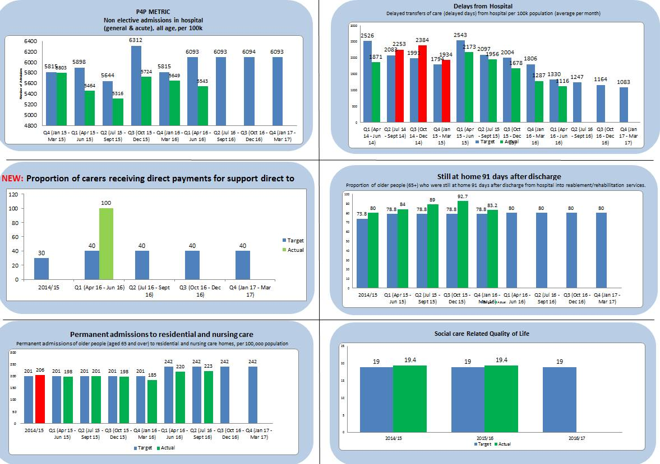

Appendix B – BCF Programme Schemes 2016/17 Progress Tracker
