

Customer Services - Trust wide report for the period

01 July 2015 – 30 September 2015 (QTR. 2 15/16)

Introduction
This report covers all feedback received by the Trust’s Customer Services Team - comments, compliments, concerns and complaints, which are managed in accordance with policy approved by Trust Board. The policy is subject to annual review and takes account of relevant regulation and best practice and emphasises the importance of using insight from service user experience to influence and improve services. The Board will review updated policy in December 2015.
The Customer Services function provides one point of contact at the Trust for a range of enquiries and feedback and offers accessible support to encourage feedback about the Trust and its services.
The report includes:
- the number of issues raised and the themes arising
- equality data
- external scrutiny and partnering
- Customer Service standards
- actions taken and changes made as a consequence of service user and carer feedback
- compliments received
- the number and type of requests processed under the Freedom of Information Act

feedback received

The tables below illustrate Customer Services activity in Qtr. 2. The Customer Services team responded to 301 issues (333 in Qtr.1); 73 formal complaints were received (81 in Qtr.1) and 163 compliments (149 in Qtr.1).
The number of formal complaints regarding CAMHS services decreased in the period from 22 in the previous quarter to 12. Most of these complaints related to access and wait times in Calderdale and Kirklees services, which are being addressed through on-going discussions with CCGs.
Across all complaints, communications was identified as the most frequently raised negative issue (23). This was followed by access to treatment and drugs (20), values and behaviours (19), clinical treatment (12), appointments (10) and admission and discharge (9). Most complaints contained a number of themes.

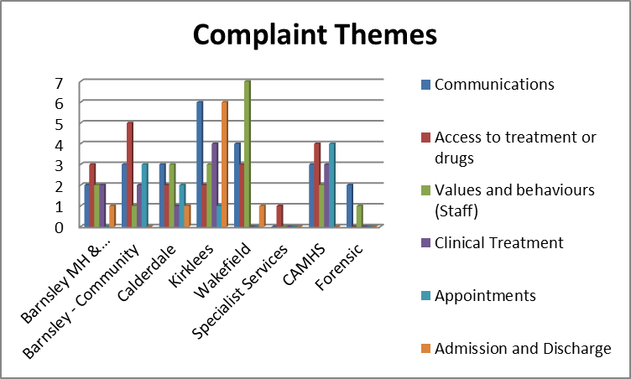

Customer Services activity Qtr. 2
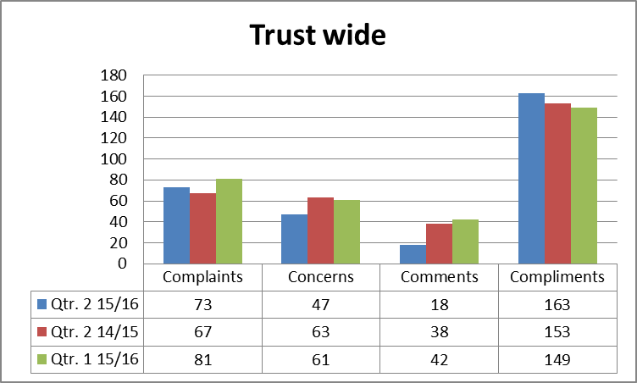 | 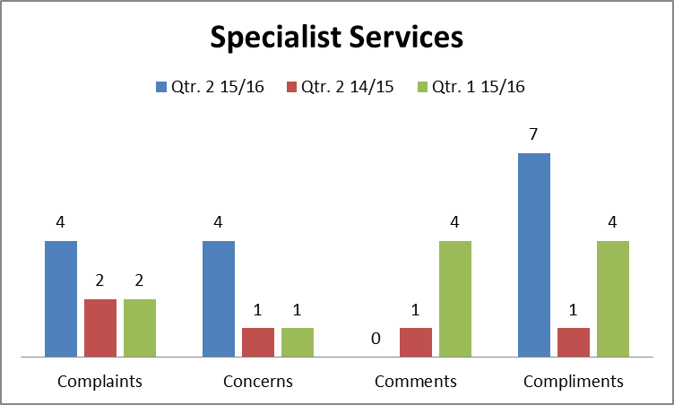
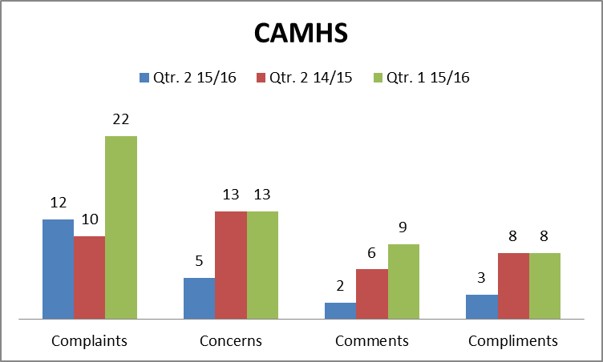 | 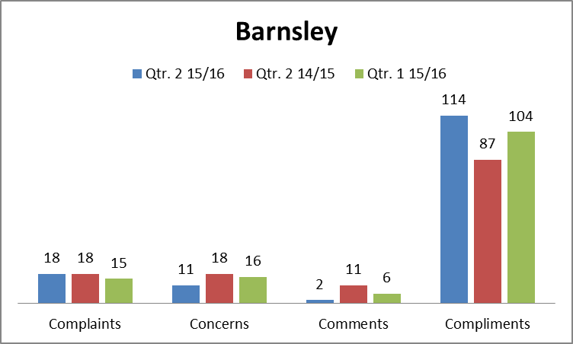
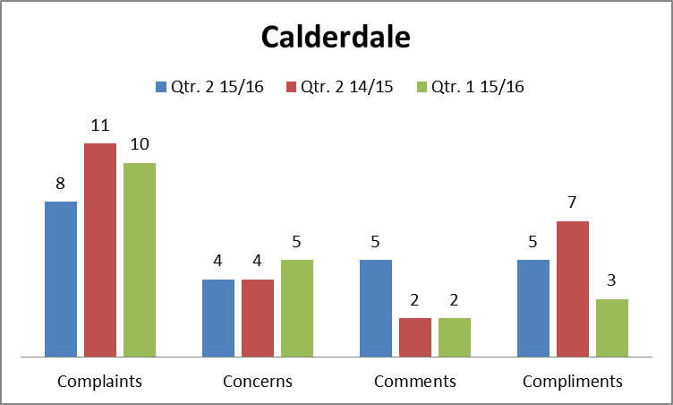 | 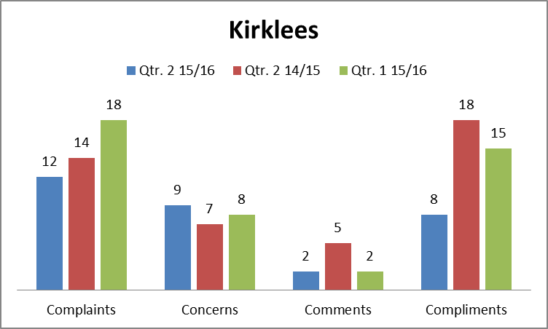
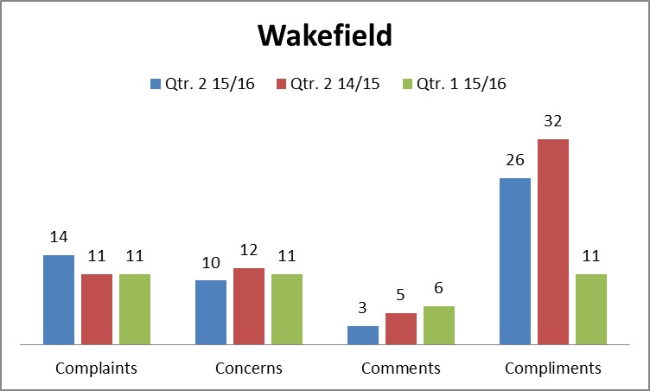 | 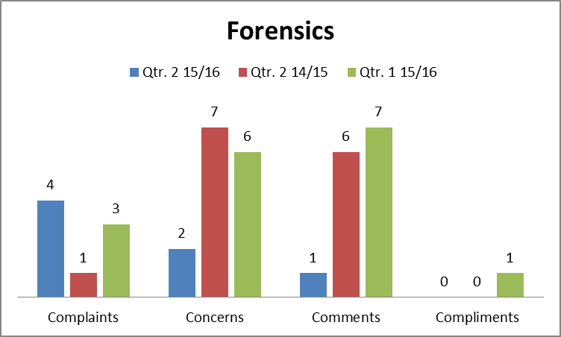

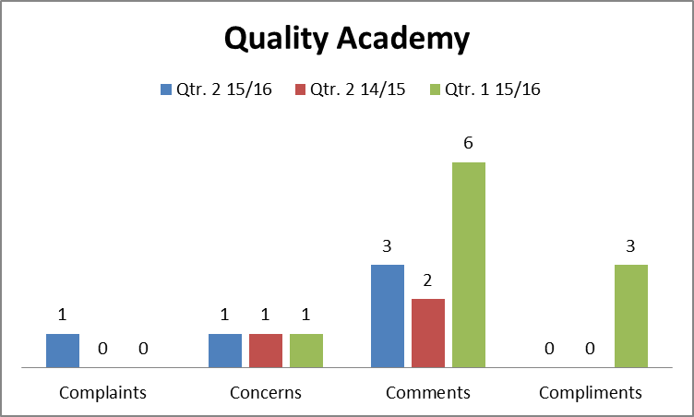

Number of issues raised informally
During Qtr.2. Trust services responded to 47 issues of concern at local level. The Customer Services team worked with service lines to ensure the recording of issues raised informally and to capture action taken in response to this feedback. This promotes a default position of putting things right as and when they happen wherever possible and supports shared learning about service user and carer experience.

TRUSt WIDE EQUaLITY DATA
Equality data is captured, where possible, at the time a formal complaint is made. Where complaints are received by email or letter, an equality monitoring form is issued with a request to complete and return. To support improvement in the number of forms returned / completed, additional information is now also shared explaining why collection of this data is important to the Trust and that it is essential to ensure equality of access to Trust services.
The Team continues to explore best practice in data capture, both internally with teams and externally with partner organisations, and incorporates any learning into routine processes.
The charts that follow show, where information was provided, the breakdown in respect of gender, age, disability and ethnicity trust wide. The return rate of information is shown beneath the tables.

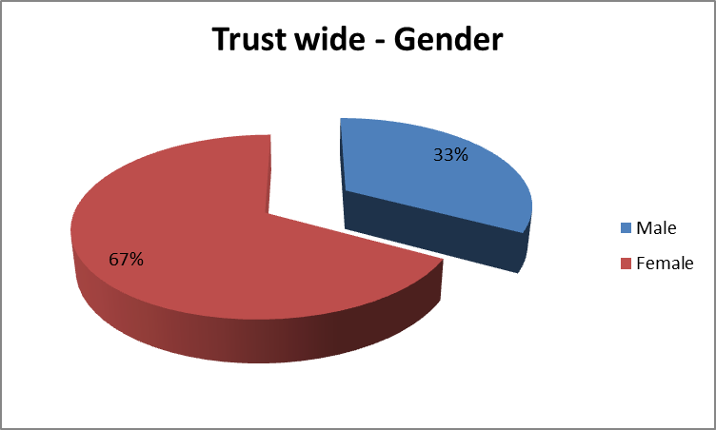 |  |  |  | 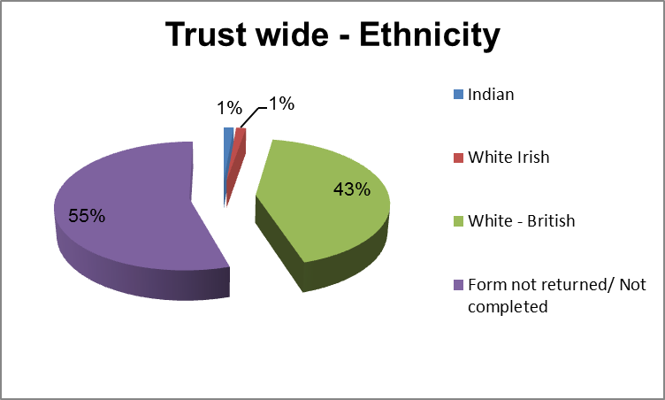
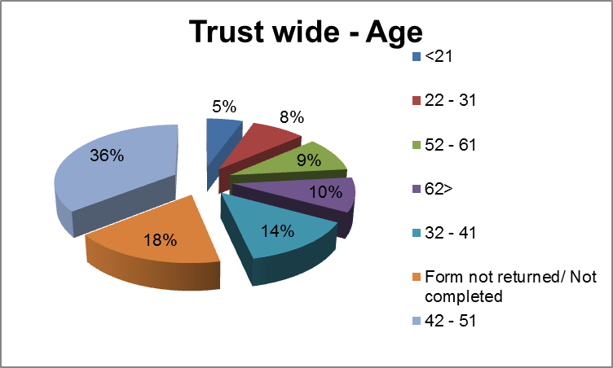 |  |  |  | 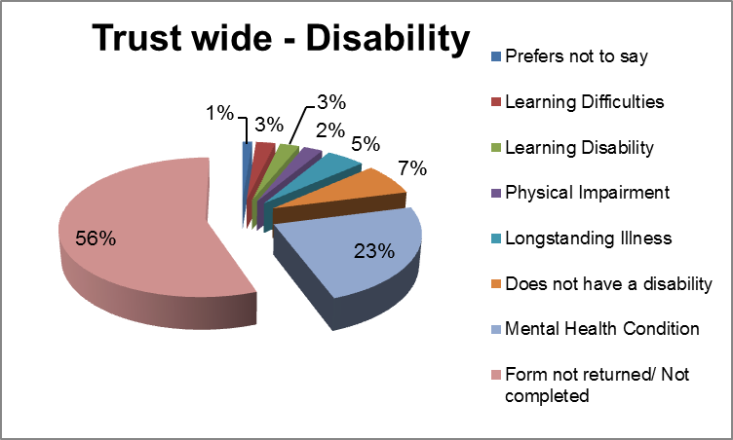
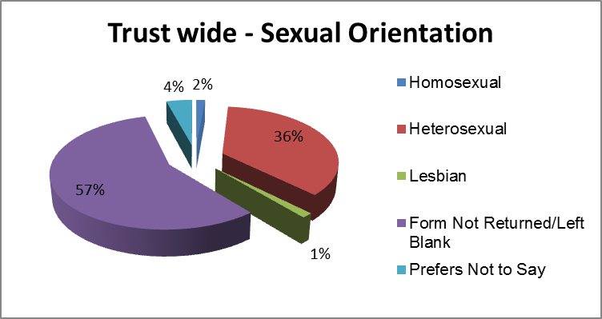
Age 60/73 | Gender 73/73 | Disability 27/73 | Ethnicity 33/73 |  | Sexual Orientation 44/73

Mp contacT
During Qtr. 2 there were 10 occasions where complaints and feedback were received via local MPs, acting on behalf of constituents. MP enquiries are processed in line with routine practice and contact made direct with individuals wherever possible.
8 enquiries related to CAMHS services and access issues. These were raised by Paula Sherriff (2), Barry Sheerman (2), Jon Trickett, Dan Jarvis, Holly Lynch and Jason McCartney.

Jo Cox and Paula Sherriff raised issues in relation to Kirklees services, regarding funding for an assessment and referral to services respectively.

The Trust makes proactive contact with MPs to keep them informed of news and initiatives on a monthly basis via the electronic stakeholder bulletin and offers specific briefing about relevant issues.

Parliamentary health service ombudsman (PHSO)

In Qtr.2, 7 complainants asked the Parliamentary and Health Service Ombudsman to review their complaint following contact with the Trust. Such cases are subject to rigorous scrutiny by the Ombudsman, including a review of all documentation and the Trust’s complaints management processes. Information requested by the Ombudsman in relation to the above was provided within the prescribed timeframe.

During the quarter, the Trust received feedback from the Ombudsman regarding 2 cases (1 Forensics (medium secure) and 1 Wakefield OPS inpatients) which had been subject to review.

Neither case was upheld and both are now closed with no further action required by the Trust.

The Trust is still waiting decisions on 4 cases previously referred. It can take a number of months before the Ombudsman is in a position to advise the Trust on its decisions.

Mental Health Act
2 complainants raised concerns with the Trust in Qtr. 2 regarding detention under the Mental Health Act. One individual chose not to specify their ethnicity - one described themselves as white – British.
Information on the numbers of complaints regarding application of the Act is routinely reported to the Mental Health Act Sub Committee of the Trust Board.

Care quality commission (cqc)

The CQC did not refer any issues to the Trust regarding comments, concerns, compliments or complaints in the period.

nhs choices

The Trust has introduced measures to attempt to drive traffic to NHS Choices, in recognition that this site is an external source of information about the Trust. Survey materials promote NHS Choices as an additional means to offer feedback about the Trust and its services. The website is monitored to ensure timely response to posted feedback.

During Qtr.2 6 individuals added comments on NHS Choices about their experience of Trust services. All posting are acknowledged. The Trust has requested contact with 2 individuals to follow up on the issues posted (visiting in Forensic services and access to day services in Wakefield mental health community services).

4 positive comments were posted regarding Wakefield in-patient services and Wakefield older people’s services.

JOINT WORKING
National guidance emphasises the importance of organisations working jointly where a complaint spans more than one health and social care organisation, including providing a single point of contact and a single response.
Joint working protocols are in place with each working partnership. The purpose of these is to simplify the complaints process when this involves more than one agency and improve accessibility for users of health and social care services.
The Customer Services function makes connection to local Healthwatch to promote positive dialogue and respond to any requests for information. Healthwatch are provided with copies of quarterly reports and request additional information from the Trust on occasion. Healthwatch are encouraging local people to share their experience of health services via their websites and will theme and share feedback as data is collected and collated.

Issues spanning more than one organisation Qtr. 2 | Complaint | Concern | Comment | Total
Barnsley Hospital NHS Foundation Trust | 2 | 0 | 0 | 2
Barnsley Metropolitan Borough Council | 0 | 1 | 0 | 1
Care Quality Commission | 1 | 0 | 0 | 1
Member of Parliament | 8 | 2 | 2 | 12
NHS England | 1 | 0 | 0 | 1
NHS Wakefield CCG | 0 | 1 | 0 | 1
Other | 1 | 0 | 0 | 1
Total | 13 | 4 | 2 | 19

CONTACT WITH CUSTOMER SERVICES TEAM
The customer services team processed 129 general enquiries in Qtr. 2, in addition to ‘4 Cs’ management. Consistent with past reporting signposting to Trust services was the most frequently requested advice. Other enquiries included provision of information about Trust Services, providing contact details for staff and information on how to access healthcare records. The team also responded to over 429 telephone enquiries from staff, offering support and advice in resolving concerns at local level (an increase in staff contact on the previous quarter).
In responding to contact of any kind, the team negotiates with each individual regarding the timescales for responding to issues, and regular contact is maintained until issues are resolved / closed. This connection results in positive feedback to the service regarding complaints management.
‘Meeting Expectations’ is a recently introduced real-time feedback process, to enable customer services to listen and respond to the feedback provided by people using the customer services function, and to act on feedback quickly and efficiently. Two questions are asked as part of on-going contact with people raising feedback using the customer services function:
Thirty two people offered this feedback during Qtr.2
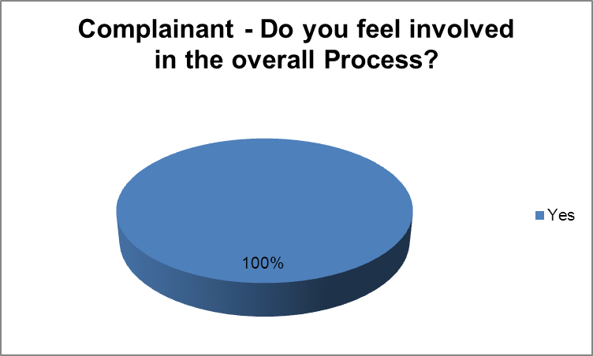 | 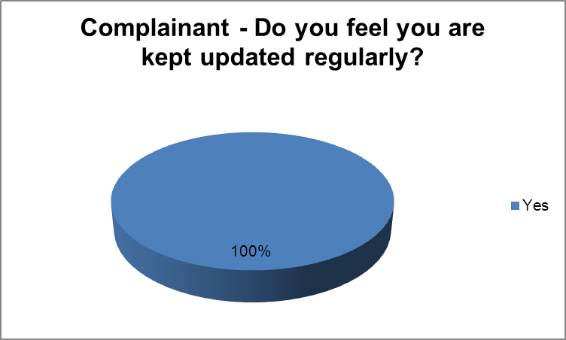
The Trust recognises that it is good practice to offer complainants the opportunity to meet staff to discuss issues. This offer is made early in the process to all complainants, but is particularly encouraged where complaints relate to more serious issues or complex circumstances.

These meetings are ideally attended by both Customer Services and service staff and provide an opportunity for staff to reflect on the experience from the service user’s perspective. A small number of complainants take up the offer to meet, with those declining indicating they are satisfied with the contact offered via Customer Services.
In relation to staff satisfaction (evaluated by questionnaire), 5 members of staff offered feedback – which indicated they were 100% satisfied with the support provided.
Complainants are offered contact details for independent advocacy services when their complaint is acknowledged and people are encouraged to use this support if helpful. 37% of complainants did not feel they required this support, and were happy to raise their concerns themselves with the support provided by Customer Services. A small number of service users were already supported by an advocate when they first contacted the Trust.
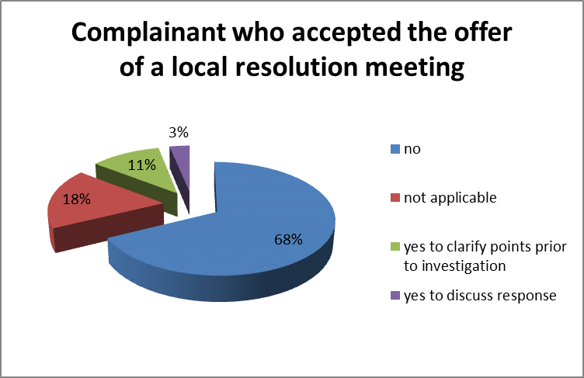 | 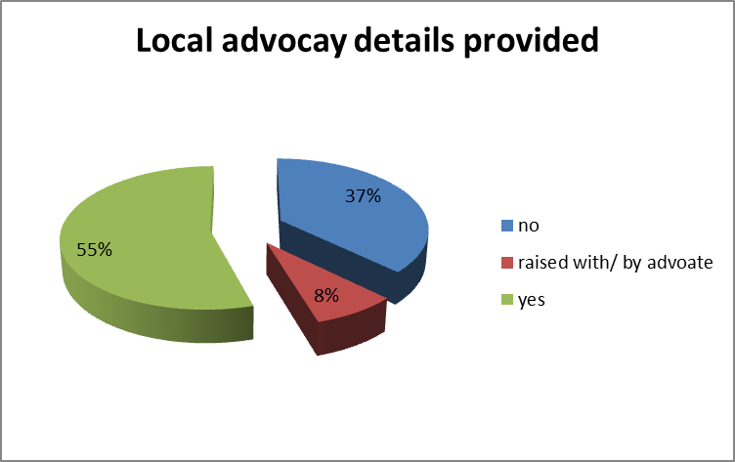
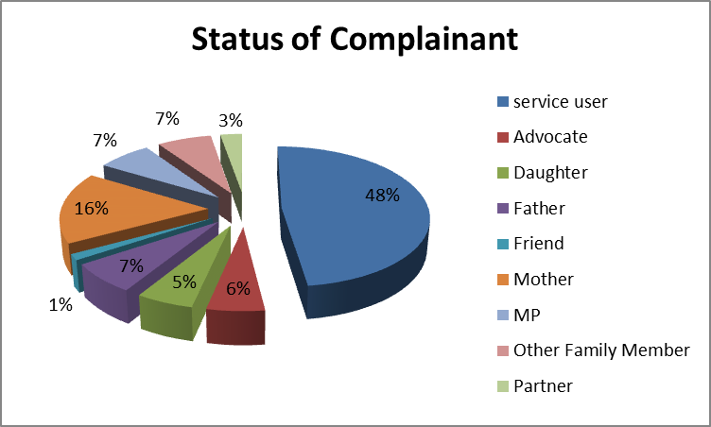
Complainants may wish to communicate in writing (by letter or completion of the Customer services feedback form), by ‘phone, email, text message, via the website or through face to face meetings. Ensuring that people have access and opportunities to feedback their views and experiences of care is essential to delivering the Trust’s values and is part of how we ensure that people have a say in public services. The Customer Services function is part of a developing framework of activity to facilitate feedback about all aspects of services and ensuring any lessons learned are acted upon. This includes internally and externally generated surveys, real time data collected via tablets, friends and family test results, NHS choices, Patient Opinion and focused engagement activity.

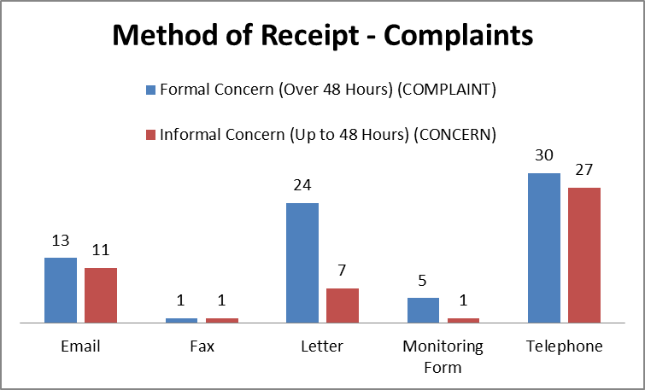

RESPONDING IN A TIMELY MANNER

The customer services standard is for complaints to be acknowledged within three days, with a named case worker assigned. Timescales are negotiated on an individual basis, with each complainant offered regular updates on progress until issues are resolved to their satisfaction or a full explanation has been provided. All complaints are dealt with as speedily as possible. The team (internal) standard is for every complaint to be responded to within 25 days; or 40 days for more complex cases.

In Qtr. 2, 74 complaints were closed. 14 were closed within 25 days, 10 were closed between 25 & 40 days and 27 took longer than 40 days to investigate and offer a response. This was due to delay in investigation at BDU level (allocation of a lead investigator) and the length of time to investigate. General Managers are alerted in such cases.

23 cases could not progress to investigation, due to consent not being given to investigate or no further contact being received despite follow-up.
44 formal complaints remained open at the end of the quarter (14 of which were received prior to Qtr. 2).
The Customer Services Team is now providing both a ‘position statement’ and ‘a lessons learnt’ report on a weekly basis to assist BDUs with speedy access to feedback about services, and to support the efficient and effective management of concerns and complaints.
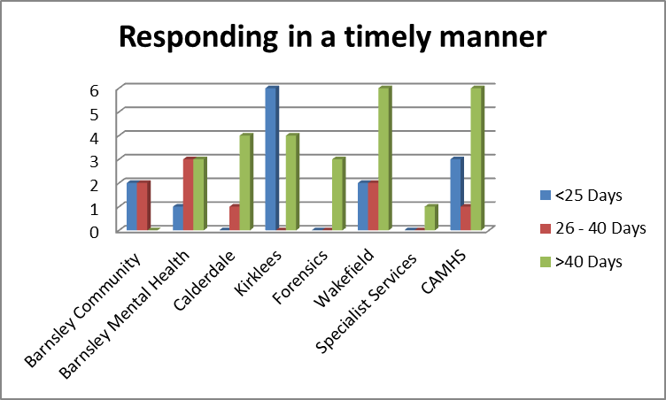

Compliments
During Qtr. 2, 163 compliments were recorded. These are acknowledged by the Chief Executive and positive feedback is shared with the individual, the team and across the Trust via the intranet to support sharing of positive practice.
Example compliments received in Qtr.2

Thank you very much for looking after me whilst I was on the ward and so ill.

Trinity 1, Wakefield.

.
Calderdale, CMHT
Thank you for making my time here a happy one. You have all been very kind and looked after me very well.
Stroke Unit, Barnsley.

It is without doubt that your team have always provided me and my family with exceptional care in helping me to overcome the many problems I have experienced in my life. You have helped me gain confidence and encouraged me to give life a go. Always remember, you have made a difference.

CMHT (Dearne) - Barnsley

Staff were extremely helpful and supportive and I commend you on how approachable staff are and how you managed my care so well.
Calderdale Community Learning Disability Team.

A big thank you for your help and advice when visiting me at home. It was comforting to also know that you were also at the end of the phone if I needed you.
CMHT - Community Therapies Team (South Kirklees)

Most frequently used words in compliments about Trust services:
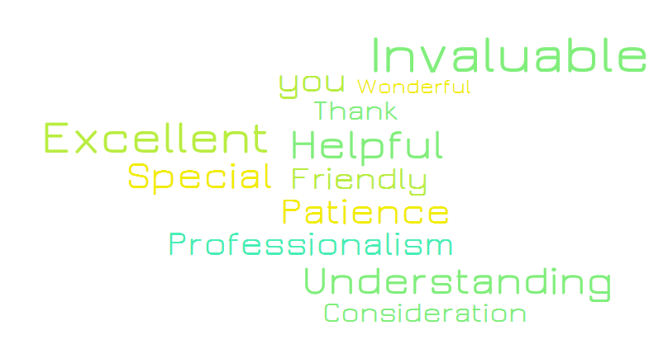

Action taken in response to feedback / changes made as a consequence of feedback
Not all complaints require action plans to remedy issues, but all provide helpful feedback which is used in services to support service improvement. The responsibility to deliver on action plans is held within the BDUs and monitored through governance processes.
All complainants are offered the opportunity to meet with Trust staff to discuss their concerns, and some take this up. All complainants received a detailed response to the issues raised and an apology that their experience did not meet their expectations.
The Customer Services monitoring form has been shared with services and staff are encouraged to capture all feedback at service level. Progress in capturing this additional information is being monitored.

Actions taken by BDUs in response to service user and carer feedback include:
Barnsley BDU
- Staff to ensure that information regarding alternative services is provided and the purpose and process of assessments is explained. (Single Point of Access)
- Discussions to be held within the team to promote wider learning. (District Nursing)
- Staff to ensure that service users are signposted to sources of additional support as appropriate. (CMHT-OPS)
- Medication procedures to be reinforced to all staff (Inpatient –Ward 4)

Calderdale & Kirklees BDUs

- Staff to ensure policies and procedures to ensure patient confidentiality are followed without exception. (Inpatient-Elmdale)
- Staff to ensure that reasons for any delay in access to services are clearly communicated to service users. (IAPTS)
- Clinicians to offer service users the opportunity to meet with the clinician individually following a joint appointment. (Psychological services)

Wakefield BDU

- Practitioners to ensure that they adhere to principles of good communication and are sensitive to different cultural perceptions of communication. (Community CMHT)
- Staff to clearly explain the remit and role of the service. (Community-Day Treatment)
- Staff to ensure the assessment process is explained and to check understanding. (Acute-Crisis Service)
- Staff to ensure contact details for the support line are provided to service users as appropriate. (Acute-inpatient)
- The service to ensure discussions with all parties involved in regards to consent, expectations of involvement and clear agreement in relation to communication. (Community- CMHT)
- Service user concerns to be raised anonymously at ward meeting to share lessons learnt. (Acute, inpatient)

CAMHS services

- To review the pathway of referral to alternative therapies. (CAMHS, Calderdale)
- Manager to review notes and recent care completed and to ensure that families know how to contact the team in an urgent/crisis situation. (CAMHS, Barnsley)
- Full and clear explanation to be provided in relation to decisions affecting medication. Staff to ensure that children, young people and their families feel involved in their care and treatment and that all urgent calls are returned in a timely manner. (CAMHS, Kirklees)
- Full explanation of decisions and signposting to appropriate services (CAMHS, Barnsley)

Forensics

- Staff to ensure that the service user feels fully involved in decisions made about their treatment, and that their opinion is considered when making decisions about medication. (Forensics, Johnson Ward)
- Staff to ensure that security and vigilance is increased in light of illicit substances being brought onto the ward. (Forensics, Hepworth Ward)

The table below shows improvements made as a result of feedback as mapped against Trust quality priorities:

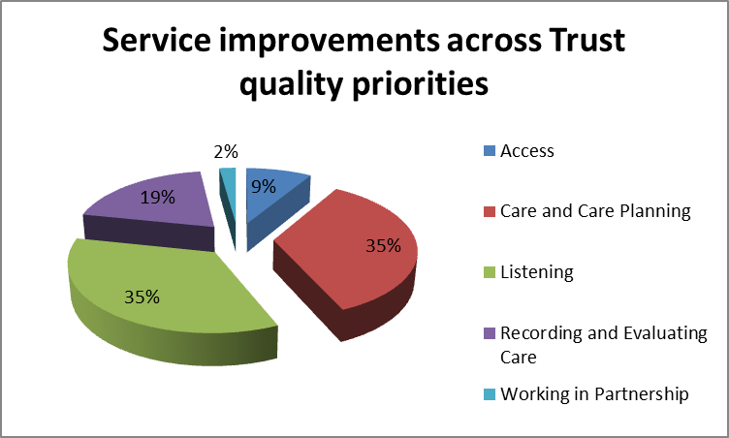

examples of service user and carer experience

Lynne raised concerns regarding issues relating to a breach of confidentiality, in which staff shared personal information with her family members without her consent.
As a result of the issues raised the Ward manager has ensured all IG mandatory training is up to date and has reinforced to staff the need to ensure consent to share information is always sought - and that this is frequently checked to ensure no change in position.

Lynne raised concerns regarding issues relating to a recent breach of confidentiality in which staff shared personal information with her family members without her consent. As a result of the issues raised the Trust instructed a full review of the current IG processes in relation to the release of a young person’s healthcare records, ensuring that, where a young person has capacity, communication about care and treatment is with them primarily, and where consent is given, information is relayed to the family.

Lynsey was unhappy that her son had not been added to a waiting list for therapy, despite having been assessed and advised that contact would be made. On following up the referral, Lynsey was told her son would be added to the bottom of the list.
Staff met with Lynsey to discuss these concerns, and a sincere apology for the error was provided. Her son, Richard, has also started therapy sessions. Staff have been reminded of the importance to follow up agreed actions to ensure errors are minimised.

Freedom of Information Requests
73 requests to access information under the Freedom of Information Act were processed in Qtr. 2, an increase on the previous quarter when 65 requests were processed. Many requests were detailed and complex in nature and required significant time to collate an appropriate response working with services and quality academy functions.
The Customer Services team works with information owners in the Trust to respond to requests as promptly as possible, but within the 20 working day requirement.
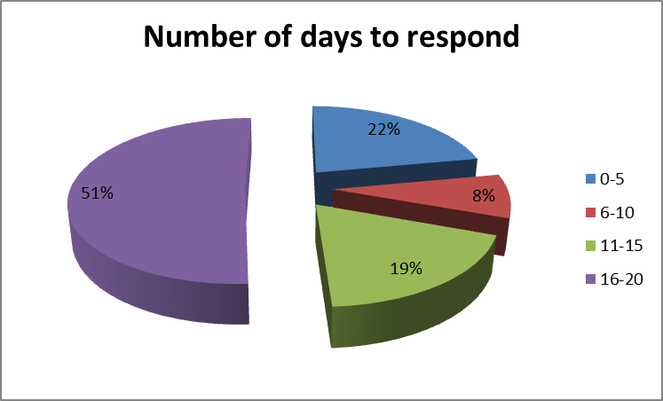 | 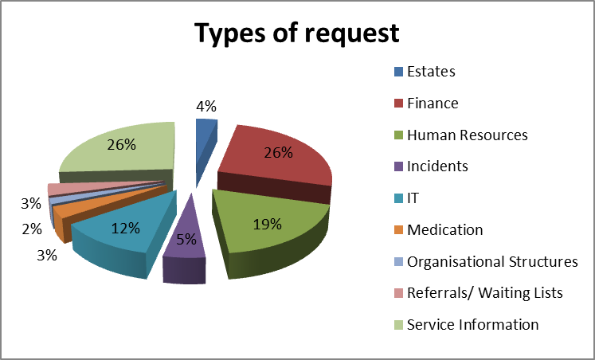
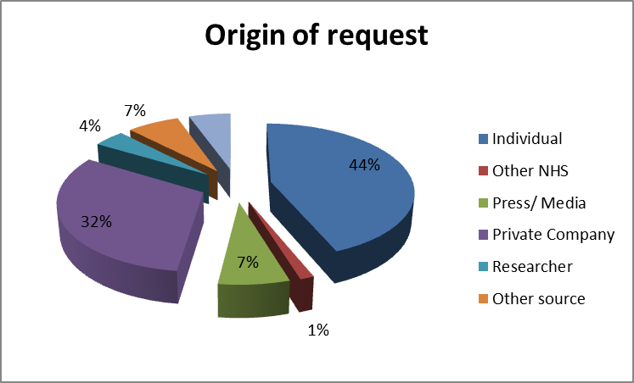
During Qtr. 2, 1 exemption was applied, under section 21, as the information requested was reasonably accessible to the applicant by other means. A further exemption was applied as the information requested was commercial in confidence. There were no complaints or appeals against decisions made in respect of management of requests under the Act during the quarter.

Looking forward

Customer Services efforts continue to focus on gathering insight into service user experience and to support teams to develop action plans to change and improve services as a consequence of feedback.
The Customer Experience Group has been re-constituted, with a clinical lead as Chair and with a membership which includes trios from each service area, a service user and a carer. The group will support delivery of the nursing strategy action plan which focusses on improving the experience of people who use Trust services.
Weekly reporting to BDU on complaints management continues. This is subject to evaluation and will be refined based on feedback form services. Revised Customer Services quarterly reporting is planned to better support BDUs to access summary information pertinent to their services. Revised reporting will be introduced in Qtr. 3.

