
Calderdale & Huddersfield Foundation Trust
Quarter 2 Quality Report
2015-16

Subject: | Quarter 2 2015-2016 Quality Report
Prepared by: | Juliette Cosgrove – Assistant Director of Quality  Andrea McCourt - Head of Governance and Risk  Lisa Fox – Information Manager
Sponsored by: | Julie Dawes, Director of Nursing
Presented by: | Julie Dawes, Director of Nursing
Purpose of paper | Discussion requested by Trust Board  Regular Reporting  For Information / Awareness

Introduction

This quarterly quality report covers contractual, quality account, national and local quality priority requirements to provide a comprehensive overview of quality performance during the first quarter of 2015-2016 within Calderdale and Huddersfield NHS Foundation Trust (the Trust).

Each year the Trust works with the commissioners to agree what should be included in the local contract including CQUIN priorities. These cover key clinical priorities and build upon our strategic aims.

The Care Quality Commission Intelligent Monitoring reports also provide a framework for determining quality priorities, a full inspection within 2015/16 is expected under the new regulations. In preparation for that we worked with Price Water House Cooper to conduct a self-assessment. As a result of that we have identified a number of areas where we will focus our improvement effort.

From all these sources the following diagram shows the Trust key priorities for 2015-16, these have been broken down into the 5 key CQC domains

Summary of Key Performance Frameworks:

2015/16 Quality Account:
There are four Quality Account priorities for 2015/16. These are listed below and further detail regarding progress can be found on the page number indicated

Domain | Focus/Priority | More Details
Safety | Improving Sepsis Care  (aligned with CQUIN measurement) | Pg.23
Effectiveness | To ensure Intravenous antibiotics are given correctly and on time (continued from last year) | Pg.18
Effectiveness | Improving the discharge process | Pg.113
Experience | Better Food & Improving Nutrition  (aligned with CQUIN measurement) | Pg. 80

2015/16 CQUINS:
There are nine CQUIN areas for 2015/16. These are listed below and further detail regarding progress can be found on the page number indicated. The information contained in the Q2 performance box provides a quick overview of target attainment during the second quarter, where applicable.

 | Indicator Name | Q2 Performance | Page
1 | Acute Kidney Injury | 32% | Pg. 52
2a | Sepsis Screening | 40% | Pg. 23
2b | Sepsis Antibiotics | 75% | Pg. 23
3 | Urgent care | 88% | Pg. 94
4a | Dementia - Find, Assess, Investigate and Refer | 92%/100%/100% | Pg. 59
4b | Dementia - Clinical Leadership | Y | Pg. 59
4c | Supporting Carers of people with Dementia | Y | Pg. 59
5a | Asthma Care Bundle | 80% | Pg. 40
5b | Pneumonia Care Bundle | 78% | Pg. 40
6 | Diabetes – Inpatient | 64% | Pg. 52
7a | Medicines Reconciliation/E-Discharge | 82%/88% | Pg. 18
7b | Medicines Discharge - Improvement | Y | Pg. 18
8 | End of Life Care | 44% | Pg. 86
9a | Nutrition patient satisfaction | 76% | Pg. 80
9b | Nutrition reduce waste | 5.48% HRI  3.34% CRH | Pg. 80
9c | Nutrition Vending | Y | Pg. 80

Domain Three – Experience (Caring)

Patient experience compliance summary

Indicator | Compliance
3.1 Dementia (CQUIN) | Achieved
3.2 Improving In Patient experience | Achieved
3.3 Friends and Family Test (contract) | Partial
3.4 Improving Hospital Nutrition (CQUIN, Quality Account) | Achieved
3.5 Improving care for end of life patients and their relatives | Partial
3.6 Claims | Reporting only
3.7 Inquests | Reporting only
3.8 Learning from Complaints | Reporting only
3.9 Mixed Sex Accommodation | Reporting only

Highlights:
3.1 Dementia | Dementia Find, Assess, Investigate, Refer CQUIN achieved.  Journal Testing going well,
3.2 Improving the In Patient Experience | Progress with five projects in programme for wards to improve in patient experience
3.3 Improving Hospital Nutrition | Achievement of all CQUINs

3.1 Dementia

Aims and Objectives of Work:

Improving services for patients with dementia has the potential to enhance the quality of their care experience as well as shortening their length of stay and reducing unnecessary costs. Dementia is not generally the prime reason for admission to hospital and therefore it can become difficult to factor into a patient’s care programme.

The dementia quality improvement work has 3 objectives:

1) To improve early diagnosis of dementia in order that people can live well with dementia and receive the care and treatment they need
2) To work in partnership with carers to ensure that we understand and meet the specific needs and preferences of people with dementia
3) To deliver training and clinical leadership to all staff to ensure that people with dementia receive person centred and appropriate care whilst in hospital

There are also 3 CQUIN requirements which support the aims above:

- Dementia Assessment and Referral
- Clinical Leadership & Training
- Carers Support

Current Performance:

Improved Diagnosis:

The dementia assessment is completed by the doctors on the ward for patients age 65 and over. This is a 3 part process which each part must achieve 90%.

- Part 1: How many patients have been asked the following question “Has the person been more forgetful in the past 12 months, to the extent that it has significantly affected their daily life?” If the answer is yes, part 2 must then be completed.

- Part 2: For patients that were yes in part 1, abbreviated memory tests score (AMTS) must be completed.

- Part 3 For those patients that had an AMTS score of 8 or below they must now be referred to their GP

We consistently achieve 90% or above in each element.
The assessment is included in the clerking in document. The assessment is then included as a mandatory field on the electronic discharge system with the option to refer those appropriate back to their GP for further assessment.

Performance in this area also fulfils the first national CQUIN requirement.

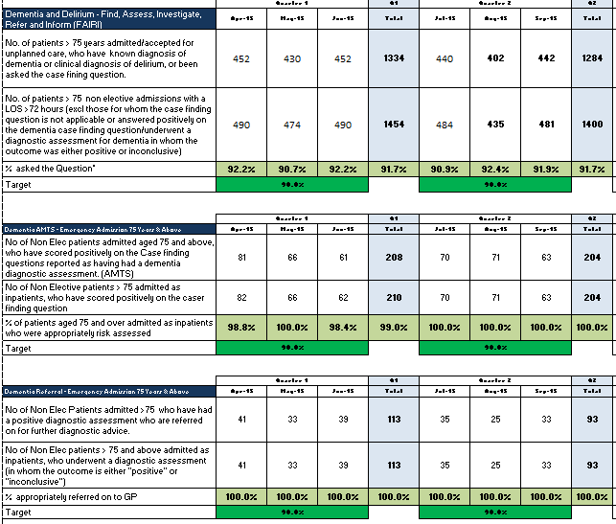

Partnership Working:

The mental health liaison team employed by the mental health trust support assessment of people with dementia, and provide expert advice for patients and their families, and for staff. The principle aim of the service is to prevent unnecessary admission to hospital, often activating appropriate community services for support and care closer to, or at, home. The team also support timely discharge of people with dementia, activating appropriate community care as above.

5 Action plans to meet national requirements
- Assessment and diagnosis
- Training plan
- Carer support – designated projects to support carers and people with dementia
- Dementia friendly environments
- Person centred care – Butterfly scheme and POD (prevention of delirium) programme

Dementia friendly ward and department refurbishments and upgraded

Working in Partnership with Carers

A patient journal is being developed and tested on the trauma orthopaedic wards. Working in partnership with carers, the social engagement workers are supporting this initiative capturing the events of the day, requests for information or for items from home and generally communicating through a two way process with carers. The journal was introduced on one ward during quarter one, and feedback from the carers was very positive. In quarter two the journal has been used on both orthopaedic wards and continues to develop. The aim for quarter three is to refine the design of the journal and involve more members of staff in the communication process. In quarter four, formal evaluation will take place.

Training

A training strategy addresses 3 levels of training. These are dementia awareness, dementia competent and dementia expert.

Dementia awareness is currently delivered to wards and departments by request. An e-Learning dementia package has been developed this will be available from November 2015, and will be mandatory for all Trust staff from April 2016.

Dementia competent is currently delivered through education, ward/department based support, and care pathways:-

- Vulnerable adult leaders training
- Vulnerable adult champion training
- Person centred dementia training
- Butterfly scheme in place on all relevant adult wards, supported with training
- Memory care assessment tool to facilitate person centred care
- Prevention of delirium pathway (POD) included in clinical documentation
- Recruitment of volunteers – rolling programme whereby A level students receive training and induction each year to support people with dementia and delirium on the POD pathway (student enrichment scheme)
- Engagement and Care Support workers in post on wards 19 and 20.
- MYLIFE software to promote social engagement. 6 units now in use, 3 on each hospital site

Dementia is now included in the Vulnerable Adult Network – operational group where issues relating to dementia, delirium, LD, safeguarding adults, person centred care, dignity and mental health, nutrition, and falls are discussed. This operational group oversees the dementia action plan and reports to the Patient Experience Group and Safeguarding Committee.

Training performance supports the second element of the CQUINs requirement. Currently this measures the number of senior nurses at band 6, 7 and 8 who receive dementia awareness through the vulnerable adult leader’s course. The training targets new starters and nurses who have been promoted into senior positions. It runs on a once a year basis and is planned for February 2016.

Improvement Plans for Q3 onwards

Delivery of person centred care training – 3 sessions delivered in Quarter 2 and 3 more planned for 2015.
Support to POD students on wards 4, 8, 19, 20 and 21 at HRI, and ward 5AD at CRH –
With designated support from key ward members and 3 Student leads

POD and supporting roles – social engagement and care support workers and intergenerational student enrichment scheme, enhances care and outcomes, staff experience, patient and carer experience, reduce incidents and need for 1:1. Resources including MYLIFE software and recruitment of more students in October 2015

Butterfly scheme promotes person centred care and ensures people receive care relevant to their needs and choices – uptake would improve care and outcomes, patient and carer satisfaction, staff satisfaction, reduce incidents and need for 1:1

Principles into Practice ward based support from the vulnerable adult strategic leads is providing direct education and support regarding the care of people with dementia and/or delirium on adult wards

3.2 Improving the Inpatient Experience

Aims and Objectives of Work

It is important that we measure patient experience, not only in terms of their satisfaction with the care they received but also giving them the opportunity to tell us how we can make it better. This may often be about the small things as well as any large system changes.

The primary method of measuring the patient experience in the trust is through the Friends and Family test (FFT) which is now well established across all inpatient areas and is becoming embedded as a performance measure and indicator for improvement at ward level.

FFT is no longer a CQUIN, however is now incorporated into the trust contract with an expectation to at least maintain the 14/15 position in relation to a response rate of 40% or more.

In addition to this the trust is aiming for a local target of 95% of respondents stating they would recommend the care they received.

Q2 Update

Feedback from the FFT comments has been used to influence the Inpatient Experience Improvement Programme, with 5 key projects being carried over from the end of 2014/15. These commenced during last year and are now being formalised as a programme for all wards to participate in.

A summary of each project is detailed below:

- Hello my name is … This is aimed at reminding staff of the importance of introducing themselves to patients, carers and visitors and to always include their role in any proposed care or treatment with them. ….

Further emphasis has been placed on embedding this campaign during Q2, with the Divisional Patient Experience and Caring Group leads liaising with all wards and departments to promote the importance across all professions. An article has also featured in CHFT weekly reminding staff of this simple intervention and the impact it can have on delivering compassionate care

- Ward orientation. This project has three components:

- Orientation of patients to the ward supported by a welcome to the ward leaflet. Our patient feedback has told us that patients do not always feel welcomed onto the wards and that once they are there, they would like more information about the ward routines.
- Availability of individual ‘about me’ information for all patients. These aim to provide an ‘at a glance’ source of information for staff about individual patient care needs and a personal ‘what is important for me’ statement
- Provision of a public facing information board for patients / visitors about the ward. The public facing board will provide consistent information for patients and visitors across all wards.

Ward leaflets: Quarter 2 has focused on an evaluation of the leaflets on two of our inpatient wards. This was carried out independently by volunteers; as a result some slight amendments have been made, including changing the leaflet from an A3 double sided laminated document, to a folded A4 booklet. In general the leaflets evaluated well - “I found it all useful it is very interesting and well put together”
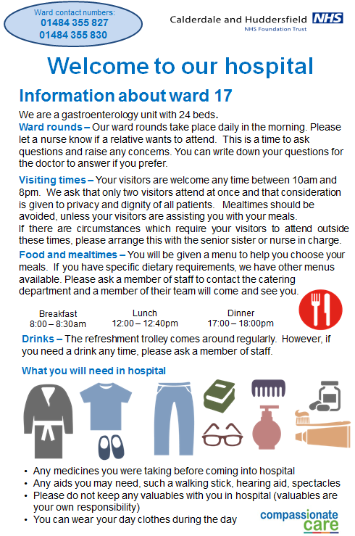
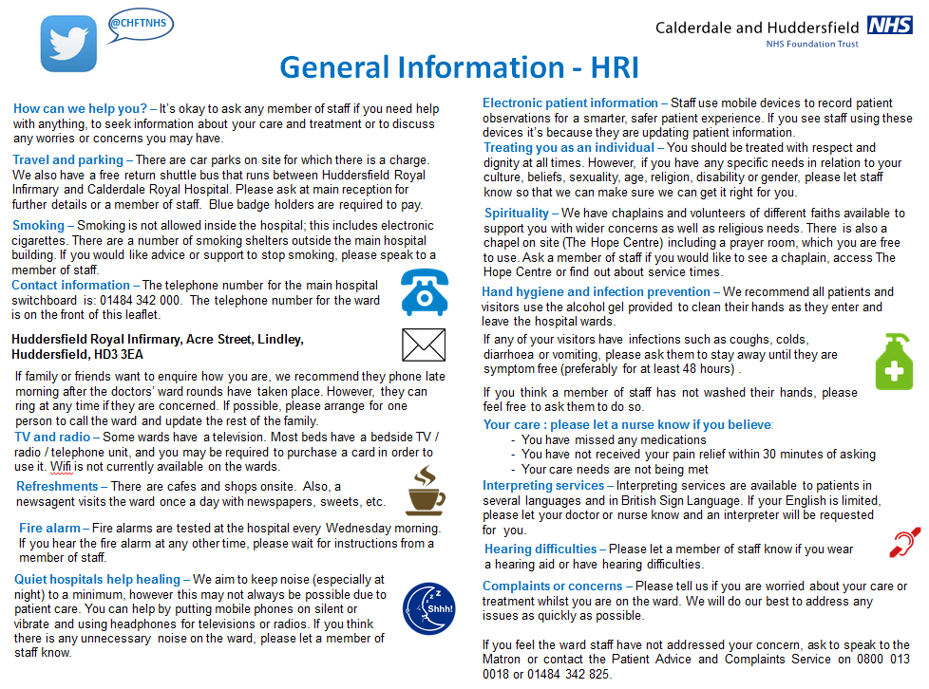

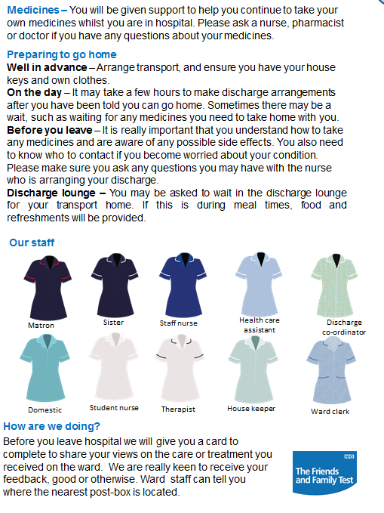

The behind the bed boards are now located across all permanent inpatient wards and assessment units. These have also been mounted on the 2 extra capacity medical wards at CRH. An alternative design is being developed for the Neonatal Unit.

During Q2 the public facing boards have been put up at the entrance to all inpatient areas, these provide information on some of the KPIs along with an opportunity to share changes introduced in response to feedback via a ‘you said, we did’ approach. These boards have been designed in line with the Trust corporate branding using simple icons to help create a visual impact.

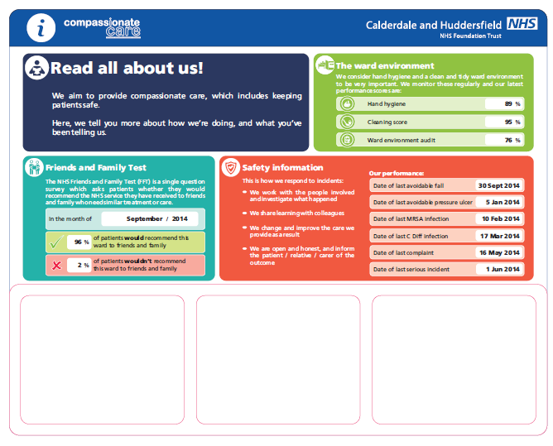

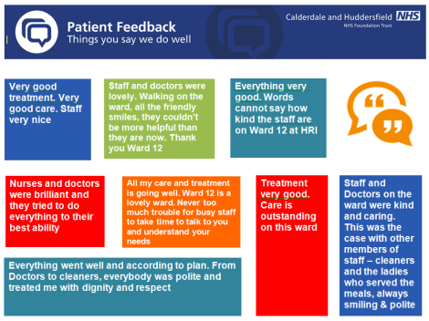
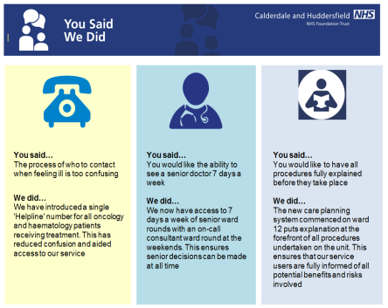
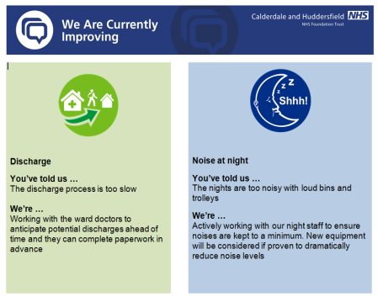



- Reducing Noise at night. Noise at night is something patients continue to raise with us through our patient feedback. Research tells us that quiet hospitals help healing – we have therefore made this our message in a campaign to reduce avoidable noise.

During Q2 there has been further progression, action planning and ongoing assurance across the inpatient wards. Core concerns identified relate mainly to noisy bins, noisy staff and noisy equipment.
Some ward have purchased soft closing bins and located these close to the nurses station (most frequently used), however this has not been done consistently across all wards. During Q3 there will be a review of the areas using the new bins to assess whether they are making a difference
Noise at night from staff is a common area of concern raised by patients via FFT comments. Leads have been identified on each ward to act as the champion, providing appropriate challenge to colleagues and escalating consistent difficulties e.g. domestic staff arriving on ward areas in a morning. All staff have been encouraged to promote the 3 step challenge:
- Step 1. Take a minute to just listen – imagine you are trying to rest or sleep, what do you hear? Think how you can help to make changes to create a quieter ward or department.
- Step 2. Take five minutes to ask patients or families on your ward or department what disturbs their rest.
- Step 3. Make it happen –We regularly challenge colleagues about being naked below the elbow when entering our clinical areas – so please make
It normal practice to help reduce unnecessary noise too –Together we can – “Shhh” and create a calm healing environment

During Q3 support will be co-opted from staff working in the hospital at night, who will be better placed to observe and address issues as they arise.
Noisy equipment that has been identified during Q2 includes the bed pan machine washers and some issues with Nerve centre equipment, these will be looked into during Q3.
There has been joint working with Estates on this project, who have supported the wards by addressing squeaky trollies and placing sponges on door frames to prevent banging.
A reduction in noise related comments have been noted on some wards

- How can I help? Patients have expressed a view that staff are not always empowered or enabled to respond to solve problems for them. Another view from patients is that they don’t always want to bother staff with their issues as they can see how busy they are. This project recognises the following as being key to achieving a culture of ‘How can I help you?’ within a team:
- Sharing experiences of helping
- Troubleshooting on behalf of patients and colleagues
- Taking actions to solve problems, no matter how large or small
During Q2 the project has been linked to some improvement work for complaints, this includes achieving a change in staffs approach to complaints, via a co-ordinated campaign. Key actions in this project are to promote a culture where staff feel empowered to sort out concerns on the spot and to encourage staff to recognise that dealing with situations / capturing a complaint on behalf of a patient is their responsibility, not that of the corporate team. The result we are aiming to achieve is an improved handling of concerns by staff and that these do not therefore develop into a complaint. Having a ‘How can I help?’ attitude will be key to achieving the result.

- Regular information round. Surveys of patients’ views have revealed that doctor/patient communication is not always as good as it could be and in some cases it is judged by patients to be extremely poor. The areas where we seem to consistently fail relate to communication between doctors and patients about a patient’s clinical condition, the treatment plan, and expected outcomes. This project is being linked to a set of ‘always events’ and a learning package in the style of a short DVD based on some good practice examples of communication on the ward.

This project is still in the design phase and further details will be shared in the Q3 report

Plans for Improving the Inpatient Experience from Q3 onwards:

- Hello my name is …
Continued embedding
Commence measurement via ward surveys

- Ward orientation.
Printing and distribution of leaflets, translation into top 5 languages
Complete design of behind the bed board and public facing board for NICU
Commence patient feedback via ward surveys

- Regular information round.
Agree content of learning package – short DVD based on some good practice examples of communication and look into the production

- Reducing Noise at night.

Review success of quiet closing bins on the wards where these have been purchased
Co-opt support from staff working at night
Look in to the issues raised re equipment
Ensure the message is being acknowledged across all professional groups

- How can I help

Progress the work being led through the complaints task and finish group – culture of staff feeling empowered to sort out concerns on the spot

3.3 Friends and Family Test
 | Percentage response rate |  |  |  |  |  | Percentage would recommend
 | Apr 15 | May 15 | June 15 | July 15 | Aug 15 | Sept 15 | Apr 15 | May 15 | June 15 | July 15 | Aug 15 | Sept 15
Inpatient | 25.8% | 21.4% | 21.9% | 26.5% | 28.1% | 24.4% | 97.3% | 96.4% | 97.4% | 96.6% | 97.1% | 96.5%
Maternity | 18.2% | 23.8% | 26.3% | 27.5% | 29.6% | 42.6% | 94.0% | 91.1% | 94.8% | 97.8% | 95.2% | 98.8%
A&E | 6.8% | 10.0% | 8.6% | 5.7% | 2.7% | 9.6% | 90.7% | 90.5% | 91.1% | 91.1% | 84.8% | 86.2%
Community | 3.8% | 3.3% | 3.2% | 3.1% | 3.2% | 3.0% | 90.9% | 89.1% | 90.6% | 92.4% | 89.7% | 91.6%
Outpatient | 14.4% | 13.9% | 13.6% | 13.8% | 13.5% | 13.3% | 88.0% | 87.9% | 88.4% | 89.5% | 89.2% | 89.2%

Inpatients: Quarter 1 reported on some changes that were introduced in April 2015 for the inpatient FFT that have resulted in a significant drop in response rate. The requirement is to include patients admitted into any inpatient area regardless of whether they have an overnight stay. Prior to April 2015 this was not the case.

Since the change was introduced not only has the response rate dropped, but also our ranked position. It is worth noting that nationally there are fewer trusts achieving the high levels of response rates which had been seen last year.

During Q2 the Divisional FFT leads have been liaising with teams to ensure they are progressing the FFT process for this patient group. The ‘day case’ category covers a number of areas where a patient does not have an overnight stay, e.g. admissions / decisions units as well as all areas where a procedure is carried out, 27 in total. A more formal arrangement has been established to monitor weekly progress at each individual area, this requires a named lead for each area who are responsible for ensuring that:

- colleagues are aware of the requirement
- they have a supply of the FFT postcards
- they have located the nearest FFT post box / ordered another if the nearest location isn’t suitable.

Whilst there have been some slight improvements, there is still significant work to do to get back to the 40% target.

Whilst it is important to maintain a high response rate, an additional key measure for the trust is to have our patients stating that they would be happy to recommend the care they received.
During 2014/15, this averaged at 96.3%, which placed us in the top half of Trusts when compared nationally. It is reassuring to note that the Trust has continued to score well, remaining around 97% across all months.

Maternity: The response rate for maternity services has always fluctuated along the 4 touchpoints of the pathway. Up until recent months the responses have relied on text messaging (with the exception of antenatal). A number of approaches have been tried to promote the text with women and encourage them to respond to the text messaging, with limited success.
The introduction of the maternity EPR system (June 15) removed the link to envoy, our FFT text provider; therefore postcards or web based tools via electronic devices were introduced. This appears to be having a positive month on month effect with September 15 achieving the 40% target.

The percentage of women who would recommend the service has also seen an improvement with a score of 98.8% in September 15. A programme of improvement work is being led by the Maternity patient experience champions group, currently focusing on the Trust priorities of ward orientation / information, reducing noise and night and the Hello my name is campaign.

A&E: This response rate has been a significant challenge since the removal of the token system. The replacement system for collecting responses was by postcard and issuing the cards and promotion of the test was not always achieved during periods of high activity. SMS text messaging has been implemented in Sept 15 this has seen some initial improvement, but not to a level required. Further evaluation is required with the A&E team.

The A&E score for patients recommending the service remained around 91% for Q1 however this has taken a dip in Q2. A patient experience group has been set up which will include a focus on messages from complaints / concerns / FFT and leading on improvement work. An example of issues raised in the FFT comments is the waiting time in the department with further reference being made to the need to keep patients informed of the length of the wait. In response to this the departments now have electronic screens displaying real-time waiting times

Community: The response rate for community has always been low, never achieving higher than 4%. The current method of capturing the feedback is the use of SMS text messaging and recognising that this is not reaching all patients a decision has been made to move to a variety of data collection methods which will run alongside the text service. This will include a web based method which staff can ask patients to input directly onto a mobile device such as staff lap tops or mobile phones. The new data collection methods are expected to be embedded during September with improvements seen shortly after.

Further focus is being placed on the use of comments to better understand opportunity for improvement as the percentage of patients who would recommend the service is lower than we would expect it to be. Themes will be identified from the comments to progress this work

Outpatients: The response rate for outpatients remains fairly low, at just below 14% throughout Q2. However a national benchmarking report from June 15 shows the Trust rate to be in the top 25%. SMS text messaging is the current method of obtaining the feedback. In order to achieve an improvement staff working in the outpatient departments have been asked to ensure that postcards promoting FTT are in place in all waiting areas. Along with verbally informing patients to expect a SMS survey. There is also a plan to add FFT to the Electronic Communication Boards in the OPD areas.

The June 15 benchmark data for percentage would recommend places the Trust in the lowest quartile. Common themes from FFT comments have been used to inform a Patient experience focus group which took place in September 15. The outputs from this have been turned into a transformation project, with a plan for delivery during Q3

3.4 Improving Hospital Nutrition

Aims and Objectives of Work

The Trust has a responsibility to provide the highest level of care possible and this includes the quality of the food that is provided for patients, visitors and staff.

Nutrition designed to meet patients’ individual needs is central to a good recovery. The Trust aims to provide patient choice which is both hot and appetising and nutritionally balanced. Nutrition is an agreed priority for the trust in the annual Quality Account and is supported by the 2015/16 CQUINs which aim to:

- Measure and Increase patient satisfaction with food
- Show a reduction in the amount of food which is wasted.
- Improve the Hospital vending facilities.

Current Performance

Patient Satisfaction: Patient satisfaction is being measure by the distribution of a questionnaire to inpatients. Volunteers on the HRI site and members of ISS on the CRH site sample 400 or more patients each quarter. The Q1 and Q2 performance is outlined below:

As a result of this work, the catering team at CRH have raised the profile of supervisors and team leaders on the ward so they are available to speak to patients and staff around any concern related to food and feedback from the wards around this has been positive.

Concerns had also been raised around the lack of choice for patients who require a soft mashable type diet, as such a meeting took place in Q2 with staff from one of the CRH rehab wards and now a wider choice of category D and E meals are being tested with patients, staff and dietetic team to see how this is benefiting patients. Alongside this, Halal meals are also under review to improve both quality and choice.

Throughout Q2, ISS have been working with Burlodge, the heated trolley provided on the CRH site, and Anglican Crown who provides majority of the meals. The review looked at different ways the food could be plated and reheated in order to prevent some meals becoming overheated and drying out. It is noticeable that complaints from both patients and staff have reduced since this piece of work began.
Highlighted below are some of the other work that has taken place as a result of feedback during Q1 and Q2.
HRI site:
Negative Comments:
Comment | Action
Temperature of Food re food not hot | - Porters assisting with swift delivery of meal trolleys to wards.  - Smaller portions of less dense food products i.e. vegetables de creasing temperature loss.  - Assistance at ward level to cut service time down.
Cooked breakfast option | - Ward staff able to order cooked breakfast option at patients request.
Meal plates too hot | - Plate warmers have been turned down to alleviate this issue.
Sandwiches more variety | - Will look into alternating sandwich options and look at other varieties.
Tea and coffee always cold | - Ward issues will contact wards
Over cooked vegetables | - We have reduced the timings for vegetables and haven’t had issues since.
More green vegetables | - 27% of the current menu are green vegetables.
Cold Toast | - Toast is made on the wards will contact wards
Not enough salt and Pepper | - Salt and pepper sachets served with every meal if the patient required extra we would take advice from ward staff.
More choice at Breakfast | - Currently a continental breakfast 3 choices of cereals, Porridge,2 choices of bread rolls, preserves, toast from ward and hot breakfast on request from ward staff.

Positive Comments
Food better than I thought it would be.
Like salads & soups
Very satisfied with the meals that I have had.
Porridge and rice pudding are exceptional.
Meals are always tasty and hot
Very friendly catering staff
Very happy 1st class
Impressed with catering staff who frequently ask if you are happy with the food.
I was in hospital 5 years ago and the food is much improved.
My whole experience of this has been good so far, meals have been the icing on the cake.
The meals and staff have been excellent can you book me in over Xmas please.
Meals are an important part of a long day, something to look forward to, I haven’t been disappointed.

CRH site:
Negative Comments
Comment | Action
Temperature
The food was sometimes cold , and I sometimes did not get what I had asked for | The comments are almost generic and relate to the plated meal system. Work is being undertaken presently within the Department looking at temperatures and checking for abnormally high temperatures occurring. Also a Patient Service Catering Supervisor is being developed to work around the ward areas to intercept problems and encourage meals to be given out as soon as is possible to avoid drying. Matron walkabouts with Catering Senior Team should also bring a better understanding of system.
Food left standing in trolley
Meat dry and overcooked
Food and gravy dry
Left standing long time sauce had stuck to the plate
Food
Vegetables overcooked and could have done with more variety of vegetables | Looking into choices available and going to make alterations to menu shortly so will take this matter on board as part of this next piece of work.
Breakfast menu boring-Kippers would be nice | Additional items can be made available for patients with menu fatigue and we intend to communicate this better to ward areas with the introduction of the Patient Service Supervisor. Meeting has taken place with Dietician/SALT Team also to communicate this matter further
- Rice pudding never available.  - There was no bread for breakfast | Both comments related to two items that are always in stock with contingencies. There appeared to be a communication issue with ward based staff
Soups powdery | Continuing to review soup product for lunch time as it is the fresh homemade soup for evening meal which is very popular, and there will appear a disparity in the two. Unfortunately the kitchen presently does not have the capacity to produce enough homemade soup for both meal times
Overall
Portion size too big | Can accept comments re menu card as there is flexibility to request larger or smaller portion sizes, but perhaps layout of menu is complicated. Bulk breakfast is in the middle of being rolled out giving more flexibility at breakfast time.
Menu too complicated, too many boxes
Patient missed meal times | When asked patient explained that the ward staff had not fed him, nothing had been sourced from Catering.
Not getting what had been ordered | Newly reprinted menus have now been received. Catering staff had tried to make sure wards are not in possession of old menu cards.

Positive Comments
So far very good- Happy
Quite good food, I was surprised I enjoyed it
Absolutely
Really satisfied, didn’t think that it would taste as good as I imagined- Gammon very nice
Soups and Ham sandwiches very good
Enjoyed salad/Omelettes/
Overall happy with the service, no complaints
Always enjoyed meals, nice choices

Food Waste

We are continuing to work on reducing the amount of patient food waste; actions are currently focusing on improving communication at ward level which helps to feed back to patients the food choices available to them. This work is also helping to increase accurate ordering at ward level.

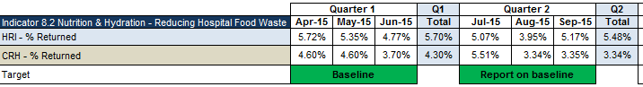

During Q2, there has been work with our supplier for HRI which is looking at provide food in smaller foils, this will allow the meals to retain their heat and continue to remain appetizing for longer and as such reduce waste by reducing the amount of the meal that is returned untouched.

Vending Facilities

The following report was submitted in support of achieving the third CQUIN element which is looking at improving vending machine facilities on the HRI site

Remit: - Huddersfield Royal Infirmary (HRI) is reviewing their vending service offered to patients, visitors and staff across the HRI Site, working with Joe Harvey Health Education Trust Director and Food for Life Associate. The outcome is for CHFT to become a flagship in having a radical approach to vending in line with the Simon Stevens CEO for the NHS recommendations.

Current Services: - Traditionally the 9 available machines have provided snacking and beverages options within the HRI site in three dedicated locations, the current vending service provision is from two companies, LTT vending, who provide 4 cold beverage machines stocking a range of traditional cola and sugar based branded products, water, fruit juice, and energy drinks. Wilkes Group operate the 2 hot drinks machines offering tea, coffee, and 3 snack machines providing a range of traditional branded products.

The Trust has worked with service providers to ensure the machines are not just based on traditional sugary drinks, confectionary bars and unhealthy snacks, the cold drink offerings now include a range of juice drinks and water. Snack machines are marked with green circles these are linked to a “spot the dot” campaign highlighting hand-picked healthier snacks.

The two companies currently provide a fully managed vending service for the Trust this include loan of the equipment repair and breakdown cover, maintaining stock levels, cleaning and full cash handling for all machines.

Proposal: A full review of HRI’s vending services is being undertaken to improve customer satisfaction and health and well-being of the population we serve as well as ensuring ongoing income generation.

This will be achieved the following next steps:-

- Engagement of Food For Life
The review includes partnership working with Joe Harvey from FFL who will support CHFT on the back of his expertise in improving vending in schools.

- Complete Vending Users Survey
The surveys have been completed and we are currently reviewing the results. A site visit has also been completed looking at where vending is currently located

- Networking
Use learning from other NHS and public sector organisations (Royal Brompton/Liverpool ISS)

- Hot Food Provision
Continue to explore the option of offering food that is nutritious healthy with the ability to re-heat offering a genuine alternative to current out of hours feeding arrangements.

Updates on these areas will be provided in Q3. There is a vast amount of work surrounding hospital nutrition, some of the complimentary work streams and projects are outlined below:

Partnership working with Food for Life:
Calderdale CCG have funded the Soil Association Food for Life (FFL) for the next 2 years. Part of their role will be using their expertise in supporting CHFT in improving the food experience for staff, visitors and patients. FFL for life also link into other NHS organisations and are keen to share other projects with CHFT
Part of this support has already been outlined above with the vending project.

Nutrition and Hydration Strategy:
In October 2015 FFL are supporting CHFT in an engagement event with staff, and users to help in the development of a Nutrition and Hydration strategy for the Trust.

Fruit and Veg stall HRI:
From the 7th October as a pilot for approximately 7 weeks a food and veg stall will be in place in the main entrance at HRI. It demonstrates excellent partnership working with the Council and local businesses selling local produce and if proves to be successful will be rolled out onto the CRH site too. This is to encourage health and Wellbeing of staff and public and also links into the NHS CEO Simon Stevens drive to improve health in the NHS

Calderdale Food Assembly:
On the 8th October 2015 an assembly was undertaken where the FFL hospital work at CHFT was shared with nursing homes. The event brought together caterers and procurement teams from all settings to enable networking and learning.

Packaging Test study:
CHFT are involved in a study to measure food packaging opening ability and ease of access for common NHS packaging items. It is in conjunction with the Hospital Caterers Association, NHS England led by Caroline Lecko and Sheffield Hallam University led by Alistair Yoxall. The test is in 3 stages looking at strength, dexterity and the pack open ability test. The request has been for mainly female over the age of 65. We have used our patient reps to assist with this study and has involved them basically being observed open the packaging. Updates will be given on the outcome of the study

Food for Life Catering Mark:
In December last year ISS achieved their Bronze Catering mark in retail. This relates to the coffee shop and the onsite restaurant. In December 2015 they will be going for silver award and to achieve this they are planning on buying products like fish, fruit, vegetables, meat from a local source.

Incredible Edible:
On the 17th June 2015 Incredible Aqua Garden (part of the Incredible Edible Todmorden Group) created edible landscapes in the grounds of Calderdale Royal Hospital. Incredible Aqua Garden, along with a group of volunteers from Lloyds Bank, Halifax, planted edibles in four sites, within the hospital grounds.

The two courtyards have 'sensory' planters, containing herbs and other plants, which are good to look at, to touch, to smell and to taste, and brings a new dimension to the spaces.
The area in front of the Learning & Development building has three raised 'kitchen garden' beds, containing summer vegetables, herbs and fruit.

There is a new planter in front of the Macmillan building which have a variety of herbs and edible flowers.

5 fruit trees will also be planted on the CRH site over the next month

MUST (Malnutrition Universal Screening Tool) Compliance:
In August 2015 an audit of MUST screening was undertaken across 4 wards totalling 90 patients
Feedback will be shared with the sisters in at October’s sister meeting

Key findings
- 98% of patients had a MUST care plan
- 30% were completed in full
- 68% had accurate height and weight
- 68% had BMI recorded accurately
- 43% had a relevant care plan in place
- 23% fluid balance charts completed in full
- 32% had food diaries completed in full

Whilst it was a positive that almost all patients had a MUST care plan, Q3 will look to understand some of the barriers to fully completing the MUST tool and the Fluid Balance Charts.

3.5 Improving End of Life Care

Aims and Objectives of Work

End of life care provides particular challenges, not only because of the special needs of many at the end of life but also because of the need to coordinate and integrate a wide range of services across different sectors. However the rewards for getting it right are huge. Personalised, integrated care at the end of life can transform that experience for the individual, their family, and the staff caring for them (source: NHSIQ)

Current Performance

The chart shows the percentage of patients who are supported by an end of life care plan who then go onto die, since the ICODD was implemented in November 2014 (currently 45.30%).

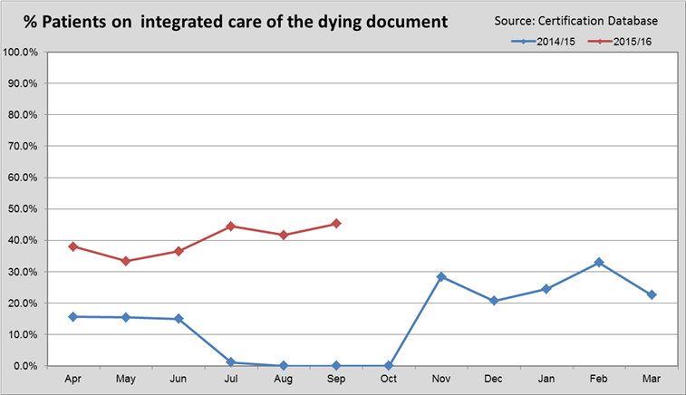

Progress against Improvement Plans for last 12 Months

- The introduction of comfort bags has received warm feedback from both families and clinicians. The bags contain little essentials, such as bed socks, tissues, a dental kit, and a notebook and pen, to ease time spent at a bedside if a relative needs to stay overnight.

- Education and training is being rolled out to Cardiology and Complex care wards. The one day sessions started in June and will continue to November 2016. Extra sessions have been planned for medical staff at the Clinical Governance half days in November and time out sessions arranged for ward staff.

- Funding received earlier this year from Health Education for Yorkshire & Humber for training. CHFT commissioned Kirkwood Hospice to deliver a series of free one day courses for doctors and registered nurses working in the Trust. This course is designed to improve knowledge, skills and confidence when communicating with palliative care patients. It will focus on the five priorities of care. There have been three sessions to date and one more session planned for October. Over the 3 study days we have had 56 attendees. .A further six sessions are planned in 2016. The course has evaluated very well by those who have attended.

- Continue to identify and review end of life related complaints using the criteria of death during admission or within 3 months of discharge. Identify any themes. This gives the trust insight in where to focus training/action which is specific to each area, and in particular whether there are nursing or medical actions required. Reports are being produced every 2 months and trends identified. Themes identified so far are - lack of or poor communication, poor care, poor symptom management, reference to the LCP and poor discharge planning. This is reported through the end of life meeting and will be shared with staff through training and education.

- Continue to monitor use of the ICODD. This is an individualised plan of care which helps to support and care for people who are dying. Compliance is increasing as staff attend the organised training sessions and awareness spreads.

- Participation in the National End of Life Care Audit. Data for CHFT has been submitted for 80 patients who died during May 2015. The closing date for submission of data was 30th September 2015.This audit will look at the progress acute hospitals have made in addressing the ‘five priorities of care’ for people in their last hours, days of life. Reports are expected to be published in March 2016.

- Local audit carried out of 20 patients who died in May 2015 whilst being cared for on the individualised care of the dying document. The data is currently being analysed – The report will be produced within the next few weeks and results presented at the next available slot at the Clinical Governance meetings.

Plans for improvement 2015/2016

- More training days on advanced communication skills and end of life care are organised for 2015/2016. Two more sessions are planned for 2015 and five in 2016.

- Purchase of more comfort bags for use with the ICODD– Comfort bags contain useful items for the relatives of patients dying on the ward; bed socks, lip gel, toothbrush/paste, etc.

- Further improvement in the use of the ICODD through training and education.

- Further improvement in review of decisions for DNACPR through training and education and the data received from monthly audits.

- Local survey to bereaved relatives will take place in October 2015. Questionnaires will be sent to relatives/carers of patients who died in January and February 2015. The questionnaire will be used to assess the quality of care and the level of support provided to individuals and their families in the last days and hours of life. One of the recommendations from the National Care of the dying audit was that all hospitals should undertake local audits of the care of the dying including the assessment of the views of bereaved relatives, at least annually

3.6 Claims

All formal claims received are handled on behalf of the Trust by the NHS Litigation Authority who effectively provides indemnity through our annual insurance premium. The annual premium is based upon our claims history. Learning from claims will improve the quality of the care we provide and help to reduce further increases in our premiums.

Activity relating to claims is captured throughout this section. A new process for capturing learning from claims has been introduced during the Q2 and this learning will be available in the Q3 report.

Clinical Claims | Q1 | Q2 | Comment
New Claims opened during quarter | 44 | 36 | Reduction on Q1/Q2 last year
Claims closed in quarter | 17 | 19 | 3 cases were settled this quarter.
Services with highest level of clinical claims | 61% relate to 3 service areas:  - Emergency Network  - Orthopaedics  - Women’s Services | 64% relate 3 service areas:  - General & Specialist Services  -Women’s Services  -Emergency Network | There has been an increase this quarter, in cases relating to General & Specialist Services

Non Clinical Claims | Q1 | Q2 | Comment
New Claims during quarter | 6 | 4 | Reduction on Q1/Q2
Claims closed in quarter | 3 | 10 | 1 case liability accepted

Inquests | Q1 | Q2
Inquests opened during quarter | 12 | 10
Inquests held during quarter | 6 | 5

New claims:

40 new cases have been registered on the Datix system in Quarter 2, 2015/16.
- 36 clinical claims – of which 1 was a formal letter of claim; 35 were requests for records;
- 3 employer liability claims
- 1 public liability claims.

In addition, of the existing cases on the system, 11 requests for records have progressed to formal claims.

The numbers of new cases opened per quarter over the last two years are shown in the graphs below:

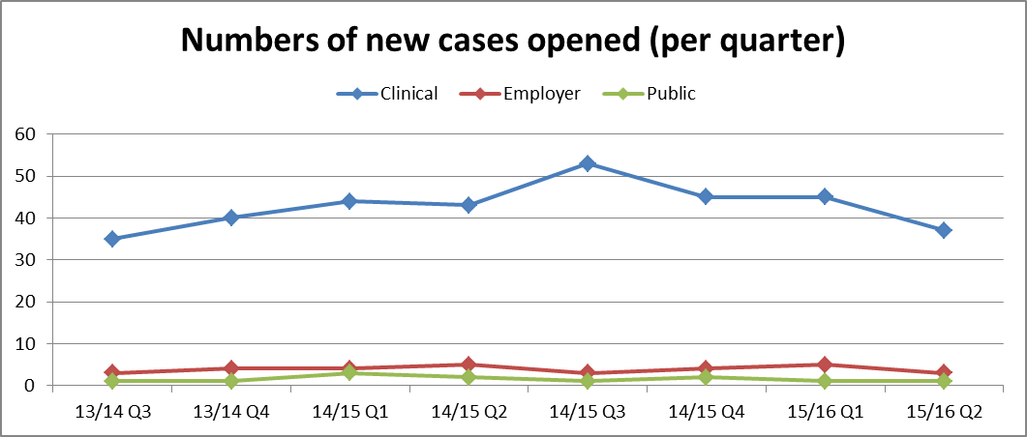

The number of clinical claims opened peaked in Quarter 3 14/15, with a reduction in the following quarters and a further fall in Quarter 2 15/16

Non clinical claims increased slightly in Quarter 115/16 but have fallen again in Quarter 2.

Clinical Cases Opened: Reviewing the number of clinical cases opened per quarter by Division, shows that the reduction is across all Divisions.

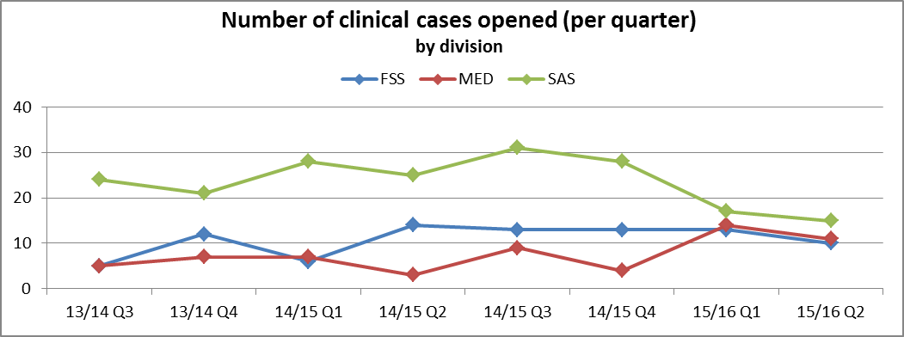

Drilling into the Q2 cases, the spread of the directorates is shown below:

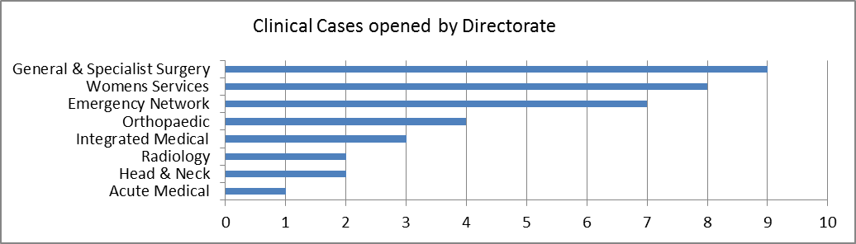

Employer liability claims have reduced in Quarter 2

Clinical Negligence – New Letters of Claim / Letters before Action:

Directorate | Incident date | Summary | Previous Investigation
Children’s | 29/08/2014 | On initial admission to A&E xray of lower arm identified no abnormality. On return visit to A&E lower arm re-x-rayed with no abnormality identified and referred to Fracture clinic. X-Ray of whole arm in Fracture Clinic revealed missed buckle fracture in upper arm. Claim alleges failure to correctly assess injury and to carry out appropriate investigations resulting in increased pain and suffering through lack of diagnosis. Also possibility of complications due to delayed diagnosis. | Complaint - upheld
Orthopaedic | 18/12/2013 | Alleged failure to provide adequate treatment when left thumb nail removed and post-surgery treatment to avoid infection. | Complaint - not upheld
Acute Medical |  | Alleged failure to identify broncho carcinoma developing on regular check chest xrays taken in December 2011; February 2013 and December 2013. Diagnosis delayed until March 2014. | No records
Emergency Network | 08/12/2012 | Alleged failure to recognise and treat an Abdominal Aortic Aneurism. | Inquest - Natural Causes
Acute Medical | 23/04/2010 | Claim being pursued against LTHT and CHFT. Alleged failure by LTHT to diagnose diffuse large B-cell lymphoma; treat with blind radiotherapy with a failure to remove plastic tubing from drain post operatively. Claim against nursing care at CHFT which it is alleged did not prevent falls, provide adequate catheter care or prevent pressure sores leading to considerable pain and discomfort. | Complaint - not upheld and Inquest – natural causes
Emergency Network | 31/08/2014 | When admitted with a history of falls, the level of monitoring failed to prevent an unwitnessed fall leading to a significant left sided subdural haematoma and death. | SI
Orthopaedic | 04/03/2014 | Attended Orthopaedic Clinic following ski-ing injury abroad and provided clinical report from doctor in Switzerland suggesting need for CT scan. This was not initially carried out leading to a delay in corrective surgery. | Complaint - upheld
Women’s Services | 14/01/2014 | Alleged failure to adequately risk assess pregnancy and identify need for increased surveillance scans and potential for early delivery to prevent IUD. | NPSA perinatal Review
Emergency Network |  | Claim being jointly pursued against GP and CHFT for alleged failure to provide adequate treatment in Community for leg ulcers which deteriorated sufficiently to require below knee amputation. | No records
Emergency Network | 30/06/2012 | Alleged delay in diagnosing cauda equina syndrome during three attendances at A&E. | Complaint - partially upheld
Women’s Services | 27/11/2012 | Difficulties with stiches following delivery of baby resulting in need to undergo division of vaginal adhesions. | No records
General & Specialist Surgery | 17/07/2013 | It is alleged that a piece of sponge was inappropriately left in wound causing infection. | Incident

Employer’s Liability – New Letters of Claim:

Directorate | Incident date | Summary | Previous investigation
Operating Services | 19/11/2014 | Claimant reports sustaining an injury to his back when Huntleigh trolley was moving towards door frame he attempted to stop it. | Incident
Children’s Services | 26/05/2015 | Needle stick injury when disposing of sharp in sharps bin | Incident
Pathology | 28/04/2015 | Injury sustained when moving a trolley of equipment weighing over 25kg into storage; the trolley was taken down a ramp to the storage area. The trolley picked up speed going down the ramp and trying to control it caused whiplash to neck, back and shoulders. | Incident

Public Liability – New Letters of Claim:

Directorate | Incident date | Summary | Previous investigation
Estates Maintenance | 12/03/2015 | Patient used handle on the toilet wall which came away from the wall causing him to fall and sustain soft tissue injury to right wrist and injury to right knee. | Incident/Complaint - upheld

Settled Claims

Clinical Negligence Claims:

19 clinical claims settled / closed during Quarter 2.
9 of these were unsuccessful with liability denied or the claim withdrawn. 7 were closed after being settled the previous quarter. The 3 claims settled in this quarter are summarised below. The damages and costs for clinical claims are covered by our CNST premium to the NHSLA.

Date of Claim | Directorate | Summary | Damages | COSTS
 |  |  |  | Claimant | Defence
16.07.2012 | Orthopaedic | Incorrect treatment for fractured leg with use of single screw fixing. Delay in recovery led to early discharge from Armed Forces  (Complaint investigation) | £60,000 | (Estimated) £60,000 | £6,048
24.12.2013 | Emergency Network | Failure to diagnose tendon damage to right thumb and to carry out appropriate treatment which caused a delay in treatment.  (Complaint investigation) | £6,000 | £17,425 | £2,969
07.02.2014 | Women’s Services | There was a failure to perform removal of the placenta after the birth in the manner identified in the care plan. Manual removal resulted in infection.  (Incident reported) | £5,000 | (Estimated) £10,000 | (Estimated) £1000

Employer’s Liability Claims:

10 employer liability claims settled / closed during Quarter 2.
6 of these were unsuccessful with liability denied or claim withdrawn. 3 were after being settled in a previous quarter. The employer liability claim settled in this quarter is summarised below. The Trust pays an excess of up to £10,000 for Employer Liability claims as a result of incidents occurring from 1st April 2010.

Directorate | Description (Policies) | Damages | COSTS
Directorate | Description (Policies) | Damages | Claimant's | Defence
Operations & Facilities | Tripped over bollard on pavement sustaining fractured wrist and cuts and bruises to face and knee. Breach of duty admitted and the claimant has been put to proof on causation. Earnings details are being collated.  (Incident reported) | £9,950 | £17,625 | £1,833

Public Liability Claims:

The Trust pays an excess of up to £3000 for PL claims as a result of incidents occurring from 1st April 2010.
No public liability claims have settled in this quarter.

Ongoing claims:

Claims open as at end September 2015:
- 435 clinical negligence claims – of which 316 are requests for records. The 119 “live” cases include:
  - 78 letters of claim / letters before action
  - 27 ongoing – proceedings issued / defence
  - 14 settled – awaiting final outcome and closure
- 23 employer’s liability claims, 2 have settled, awaiting final closure the rest remain under investigation.
- 7 public liability claims, all currently under investigation.

Learning from Claims

A new process for evidencing learning from claims has been introduced. As a claim is settled a Summary and Learning Form is completed and sent to the Division to identify actions taken. As the feedback is received back it will be included in the next quarterly report. No feedback is available for this quarters report due to the recent introduction of the process.

3.7 Inquests

The Trust has a legal duty to report a death to the Coroner (Coroners and Justice Act 2009) if the cause of death is violent, unnatural (died as a result of a healthcare procedure), unknown or occurred whilst in custody or State detention (including Deprivation of Liberty) and other situations.

A new Inquest Policy has been developed explaining the process involved which are corporately handled through the Governance and Risk team. The policy includes guidance for staff when they are required to provide a statement for the Coroner and the support available in preparation for attending an inquest.

To ensure we are learning from all inquests, cases which are not investigated as a serious incident will be subject to a Divisional Case Review in line with the new investigation policy.

Inquests opened in quarter by Directorate

Acute Medical | 3
Critical Care | 1
Emergency Network | 2
General & Specialist Surgery | 2
Intermediate and Community | 1
Orthopaedic | 1
Totals: | 10

There were 5 inquests held in quarter Q2, there was learning an actions off the back of one case.

1. Next of kin to be contacted immediately after a fall as per clinical records guidance and falls bundle guidance.
2. All staff to receive a copy of the in-patient falls chart and a copy to be displayed in the ward office
3. All staff to receive training in utilising the falls care bundle by the ward trainers

3.6 Complaints

COMPLAINTS
Complaints are a vital source of information for the Trust, helping to identify where the quality and safety of services and care require improvement for service users.

This section includes information on:

- Performance re: complaints management in Quarter 2 2015-16
- Learning from complaints
- Key publications in the quarter
- Areas for improvement

Formal complaints are investigated thoroughly following the Trust’s Complaints Policy. Complaints data is reported across the organisation in a number of ways:

- via the quarterly quality report to the Quality Committee and Trust Board
- via the Patient Experience Group
- via Divisional Patient Quality and Safety Boards
- via key performance information in the monthly Board Integrated Performance Report.

- Complaints Performance Quarter 2, 2015-16
The Trust received 156 complaints between 1 July 2015 and 30 September 2015, a decrease of 10% on the same quarter in 2014/15.

Key Performance Indicators
Complaints and Concerns 2015/16 | Q1 | Q2 | Q3 | Q4
Number of new complaints received  Cumulative total | 169  169 | 156  Tbc
% increase / decrease on same period 2014/15 | ↑10% | ↓10%
Number of complaints acknowledged within 3 working days - target 100% | 93% | 94%
Number of complaints closed within the quarter | 206 | 136
% complaints upheld | 56% | 48%
% complaints partially upheld | 31% | 35%
% complaints not upheld | 13% | 16%
Number of complaints re-opened within the quarter following final response | 24 | 27
Number of complaints overdue at end of quarter. | 33 | 50
Number of complaints received from Ombudsman for investigation during quarter | 3 | 4
Number of complaints upheld by Ombudsman in quarter | 0 | 2 partially upheld
Number of complaints not upheld by Ombudsman in quarter | 2 | 2
Number of concerns in quarter  Number of concerns cumulative | 158  158 | 172  335

New Complaints – Severity
The majority of complaints (70%) received in Quarter 2 are graded as yellow severity; no lasting harm.

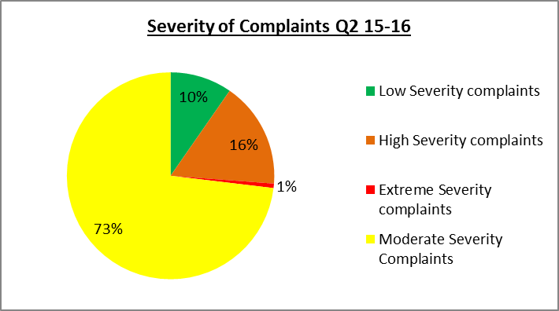

Key:
Green – no / minimal impact on care
Yellow – no lasting harm
Amber – quality care issues/ harm
Red – long term harm, death, substandard care

Red Complaints data
A red complaint is a case where the patient or their family feel the action or inaction of the Trust have caused the death or significant and non-reversible harm to the patient. At the end of Q2 there are 5 red complaints are under investigation:

Division | Directorate | Description
Surgery & Anaesthetics | Orthopaedics | Poor treatment received on ward 19 at Huddersfield Royal Infirmary, patient admitted as a result of fractured neck of femur but subsequently dislocated replacement, concerns re nutrition, management of delirium and staff behaviours
Surgery & Anaesthetics | Head& Neck | Treatment received from hospital. Contracted meningitis following routine sinus surgery.
Surgery & Anaesthetics | Orthopaedic | Care and treatment following fall at home. Treatment of fractured femur inadequate. Patient died unexpectedly next day
Surgery & Anaesthetics | General & Specialist Surgery | Delay in identifying cancer metastases
Medical | Emergency | Family seeking explanation on cause of sudden death of patient
Medical | Emergency | Care and treatment extended to patient leading to their death. Patient was treated for kidney infection when in fact was having a heart attack.

Acknowledgement time
Complaints were acknowledged 100% of the time in two of the three months in the quarter, making the overall Quarter 2 acknowledgement figure 94%. 100% complaints in August and September were acknowledged within three working days, however in July this figure was 82%, a continuation of the drive to close overdue complaints and annual leave within the team. The steps taken to improve resilience to ensure all complaints are acknowledged within time have been effective in August and September.

Overdue Complaints
The drive continues by all divisions to reduce the number of overdue complaints in the quarter leading to a reduction in numbers overdue. The number of overdue complaints has increased from 33 in quarter 1 to 50 in Quarter 2 with the breakdown as follows:

0 – 1 month overdue: 33 complaints
1 – 2 months overdue: 9 complaints
2-3 months overdue: 6 complaints
3-4 months overdue: 2 complaints

Weekly monitoring reports continue to be provided to divisions to ensure that all cases overdue are clearly identified and timescales for completion of complaints that are due are clear, seeking to prevent further cases becoming overdue.

25 of the overdue complaints are within the Medical Division; however 18 of these are overdue by up to one month.

10 of the overdue complaints are within the Surgical and Anaesthetics Division

Outcome of Complaints
Information on the number of complaints which are upheld, partially upheld or not upheld is included in this report for the first time. Overall across the two quarters 53% of all complaints are upheld and 32% partially upheld. (The HSCIC counts partially upheld complaints as upheld complaints so if looked at in this way the figure is 85%).

On average across Quarter 2, 14% of complaints were not upheld.

Ombudsman Complaints
During quarter 1 the Trust is aware of three complaints that have been raised with the Parliamentary and Health Service Ombudsman following final response.

During Quarter 2 there were 13 active complaints cases which the Ombudsman is investigating. Five relate to care in the emergency department and four relate to care by Acute Medicine. The breakdown of these is as follows (Red lines indicate complaints that were graded and managed as red complaints, i.e. where Trust actions / inactions caused death or significant and non-reversible harm to the patient):

Medical Division
Directorate | Complaint Date | Issue of Complaint
Acute Medicine | 2012 | Care prior to death
Acute Medicine | 2013 | Distress re: events prior to death
Acute Medicine | 2013 | Care prior to death
Emergency Dept.* | 2013 | Patient fall causing prolonged pain
Emergency Dept* | 2013 | Negligent care in A&E and Surgical Assessment Unit in 2010
Acute Medicine | 2014 | Stroke Care
Emergency Dept* | 2014 | A&E care prior to death in ICU following surgery
Emergency Dept | 2015 | Alleged misdiagnosis, patient death cancer
Emergency Dept | 2015 | A&E treatment June 2013
*To note Emergency Department was not in Medical Division until 2015

Surgical and Anaesthetics Division
Directorate | Complaint Date | Issue of Complaint
Head & Neck | 2014 | Care & treatment by Ophthalmologist

Family Specialist Services Division
Directorate | Complaint Date | Issue of Complaint
Women’s | 2013 | Care & treatment HRI
Children’s | 2013 | Care during, labour, birth, discharge, baby death

During quarters 1 and 2 six Ombudsman complaints have been closed, of which two were partially upheld and four not upheld. Details of the two upheld complaints are given in the section below on learning from complaints.

National Quarterly Complaints Returns
The new quarterly national complaints information, KO41 return was submitted within time to the HSCIC. This monitors written hospital and community health services complaints in the NHS.

This return requires more analysis of themes of complaints and requires a considerable amount of work to re- align coding of complaints to provide this level of detail. It is expected that this information will be submitted retrospectively in Q3 and will be shared in the Q3 report. The main change is the move to report all aspects of a complaint rather than the main issue in a complaint, as previously.

Complaints Numbers by Division

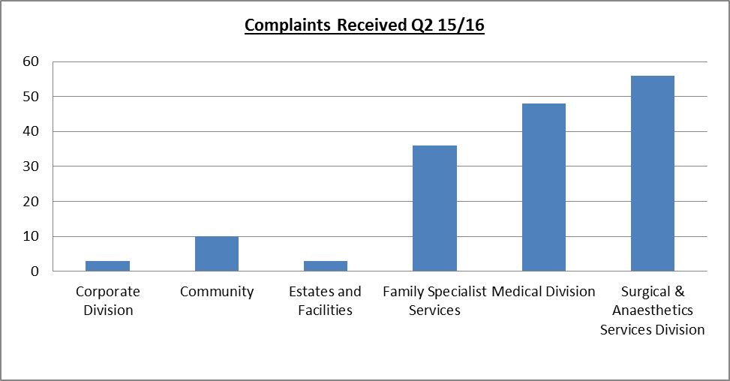

The split of complaints by Division by month was as follows:

Division | 2014/15 | Total Q1  2015/16 | July | August | September | Total Q2  2015/16
Corporate | 3 | 2 | 1 | 1 | 1 | 3
Family & Specialist Services | 146 | 34  (CWF 14)  (DATS 20) | 14 | 9 | 13 | 36
Estates and Facilities | 12 | 16 | 1 | 0 | 2 | 3
Community | N/A | 5 | 4 | 4 | 2 | 10
Medical | 174 | 56 | 15 | 16 | 17 | 48
Surgical & Anaesthetic Services (SAS) | 282 | 56 | 24 | 15 | 17 | 56
Total | 617 | 169 | 59 | 45 | 52 | 156

Analysis of Complaints by Theme
Complaints are analysed in two ways below, by primary subject code.

Complaints by Primary Subject Code
The top three subjects of complaints remain clinical treatment, communication and appointments as shown below, consistent with 2014/15:

Subject | 2014/15 | 2015-16 Q1 | 2015-16 Q2
Treatment, procedure (& clinical treatment) | 30% | 26% | 36%
Consent, confidentiality, communication | 25% | 25% | 24%
Access, appointment, admission, transfer, discharge | 14% | 15% | 18%

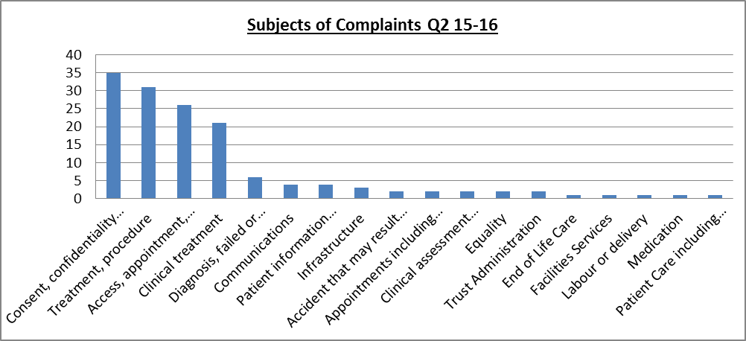

Once further work on coding of reasons for complaints is completed data will be re-run for Q1 and Q2 2015/16.

- Learning From Complaints

The feedback we receive from complaints gives the Trust a wealth of information that can be used to improve services as an individual complaint provides detailed insight into a patient’s experience.

As an organisation we need to ensure that we learn from complaints so that we can:

- Share good practice
- Increase patient safety
- Improve the patient experience
- Reduce the number of complaints

It is therefore essential that information on learning from complaints is captured and shared across the organisation. Each service and division needs to be clear:

- How the services records learning from complaints
- How this learning is disseminated within the service / directorate / division
- How it can point to changes arising from learning from complaints

The complaints process includes a form to document learning from each individual complaint, known as learning from experience form.

There continues to be a low level of completion of the learning forms in the Surgical and Anaesthetics Division. This has been brought to the attention of the Associate Director of Nursing for action.

Further work is needed to ensure that staff, teams and services are learning from complaints. Issues identified are:

- Variable completion of learning from experience forms by division
- Identification of actual learning – the majority of learning forms completed talk about the need for better communication but do not identify learning. The focus needs to shift to identify changes made as a result of complaints upheld.

Action being taken to improve this is:

- Re-design of learning from experience form
- Clearer communication to staff on what is expected in terms of learning
- Focus on ensuring the learning from experience forms are completed within divisions
- Quality assurance process within complaints team to ensure complaints are referred back to division to identify learning if this has not been included within the draft response / complaints file
- Development of patient stories framework - this was deemed to be the most powerful way of sharing learning by the members of the Complaints Task and Finish Group
- So What Happened Next ? newsletter to share with staff examples of learning identified and improve awareness of what learning is

This section includes details of learning in relation to:

- Complaints relating to Sign Language interpreters
- Learning from red / significant harm complaints
- Learning from Ombudsman cases in Quarter 2

Complaints relating to Sign Language Interpreters
As reported in the quarter 1 2015/16 report, an unexpected number of complaints were received during the period January to April 2015 relating to the services provided by the Big Word, with 8 complaints in total received and a petition from the Calderdale Deaf Community. The complaints relate to the skill level and availability of British Sign Language (BSL) Interpreters employed by the Big Word.

- As a result of the complaints an engagement event, attended by over 40 members of the deaf communities of Calderdale and Kirklees, was held on 21 August 2015 which included patients, carers, parents and local BSL interpreters, with BSL interpretation. Additionally the agreement to transfer services over to the preferred new provider, Pearl Linguistics, was paused to enable the Trust to consider the feedback from the engagement event and commission the most appropriate service for this client group.

- Key messages from the audience included the importance of local knowledge/accents; feeling assured that the BSL interpreter had been booked and for a long enough duration; having suitably qualified BSL interpreters.

- Notes and feedback from the event have been analysed and is being used to help draw up a list of requirements that the Trust will want to see from its BSL provider. Work with our deaf communities will continue during this process to help the Trust make the best decision about BSL interpretation services.

Learning from Red Complaints
The following red complaints are closed and formal action plans are being developed for each complaint.

Medical Division
Directorate | Complaint Date | Description | Upheld? | Issues and learning Identified
Acute Medicine | 2013 | Care and treatment on ward including fall leading to fracture of ankle. Patient developed pneumonia and died in hospital. | UPHELD | Call bells out of reach  Failure to follow procedure on the administration of medication  Incorrect completion of fluid balance chart  Failure to provide assistance with drinking  Failure to provide appropriate drinking vessel  Failure to provide adequate information to family  Significant delay in escalation of concern to medical staff  Audit of intentional care rounding  Improvement in communication between the multi-disciplinary team  Improvement in Falls assessments and supporting documentation
Emergency Department | 2013 | Patient administered medicine to which they had a known allergy when wearing a red wristband. | UPHELD | Failure to follow procedure on the administration of medication
Acute Medicine | 2014 | Treatment whilst on ward | UPHELD | Failure to monitor and manage nutrition  Failure to monitor and manage dementia  Failure to monitor and manage wounds  Communication regarding MDT, End of life care, discharge process  Failure to be professional and compassionate at all times  Failure to monitor and manage the impact of challenging behaviour (dementia)  Failures or delays in intentional rounding  Medication for patients who are approaching end of life, Medication reconciliation, medication review  Failure to implement falls bundle  Failure to monitor and manage pain  Mobility and manual handling requirements not clearly communicated
Acute Medicine | 2014 | Poor treatment of patient from ward staff at HRI. |  | Support and supervision of newly qualified staff  Escalation process  Management of thickened fluids  Engage with families who wish to take an active part in the care of relatives  Weekly Patient Experience Ward Rounds  Implement the safer staffing monitoring tool.  Perform regular ward exemplar audits  Participate in competency assessments.  Ensure bedside handover takes place at every shift change and check bedside records  Ensure the daily checks of the call bells are performed.  Clearly define the role of the nurse in charge.  Weekly record audits to be performed
Emergency | 2015 | Poor treatment received on MAU | Partially upheld | Communication
Acute Medicine | 2015 | Poor treatment on CCU | UPHELD | To be confirmed

Surgery and Anaesthetics Division
Directorate | Complaint Date | Description | Upheld? | Issues and learning Identified
General & Specialist Surgery | 2015 | Clinical decision making (including delay) may have meant a different outcome for the patient. Lack of compassion. Pain not managed. Lack of information. | UPHELD | No Stimuli in SAU side room  Nursing documentation inadequate on SAU  Failure to explain to family how extreme the patient’s condition was  Failure to provide time and privacy when explanations given by Doctor

Action Plans have been completed for the following 11 red complaints since April 2015
Received | Division / Directorate | Description | Upheld?
2014 | MEDICAL - Acute | Care and treatment extended to patient leading up to death. | UPHELD
2014 | MEDICAL - Acute | No record made of patient's fall during night. Delay to appropriate care, investigations and treatment due to lack of documentation and day staff unaware of incident. Patient fell prior to this whilst left unattended at toilet. | UPHELD
2014 | MEDICAL - Acute | Family unhappy with end of life care provided to mother which caused family "deep anguish and distress". | UPHELD
2015 | MEDICAL - Emergency | Letter received from family of deceased patient with concerns around the care he received whilst he was an in-patient at CRH prior to his death. | PARTIALLY UPHELD
2015 | MEDICAL - Emergency | Concerns re care patient received prior to death. Pt passed away from a ruptured abdominal aortic aneurysm at BRI. Did delay to scan at HRI affect outcome? Why no scan undertaken in A&E, why no-one listened to either pt or wife. Wife felt had things being done sooner her husband have survived. | PARTIALLY UPHELD
2015 | MEDICAL - Acute | Poor treatment before patient passed away. | UPHELD
2015 | MEDICAL - Acute | Failed discharge complaint regarding patient with Alzheimer’s. | UPHELD
2014 | SURGERY & ANESTEHTICS  Orthopaedics | Various issues relating to nursing care. Safeguarding issues raised. | UPHELD
2015 | SURGERY & ANESTEHTICS  Orthopaedics | Patient's wife wishes nurses to have more compassion. | PARTIALLY UPHELD
2014 | SURGERY & ANESTEHTICS  General and Specialist Surgery | Missed lung nodule in cancer patient in 2009, patient died 2014. Delay to patient receiving treatment in A&E in 2014. | UPHELD
2015 | FAMILY SPECIALIST SERVICES - Women | Patient care following death of infant during birthing procedure and staff involved | NOTUPH
Learning from Ombudsman Cases
Two Complaints were partially upheld by the Parliamentary and Health Service Ombudsman (PHSO) in Q2.
PHSO Case: Partially Upheld
This complaint related to care provided to an adult in A&E at Huddersfield Royal Infirmary (HRI) in March 2012. The PHSO identified the following service failings:
- Medical Management – failure in the management of heart problem – delay in recognising and starting treatment for acute coronary syndrome
- Standards of record keeping – records not fully completed and not appropriate standard
- Delays in responding to complaint

Actions and learning identified from this complaint and shared with the complainant in July 2015 is summarised below:

Area of concern | Action taken
Improving patient experience and empathy | - Set up a patient experience forum at A&E at Huddersfield Royal Infirmary and Calderdale Royal Hospital involving staff and patients  - Gain feedback via the Friends and Family survey and act on results  - ‘YOU SAID WE DID’ board – display showing what has been implemented
Delay in assessment | - Introduction of the Emergency Department Intervention Team – led by senior staff for early recognition of illness and injury which operates 24 hours a day
Delay in complaint response | - Full review of complaints procedure  - Increased focus on early contact with complainant  - Dedicated senior nurse to co-ordinate and manage complaints within the Department  - Feedback to the patient experience group
Lack of effective clinical record keeping | - Electronic recording on EDIS system, issues identified with retrospective documentation i.e. times needs to be considered when addressing complaints to ensure accurate picture is given  - Monitoring is in place to audit the accuracy of the record i.e. the time the action happened rather than the time it was written  - Awareness of the importance of effective clinical records highlighted at departmental staff meetings
Inaccuracy on the letter | - This was due to an administration error (explained in previous letter)
Appropriate monitoring equipment not accessible and used | - The reason that the monitoring equipment was not used was that the doctor did not recognise it as a rhythm that required monitoring.  - The Early Warning Score (NEWS) system is now used within the Emergency Department as a standardised method of escalation to senior staff.
The care did not follow the Acute Coronary Syndrome (ACS) Pathway | - This was due to the doctor not recognising that this was required  - Training issue now addressed with individual doctor  - Access to ACS nurse embedded within the Department  - ACS nurse delivering training as part of each doctor induction programme to ensure shared learning

PHSO Case: Partially Upheld
This complaint related to a fracture to a toe not manipulated correctly on initial presentation at A&E at HRI. The final report from the PHSO was received on 22 June 2015 and partly upheld the complaint.
It was confirmed the Trust had acknowledged within the complaint’s response the failure to undertake a pain assessment and offer pain relief.

However the Trust had not acknowledged that the doctor’s performance was below standard, i.e.:
- Initial treatment (manipulation of the toe) had been pointless
- Inadequate record of the episode
- No treatment plan following a second x-ray

The recommendation from the PHSO and action taken was for the Medical Director to discuss the incident with the doctor, who was employed on an ad hoc basis by the Trust.

Key Publications in Quarter 2 2015-16

Parliamentary and Health Service Ombudsman Complaints about Acute Trusts 2014 -15

The Parliamentary Health Service Ombudsman (PHSO) in September 2015 published their annual report for 2014-15 which details the information collected about complaints involving acute trusts in England in 2014-15. The report provides details of the number of complaints received for each Trust, the outcomes of these complaints and the reasons which led people to complain. In 2014-15 the PHSO upheld 44% of investigations into complaints about acute trusts.

The report confirms that there continues to be an increase in complaints about acute Trusts. The report can be found at:

http://www.ombudsman.org.uk/reports-and-consultations/reports/health/complaints-about-acute-trusts-2014-15/5

Summarised below is the Ombudsman activity in 2014-15 relating to the Trust.
This shows 70 contacts to the PHSO were made regarding the Trust and of these 18 were taken forward, 9 were not upheld and 4 were partially or fully upheld. It is assumed the remaining 5 are still under investigation. Comparison with two neighbouring Trusts identifies similar levels of complaints referred to the PHSO.

Acute Hospital | Contacts made to PHSO | Investigations Accepted by PHSO | Complaints Not Upheld | Complaints Upheld / Partially Upheld
Calderdale and Huddersfield FT | 70 | 18 | 9 | 4
Bradford Teaching Hospitals | 58 | 11 | 3 | 9
Mid Yorkshire Hospitals | 73 | 12 | 5 | 5

The main reasons nationally that complainants referred to the PHSO in 2014-15 are summarised below. These are consistent with two of our top themes of treatment and communication.

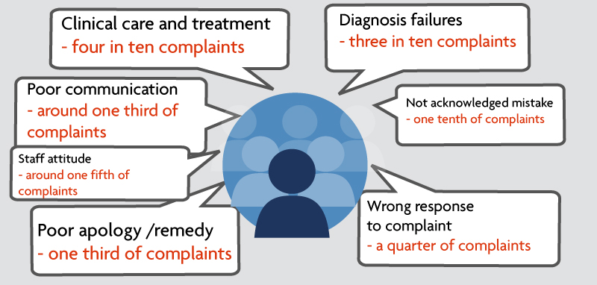

Areas for Improvement
An update against the key priorities for 2015-16 for the patient advice and complaints service are:

- to eradicate overdue complaints – work continues to reduce the numbers of overdue complaints
- work continues to improve the quality of complaints responses and reduce the number of re-opened complaints
- to respond to all complaints within agreed timescales – close monitoring via weekly reports highlighting complaints due dates and any overdue
- to complete coding changes for reasons for complaints for quarterly KO41 reports to submit retrospective completed data in Q3
- to continue to encourage meetings/discussions with complainants at the early stage of the complaints process
- to develop systems to improve the identification of and sharing of learning from complaints across the Trust
- to revise complaints literature and intranet site to ensure complaints process accessible, with focus on approaching staff in first instance with concerns
- continue to ensure an effective interface between divisions and the corporate complaints team
- to develop and plan delivery of training programme on complaints to support staff in managing complaints effectively

3.9 Ensuring Privacy and Dignity - Mixed Sex Accommodation

Aims and Objectives of Work

Being in mixed-sex hospital accommodation can be difficult for some patients for a variety of personal and cultural reasons. Therefore all providers of NHS-funded care are expected to eliminate mixed-sex accommodation, except where it is in the overall best interest of the patient or reflects their personal choice

A breach is said to occur when a member of the opposite sex shares sleeping accommodation.
The breach takes into consideration how many patients were affected by that breach.

Current Performance
During quarter two there were no mixed sex breeches within the organisation. However, we continue to enact our improvement plan by revising trust policy and raising awareness particularly in critical care areas.

The Trust revised policy is now completed ratified and is available on the trust website.

The monitoring process is more robust, with the status regarding mixed sex issues being included in the SITREP.

Performance continues to be monitored and reporting within the Integrated Board Report which is review monthly by the Executive Team.

Our real time patient monitoring and patient survey demonstrate that some patients feel they are being cared for in mixed sex accommodation. We have commissioned further analysis into patient experience regarding this issue; the results should be available for the Quarter 3 report.
We monitor all mixed sex breaches and this demonstrates that we rarely breach this standard, over the entire of 2014/15 there were 2 instances of mix sexed accommodation breaches which affected 15 patients. These exceptions occurred due to patients being stepped down from critical or high dependency care.
We recognise that the process of step down and transfer to an appropriate bed needs to be enacted in a timely manner and we are focusing much of the awareness raising in these areas.
We measure compliance monthly and undertake root cause analysis to understand if the breach has occurred and share any learning. The main learning points have been around recognising a need to improve the planning and discharge of patients from high dependency areas.

