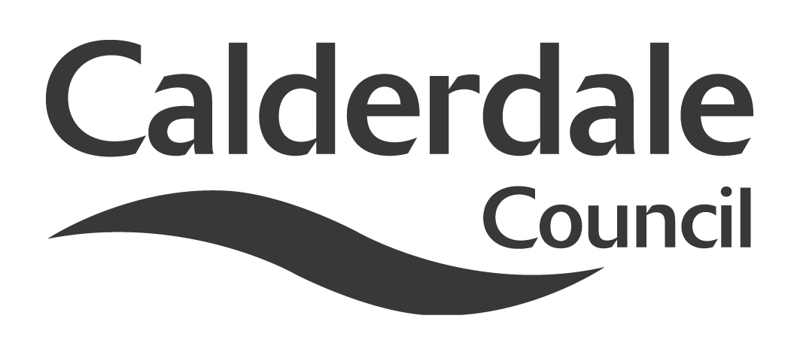
5

Name of Scrutiny Panel | ADULT HEALTH & SOCIAL CARE
Meeting Date | 15 December 2015
Subject | ADULT SOCIAL CARE COMPLAINTS & COMPLIMENTS REPORT
Wards Affected | ALL
Report of | DIRECTOR, ADULTS HEALTH AND SOCIAL CARE
Type of Item  (please tick✓ ) | Review existing policy
Type of Item  (please tick✓ ) | Development of new policy
Type of Item  (please tick✓ ) | Performance management (inc. financial) | ✓
Type of Item  (please tick✓ ) | Briefing (inc. potential areas for scrutiny)
Type of Item  (please tick✓ ) | Statutory consultation
Type of Item  (please tick✓ ) | Council request
Type of Item  (please tick✓ ) | Cabinet request
Type of Item  (please tick✓ ) | Member request for scrutiny (CCFA)

Why is it coming here?
The purpose of this report is to provide Members with information regarding complaints and compliments received by Adults Health and Social Care (AHSC). The reporting period covered by the report is from the 1 April 2014 to 31 March 2015.

What are the key points?
During this reporting period AHSC received a total of 81 representations from service users as well as 99 Compliments.

The report provides an outline and analysis of the nature and type of complaints received. Adult services respond to all complaints by following the statutory procedures and seek to learn and improve services as a result of complaints received.

Possible courses of action
Members are asked to consider and comment on this report.

Contact Officer
Toni Kershaw, Customer Insight Lead Officer

Should this report be exempt?
No

Report to Scrutiny Panel

Background

The NHS and Community Care Act 1990 require Local Authorities to set procedures for dealing with Adult services complaints and representations from service users or people advocating on their behalf. The Act requires systems to be in place to provide feedback on complaints to the management of services provided. In Calderdale Members receive regular reports monitoring complaints and compliments received. This report outlines all representations received in the period 1 April 2014 to 31 March 2015

Main issues for Scrutiny:

1. Overview
During this period a total of 81 representations were received. These were categorised in the following way:

- 24 comments (feedback which doesn’t require action in terms of a response)
- 3 concerns (feedback requiring immediate action rather than investigation)
- 54 complaints (feedback requiring investigation and response)

99 compliments were also received during this period.

There has been an overall reduction in the number of representations from the previous year reducing from 104 to 81. This includes a significant reduction in the number of complaints from 96 to 54.

2. Outcome of Complaints Received.
Of the 54 complaints that were received, none are open cases at the time of writing this report. Of the 54 that were closed:

- 13 were closed and the complaint was upheld
- 22 were closed and the complaint was not upheld
- 17 were closed and the complaint was partially upheld
- 2 were withdrawn by the complainant

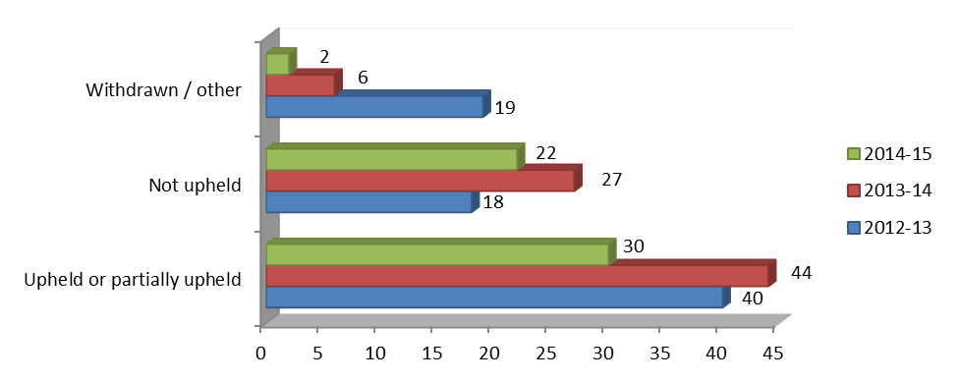

2.1 Type of Concern / Complaint:
The chart below shows the types of complaints that were received.

2.3 Average Time to Respond
There are no statutory timescales for responding to individual complaints however a 15 working day timescale is used as a general guide to measure performance. Below is a comparison of response times by each service area.

Service Area | complaints closed | Average Response time |  | complaints closed | Average Response time |  | Trend
 | 2013 - 14 |  | 2014 -15
Adult Care Services | 10 | 26 days |  | 16 | 57 days |  | Downward
Assessment/Care Management | 19 | 38 days |  | 10 | 79.3 days |  | Downward
Home Care Services (external) | 23 | 23 days |  | 11 | 17.7 days |  | Improved
Residential Services | 7 | 7 days |  | 3 | 12 days |  | Downward
Direct Payments | 8 | 30 days |  | - | - |  | Improved
Hospital Social Work Services | - | - |  | - | - |  | -
Adaptations | - | - |  | - | - |  | -
Supported Living Services | 4 | 20 days |  | 1 | 20 days |  | Downward
Day Care Services | 2 | 48 days |  | - | - |  | Improved
Gateway to Care | 3 | 11 days |  | 4 | 14.25 days |  | Downward
Finance | 2 | 46 days |  | - | - |  | Improved
Continuing Care | 1 | 19 days |  | - | - |  | Improved
Reablement | 1 | 12 days |  | - | - |  | Improved
Respite | - | - |  | - | - |  | -
Community Mental Health | 2 | 38 days |  | 1 | 38 days |  | Downward
Complex Care | 1 | 13 days |  | - | - |  | Improved
Out of |Hours | 1 | 11 days |  | - | - |  | Improved
Outreach | 1 | 40 days |  | - | - |  | Improved
Physical Disabilities | 2 | 4 days |  | 3 | 52.3 days |  | Downward
Safeguarding | 1 | 69 days |  | - | - |  | Improved
Other | 2 | 1 day |  | - | - |  | Improved

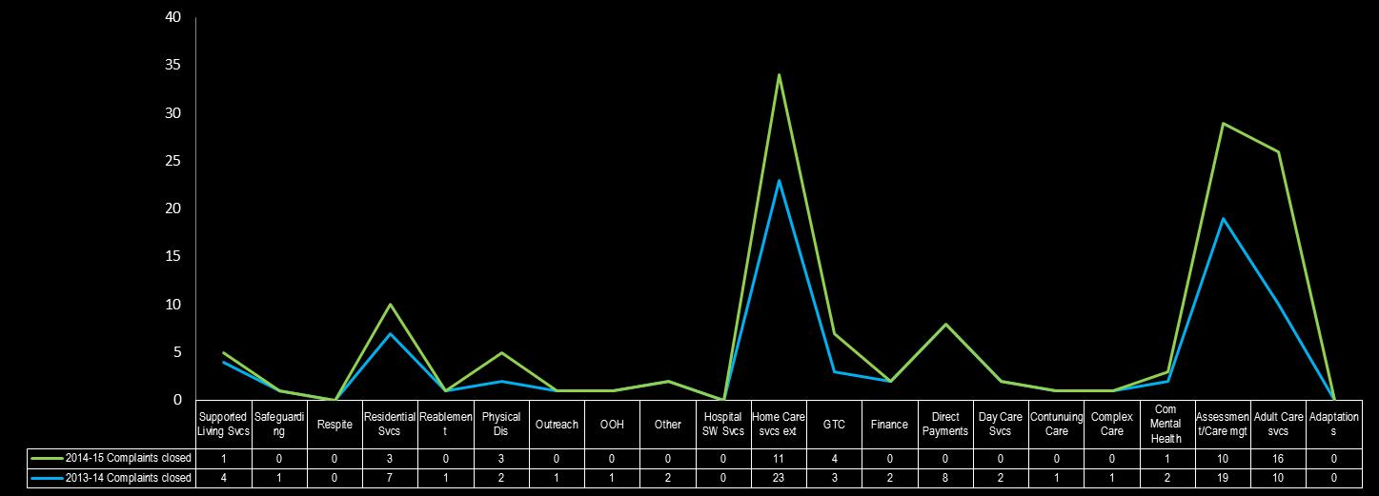

The following chart is a breakdown of complaints received in relation to Home Care providers:

Of these 11 Home Care complaints all were in relation to the level of service being provided
3. Learning from Complaints
Examples of learning complaints from are attached as Appendix A.

4. Equality and Diversity – Analysis of Complaints:
The following shows an analysis across the equality and diversity areas which are recorded for monitoring purposes. 26 monitoring forms were returned in this reporting period showing that:

- 24 respondents stated that they were white or British white
- 14 respondents were female and 12 were male
- 13 respondents stated that they had a disability whilst 3 chose not to say
- 9 respondents stated that they were Christian whilst 7 chose not to say

The chart below show the spread across the various age groups

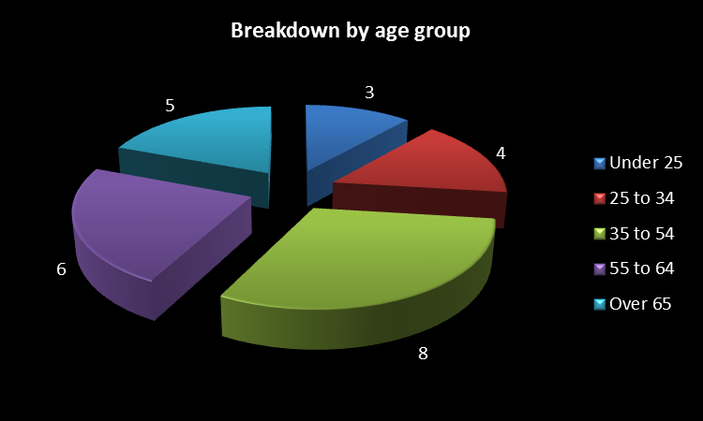

5. Compliments
Adult Services received 99 compliments during the reporting period, compared with 94 in the previous period.

Appendix A
Examples of learning from complaints:

Nature of Complaint | Learning Outcome
Received conflicting information from social worker regarding parents who were both in receipt of a care/support package | Consider the need for joint working of a couple’s case to separate individual Social Workers.
Relative spent 14 weeks in hospital was discharged without notifying the family. | Clarification was needed to whom would inform the family re discharge of elderly relative from hospital
Service user was in respite care for 2 weeks. Social Worker had confirmed there would not be a cost; has now received a bill. | Consider reallocation of cases where there is a breakdown of relationship with the current worker.  Care homes to be informed that they work in partnership with the family – particularly to avoid needs that may be out of character for that individual.
Service user was discharged from hospital even though daughter had confirmed she was not fit to go home alone. Poor communication from the social worker. | Decisions need partnership working with all involved, particularly carers.  The individual, their carer and representative should have recourse to line managers through the case if they are unclear or unhappy about the Social Workers role and responsibility.  Social care workers must discuss all options available and revisit them where required.
Son feels that his mother has been incorrectly assessed and will not be able to meet the care charges. | Adult Health & Social Care feel it would be beneficial for the charging team to work with the allocated worker to relook at the charges.
Misinformation regarding an assessment for deceased relative. Request for reimbursement for fees paid when eligible to receive contribution. | Good practice and guidelines regarding self funders need to be clearer for staff.
Social Worker did not inform daughter when Mother’s reablement care was due to end – plan was not put in place for Home Care to take over the care package. | Reiterate the importance of effective/timely communication – both for service delivery and carer support.

