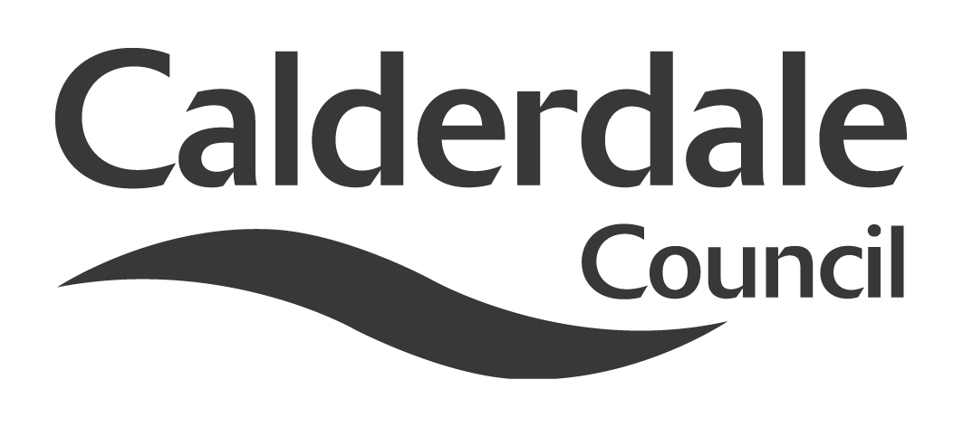
5

Report to Adults Health and Social Care Scrutiny Panel
Meeting Date | Tuesday 15 December 2015
Subject | Keeping People Safe
Wards Affected | All
Report of | Senior Scrutiny Support Officer
Type of Item  (please tick✓ ) | Review existing policy
Type of Item  (please tick✓ ) | Development of new policy
Type of Item  (please tick✓ ) | Performance management (inc. financial) | ✓
Type of Item  (please tick✓ ) | Briefing (inc. potential areas for scrutiny)
Type of Item  (please tick✓ ) | Statutory consultation
Type of Item  (please tick✓ ) | Council request
Type of Item  (please tick✓ ) | Cabinet request
Type of Item  (please tick✓ ) | Member request for scrutiny

Why is it coming here?
The Adults Health and Social Care Scrutiny Panel decided to include a themed discussion on Keeping People Safe in the Panel work programme.

Sir Robert Francis, in his report on Mid Staffordshire NHS Foundation Trust said, “[Scrutiny] made no attempt to solicit the views of the public. It had no procedure which would have encouraged members of the public to come forward with their concerns. It made little use of other sources of information to which it could have gained access, such as complaints data or even press reports.”

What are the key points?
The report includes the, Complaints information from the Adults Health and Social Care Directorate, and reports from the South West Yorkshire Partnership Foundation NHS Trust, Calderdale and Huddersfield Foundation NHS Trust and Calderdale Clinical Commissioning Group

Possible courses of action
The Panel will have the opportunity to discuss public concerns expressed through complaints and other patient and user views with a range of Council, NHS and voluntary sector bodies. The Panel may choose to make recommendations to Cabinet, NHS bodies or to Council officers.

Contact Officer
Mike Lodge, Senior Scrutiny Support Officer
mike.lodge@calderdale.gov.uk
01422 393249

Should this report be exempt?
No

Keeping People Safe
- Background

1.1 The Scrutiny Panel agreed to include a “themed” discussion on Keeping People Safe when it decided a Work Programme on 7 July 2015.

1.2 This report includes information from NHS bodies, Service and the Council and complaints, compliments and patient and service user views.

1.3 The Francis report made six recommendations about scrutiny. This item, in particular, takes account of the recommendation that overview and scrutiny committees should have access to complaints data.

1.4 Sir Robert Francis, in his report on Mid Staffordshire NHS Foundation Trust said, “[Scrutiny] made no attempt to solicit the views of the public. It had no procedure which would have encouraged members of the public to come forward with their concerns. It made little use of other sources of information to which it could have gained access, such as complaints data or even press reports.”

- Information Provided

  - Information on complaints received concerning the Council’s Adults Health and Social Care Scrutiny Panel is attached as Appendix 1.

  - Information from South and West Yorkshire Partnership NHS Foundation Trust about service user feedback is included as Appendix 2.

  - Information about patient experience and safeguarding from Calderdale and Huddersfield NHS Foundation Trust is included as Appendix 3

  - Calderdale CCG – Patient Experience Report is included as Appendix 4

  - NHS Complaints Advocacy is included as Appendix 5

- The Local Government Ombudsman

3.1 The Local Government Ombudsman reported that she upheld four complaints concerning social care in Calderdale in 2014/15.

3.2 A brief summary of each and a link to the Local Government Ombudsman report is included below.

    - Mr B complained that the Council failed to tell him the nature of allegations it received against him when it received a safeguarding alert.

The Ombudsman concluded:

I cannot say the Council should have told Mr B what the allegations were when it wrote to him in March. The Council’s policy is silent on what should have happened regarding its decision not to share the allegations after it closed the safeguarding investigation. Because of this the Council did not review its decision about not informing Mr B. There is no fault in the way the Council decided not to tell Mr B the details of allegations made against him. However, it did not have a policy in place about reviewing its decision after the safeguarding investigation ended. Because of this Mr B may have waited longer than necessary to find out what allegations were made against him and the outcome.
http://www.lgo.org.uk/decisions/adult-care-services/safeguarding/14-000-120

3.2.2 Mr. D complained that the Council is not allowing Mr. C to choose how his support package is arranged. The Council decided that Mr. C needed extra funding to meet his needs but Mr. D, his representative, says the Council is not allowing Mr C choice and flexibility. Mr D also complains the Council did not allow Mr C or his representative to appeal its decision.

The Ombudsman concluded:

As a recipient of direct payments Mr. C has the capacity to decide who he wants to provide him with support. Mr. D presented the Council with what he says is Mr. C’s wishes for his support arrangements. On the evidence available it is not clear how the Council directly involved Mr. C in the Panel’s decision as its policy and procedures suggest it should. In March 2014 the Council’s letter said it was possible to appeal against the Panel’s decision. When Mr. D contacted the Council he was willing to attend a further meeting to discuss the Panel’s decision. The Council said it would not meet with him again. When the Council responded to Mr. D’s complaint it did not refer to a right of appeal or explain how to appeal. This is fault.
The Council now says it is willing to consider an appeal. However, this would seem inappropriate given its decision to temporarily overturn the panel’s decision. Mr. C is using the extra support hours as he wishes and a family member provides him with support. Any injustice caused to Mr. C is remedied by the Council’s decision to overturn the panel’s decision. It is unclear whether the Council made the agreement for a three month period as Mr. D suggests. In any case, as more than three months have passed, it would be good practice for the Council to write to Mr. C and/or his representatives to confirm how long the arrangement will continue. It should also keep Mr. C and his representatives updated about its actions relating to his entitlement to healthcare funding.

http://www.lgo.org.uk/decisions/adult-care-services/direct-payments/14-002-668

3.2.3 The Complainant, Mr. X, says the Council:
  - Has provided him with a personal budget but since there are no relevant services locally, this means he cannot access the support he needs.
  - Has not supported him to access the specialist relationship counselling he needs urgently.
  - Will not help him coordinate his care as he cannot do this.
Mr X was diagnosed with Asperger’s syndrome and Attention Deficit Hyperactivity Disorder in 2013. He thought this would lead to the support he needs but it did not. He is muddling through on his own and feels as though he is fighting the system. He says the lack of support is causing him great difficulty and his marriage is at risk of breakdown because of the situation. He would like someone to help him find and co-ordinate services to meet his needs and to help liaise across health and social care boundaries.
The Ombudsman concluded:

I recommended the Council:
  - Apologise to Mr. X.
  - Ensure Mr. X receives the support he needs to find services to meet his needs.
  - Ensure that Mr. X is supported with co-ordination of his care and to receive a seamless service across the boundaries of health and social care.
  - Pay Mr. X £300 for the stress, anxiety it caused him and his time and trouble in bringing his complaint.
I have completed my investigation and uphold Mr. X’s complaint. There was fault by the Council which caused injustice to Mr. X. I have recommended it take action to remedy that injustice.
http://www.lgo.org.uk/decisions/adult-care-services/assessment-and-care-plan/13-020-023

3.2.4 Mr. B’s representative complains about a debt a care provider, commissioned by the Council and a Health Trust, says Mr. B and his mother, Mrs C, owe. His representative says the debt, which is about £28,000, has occurred because of the care provider’s faults. Mr. B’s representative says the Council has failed to take action and provide information to try to resolve the matter.

The Ombudsman concluded:
The Council accepts it is at fault. In view of its faults the Council has said it will improve. The Council has agreed to apologise to Mr. B and arrange to pay the disputed debt. Any injustice caused to Mr. B by the non-payment of the debt is now remedied by the Council’s actions. Provider X has also been pursuing Mrs C for the disputed debt since 2011. It referred the matter to its legal representative who contacted Mrs C and this caused her distress. She has also experienced time and trouble. The Council should acknowledge the injustice caused to Mrs C.
The Council has agreed to:
  - undertake a review of its relevant procedures and provide clear information and guidance to its staff:
  - pay the disputed debt of £28,023.69 and apologise to Mr. B
  - apologise to Mrs C and pay her £250.
The Council accepts it is at fault and has agreed a remedy. I have completed the investigation.
http://www.lgo.org.uk/decisions/adult-care-services/assessment-and-care-plan/13-009-993

- Purpose and Structure of the Meeting

4.1 The information included in this report as appendices is intended to give Members background information about a number of aspects of keeping people safe.

4.2 Although there may be brief presentations of one or two of the reports, it is hoped that most of the item will consist of discussion around the issues, rather than a series of consecutive presentations.

4.3 Representatives from Adults Health and Social Care Directorate, the Council’s Complaints Service, Calderdale Adult Safeguarding Board, Calderdale Clinical Commissioning Group, Calderdale and Huddersfield NHS Foundation Trust, South and West Yorkshire Partnership Foundation NHS Trust and Calderdale NHS Complaints Advocacy Service will be present to discuss issues concerning Keeping People Safe with the Scrutiny Panel.

4.4 This item covers a wide range of issues so is likely to leave some matters unresolved. However, it is hoped that the Panel may be able to address the following objectives:

- To consider a range of issues relating to Keeping People Safe
- To make recommendations to NHS bodies, Cabinet or Council officers
- To consider the relationship between the Scrutiny Panel and CQC
- To identify areas that require further consideration by the Scrutiny Panel

Documents are available for inspection at:

The Town Hall, Crossley Street, Halifax, HX1 1UJ

Mike Lodge
Senior Scrutiny Support Officer
2 December 2015

