



A

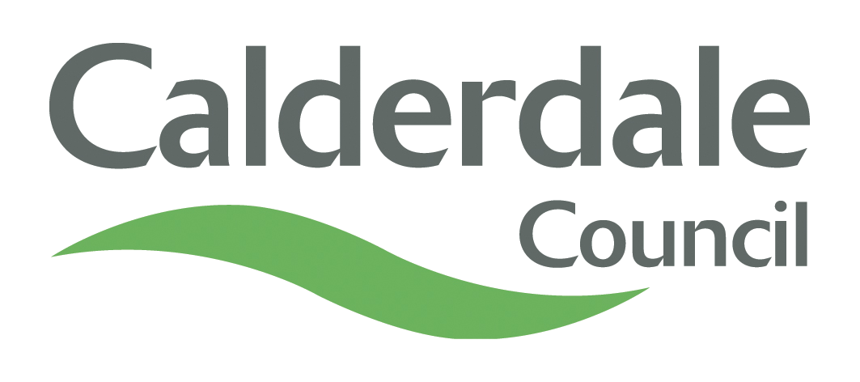
Appendix A
INTERNAL AUDIT REPORT

PARTNERSHIPS STRATEGIC GOVERNANCE

DATE OF REPORT: 12TH August 2015

Overall Opinion - Weak

PARTNERSHIPS STRATEGIC GOVERNANCE

EXECUTIVE SUMMARY CONTENTS

Section |  | Page
- Introduction  - Audit Opinion  - Scope of the Review  - Main Findings  - Main Risks  - Recommendations Summary |  | 3  3  3  4  4  5
- Action Plan and Management Response

Key Dates and Distribution
Date Draft Report Issued | NA | Auditor | Management Auditor
Date Report Issued | 13th August 2015 | Distribution | Head of Democratic and Partnership Services
Date Reminder Issued | 4th September 2015 | Distribution | Head of Democratic and Partnership Services
Date Response Received | 22nd September 2015 | Distribution | Head of Democratic and Partnership Services
Date Follow-up Issued | Not Due | Distribution | Head of Democratic and Partnership Services
Date Response to Follow-up Received | NA | Distribution | Head of Democratic and Partnership Services

EXECUTIVE SUMMARY

- INTRODUCTION

1.1. The programmed audit was undertaken as part of the Member approved Internal Audit Plan for the financial year 2015/16.

1.2. The overall objectives of the audit were as follows:

  - To determine how well Partnerships were being controlled at a Strategic level by:
- evaluating the systems in operation with regard to governance procedures and recommend improvements where necessary.
- ensuring that system controls were operating effectively and that a sound control environment existed.
- ensuring that Council policies and procedures were being met, as outlined in the Calderdale Code of Corporate Governance, and that instructions and guidance had been issued.
  - To ensure, by evidencing for all governance areas, that a strong control environment was in place by adherence to Council policies and procedures, which reduces risk, contributes towards value for money services being provided and to the Council achieving its corporate priorities and outcomes.

- AUDIT OPINION
2.1. The control environment for Partnerships Strategic Governance was considered weak overall. It was the view of the Internal Audit that the opinion of weak could easily be upgraded if the recommendation made at the time of the review was implemented as detailed in 7.1.

- SCOPE OF THE REVIEW
  - To contribute towards the Council meeting the requirements of The Accounts and Audit Regulations 2015, which,
- Requires authorities to ensure that the financial management is adequate and effective, that there are sound systems of internal control which facilitate the effective exercise of the Council’s functions and which include arrangements for the management of risk.
- Requires authorities to undertake an adequate and effective internal audit of its accounting records and of its system of internal control in accordance with proper practices in relation to internal control.

  - That being the case, the scope of the review took into account the following:
      - The extent to which the Council’s Corporate strategy, framework, policies and procedures had been rolled out to all Directorates of the Council through Directorate Nominated Officers.
      - The extent to which there was monitoring of directorates to ensure that corporate arrangements are in place and embedded within Directorates.

4. MAIN FINDINGS

  - The main findings which led to the Audit Opinion of weak were that:
- Since the previous audit, due, in part to staff changes, very little action has been taken with regards to key governance responsibilities for partnerships. These include the roll out the Council’s Corporate strategy, framework, policies and procedures, the offer advice to officers from directorates and the monitoring of arrangements to ensure they are embedded within directorates. Reliance had been placed primarily on the information on the intranet.
- Although not recently communicated directly to directorate officers it would appear that the main principles for dealing with Partnership arrangements have not changed since the last audit :
- The Partnerships toolkit should be used to assess all potential arrangements.
- Potential new arrangements should be submitted to DMT for approval.
- The dissolution of arrangements should be approved by DMT.
- All partnerships should be reviewed at least annually for continuing relevance.
- A briefing note should be submitted to the Directorate Scrutiny Panel on an annual basis.
It was established as part of this audit however, through the use of questionnaires and through a review of the database, that it was evident that there was a lack of knowledge around the Partnerships toolkit/database, the necessity to undertake annual reviews and the reporting arrangements.

- It was established through discussion with the Head of Democratic and Partnership Services at the time of the audit that, moving forward, the approach and categorisation of Partnerships needs to change. That said, the main principles, for dealing with the new categorisation of Partnerships (as stated above) are unlikely to change. It was stated that the Council can no longer afford to work alone and proper partnership arrangements which can demonstrate significant outcomes and/or savings would be required to meet budgetary constraints. It is this type of partnership which will be scrutinised using the Partnerships toolkit and registered on the database. The review of the Partnerships database, conducted as part of the audit, indicated that the majority of current arrangements fell outside this new thinking.

- It was identified that there was a need for a proactive approach to ensure that directorate officers are aware as to what is expected of them. Furthermore, particularly in the initial stages, there would be a need for monitoring to ensure that new arrangements were being adhered to.

5. MAIN RISKS
5.1 The main risks identified from the audit findings were as follows:

- Partnerships do not support the Council’s outcomes.
- Partnerships do not demonstrate Value for Money.
6. RECOMMENDATIONS SUMMARY
6.1 The Action Plan, which shows the recommendation made to management along with the management response received is detailed at 7.1.
6.2 Internal Audit will carry out a follow-up audit later in the year, at which point the Audit Opinion will be re-assessed. This will be reported to Members through the Tracking Report which is presented to each meeting of the Audit Committee.

7. ACTION PLAN AND MANAGEMENT RESPONSES

7.1 Action Plan and Management Response to Recommendation made in Internal Audit Report Issued 12th August

Rec  No. | Report Recommendations | Management Response/Proposed Action Plan | Name of Responsible Officer | Proposed Date of Action
1. | In order to strengthen the control environment relating to Partnerships the following action should be taken :  - The instructions relating to the Partnerships toolkit and database should be reviewed for continuing relevance.  - Consideration should be given to posting the instructions under Support for Services.  - The Directorate Nominated Officers should be informed as to what is expected of them with regards to Partnerships. This should include reference to the Partnerships toolkit/database, authorisation of new partnerships, the dissolution of partnerships, the review of partnerships and reporting requirements.  - A programme of monitoring should be devised to ensure that instructions are being followed. | Agreed  Agreed  Agreed  Agreed | Head of Democratic and Partnership Services  Head of Democratic and Partnership Services  Head of Democratic and Partnership Services  Head of Democratic and Partnership Services | By 01/12/2015  By 01/12/2015  By 01/12/2015  By 01/12/2015

