CALDERDALE CARE CLOSER TO HOME
SERVICE SPECIFICATION
20th January 2015 version 13.1



Care Closer to Home specification contents | Page Number
1.0 Population Needs  1.1 Background  1.2 National Policy  1.3 National context and Evidence Base  1.4 Local context (Case for Change)  1.4.1Better Care Fund Plans  1.4.2 Developing a new Preventative Strategy for Calderdale  1.5 Population and Health Outcomes  1.5.1 Introduction  1.5.2 Early Years  1.5.3 Children and Young People  1.5.4 People of Working Age  1.5.5 Later Life  1.5.6 Lifestyles  Summary  1.6 Current Model of Care  1.7 Responding to the needs of the local community  1.8 Finance  1.9 Quality of Care  1.10 Workforce  1.11 Social Capital  1.12 Demographic Profile  1.13 Summary of Case for Change | 3  4  6  7  7  9  10  10  10  10  11  11  11  12  12  13  14  14  15  16  16  17
2.0 Outcomes  2.1 NHS Outcomes Framework Domains & Indicators  2.2 Local defined outcomes  2.3 What local clinicians have told us about services  2.4 Working with partners | 17  18  19  20
3.0 Scope  3.1 Vision, Aims and objectives of the service  3.2 Geographical Coverage  3.3 Facilities  3.4 Service Description  3.5 How Community Based Care will be different  3.6 Any acceptance and exclusion criteria and thresholds  3.7 Interdependence with other services/providers | 21  22  23  23  35  36  36
4.0 Service Delivery  4.1 Service delivery  4.2 The role of technology  4.3 Care Pathways  4.4 Personal Support  4.5 Think Carers, Think Family  4.6 Location (s) of service delivery  4.7 Transfer of Care – Discharge Planning  4.8 Expectations From Providers  4.9 Scope of Professional Practice/Workforce  Requirements  4.10 Safeguarding of Adults in vulnerable circumstances  4.11 Safeguarding Children  4.12 Prescribing and Medicines Management  4.13 Access  4.14 Measuring and Response to Service User and Carer  Experience  4.15 Changing the way a service is currently provided | 37  38  38  38  38  38  38  39  39  39  40  40  41  42  42
5.0 Applicable Service Standards  5.1 Applicable National Standards  5.2 Applicable Standards as set out in Guidance  5.3 Applicable Local Standards  5.4 Infection Prevention and Control | 43  43  43  43
6.0 Applicable quality requirements and CQUIN goals  6.1 Applicable quality requirements  6.2 Patient Safety  6.3 Applicable CQUIN goals (See schedule 4 Part F) | 44  45
7.0 Phasing of services  List and Brief Descriptions | 46  47
APPENDICES  Appendix 1 – Additional information on Calderdale Case for Change  Appendix 2- Case studies  Appendix 3- Quality Outcomes  References - END | 50  51  56  61

Service Specification No. | 13.0 – PHASE 1
Service | Care Closer to Home Services
Commissioner Lead | NHS Calderdale Clinical Commissioning Group
Provider Lead
Period | 1st April 2015 to 31st March 2016
Date of Review | On-going

1. Population Needs
  - Background

This specification represents Phase 1 of a 3-phased programme to transform community services in Calderdale for children, young people and adults. Through this-phased approach, we will improve the health and wellbeing of our population by shifting the balance from unplanned hospital care to integrated, planned, community and primary care based care. The programme is closely aligned to delivery of our Better Care Fund initiatives.

Our system has recognised that significant change is essential in order to ensure that children, young people and adults can access the right care at the right time and in the right place, whilst ensuring the system is able to respond to the challenges it faces. Too often our residents do not receive the care and support they need to prevent ill health, maintain their health and to stay independent for as long as possible. The services currently commissioned for the population of Calderdale are fragmented, with duplication and inconsistency in the way services are delivered. Frequently, when ill, our patients do not know how to access the most appropriate care easily. We also know that we have an important opportunity to reduce preventable hospital admissions. There is a need for effective, integrated working between hospital, community, primary care, social care and third sector organisations and to empower the communities in Calderdale to adopt healthy living practices.

We have made significant efforts to engage with our population including children, young people and adults to ensure we create the right blend of integrated community services which are fit for purpose for the future. The Care Closer to Home Model as described in section 3.0 allows us an opportunity to transform services to meet the needs of our population (as set out in section 1.5). Ensuring services are safe and of the highest quality will be key to these changes.

We will commission services that are delivered as close to home as possible, in the person’s home where needed, utilising multidisciplinary working and technology. We will make access to these services easier via the provision of a single point of access.

Calderdale is one of the smallest metropolitan districts in terms of population, but at 140 square miles, one of the largest in terms of area. Despite being a metropolitan district, Calderdale has very distinct rural elements; most of the area is classified as rural and while definitions vary, up to a quarter of its population lives in rural areas. Combined with the topography of the area, this pattern of settlement clearly has major implications for the location of facilities, for transport, and for how close people are to health and other care services.

We have seen improvements in health outcomes in Calderdale over the last decade including:
- life expectancy has increased for both men and women in Calderdale
- there are both health and socioeconomic disparaties between the health economies in Calderdale
- premature mortality rates from ‘all causes’ and early death rates from cancer, heart disease and stroke have improved
- A reduction in smoking rates and teenage pregnancies.
- Improvements in the childhood immunisation coverage rates, flu vaccine uptake rates and the successful introduction of new vaccine programmes.

However, when we compare ourselves with similar districts in England, there are still major improvements that can be made in the areas key disease groups such as respiratory disease, cardiovascular disease and cancer. At the same time, we also know that the overall picture of health in Calderdale disguises some wide variations in outcomes linked to geography, deprivation or ethnicity.

We know that we are facing significant challenges; an ageing population, sustaining high clinical quality standards, and responding to the workforce and financial challenges. We also know that the system reform needed can only be delivered with the input and commitment from all our partners and stakeholders. Working closely with our commissioning partners, particularly Calderdale MBC is critical to delivery of this programme. The programme is aimed at responding to the priorities established by the Calderdale Health and Well Being Board (HWBB) and wealth of intelligence we have locally on the needs of our population.

  - National Policy

National policy for integrated care has changed significantly over the years and as a result of these changes, new models of care have developed focusing on personalised services to address inequalities, prevention and early intervention.

Users of health and social care including children, young people and adults currently face multiple access points for services that are often uncoordinated and fragmented across the public sector. A report by the National Collaboration for Integrated Care and Support highlights that too often; we don’t communicate properly with each other, don’t work together as a team or don’t treat people as whole individuals with physical health psychological and social needs. As a result, care and support is often fragmented, delayed or duplicated, which can result in missed opportunities to prevent needs from escalating by intervening early. This leads to poorer outcomes and experiences for the people who use our services. (National Collaboration for Integrated Care and Support– Integrated Care and Support: Our Shared Commitment - 2013)

A high quality, efficient and sustainable health and social care system has a breadth and depth that reaches beyond the traditional hospital. In order to respond to the challenges that the system faces it needs to unite primary, secondary, community, social and preventative care in order to deploy professionals, including those that work with children and adults from these specialties in multi-disciplinary teams (MDTs). By working seamlessly together within local communities, the MDTs can help tackle the health and social inequalities on the frontline and support people to be as independent and in control of their own lives as possible.

Whilst not exhaustive, at the time of preparing this specification, there are a number of key areas of important national policy or best practice that have particularly informed its development. These are shown in the table below:

Policy area/Issue | Summary
NHS England: Everyone Counts Planning for Patients 2014/15 to 2018/19 | The guidance emphasises the need for transformational change and new models of care to deliver great outcomes and better services now and for future generations. With a focus on providing high quality care, the guidance outlines stretching ambitions for the NHS that include:  - Securing additional years of life for local communities  - Improving the health related quality of life for people with long term conditions  - Reducing the amount of time people spend in hospital through better and more integrated care in the community and outside of hospital  - Increasing the proportion of people living independently at home following discharge from hospital  - Increase the number of people who have a positive experience of care, be it in hospital, outside of hospital, in general practice, or in the community  - Make significant progress towards eliminating avoidable deaths in hospitals.
The Keogh Urgent and Emergency Care Review | The need to improve urgent and emergency care services has been set out as a clear case for change in the Keogh Review.
The Report of Mid Staffordshire NHS Trust – The Francis Inquiry | The report of the failings at Mid Staffordshire Trust and the associated reports by Sir Bruce Keogh (Review into the Care and Quality of Treatment provided by 14 Hospital Trusts in England) and Don Berwick (Improving the Safety of Patients in England) describe the actions needed to ensure there is a clear focus on providing safe and compassionate care.
NHS Belongs to the People - A Call to Action | NHS England called on patients, the public and staff to join in a discussion about the future of the NHS, so it can plan how best to deliver services, now and in the years ahead. This call to action set out the facts about future demands on NHS services, how the budget is currently spent and how services are delivered. This Call to Action was an opportunity for everyone who uses or works in the NHS to have their say on its future.
The Better Care Fund | Nationally it has been agreed that £3.8bn of NHS funding will transfer to Local Authorities to create a single pooled budget for health and social care. The aim of this it that the fund should be an important catalyst for change, and enable the move towards more preventative community- based care to help to keep people out of hospital and in the community settings for longer.
Future Hospital: Caring for Medical Patients | The Publication by the Royal College of Physicians provides a clinical evidence base and case studies of the benefits associated with changing the way we care for people with medical needs by integrating care across hospital, community and social care services.
The draft Health and Social Care Bill and ‘Dilnot’ Report | The government’s proposals for social care funding reform (due to come into effect in 2016) will place a cap on the social care costs paid by an individual. The impact of this will further increase funding pressures for Local Authorities.
Information Management and Technology | There are a number of national policy directives that set a clear direction and evidence base for increased use of technology in health and social care delivery to improve, patient safety, experience and efficiency of services. The change proposals described in this document include plans for optimising the use of technology to enhance the effectiveness and efficiency of service provision.
National economic context | Nationally the country continues to recover from the economic crisis, public spending continues to be reduced in key areas. The national spending review in 2013 identified further reductions for local government and no growth for health. The financial context for delivery of health and social care will continue to be challenging.

  - National context and Evidence Base

Publications such as the Care and Support White Paper, King’s Fund, Future Forum and The Common Purpose Framework also recognise that the evidence base for community based care and integration achieving major cost savings is still emerging and is currently patchy and inconclusive. However, the evidence is stronger for improving outcomes, quality and patient experience. Now the case has been made even stronger for more integrated care with a seminal publication by National Voices, a patient-user forum. It has identified the lack of joined-up care as a source of huge frustration for patients, services users and carers and that “achieving integrated care would be the biggest contribution that health and social care services could make to improving quality and safety”.

A definition of integrated care has been developed from National Voices derived from consultations with patient organisations and national workshops involving Service Users, Charity Representatives and NHS and Social Care

The overarching summary is from a service user perspective commissioned by NHS England in collaboration with National Voices:

Person centred coordinated care – ‘I can plan my care with people who work together to understand me and my carer(s), allow me control, and bring together services to achieve the outcomes important to me’

Key area identified were, care planning, my goals/outcomes, information, transitions, communication, and decision making

Examples of comments from members of the public in Calderdale:

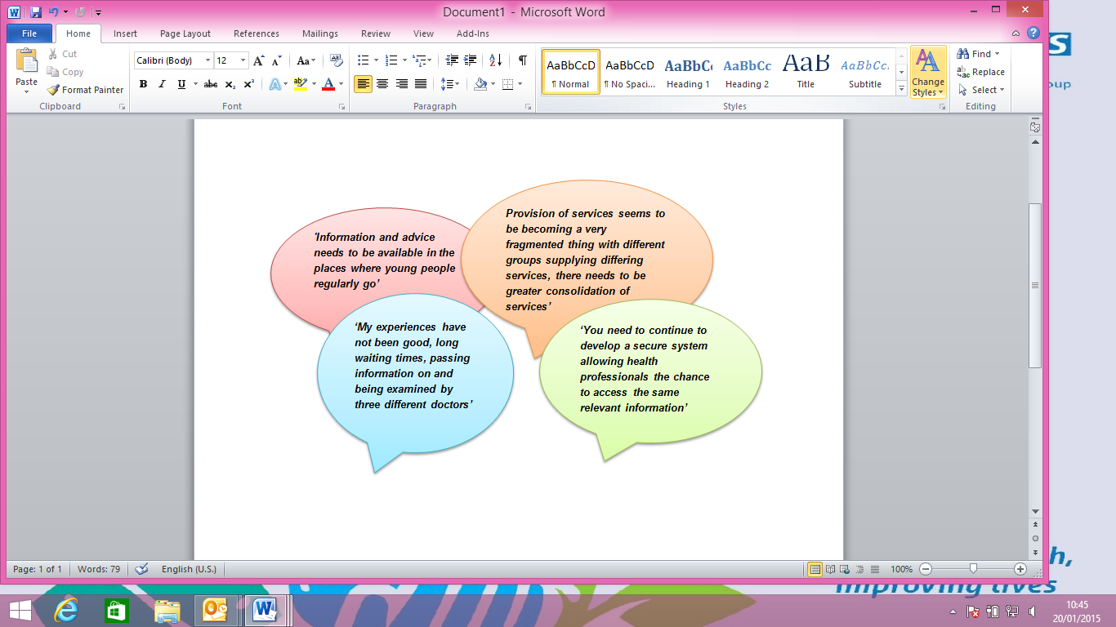

  - Local context (Case for Change)

As commissioners of health and social care services in Calderdale for children, young people and adults, we recognise that the coming years will bring significant challenges in the ability of the current system to sustain and improve the quality of care and support delivered to the local population. The scale of the challenge has been well documented nationally by a range of organisations such as the Institute for Fiscal Studies (IFS), The King’s Fund, the Organisation for Economic Co-operation and Development (OECD) and the Health Select Committee.

This case for change in Calderdale sets out our response to the pressures and drivers for change in the health and social care system and the actions that will enable us to transform the way services will be delivered by commissioning and designing services that:

- Enhance the individuals experience of physical and mental health and social care services across the local population when people need to access them
- Improve the physical and mental health and social care outcomes for a growing and ageing population
- Support people to maintain their physical and mental health as well as their independence
- Provide the best possible care closer to home
- Maximise the value obtained from every pound we spend on physical and mental health and social care so that services are sustainable in the long term

Calderdale has a long and successful history of joint working with commissioners and providers, both locally and regionally. Calderdale Clinical Commissioning Group is an active partner on the Calderdale Health and Wellbeing Board and is committed to supporting the delivery of the key agendas emerging locally which will have a direct impact on the development of a future model of community services. The emerging local agendas include:

    - Better Care Fund Plans

The Better Care Fund, initially announced in 2013 as part of the Governments comprehensive spending round, is a pooled fund and key vehicle for transforming community services. Although the Better Care Fund is central to health and social care integration, it also has a much wider role in enabling integration of the system around natural patient flows. We will be looking to this pooled fund to enable and support multi-disciplinary working in each locality, strengthen and extend home care and shift the emphasis from hospital to home. The vision for health and social care services for Calderdale developed as part of the Calderdale Better Care Fund Plan is described below:

The Calderdale Story
Hospital when I need it, Home when I want it

Hospitals, GP’s and social care all play a vital role in supporting our residents and we are committed to ensuring all parts of this system are of high quality and as effective as possible. We do know, however, that sometimes people get ‘stuck’ in one part of the system and do not then get the best outcome for their own needs. In particular for some people, such as older people and those with long term conditions, our current system can mean admissions to hospital that could be avoided, admissions to care homes that are not appropriate and unnecessarily extended time in hospital that undermines independence.
This is bad for our residents’ long term health and it’s also an inefficient use of money. The cost of inappropriate care in hospital and in care homes means health and local authority commissioners struggle to fund preventive and community based services, yet these are the services which will help people to remain independent, either at home with their families for as long as possible, or in homes that mix independence with specialist support when it’s needed.
To change this we need to be more proactive in recognising holistic environmental, social and health support needs at an early enough stage to ensure people are in control and can coordinate care and support around themselves as experts of their own condition. We need to support a mind shift which means we stop thinking we are here to provide reactive care in acute, 24 hour settings and focus instead on how we help people to keep themselves healthy, well and in control of their lives. Our Better Care Fund Plan is our opportunity to set out a joint vision and a set of expectations which will guide our joint planning towards truly integrated commissioning of integrated services.
The Calderdale Better Care Fund story is not just about health and social care, it is about the wider services which can support people to live independently at home, the third sector, community groups, housing and civic sector. It is about communities and our society. Our vision for the future for people in Calderdale means that in five years:
- New supported living housing developments like Extra Care will enable more people to remain in their own home and with their partners in the community, secure in the knowledge that help is on hand when they need it.
- Additional ‘step down’ developments will enable many more people to adjust to managing their disability in a safe setting with care support, out of hospital but en route to moving back home or into supported living accommodation (the step down accommodation in Calderdale is referred to as Heatherstones).
- People will be able to benefit from short term reablement and convalescence so that those who just need that extra time to regain their confidence will be able to manage independently at home and we will have helped reduce hospital readmissions and care home admissions.
- Reablement services will be jointly designed by health and social care so that they support peoples’ physical, psychological and social needs in an efficient and effective way
- Provision to meet continuing health and social care needs will be jointly commissioned so that health and social care work together, with residents, to design coordinated care that suits their needs
- End of life care will be sensitively planned with people and their families and wherever possible the person’s actual place of death will be where they have chosen. Support to the bereaved will be there at the right time.
- Community and social care services will be linked into general practice, which will continue to have a strong coordinating role. These joined up services will refer on to specialist pathways, when these are needed, in a properly planned and coordinated way,
- People will be able to access rapid response services through an integrated multi-agency single point of access (Gateway to Care) either directly, through a health or social care professional, via 111 or via the Ambulance Service. This means short term support can be provided within an hour, which will help reduce ambulance conveyances to hospital significantly with the consequent impact on reducing emergency admissions to hospital.
- The transition for individuals between children’s and adult services will be seamless and be planned from the earliest point.
- Social care will continue to be provided for people with moderate needs, reinforcing our conviction that early intervention and prevention is critical if we are going to maintain people’s health and wellbeing for as long as possible.
- The financial burden on families will be reduced as a consequence of fewer people being placed in long term residential care.
- The care home sector will have been developed to support people with more complex needs and those with residential care needs only will be supported in extra care.
- We will have invested in community based, wrap around support. Many more people will have personal health and social care budgets for their long term condition/s and social care needs which will be enhanced by assistive technology in their own home.
- Integrated approaches to assessment and record keeping will mean information is only collected once, will be kept securely and will be available to those providing care and support when it is needed.
- Services provided by the voluntary and community sectors will have a greater prominence as part of holistic care and supporting our duties of wellbeing and wellness.
Through our Better Care Fund Programme we will have implemented an operating model by investing in six evidence-based schemes which shall combine effect to reduce readmissions and admissions to hospital and admissions to care homes: potentially to the levels suggested from the integrated care evidence base by 20% for hospital emergency admissions and 40% for care home admissions. As a consequence acute beds will close.

Put simply:
We will have moved from reactive to proactive care and support.
We will have prevented avoidable deterioration of people’s health and wellbeing and met their care needs at the right time and in the right place.
Support will be holistic: looking after people’s physical, psychological and social needs.
‘Everyone has a bed – and it’s at home’.

Alignment of the Better Care schemes into the Care Closer to Home Programme approach shall ensure that our changes are sustained and become the way we do things in Calderdale in the future.
The next stage for the Better Care Fund is to incorporate Children and Young People’s services. Initial discussions have identified some Children and Young People services to test with the Better Care Funds, these are; Disabled Children’s Respite, Young Carers, CAMHS and Transitions
    - Developing a new Preventative Strategy for Calderdale

The development of a Preventative Strategy for Calderdale was identified in the Calderdale CCG 5-year strategic plan.

In line with the “Living Well for Longer: National Support for Local Action to Reduce Premature Avoidable Mortality (DOH, April 2014), Calderdale CCG and Calderdale Metropolitan Council Public Health have been working jointly to develop and commission a Prevention Strategy based on evidence of what works and targeted on the areas of need in Calderdale.

The strategy focuses on the delivery of the CCG 7 clinical priorities (Alcohol, Cancer, CVD, Diabetes, MSK, Mental Health and Respiratory) and supports the development of a supported self-managed care model.

The approach of the Preventative Strategy is to focus on the four key modifiable risk factors against the key stages in a life course; Starting Well (aged 0-18), Living Well and Ageing Well. These key functions are:
- Smoking
- Alcohol misuse
- Obesity
- Physical Inactivity

The Preventative Strategy will share a strong alignment with the integrated model of care described in this specification. It will strengthen integration of physical and mental health and social care and make an early step change in improving physical and mental health and wellbeing in Calderdale for children, young people and adults. Part of a combined package in the future for post 16 young people could include support to address the areas outlined above as well as education and social care.

1.5 Population and Health Outcomes

1.5.1 Introduction
The population of Calderdale is around 206,400, comprising 101,100 men and 105,300 women. Around 86.7% of the population is White British, with 8.3% identifying as Asian British. The Indices of Multiple Deprivation (IMD) takes into consideration a total of 38 factors grouped under the headings of income, employment, health, education, crime, access to services and living environment. It can therefore be used as an overall picture of how many of the aspects of people’s lives cluster within particular geographical areas.
Calderdale is ranked 110th most deprived local authority by IMD, similar to the 2007 position (when adjusted for boundary changes and a reduction in the number of districts). Calderdale also contains some major variations between affluent areas on one hand and areas in the most 10% deprived in the country, which are concentrated in Park ward. Around 19,200 people live in areas that are among the 10% most deprived in the country.
While the geographical incidence of inequality and its symptoms are not uniform across all domains, it is clear that in many areas of activity needs are concentrated in more deprived wards.
1.5.2 Early years
The Marmot Review of Health Inequalities in England 2010 and 2014 recommends that social justice, health and sustainability should be put at the heart of all policies and we need to understand the potential impact of policies and the distribution of these effects across the population. They recommended a focus on ‘giving every child the best start in life’ with a particular emphasis on the under 5s. There are 15,800 0-5 year olds in Calderdale, and the birth rate has risen steadily over the decade, from 60.0 in 2003 to 24.8 in 2013. The Marmot Review highlighted that child development at age 5 is an important indicator of health and wellbeing. Attainment in Calderdale at the Early Years Foundation Stage is lower than the national average, with 52% of pupils in Calderdale achieving at least the expected standard, compared to 56% in England.
1.5.3 Children and Young People
Children who grow up in poverty are less likely to do well at school, achieve good qualifications and participate in higher education. They are at higher risk of living in poverty as adults and are more likely to see negative outcomes in adulthood. 19.4% of children in Calderdale live in poverty compared to an English average of 18.6%. Between Calderdale wards, this ranges from 8.8% to 32.3%, with highest rates of children in poverty in Park Ward. Children of lone parents, disabled children and those from certain (but not all) BME backgrounds are at greater risk of living in poverty.
There are around 35,000 5-18 year olds living in Calderdale and around 16.2% of LA-maintained primary school aged children and 19.2% of secondary school aged children are entitled to receive free schools meals. The Marmot Review highlights these as the years of ‘skills development’, with a focus on enabling every child and young person to maximise their capabilities and have control of their lives. In 2012/13, 65.7% of Calderdale’s children achieved 5 or more GCSEs at grades A*-C including English and maths compared to an England average of 59.2%.
Calderdale’s rate of looked after children is 70 per 10,000, compared to 65 per 10,000 in Yorkshire and Humber, and 60 in England. National data shows children in care are five times less likely to achieve five good GCSEs, nine times more likely to be excluded from school, and six times less likely to enter higher education, than their peers.
Transition into working life after compulsory school age is an important stage for young people, yet 5.7 % of 16 to18 year olds in Calderdale are not in employment, education or training. This compares to an England average of 5.3%.
Being born to a teenage mother affects a person’s life chances. The conception rate amongst girls aged 15 to 17 years in Calderdale is 34.0 per 1,000, compared to a national rate of 27.7.
1.5.4 People of working age
There are 130,700 people of working age (16-64) in the borough. The overall skills level of the workforce is below national average when measured by NVQ level 4. It is estimated that 2.7% of the total workforce in Calderdale is claiming job seekers allowance compared to 2.1 % nationally. This varies between wards, from 1.1% to 6.7%, with Park, Ovenden and Town wards having the highest rates. Incomes also vary significantly within the borough: 11.6% of LSOAs in the borough are amongst the 10% most income deprived in England and 5.4 % of LSOAs are amongst the 10% least income deprived in England. The average wage of Calderdale residents is £25,386 compared to the national average £27,310
1.5.5 Later life
As people age, there is an increased likelihood of having a long-term illness, health problem or disability which limits daily activities or the work a person can do. This is a result of the accumulation of positive and negative effects on health and wellbeing throughout life. Poor health and wellbeing affects more than the individual – family members may have to change their own lives, perhaps changing working patterns, to accommodate caring responsibilities.
Men in Calderdale have an average disability-free life expectancy (at birth) of 62.3 years which is 2.2 years less than the England average, while women have an average disability-free life expectancy of 62.2 years, also 2.2 years shorter than the England average; 13.2 % of the population report a Limiting Long Term Illness.
The number of people aged 65-74 in Calderdale is expected to increase by around 19% in the ten years to 2022, while the 75+ population will increase by over 32%, from 15,300 in 2012 to 20,200 in 2022. The wards with the highest proportions of people aged 65 to 84 are Brighouse and Northowram and Shelf, while the highest proportion of residents aged 85+ live in Brighouse. There is great variation amongst this growing proportion of the population and it is most useful to think about active later life; vulnerable later life; and, dependent later life. Individual variation mean that these ‘stages’ are not necessarily sequential and cannot be associated with specific age bands.
A recent report produced for WHO European Healthy City Network suggested that ‘dying with dignity’ could be usefully added to the life stages identified in the Marmot Review of Health Inequalities in England.
1.5.6 Lifestyle
Individual lifestyle choices are shaped by a range of factors, including individual awareness and the physical and social environment in which they live. In Calderdale, estimated smoking prevalence in adults is significantly higher than the national average at 23.7%, compared to a 30.1% in England. The number of smoking related deaths is also significantly higher.
Alcohol specific hospital stays (under 18) rates per 100,000 population are higher than the national average at 58.6, compared to a 44.9 in England. Rates per 100,000 population of hospital stays for alcohol related harm are also higher at 737 compared to the England average of 637.
Only 50.3% of adults are physically active, 5.7% less than the England average. The percentage of adults classed as obese are 26.7% compared to 23% in England. This is also the case for adults classed as overweight or obese at 66.3% compared to 63.8% for England

Community life has an important impact on social wellbeing; social isolation and loneliness is associated with poorer health. Living with an existing limiting long term illnesses or living alone in old age, makes a person far more likely to experience social isolation and loneliness, so impacting on their mental and physical health.
For example, nationally both young people and LGB people are less likely to consider that they were treated with respect and consideration, while disabled respondents were less likely to consider that the Council treated all types of people fairly. Ethnic minorities were less satisfied with their local area and choice of housing than white respondents and fewer considered that they belonged to their neighbourhood and that people in the local area could be trusted. They were more likely to consider anti-social behaviours a problem and less likely to consider they were treated with respect and consideration by local public services.
Summary
Lack of income, inappropriate housing, unemployment, low pay and poor access to healthcare are some of the factors that affect the health of individuals and communities. They are the social, economic and environmental conditions that influence the health of individuals and populations. They include the conditions of daily life and the structural influences on them, which are also shaped by the distribution of money, power and resources at global, national and local levels. They determine the extent to which a person has the right physical, social and personal resources to achieve their goals, meet needs and deal with changes to their circumstances.
Similarly, good education, employment and support for healthy living can all contribute to healthier communities and in re-designing health services, the wider inequalities faced by many residents in Calderdale have to be considered and addressed.
As commissioners we will need to maximise the value we can obtain from health spend to ensure that services can:

- provide children and young people with the best life chances
- meet the needs of an ageing population and more people with a long-term condition, recognising the disproportionate costs they currently consume in the current system
- address current unmet needs within local communities
- deliver the quality standards desired

1.6 Current Model of Care

As a patient’s level of need increases, the current pattern of care (activity) tends to be episodic and reactive in responding to the health needs of individuals. This can escalate to crisis and ultimately hospitalisation where investment in acute services dominates health care spend in Calderdale.

Patients may be receiving individual elements of care that are very good, but across the pathway, care can be disjointed and fragmented. In some instances this can be of variable quality, particularly when different providers of health and social care are involved, but also different parts of the same organisation not knowing what each other is doing. This is why it is imperative that we work across health and social care to ensure seamless care provision.

16.1. Emergency and Urgent Care
Calderdale’s utilisation of emergency care illustrates a greater reliance on acute settings (hospital) to meet patient need when compared with other CCGs across England – see chart from Atlas of Variation that ranks Calderdale’s rate of non-elective admission in the 5th (upper) quintile nationally.

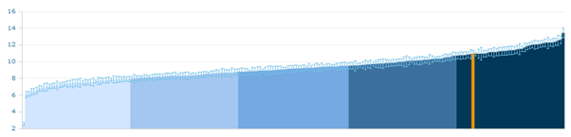
Based on the growing body of evidence that suggests a large proportion of emergency activity can be influenced by effective collaboration across the health and social care system, reviewing the variation in the rate of activity between populations highlights the scale of the opportunity we face in Calderdale to:

- Increase the effectiveness of how we design integrated services that provide care closer to home and reduce reliance on unplanned episodic treatment in hospital.
- Maximise the value we obtain from the investment we make in commissioned services that enable people to manage their own health to maintain their independence.
- Ensure patients receive integrated and high quality care emergency care and can access these services when they need it.

1.7 Responding to the needs of the local community

We know that local people want to see services improved. Whilst we know some things work well there are a number of areas which require improvement. Feedback from our recent engagement activity has told us that we need to improve access to our services and ensure people receive more services in a community setting. Current services are not responding fully to this request and we need to ensure we can develop future services with this in mind.

In addition the public want agencies to work together, including how information is shared and providing information once. Investment in staff training and new technology is part of the public response to seeing how we can achieve improvements. Supported self-managed care is also a major focus for the public including how we develop information and systems to support people to be able to do this.

Examples of comments from members of the public in Calderdale:


Examples of comments from Children and Young People in Calderdale: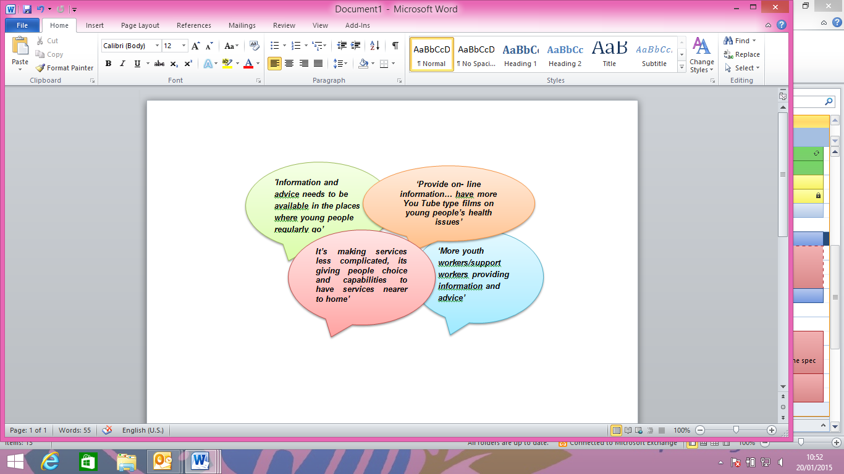

1.8 Finance

The initial impact of the national reduction in levels of funding for public sector services manifested itself as a £20bn cost reduction challenge, dubbed the ‘Nicholson Challenge’, for the whole NHS to be achieved by 2014/15, as well as a significant reduction in local authorities central funding equivalent to ~25% over 3 years. The latest economic projections suggest that the government spending review scheduled for 2015 will result in the NHS and local authority needing to deliver savings at a similar, if not higher level than those previously achieved. This will represent a significant funding pressure.

In July 2013 NHS England published “The NHS belongs to the people: a call to action” which sets out the challenges facing the NHS, including more people living longer with more complex conditions, increasing costs whilst funding remains flat and rising expectation of the quality of care. The document says clearly that the NHS must change to meet these demands and make the most of new medicines and technology and that it will not contemplate reducing or charging for core services.

The current model will be an unaffordable basis on which to meet demographic demand and inflationary pressures in the future, therefore we need to consider alternative models of care which can meet the system challenges ahead.

Combined with the expected population growth, the necessity to improve health outcomes and the quality for service provision, the scale of the financial and clinical challenge is significant

(Additional case for change and financial information is provided in Appendix 1)

1.9 Quality of Care

The lessons from the Francis Report, Winterbourne View Hospital Review and the Berwick Report, are that quality is as much about our behaviours and attitudes to patients as human beings, as it is about the transactions we need to make to ensure services improve.

We are working to deliver all Quality standards. We need to consider clinical effectiveness, patient safety and patient experience when looking to improve services. Current pressure areas include:

- Providing good quality care is dependent on the quality of the available workforce.
- Current workforce challenges experienced both at national and local level highlights a need for providers and commissioners to work differently to meet care standards.
- Requirements from the Royal College of Physicians for early involvement of senior medical professionals in the assessment and management of acutely ill individuals and specialist services for children and young people’s compliance with national standards.

A critical part of meeting the professional standards and driving up quality are the consideration of professional dependencies. This is a set of services or functions which, when co-located or co-delivered, improve quality. The programme has considered the degree to which co-location and co-delivery are essential, desirable or preferable to agree the list of dependencies to be considered when designing future health and care services.

Examples of comments from members of the public in Calderdale:


1.10 Workforce

The NHS has a large and highly valued workforce but there are increasing skill shortages in essential areas. In Calderdale over 25% of the GP workforce is reaching retirement in the next 5 years. The service has too often been configured around what can be offered. Our challenge is to drive reconfiguration of staff to meet emerging patient needs for children, young people and adults. This is supported by a recent King’s Fund report which identifies that today's workforce is facing a number of challenges. Training and development focuses on episodic care, but the greatest demand on services comes from older people who require integrated, long-term health and social care. There is a mismatch between the location of the current workforce and where care is needed, and both the NHS and social care sector require multi-skilled staff to work across boundaries. (King’s Fund, July 2013)

The Workforce Assurance Group that brings together the seven organisations across Calderdale and Greater Huddersfield has developed a workforce model to capture baseline workforce information in relation to numbers and skills for all partners. The group will now undertake a SWOT analysis which will describe the impact of each organisation’s Strategic Plans on the current workforce. This will help to identify what the key gaps and workforce challenges are for the Calderdale health and social care system over the next few years. In this document any reference to health and social care professionals includes professionals which work with children and adults.
We will continue to engage with Health Education England in order to set out our priorities in achieving a
workforce that will deliver the commissioning intentions described in relation to integration of community
based care for children, young people and adults.

1.11 Social Capital

Providing a sense of what is meant by social capital is difficult and no one single definition can satisfy everyone. However for the sake of simplicity we can think of social capital as the links, shared values and understandings in society that enable individuals and groups to trust each other and so work together (OECD).

Calderdale is made up of both urban and rural districts with a number of distinct communities, towns and networks where social capital can be found such as in neighbourhoods, churches, schools, community centres, civic associations, sports clubs or even the local pub.

These networks provide a platform to add value or have the potential to add to the social capital across the district through multiple channels such as:
• Bonds - links to people based on a sense of common identity (“people like us”) – such as family, close friends and people who share our culture or ethnicity
• Membership - links that stretch beyond a shared sense of identity, for example to clubs, societies or social groups
• Networks - links to people or groups from different social groups e.g. colleagues, associates

The pattern and intensity of these networks can vary. However the shift of services and the resources currently required to support episodic unplanned hospital admissions will need to harness the existing social capital that the district has to offer to support the shift required to provide and more importantly sustain the provision of care and support closer to home.

1.12 Calderdale Demographic Profile

It is the role of the CCG to commission healthcare services on behalf of the registered population and/or those living in Calderdale. The metropolitan borough of Calderdale has a population of 203,000 people (2011 Census) and is a metropolitan borough of West Yorkshire. It is one of the smallest metropolitan districts in terms of population, but at 140 square miles, one of the largest in terms of area. Despite being a metropolitan district, Calderdale has very distinct rural elements; most of the area is classified as rural and while definitions vary, up to a quarter of its population lives in rural areas. Combined with the geography of the area, this pattern of settlement clearly has major implications for the location of facilities, for transport, and for how close people are to health and other care services.
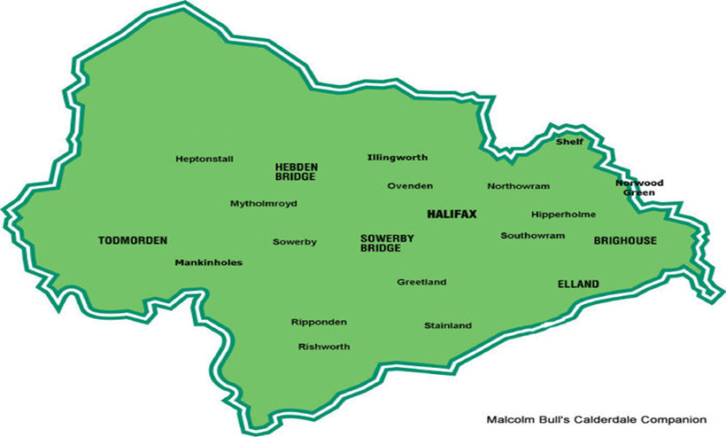

Over the coming years we know that the size of the population in Calderdale (203,000) is set to increase. The projections indicate a period of relatively rapid population growth over the coming years, with the total district population projected to grow by around 17,000 by 2021 (an 8% increase).

The largest growth is expected to occur in the older age groups with a 27% increase in those aged 65 to 74 and a 26% increase in those aged 74 to 84, a 35% increase in those aged 85 plus by 2021. The improvement in treatments has resulted in a dramatic ageing of the overall population and a substantial increase in people living with long term conditions/ co-morbidities.

The population of children and young people is set to rise in the next 10 years, with the greatest increase in the 0-15 years old group (3,600). As well as these increases there will also be greater and sometimes more complex variations in the range of needs expressed in the different communities and ethnic groups that make up Calderdale. As a consequence this will have implications for the types of services that are commissioned.

Deprivation, low income and associated unemployment and benefit dependency are closely correlated with a wide range of indicators of poor physical and mental health or low levels of well-being.

1.13 Summary of Case for Change

Responding to the system drivers outlined above will require commissioners to develop new models of delivery. Radical changes to the commissioning and provision of services are needed that will:
- meet the needs of children and young people and the ageing population and the increasing number of people with long-term conditions
- respond to what people have already told us they want from future services.
- sustain the quality of services patients experience
- commission services that maximise value for money
- integrate services with social care and other agencies to reduce the reliance on unplanned episodes of care in hospital
- empower citizens to manage their own health
- enable patients to access the advice, care and treatment they need closer to home
- maximise the use of current infrastructure to deliver care closer to home

2. Outcomes
2.1 NHS Outcomes Framework Domains & Indicators

There are 5 domains and indicators in the NHS Outcomes Framework which from the care outcomes which our Care Closer to Home specification intends to deliver. In addition to these, local indicators and outcomes have been developed
Domain 1 | Preventing people from dying prematurely
Domain 2 | Enhancing quality of life for people with long-term conditions
Domain 3 | Helping people to recover from episodes of ill-health or following injury
Domain 4 | Ensuring people have a positive experience of care
Domain 5 | Treating and caring for people in safe environment and protecting them from avoidable harm

2.2 Local defined outcomes

This section sets the outcomes to be delivered through this service. The intention is to develop suitable indicators and performance measures throughout this process to demonstrate the outcomes that are being achieved. Whilst different elements of the service will contribute more to certain outcomes than others, the overall ambition for the service is outlined below:

The following list shows the overarching national and local deliverables:
- Increase in physical and mental health related Quality of Life for patients with long term conditions,
- Value for money
- Increased patient and carer satisfaction with services, including improved responses to the Friends and family Test for local services
- Reducing avoidable emergency admissions for those conditions that are amenable to healthcare
- Reduction in the need for urgent care
- Reduction in time spent in unnecessary days spent in hospital
- Reduced premature mortality - potential years of life lost for conditions amenable to healthcare
- Ensuring that patient care and the service commissioned is primarily community based
- Enabling patients where appropriate to remain independent in their own homes by providing pro-active and efficient reactive care.
- Increasing episodes of harm free care
- Reducing inequalities

Over the past three years we have delivered a number of engagement activities which have enabled us to talk to local people on a range of healthcare services and topics. This information has been recently pulled together and analysed so the key overarching themes could be identified from what people have already told us and help us define the outcomes which are important to local people.

These themes from the engagement activity carried out over the last three years are summarised below and highlight the main issues for local people. As engagement has been extensive there are consistent themes on what people have told us about services and what outcomes are important. The themes are:

- Improve access to health services. This included opening times and appointment availability, particularly aimed at GP practices and primary care
- More services in the community, the public would like to see more staff working with and supporting local people in their own home and community.
- Working together, all agencies, not just health, should work together to improve health and wellbeing.
- Discharge planning and better hospitals. The public told us some of the things we should consider improving in our hospitals and there was a lot of focus on discharge
- Staff Training including changing the culture of the NHS, communication and transparency
- Regular check-ups including annual check-ups or possibly more frequent depending on the age and condition for everybody
- Manage risk and safeguarding, to the public meant keeping people safe when they were unwell
- Education and information. All information from the NHS should be available in easy to understand formats and use a variety of different methods to reach the appropriate audience
- Self-Care the term used by respondents was not ‘Self Care’ but self-help, self-management (manage) or ‘helping people cope’. Self-management (care) was a strong theme.
- Invest in technology. Use technology better and invest in future technology, especially for monitoring and sharing information between services and patients

Examples of comments from members of the public in Calderdale:



The information gathered has helped inform the design of the future service model for Care Closer to Home. Using the key themes we have aligned our model to ensure the views of the public, service users and carers have been used at the development stage. Due consideration for the things people want to see in our service model is demonstrated throughout. The information provided informed the development of this service specification.

2.3 What local clinicians have told us about services

The Care Closer to Home Programme was invited to attend the Calderdale CCG Practice Leads forum on the 25th June and 10th July 2014. The attendees were made up of practice managers and GPs from all the GP practices in Calderdale.
A presentation and workshop were delivered on both occasions. The group were asked to consider the following questions in the first session on the 25th June;
- What services do you want to see in the community in the future?
- What changes would the system need to make for this to become a reality?
- What is the role of General Practice in this new model?
The workshop on the 10th July was used to report back the findings and to test that the information was accurate.
The feedback included a list of services that they want to see in the community in the future. This list of services has been used when developing the Care Closer to Home Model and specification. The group also identified a number of key enablers and functions that they identified as being required to support moving services closer to home.

The themes are listed below and are in no particular order:
- Information sharing
- Shared records
- Workforce development
- Timescale for recruiting
- Organisation development
- Culture shift
- Estates- need investment in premises
- Third sector
- Communications – Multi Disciplinary Team (MDT) and GP holding responsibility
- Telephone Consultations
- Sign posting- enables patients/carers etc.
- Co –commissioning of GP services – NHS England
- Transfer of Care – decision makers are key/ who holds the risk at which points in the model?

Example of a comment from a Calderdale GP:
‘Quality integrated health and social care services underpinned by improved IT and an effective SPA would greatly enhance our patients’ outcomes and experiences of care and result in more appropriate use of Primary Care Services’

  - Working with Partners

Calderdale has a long and successful history of joint working – with commissioners and providers – both locally and regionally. As described in sections 1.4.1 and 1.4.2 there a number of key agendas emerging locally which will have a direct impact on the development of a future model of community services. These include:

- Joint Better Care Fund Plans
- Alignment of view on the planning geography for Calderdale – identifying a consistent approach to defining localities and ‘neighbourhoods’.
- Developing a new Preventative Strategy for Calderdale – focused on; smoking, alcohol, nutrition and physical exercise.

The alignment of these agendas is our opportunity to guide our joint planning towards truly integrated commissioning of integrated services.

3. Scope
3.1 Vision, Aims and Objectives of the Service

The vision for NHS Calderdale CCG is that the people of Calderdale will live healthy and independent lives secure in the knowledge that, if they need them, services will be there to keep them safe, supported and cared for.

The CCG will commission integrated services to ensure that empowered citizens (children, young people and adults) can access integrated community health, social care and primary care services that are connected by effective pathways into acute settings.

Calderdale CCG wish to commission services that provide the right care, at the right time in the right place for the people of Calderdale delivered by staff with the competencies and skills to meet the needs of patients and service users of all ages. The aim is to deliver the outcomes as identified in section 2. The CCG seeks a service provider to bring our vision to life; we are not being prescriptive in terms of:

- Service model/ provider approach
- Delivery teams/roles
- Numbers of specific staff
- Location of services

We require providers to be innovative and offer a solution that provides the right skills, in the right numbers and the ability to flex services to meet the needs of the patients of Calderdale.
Calderdale CCG wish to commission a model for the people of Calderdale that will:
- Keep them healthy and help them stay well
- Detect problems early and stop them getting worse
- Help people to stay out of hospital and long term care
- Manage admissions to hospital and long term care and make sure that when people are well enough to leave that they are supported on discharge

We will do this by commissioning an Integrated Health and Social Care model that will offer:
- Primary Prevention and Healthy Lifestyles, including Supported Self-Managed Care through Early Interventions
- Supporting People in Primary Care with Long Term Conditions
- Multi-Disciplinary Working
- Crisis Response/Single Point of Access
- Specialist Support
- Supported discharge

To deliver the care closer to home integrated model of care we need to:Establish a single point of access and single assessment process and documentation
- Minimise duplication and multiple “hand offs” offering a seamless service
- Develop the role of general practice in proactive co-ordination of care, particularly for people with long-term conditions (LTCs) and more complex health problems
- Ensure approach to delivery of primary care is holistic – addressing; physical, mental and social care needs in the round
- Promote supported self-managed care and primary prevention and proactive early intervention services
- Wrap multi-disciplinary teams around localities for people of all ages with complex needs, including social care, mental health, learning disabilities etc.

- Build on existing integrated models of care across the whole system with the patient at the centre to proactively manage LTCs, the elderly and end of life care closer to home
- Develop clearly understood pathways ensuring care is provided closer to home and not delivered in a hospital setting unless this is clinically indicated
- Provide rapid response to urgent needs to avoid unnecessary hospital emergency care
- Ensure co-ordinated early supported discharge is in place to manage discharge into planned, supportive community care
- Use innovations in IT to help record, deliver and share service information electronically through a single shared record to help with service delivery. IT innovations and developments will also, where appropriate, be utilised to support patient care

Examples of comments from members of the public in Calderdale:


3.2 Geographical Coverage

We intend to commission these services on a locality basis with certain elements to be delivered at practice level. Discussions have been held with practices and partners on whether we have 4 or 5 locality teams. More work is needed to determine the optimal number and geography for the locality teams including integrated working with the Local Authority.
We will commission these services on a locality basis with certain elements to be delivered at practice level. The areas covered by a locality team will be aligned with primary care/general practice (providing proactive co-ordination of care, particularly for people with long-term conditions and more complex health problems).

The following diagram describes our approach to commissioning taking account of the geography of Calderdale.

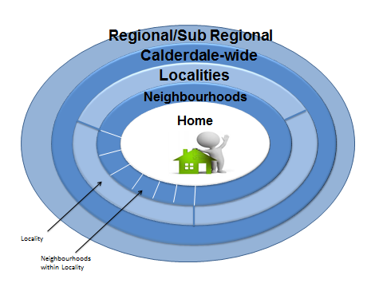

Our current thinking is based on 5 localities built around clusters of GP practices, these are:

  - Upper Valley
  - Lower Valley (inc Brighouse and Elland)
  - Central Halifax
  - North Halifax
  - West Halifax (inc Sowerby Bridge and Ripponden)

3.3 Facilities

In the engagement we were urged to make the best use of community facilities. This means thinking differently about their role as this specification and model indicates. We see new and different roles for current community facilities working with communities in the next steps in design. The buildings are not owned by the CCG but we wish to see these used imaginatively for the future where buildings are suitable and will work with providers, property services and communities in relation to this.
3.4 Service Description

Calderdale CCG’s purpose is to move care closer to home, from reactive care to preventive and proactive models based on early intervention. The aim is to enable service users to optimise their independence through the development of community-based care closer to home and self-managed care capabilities. To improve the well-being of individuals, shifting the balance from unplanned hospital care to integrated community and primary care based health and social care.

The CCG wishes to develop a pattern of services based around primary care, within localities and with multidisciplinary teams. We need high quality, responsible and accessible teams working in new ways with specialist services based in the community and in hospital.

The high level model for Care Closer to Home has been developed using local evidence and key outcomes from the engagement events undertaken across Calderdale over the past three years and clinical consensus that is informing us about the impact community services can have and what is needed to improve their effectiveness. The model responds to what patients, public and local clinicians have told us. Our aim is for the model to be designed by putting our patients at the heart of everything we do and focusing on improving the things that really matter.

Underlying key aims of the proposed service model are to:
- Keep Well, Stay Healthy
- Detect problems early & prevent deterioration
- Keep out of hospital and Long Term Care
- Manage admission and discharge

The Integrated Model of care can be seen below :
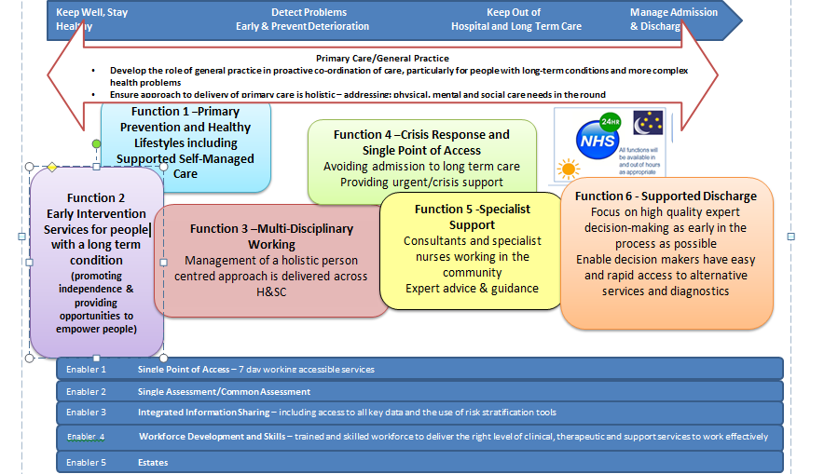

Description of the Functions from the Integrated Model of Care
The six generic functions described in the model are as follows:
- Function 1- Primary Prevention and Healthy Lifestyles, including Supported Self-Managed Care through Early Interventions
- Function 2- Supporting People in Primary Care with Long Term Conditions
- Function 3 – Multi-Disciplinary Working
- Function 4- Crisis Response/Single Point of Access
- Function 5- Specialist Support
- Function 6- Supported Discharge
Primary care/ general practice will be the cornerstone of the Care Closer to Home Model and its function is described in more detail following the six generic function descriptions.

Function 1 – Primary Prevention and Healthy Lifestyles


AIM – ENSURE INDIVIDUALS (FAMILIES, COMMUNITIES AND NEIGHBOURHOODS) CAN ACCESS
TIMELY INFORMATION TO ASSIST THEM IN MAINTAINING OR IMPROVING THEIR CURRENT
PHYSICAL AND MENTAL HEALTH

WHAT
This function will ensure individuals, their families, communities and neighbourhoods have the confidence and information to encourage and empower them to look after themselves and be as healthy as possible. It will also provide support to help individuals recognize the importance of information and positive approaches. It will also provide support to help individuals manage their physical and mental health and wellbeing more effectively to recover from episodes of ill health and will provide support for isolated people and create healthy communities.

HOW
The provision of different types of information, advice and support with regards to diet, exercise, support groups/networks and contacts for on-going support to encourage individuals to self-manage their health and wellbeing. The information, advice and support will be provided in a way that is fit for purpose for the group that it is aimed to target, for example, providing support to young people in groups of people in a similar age group. Increasingly encouraging people to use new technology to support self-managed care. The information, advice and support must be accessible to everyone in Calderdale.

WHO
Universal services drawn from across public and voluntary sectors with targeted support provided when indicated.

Function 2 – Early Intervention Services, for People with Long Term Conditions



AIM – PROVIDE SUPPORT FOR INDIVIDUALS, WITH A LONG TERM CONDITION AND OVER 75’s ON A DISEASE REGISTER SO THEY CAN MANAGE THEIR PHYSICAL, MENTAL HEALTH AND WELLBEING MORE EFFECTIVELY

WHAT
This function is focused on promoting independence and supporting individuals with long term conditions to make informed choices and enable them to manage their health and wellbeing more effectively for people with long term conditions.

HOW
The role of early identification and intervention is crucial for individuals identified with a long term condition and is reliant on on-going monitoring, support and communication. This could be achieved by a variety of methods; written/verbal information, signposting to websites and apps, signposting to patient groups and support networks e.g. a weight management or smoking cessation. This function will use assistive technology and age-appropriate tools to support individuals.
This function will communicate with all those involved in the care of the individual, including carers.

WHO
The core staff will include practice nurses, GPs’, community pharmacists and members of the Multi-Disciplinary Team (MDT), schools, community matrons, nurses, mental health, social care professionals including those professionals which work with children and young people and volunteers. The core staff listed is to provide a guide to who could deliver these services and is not limited to those listed.

Function 3 - Multi-Disciplinary Working



AIM – PROVIDE AN INTEGRATED APPROACH TO THE DELIVERY OF SUPPORT AND CARE FOR AN INDIVIDUALS PHYSCIAL, MENTAL HEALTH AND SOCIAL CARE (CLOSER TO HOME) PARTICULARLY WHERE THERE ARE MULTIPLE DIAGNOSES AND AGENCIES INVOLVED IN THE CARE OF THE INDIVIDUAL

WHAT
This function is focused on a holistic person centered approach providing care and support and requires different professionals, carers and individuals to work together on the shared objective of ensuring the best possible care for individuals. The holistic approach considers the range of care as well as the environment, including the care setting and the community where the person is living and receiving care.

Multi-disciplinary working is an integrated approach which will be delivered locally to support and care for an individual’s physical, mental health and social care needs. Dependent on need support and care will be available from appropriately skilled members of the MDT. This could involve one or more members of the team at any one time, however everyone will have a named ‘care coordinator’ who will work with them to coordinate services across health and social care.

It will be this function that provides the main platform for the interface of community health services working with community geriatricians, paediatricians, palliative care teams, and the voluntary/community sector and care agencies. It will be these individuals who will lead discussions at the weekly MDT meetings.

HOW
This function focusses on referring and identifying individuals early and carrying out skilled assessments by the right person and with the ability to put the appropriate responses in place. This function focusses on removing the barriers to an individual receiving good care by making arrangements for the individual and coordinating the process to reduce the impact on the individual and their carers and the need for admissions to hospital and longer term care services.

This function will involve all those contributing to the care of the individual, including the individual as well as their carers, in the planning of care. This function will be closely aligned with the intermediate tier service and hospital discharge processes to provide joined up and seamless services.

WHO
Multidisciplinary working involves all primary, community, social care, mental health and specialist staff working together.

Function 4 – CRISIS RESPONSE/SINGLE POINT OF ACCESS



AIM – PROVIDE AN INTEGRATED SERVICE THAT PROVIDES RAPID ASSESSMENT AND TREATMENT FOR INDIVIDUALS WITH PHYSCIAL AND MENTAL HEALTH NEEDS IN THEIR OWN HOME

WHAT
The Intermediate Tier function is focused on maximising independence for individuals wherever possible. This function has the responsibility for providing and supporting rehabilitation and reablement.

A rapid assessment and treatment service will be delivered in individual’s homes supported by an integrated service led by therapists alongside social care professionals (short term support within an hour for urgent health needs or breakdown of care). It provides comprehensive assessments which inform and support reablement delivery during post-acute care. The aim is to reduce long-term care needs whilst providing information to inform future planning of services and involves teams that are outside the direct scope of this redesign for various management/funding reasons.

HOW
Rapid assessments by staff that are able to offer ‘step up care’ to avoid unnecessary admissions. These will address health and social care needs with integrated packages of care being delivered.

The urgent response function will be part of the access and coordination hub (such as single point of access) within the individual’s home locality. Individuals who require on-going care will be transferred to other functions (e.g. on-going care, complex case management or specialist care) once the acute need has been stabilised, but usually within 24 hours. It is intended that patients will access the urgent response function for the time that is necessary and this will be limited to a maximum of 5 days as beyond this, it is a long term care need.

WHO
The service will link with GPs and Out of Hours services as well as the ambulance service, 111, social care providers, A & E and supported discharge services. Emergency Care Plans will be held by patients and will be made available and will be kept up to date by the patient or care coordinator with the relevant contact numbers of family members, carers, friends and any professionals involved.

Function 5 -Specialist Support

AIM – ENSURE THE AVAILABILITY AND INPUT OF SPECIALIST PHYSICAL AND MENTAL HEALTH ADVICE TO SUPPORT CARE PLANNING FOR PATIENTS WITH COMPEX OR DETERIORATING CONDITIONS

WHAT
This function focuses on specific conditions that require specialist care with the focus on attending to holistic needs. Individual needs will be central and if necessary, care may be provided across boundaries and specialities.

Specialists will be available to provide urgent advice to those involved providing support in decision making and care planning for patients with complex and/or deteriorating conditions.
Access to the right specialist care at the right time will ensure individuals and families receive responsive care.

HOW
Sufficient specialist staff will be available to support patient care and deliver therapeutic intervention working with patients, carers and GP practices at the most appropriate location to provide community services and specialities.

These services will play a key role in both treatment and prevention and care for individuals with specific needs such as long-term conditions or following a period of ill health.

These services will be incentivised to promote the following aspects of their role:
- Supporting individuals who require specialist professional input due to specific needs from a patient group who are also often vulnerable due to age, long term conditions or following an episode of ill health.
- Some services are small in volume but complex in terms of what needs to be delivered. Co-working in a networked approach with other specialty, acute, primary and community services is essential to assist the small resource to spread further.
- The ethos of promoting and maintaining health and wellbeing is important in these services and most have established education strategies and support arrangements to reduce the impact of risk behaviours on the individuals themselves and others.

Some specialist teams/services such as specialist mental health teams are outside the scope of this function but it is intended that staff working in Care Closer to Home services work seamlessly with colleagues in mental health services to deliver the best care for patients.

WHO
Specialist services include services such as; podiatry; tissue viability; musculoskeletal physiotherapy; bladder, bowel and pelvic floor services; specialist nursing such as cardiac nursing, disabled nursing team and others. Co-working in a networked approach with other speciality, acute, primary and community services is essential.
Function 6 - Supported Discharge



AIM – FACILITIES AND SUPPORT ARE ALWAYS AVAILABLE TO PROMOTE AND MAINTAIN INDIVIDUAL PHYSICAL AND MENTAL HEALTH INDEPENDENCE

WHAT
This function will ensure that facilities and support are always available in the individual’s own home or other environment wherever possible to promote independence by:
- Avoiding unnecessary hospital admissions by providing timely care
- Ensuring discharge from hospital can occur as soon as safely possible
Teams will be located both in the acute hospitals (A&E, Medical Assessment Unit (MAU), Paediatric Assessment Unit (PAU) and Surgical Assessment Unit (SAU)) and in each community locality so that there is seamless coordination of plans to support discharge (building on the virtual ward/frailty model).

HOW
- By communicating with all those involved in the care of the patient (both adults and children) and involving the patient (and carer) in the planning and preparing for discharge from hospital service or prevention of admission
- By working into A&E, MAU, PAU and SAU creating in-reach services to support discharge planning (building on the frailty model)
- By focussing on high quality expert decision making as early in the process as possible (particularly for elderly patients)
- By planning for discharge by localities, to enable timely or early discharge
- By ensuring decision makers have easy and rapid access to alternative services and diagnostics
- By using innovations in IT to help record, deliver and share service information electronically through a single shared record to help with service delivery
- Consultants and specialist nurses to work in the community providing expert advice and guidance to avoid hospital admission
- Avoid unnecessary hospital admissions by providing timely care for patients in their own homes/choice of care

WHO
Multidisciplinary teams in primary, community, social care, mental health and specialist staff for example the Disabled Children’s Team (DCT) working together. Co-working in a networked approach with other specialty, acute, primary and community services is essential.

General Practice
General practice will be at the heart of integrated care closer to home and will work in a more collaborative way with Community health Services, Social Care, Third Sector organisations, Community Pharmacists and other partners. It will form a key part of the multi-disciplinary working across the community based care organisations in order to ensure the best possible care for individuals.

GP’s as expert generalists build longstanding relationships with their patients and local communities. They are key to developing services that support the growing number of patients with multiple, complex, long term health problems and helping them manage their conditions at home and in the community with support from the right specialist at the right time. It is expected that through the integrated model of care closer to home, there will be benefits to general practice and primary care services, below are four areas where benefits have been identified:
- Collaborative working – providing an opportunity to develop a wider range of community services avoiding duplication through more joined up ways of working with the multi- disciplinary teams, whilst at the same time making more effective use of resources
- Capacity – enabling better access for people requiring primary care services. This could be in the form of more available appointments, specialist nurses working from the practice and expanding on good practice currently working in the community, such as the Quest Matrons
- Better access – to consultations provided in different sites. Specialist will be available to provide urgent advice to primary care professionals providing support in decision making and care planning for patients with complex and/or deteriorating conditions.
- Closer to home – services provided closer to home and in reassuring settings providing a wider range of tailored services and continuity of care. This will provide an opportunity to build more extensive community teams involving community nursing, secondary care specialists and social care.

The network of services within the localities will wrap around general practice to enable general practice to take a much stronger role in ensuring the delivery of integrated care closer to home, particularly;
- Proactive co-ordination of care, particularly for people with long-term conditions, those aged 75 plus and people with more complex health and care problems – supported by risk profiling
- Introduction of a single care plan for children and young people
- Involving patients and cares more fully in managing their own health and care
- Holistic care: addressing people’s physical and psychological and social needs health needs, and social care needs
- Ensuring fast, responsive access to care and preventing avoidable emergency admissions and A&E attendances
- Preventing ill-health, ensuring ore timely diagnosis of ill-health, sand supporting wider action to improve community health and well-being
- Ensuring consistently high quality of care: effectiveness, safety and patient experience

Clinical responsibility for all patients within their own homes (including residential and nursing) sits with the registered general practice. Moving to integrated closer to home care will result in some episodes of care for which a secondary care service will maintain clinical responsibility for that care until the point of discharge and transfer to care back to general practice (see transfer of care/discharge planning section 4.7 in the specification)
N.B: General Practice extract is currently being discussed with the Local Medical Committee (LMC) and therefore maybe altered following these discussions.

Community Pharmacy
Pharmacies are trusted and professional partners that play a key role in supporting individuals, families and community health by:
- Providing support and advice to patients receiving prescribed medication and when purchasing medicines over the counter and access to a health professional without an appointment.
- Providing public health education and advice to patients in their localities and provide a number of national and locally commissioned services to Calderdale residents.
- Providing minor ailment services (access to treatments without a prescription for a number of common complaints, a head lice service is also in place.)
- Providing special services to support care closer to home for example access to urgent medicines out of hours and medicines for end of life care.
- Providing nationally funded ‘medicines use reviews’ for patients on regular treatments medicines and those starting new treatments, to help patients understand how to get the best from their medicines.

Effective community pharmacy services have a significant and increased role to play in ensuring we have a sustainable healthcare system.
Community Pharmacy and the network of services within the community will need to work closely to maximise the benefits from better communication between health care professionals.
Community Pharmacy will play a key part in supporting the delivery of the integration of care closer to home by:
- Providing health education
- Providing medicines optimisation ( long term conditions)
- Providing general health advice and effective signposting to other services.
- Strengthening the role of community pharmacy as a provider of community services to patients.
- Maximising the use of minor ailments schemes

Multidisciplinary teams will be required to communicate with the patient’s regular pharmacy to ensure that information is shared effectively to optimise patients’ use of medication.
N.B: Community Pharmacy extract is currently being discussed with the Local Pharmaceutical Committee (LPC) and therefore maybe altered following these discussions.

Patient and Public View on the Care Closer to Home Model (Adults)
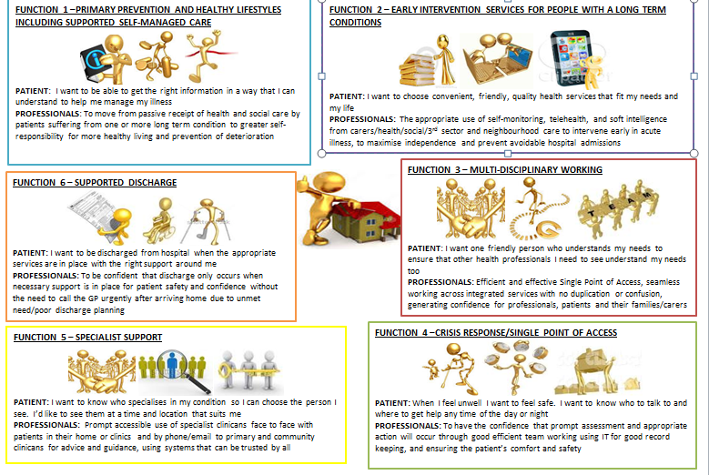
Patient and Public View on the Care Closer to Home Model (Young People)
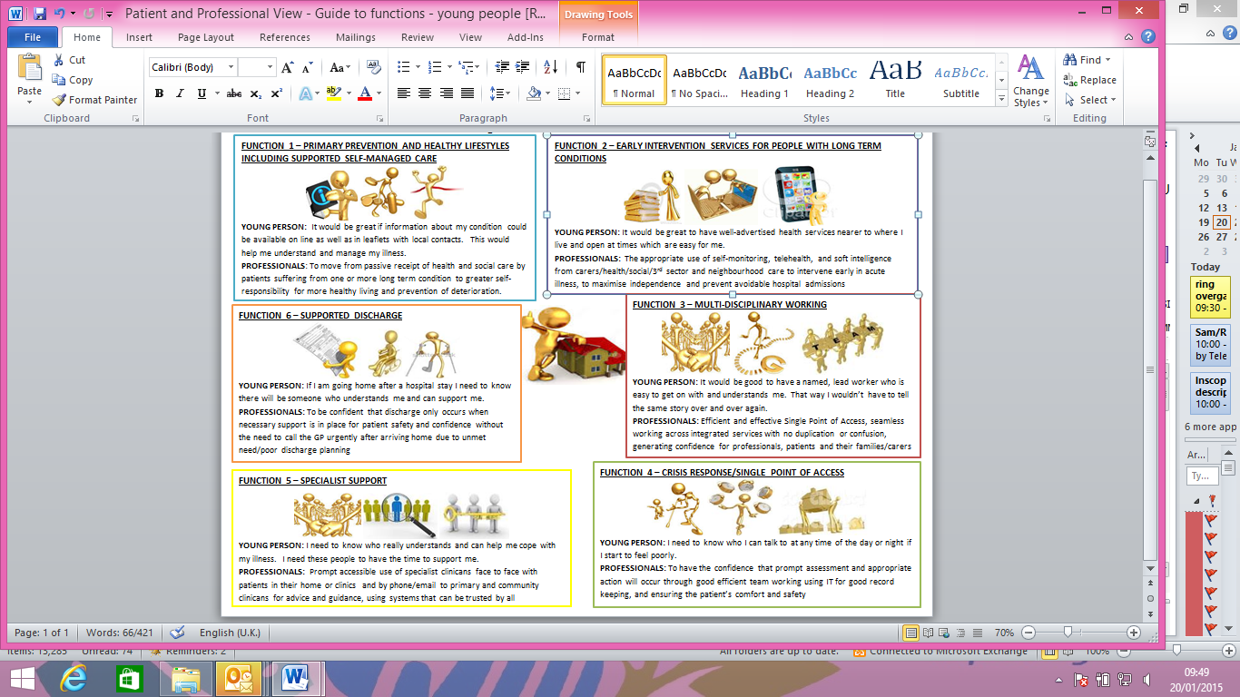
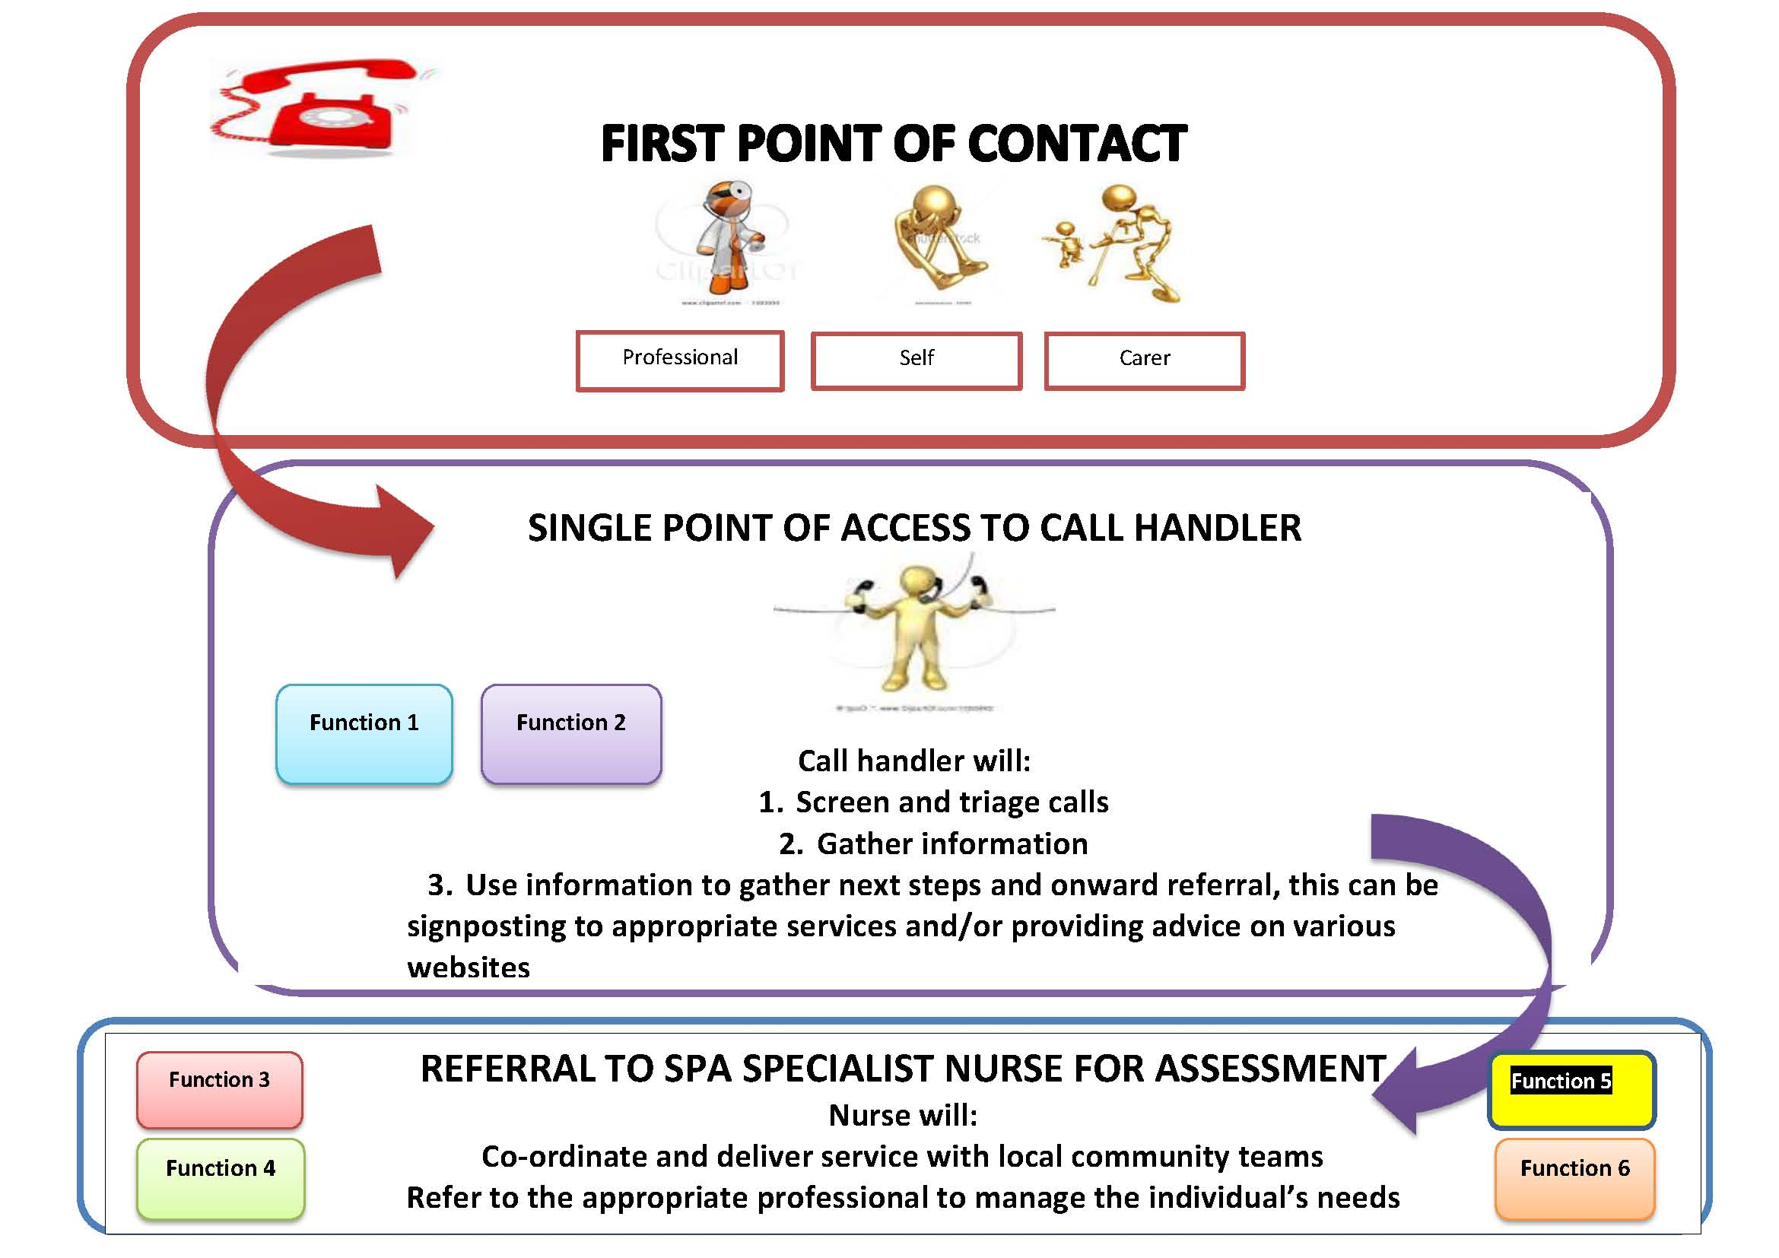

Enabler 1 – Single Point of Access
The Single Point of Access (SPA) and triage process is a key element to the Care Closer to Home integrated model of care, which aims to build and evolve the current SPA model developed within the redesign of the Integrated Intermediate Tier in 2011, following a 12 week consultation process with the public.

The aim of this service is to improve access to community services for children, young people and adults, by providing an integrated service with joint health and social care triage, extending opening times and providing availability out of hours.

The SPA model will provide everyone with access to telephone advice and triage will be provided 7 days a week and out of hours. The model above sets out the pathway from contact to the call handler who will; screen and triage all calls, gather information and use information to gather next steps and onward referral.

Cases assessed as urgent will be given a timed appointment or visit within 4 hours of the time of calling. Cases assessed as non-urgent and that cannot be resolved by the phone, individuals will be offered the choice of an appointment within 24 hours or to suit the need after the 24 hour period

Health and social care professionals in this specification includes those professionals which work with children and adults.

If a professional assessment is needed, the referral will be transferred to the nurse/professional who will co-ordinate delivery of the service with the locality team(s) by allocating the right professional(s) to manage the patient’s needs.

Enabler 2 – Single/Common Assessment
It is essential that a single/common assessment and planning framework is identified for use across all services. Where plans currently exist through consultation, for example the Education, Health and Care (EHC) plan for children and young people; these are incorporated into any new plans. It aims to help the early identification of an individual’s needs and promotes coordinated service provision involving health and social care organisations working closely together to make sure the right care services are received at the right time.

With the individual’s permission, the assessment information can be shared with other professionals who will be involved in providing services.

Enabler 3 – Integrated Information Sharing – including access to all key data and the use of risk stratification tools
With the individuals consent, relevant information will be visible to health and social care professionals involved in providing care to adults and children.

The aim is to have access to a single shared patient record. This will be critical to the delivery of an integrated care system, so patients and their carers only need to give information once. Currently there are multiple clinical systems and IM&T platforms in use across the primary, community, mental health and social care services operating in Calderdale. There is no existing perfect system on the market, currently our primary care providers use SystmOne, EMIS Web and Rio.

Further work is needed to ensure a common position in the exchange of clinical information and business intelligence, in a seamless manner to consistent standards such as compliance with interoperability toolkit (ITK) or other interfacing/messaging standards.

Patients will be stratified according to whether they are high, medium or low risk using the risk stratification tools developed. Depending on their stratification they will have different levels of input by community staff. This will be monitored closely, particularly in line with local and national guidance to specific individual patient needs. Levels of input will be adjusted accordingly when necessary.

Enabler 4 – Workforce Development and Skills

Integral to the delivery of this vision is the creation of a workforce trained to deliver the right level
of clinical, therapeutic and support services and who work effectively within the whole system
and that has the skills and competencies that match their grade and who are able to provide
appropriate services. We need high quality, responsible and accessible teams that have the
capability to work in new ways with specialist services based in the community and in a hospital
setting.

Enabler 5 – Estates

To deliver the integrated services proposed, existing buildings will need to be enhanced within community and primary care settings.

3.5 How Community Based Care will be Different

In developing models of community based care, real life case studies have been developed working with Health Care Connect to show how services are changing. Some of the stories are included in Appendix 2 to demonstrate the impact that the new model of care will have on health and wellbeing across Calderdale (Appendix 2)

3.6 Any acceptance and exclusion criteria and thresholds

The following general service exclusions apply:
- Patients not registered with a Calderdale and surrounding area GP practice
- Patients who are medically unstable requiring hospital treatment
- Patients who are appropriate for GP practice attendance
- Patients who have acute psychiatric illness
- Provision of equipment where there is no identifiable nursing or therapy requirement
- Patients who only need assistance with personal hygiene or toileting
- Verification of death
- Routine collection of specimens for people with no identifiable nursing or rehabilitation needs
- Patients whose needs do not fit within the criteria for each specified element of service

3.7 Interdependence with other services/providers

The aim is for the service to provide:
- Personalised and holistic care
- Community based, multi-disciplinary, multi-agency
- Patient experience a real seamless pathway of care
- A “supply chain” for health and social care
- Integrated care across services that include primary care, third sector and social care
- Different organisations bring different positive aspects of care
Not:
- Episodic care across multiple fragmented providers
The following table provides a list of those services out of scope but provide a vital role as an independency to the Care Closer to Home Model

Service | Interdependency
General Practice | Information systems which allow electronic referrals and data share.  Care co ordination  Access to medical advice and OOH support  Senior decision maker
NHS 111 | National access to a professional on health advice 24/7  Navigation to local SPA where appropriate
NHS Local Hospital | In / outreach provision  Enabling levels of care  Early assessment of need and discharge planning  Access to specialist practitioners
Voluntary Sector | Transport solutions  Day centre provision  Befriending and sitting services  Signposting and low level post discharge support  Supporting patient participation in society  Supporting health and well being  Awareness of service availability and accessibility
Independent Sector | In / outreach provision  Enabling levels of care  Early assessment of need and discharge planning  Access to specialist practitioners
Ambulance Services | Agreed protocols to support access to the right care at the right time
Hospice | Providing access to specialist palliative care services
Walk In | Providing primary care access in and out of hours  Care co ordination  Access to medical advice and OOH support  Senior decision maker
OOH and urgent care | Protocols, IT systems and handover arrangements to support seamless delivery.
Mental health | Links to support dementia pathways and a holistic approach to physical and mental health and prevention.
Social Care | Social care assessment  Short term re-ablement and assessment  Occupational therapy  Partnership working enabling integrated care delivery  Developed communications and IT system that enable partnership working.
Public Health | Partnership working to enable integrated care and prevention
Community Pharmacy | Access to prescribed medicines  Advice on medicines  Support to management of long term conditions and first point of contact
Continuing Health Care | NHS continuing healthcare’ means a package of ongoing care that is arranged and funded solely by the NHS where the individual has been found to have a ‘primary health need’. The CCG has assumed commissioning responsibility for NHS continuing healthcare from 1 April 2013 and must deliver its responsibilities in accordance with the National Framework for NHS Continuing Healthcare and NHS-funded Nursing Care November 2012 (Revised)

4.0 Service Delivery
4.1 Service Delivery
The aim of the integrated model of care will enable patients to optimise their independence through the development of community-based care closer to home and supported self-managed care. The specification is designed to develop a network of services based within localities and around primary care supported by multi-disciplinary working. We need high quality, responsible and accessible teams that have the capability to work in new ways with specialist services based in the community and in a hospital setting.

As described in our Model of Care and the two case studies provided in appendix 2. Primary Care/General Practice will develop the role of general practice in proactive co-ordination of care, particularly for people with long-term conditions and more complex health problems. They will also ensure the approach to delivery of primary care is holistic – addressing; physical, mental and social care needs in the round.

4.2 The role of Technology
Although technology is moving on at pace, we have not, to date, embraced the opportunities fully in community services. Remote consultations, alarms and sensors to assist in supporting people at home, electronic records and appointment booking and many other developments all bring possibilities and should be explored particularly in rural settings. We are interested in innovative approaches to the use of technology in the delivery of effective home based and local care.

4.3 Care Pathways
The integrated services will provide care to individuals in line with evidence based care closer to home pathways as agreed with the commissioner to ensure high quality, safe services for individuals that are effective, safe and value for money.

4.4 Personal Support
Personalisation and choice and control for individuals over the management of their own health are all important. This will be facilitated through access to information, education, the use of personal health budgets to support self-managed care.
There will need to be a commissioning and delivery framework that enables increasingly flexible and bespoke packages of support so individuals can be more in control of their services, including personal health budgets as these become established
We also wish to engage a provider who can understand and develop the opportunities offered through the use of Personal Health Budgets which together with the use of Personal Budgets from social care will give individuals choice and control over the management of their health needs.
4.5 Think Carer Think Family
The key role of carers and the need to support carers’ health and wellbeing in addition to that of patients is important. The provider must support the requirements for carer assessments.
4.6 Location(s) of Service Delivery
The aim of the integrated model of care is to base services closer to home in four to five localities across Calderdale. One of the key themes from the engagement activity carried out requested more services to be delivered in the community, particularly seeing more staff working with and supporting local people in their own home and community.
Locations identified by the provider must have the appropriate facilities, equipment and staffing to provide clinical treatment (where necessary), management and rehab to meet the needs of all.
4.7 Transfer of Care – Discharge Planning
Planned discharge from each service will ensure that the individual receives a co-ordinated seamless transfer of care into any setting or services as required, for example early supported discharge or outreach services.
Handover is the system by which the responsibility for care is transferred between healthcare professionals. This ensures that changes in clinical teams are not detrimental to the quality of healthcare.
The patient, family and carer(s) will be fully involved in all stages of the transfer of care planning. Transfer from any service will be planned to ensure that the individual receives a co-ordinated seamless transfer of care into any setting (including home) or other service(s) as required which includes transitional arrangements.
Handover can be smooth and seamless or it can be bumpy. It depends for success on an agreed proven through which information can flow and open the presence of a mature, patient centred dialogue on the point of the individual or team seeking to handover care, and on the part of the individual or team who are being asked to take on responsibility. It also depends upon the present of appropriate capability and capacity within the receiving team.
Handover is the system by which the responsibility for immediate and on-going care is transferred between professionals. This ensures that changes in clinical teams and other professionals are not detrimental to the quality of care and support. Patients transferred from a clinical setting should have a standardised clinical handover clearly documented using an electronic template for example with Systm1 and EMIS web by the ‘relevant service’. If out of hours the ‘service’ will task the handover to the responsible lead
The handover process should define leadership responsibility and define who is relinquishing responsibility and who is responsible for on-going care.
Discharge planning will be commenced on admission to the Service to enable on-going support needs to be identified and arrangements put in place to meet them; an outline plan will be developed during the initial assessment phase and documented in the care plan in partnership with individuals, carers and multi-disciplinary teams involved. This will be reviewed and amended as required following multidisciplinary discussions.
For those individuals who can return home with pre-existing services the SPA will make arrangements for reinstatement of the appropriate package of care. On discharge the SPA will provide appropriate information to the individual’s GP and any other professionals who will be involved in follow up care (using the electronic template on Systm1 and EMIS web).
The individual’s care plan will go with them on discharge from a service. Individuals should also receive
information about services from which they could benefit.

If the assessment indicates a need for acute medical, surgical or palliative care the Providers will make all necessary arrangements and provide a timely verbal update to the receiving environment and will ensure the individual’s records are sent with the individual
4.8 Expectations From Providers
The intention of this specification is for the focus to be on the outcome measures. As a result of this, the commissioner will not specify any operational structures e.g. handover meetings, MDT meetings etc., instead these areas will be measured through the KPIs and patient satisfaction measures.

4.9 Scope of Professional Practice/ Workforce Requirements

Providers must take into account best practice in relation to “codes of conduct” and “scope of practice” in order to mitigate risk when transforming or extending roles of any professional employed by the provider.
This should include, but is not restricted to; definitions the procedures, actions, and processes that are permitted for the licensed individual. The provider must also ensure ongoing support of effective practice through Continuing Professional Development (CPD)

4.10 Safeguarding of Adults in Vulnerable Circumstances

The Providers will have in place systems and processes which comply with the local Safeguarding Adults

Board Multiagency Policies and Procedures. The Provider(s) staff should be trained to the standards of the National Competency Framework for Safeguarding Adults. The Providers will comply with the Quality Requirements and key performance indicators, for Safeguarding.

In addition the Provider shall comply with each of the Local Authority’s local policies and procedures for safeguarding adults, including the local multi-agency policy, as amended from time to time:
- West Yorkshire Multi-Agency Safeguarding Adults policy and procedures: http://www.kirklees.gov.uk/community/careSupport/keepingSafe/pdf/safeguardingAdultPolicyProcedures.pdf)

- At the reasonable written request of the Commissioner and by no later than ten (10) Business Days following receipt of such request, the Provider shall provide evidence to the Authority that it is addressing any safeguarding concerns raised through the relevant multi-agency reporting systems.
- Ensure that staff practices in accordance with the Mental Capacity Act 2005.
- Ensure that staff undertake safeguarding adults training appropriate to their role and grade
- Ensure that organisational representatives / practitioners make an effective contribution to safeguarding case conferences / strategy meetings where required as part of multiagency procedures.
- Ensure that there is a system for monitoring complaints, incidents and service user feedback, in order to identify and share any concerns of abuse (including potential neglect), using multiagency safeguarding procedures.
- Ensure that all safeguarding concerns relating to a member of staff are effectively investigated, that any disciplinary processes are concluded irrespective of a person’s resignation and that ‘compromise agreements’ are not allowed in safeguarding cases
- Ensure safe recruitment policies and practices which meet Employment check standards including ensuring that appropriate CRB/DBS checks are completed and repeated with national requirements and guidance.
- Ensure that all contracts of employment (Including volunteers, agency staff and contractors) include an explicit responsibility for safeguarding children and adults.
- Adhere to national Prevent guidance and procedures ensuring that the procedure is accessible to all staff, and that sets out how to escalate Prevent related concerns and make a referral in line with the National Prevent strategy

4.11 Safeguarding Children
The Provider will comply with guidance in Working Together to Safeguard Children March 2013, A Guide to Inter-Agency Working to Safeguard and Promote the Welfare of Children. This states that providers of services such as these ‘should identify a named professional for safeguarding’. Named professionals have a key role in promoting good professional practice within their organisation, providing advice and expertise for fellow professionals, and ensuring safeguarding training is in place. They should work closely with their organisation’s safeguarding lead, designated professionals and the local Safeguarding Children Board.

4.12 Prescribing and Medicines Management

The provider(s) will have appropriate monitoring systems in place to assure the commissioner that they comply with regulations and good practice guidance pertaining to the storage, prescribing, administration and supply of medicines.

Prescribing by medical and non-medical staff will be monitored by the provider through ePACT data analysis and clinical audit; the provider will be responsible for ensuring that staff adheres to local and national prescribing guidelines, policies and commissioning statements.

The CCG will supply the provider with the relevant prescribing codes with attached prescribing budgets for services delivered by the provider. The CCG will continue to hold this budget except by explicit agreement

of both the commissioner and the provider. The provider will also be required to ensure that appropriate arrangements are in place to manage and supply NHS controlled stationary (e.g. prescription pads) to staff.
There will be a quarterly meeting with the CCG to monitor progress against prescribing budget and to monitor adherence to local and national standards.

4.13 Access
The Provider(s) will deliver a single point of access to the service. The key functions will be:
- Initial contact handling for any health or social care worker or patient/service user to include contact handling; information gathering within given parameters; using information to determine next steps; referral; involvement of clinical/professional senior decision making;
- Providing professional/clinical decision making and accountability;
- Managing resource allocation and demand;
- Prioritisation, delegation and transfer of care;
- Proactive tracking and care navigation throughout the whole patent/service user journey; and
- Proactive reviewing of the effectiveness and efficiency of the care pathway.

The single point of access will provide an initial integrated health and social care assessment, which will indicate the level of care required or provide advice and/or a sign posting service to support recovery and promote well-being and independence.
The Providers will have systems and policies in place to ensure that it is responsive to the individual needs of its service users and will demonstrate it makes all reasonable adjustments to ensure that its services are accessible, appropriate, flexible and safe.
The Providers will consider the specific needs of protected groups in relation to the service provided, making specific arrangements where necessary, such as interpreting, longer appointment times or home visits.
All protected characteristics will be considered and adjustments made, but particular attention will be paid to disabled people, including those with learning disabilities and to people who may have additional communication requirements.
The provider will produce accessible materials and signposting information to publicise and promote the services as required. The information will include a clear description of how the service operates, how it fits with other services, what to expect from the service (in terms of processes and outcomes), and how to register a compliment/complaint. The Providers will ensure that information about the service, including contact details for the single point of access, is provided to all individuals using the service and potential service users and their carer/family, in appropriately accessible formats. This information should reflect the diversity of the local community.

The Providers will have systems/procedures/policies in place to equality monitor referrals and service users, and be able to report and evidence actions undertaken to address any preventable inequalities of access, experience or outcomes, where these become apparent and to ensure that they are, where appropriate, providing services to the local community equitably.
The Providers will assess the impact of its services and work with service users and other stakeholders to understand whether there are any barriers to improved access, experience or outcomes. Where these are identified, reasonable steps should be taken to minimise the impact of the barriers.
- 4.14 Measuring and Responding to Service User and Carer Experience

The provider will actively gather patient/carer experience data, including equality data, from each patient using the service.
The opportunity to participate in the National Friends and Family Survey will also be offered to each person using the service.
The provider will review patient/carer experience data on a monthly basis, and where appropriate take action to improve patient/carer experience by identifying common themes and positively acting upon them.
The provider will produce a patient/carer experience report, to include actions taken and improvements made, the report will be shared with the CCG on a quarterly basis. Any findings/actions taken from the above reports will be published in order that to service users and the general public can review the service.
The provider will promote and look into innovative methods of capturing service user/carer experience to ensure input from a proportionate sample of service users including protected groups. The providers will also have systems and procedures in place to respond to complaints and ad hoc service user and carer feedback, the findings from these mechanisms will contribute to the quarterly report.
4.15 Changing the way a service is currently provided
Where the Provider wishes to change the way a service is currently provided this is likely to give rise to an obligation to engage and/or consult with patients and or their representations. This statutory obligation is that of the CCG but the CCG will expect the Provider (at its own cost) to co-operate with it in doing so. Both the CCG and the Provider will work to the principles and approaches set out in the commissioners Patient Engagement and Experience strategy. The provider will work to the legislation set out in the strategy which includes the Health and Social Care Act 2012, The Equality Act 2010 and the NHS Constitution. Where these circumstances arise, the Provider will be expected to propose a detailed engagement plan for approval by the CCG.
The CCG and the Provider will need to ensure that any service change has been subject to the appropriate legislation and that a clear audit trail of activity can demonstrate this has taken place. The audit trail would include a plan for delivering an engagement and/or consultation and a report of findings. The provider will be required when requested to submit any plans for engagement and consultation to the commissioner to ensure an appropriate process is being followed. Where service user involvement has been undertaken the providers will demonstrate progress on involving all equality groups through equality monitoring.
The provider will share the findings from any engagement and/or consultation activity with the commissioner, service users/carers and the general public.
The CCG will carefully consider the outcome of any consultation exercise and reserves the right to amend the service specification. Any such amendment will be dealt with in accordance with the variation procedure contained at Clause xxx notwithstanding that the service may not have commenced.
5. Applicable Service Standards
5.1 Applicable National Standards
- The Department of Health refreshed 2001 guidance ‘Intermediate Care – Halfway Home’ July 2009 as part of the ‘preventative package for older people’.
- Standards for Better Health (updated 2006)
- The National Framework for NHS Continuing Healthcare and NHS-funded Nursing Care, November 2012 (Revised)
- Transforming Community Services – Quality Framework (2010)
- Care Quality Commission: Essential Quality Standards of Quality and Safety (2010)

- Common Core Principles for Supporting People with Dementia (2011)
- The Health & Social Care Act 2008: Code of practice on the prevention and control of infections and related guidelines (2010)
- Disclosure and Barring checks
- Mental Health Capacity Act 2008
- Deprivation of Liberty Safeguards 2009
- The Controlled Drugs (Supervision of Management and Use) Regulations 2013
- Human Medicines Regulations 2012
- Serious Incident Framework 2013. http://www.england.nhs.uk/wp-content/uploads/2013/03/sif-guide.pdf
- National Patient Safety Agency (2010). National Framework for Reporting and Learning from Serious Incidents Requiring Investigation. Available at http://www.nrls.npsa.nhs.uk/resources/?entryid45=75173
- Any other as appropriate to the services/staffing

5.2 Applicable Standards Set Out in Guidance and/or Issued by a Competent Body
- Ready to Go: Planning the discharge and transfer of patients from hospital and intermediate care (DH 2010)
- Royal College of Physicians National Clinical Guideline for Stroke (2008)
- NHS Yorkshire and Humber Stroke Assurance Framework
- Immunisation Against Infectious Diseases (DH 2006) plus updates via http://www.dh.gov.uk/en/PublicationsandStatistics/Publications/PublicationsPolicyandGuidance/DH_079917

5.3 Applicable Local Standards
- Local governance policies and procedures
- Infection, prevention and control guidance and reporting
- CCG prescribing guidelines, policies and commissioning statements
- Personal Health Budget Processes

5.4 Infection prevention and Control
Infection prevention and control including healthcare associated infection is everyone’s responsibility and require cooperation and information sharing across the healthcare organsiations in order to effectively manage, monitor and reduce the incidence of infection.
Calderdale CCG works in partnership with other agencies across Calderdale and the wider health economy to prevent and control infection. There is an expectation that services which are commissioned have systems and processes in place which meet the requirements of ‘The Health and Social Care Act 2008: Code of Practice on the prevention and control of infections and related guidelines
6. Applicable quality requirements and CQUIN goals
  - Applicable Quality Requirements

The Provider(s) will be expected to meet the essential standards of quality and safety set out by the Care Quality Commission (or any successor organisation) on its website at www.cqc.org.uk/usingcareservices/essentialstandardsofqualityandsafety.cfm

The Provider(s) will be expected to ensure that the safety of individuals in its services is enhanced by the use of processes, working practices and systemic activities that prevent or reduce the risk of harm to those individuals.

The Provider(s) will be expected to provide evidence of a range of safety policies and procedures. The Providers will ensure that all staff receive the necessary training and instruction in all such policies and procedures in their provision of services, and that this can be evidenced to the Commissioners.

All safety incidents should be reported to the Commissioners using agreed processes.
The Provider(s) will be expected to report all Serious Incidents immediately and to co-operate in all investigations undertaken. The Provider(s) will be expected to comply with all infection, prevention and control guidelines.

The Provider(s) will be expected to demonstrate systems, policies and procedures for risk assessment, risk management, investigation and learning lessons from incidents. The provider will have in place Business Continuity plans and complaints policies – all of which will be agreed with the Commissioner.

The Provider(s) will be expected to ensure that each individual receives the highest possible standard of care and support based on an assessment of individual need, and that individuals receiving care and support achieve benefits that meet their needs, through decisions and services based on what assessed research and evidence has shown to provide effective outcomes, and input from individuals and their carers/families.

The Provider(s) will ensure that services are delivered in an environment that treats every service user and carer as a valued individual, with respect for their dignity and privacy. Where services are delivered outside the home, the Provider(s) will:
- Ensure that the provision of the services and the premises protect and preserve dignity, privacy and confidentiality;
- Ensure that services are compliant with the elimination of mixed-sex accommodation
- Allow individuals to have their personal clinical details discussed with them by a person of the same gender, where required by the individual and if reasonably practicable;
- Ensure that all staff behave professionally and with discretion towards all individuals and visitors at all times.
- Ensure that individuals are aware of their rights under the NHS Constitution.

The Provider(s) will be expected to demonstrate that their managerial leadership, clinical/professional leadership and accountability, as well as their culture, systems and working practices ensure that probity, quality assurance, quality improvement, equity and safety are central components of all its activities.

The Provider(s) will be expected to ensure that people receive services as promptly as possible, that they have choice in access to services and treatments, and that they do not experience unnecessary delay at any stage of service delivery or on the pathway.

The Provider(s) will ensure that individuals accessing services are able to make informed choices, exercise control and are able to sustain their independence
The Provider(s) will be expected to ensure that clear policies are in place to obtain the most appropriate level of urgent or emergency care for individuals in the most appropriate setting.

6.2 Patient Safety

The commissioner expects that the provider will have effective and robust risk management systems in place for reporting, investigating and learning from patients safety incidents.

All patient safety incidents will be reported to the National Patient Safety Agency (NPSA) electronically via the National Reporting and learning System (or any successor organisation or system).

NPSA and Medicine and Healthcare Products Regulatory Agency (MHRA) guidance disseminated via the Central Alert System (CAS) including patient safety alerts and other safety solutions and products developed for the NHS will be disseminated, implemented and evaluated in a timely manner. Where the guidance and/or alert have specified timeframes, the provider will work within these. If the provider chooses not to comply with this guidance a response including decision process should be provided to the commissioner.

Incidents and Serious Incidents
The Provider is expected to work with Commissioners to ensure implementation of all standards that are included within the above policy and procedures. The provider is required to share with the commissioners any report relating to a serious incident that may be required by external bodies.

Never Events
If, and each time a Never Event occurs, the Commissioner shall apply the Never Event Consequences set out in the contract applicable to the Never Event in accordance with relevant Guidance.

The provider will report all Never Events as Serious Incidents to the commissioner as outlined in the up to date NHS policy framework. Please note that the policy framework published in February 2011 is still valid, apart from the update to the definitions in the “never events” list. The policy framework and associated equalities assessment.

Outcome Framework
Key performance indicators (KPI’s) have been developed through an outcome framework approach. They have been directly linked to the themes that have emerged from the engagement work that has been undertaken in relation to Care Closer to Home.

Consideration has therefore been given to the end point of achievement. Historically, we have measured different stages of a patient patient pathway and focused too much on activity rather than results and outcomes. One of the key aims of the Care Closer to Home model is to ensure the outcome is achieved and to give Provider(s) more flexibility in delivering a service in an innovative, patient centred way.

The key areas of focus and importance have been identified by their inclusion as KPIs in Annex 3. The KPIs are organised into outcomes and have been linked to the functions detailed in the service specification. Further work is being undertaken to revise the KPI’s to ensure we have captured the key indicators aligned with Better Care Funds.

Reporting Requirements
The Provider(s) shall be required to report performance and quality assurance issues to the Commissioner. The Commissioner will monitor performance and quality in conjunction with other specified requirements in the NHS Standard Contract and will work with the Provider(s) to identify and implement any necessary remedial actions to ensure that the LIS and performance management framework is evoked and adhered to where appropriate.

There is an expectation that multiple Provider(s) will work together to ensure all relevant KPIs are reported on within the required timescales but ultimate responsibility will be with the Lead Provider.

By exception
Where the Provider(s) fails to meet an indicator there is a requirement to provide a narrative as to the reasons for this and should include trend/theme analysis against each of the failed indicators.

The following contractual levers are also proposed to be included in the contract documentation;

The Provider(s) shall notify the Commissioner of any significant staff shortfall that may affect performance before the shortfall occurs.

The Provider(s) shall notify the Commissioner of any other foreseeable issue that may affect performance before the issue occurs.

Continuous improvement will be evidenced through key performance indicators, action plans, progress monitoring and improvements / outcomes achieved and reported at regular intervals. Services will provide quality reports providing evidence against clinical effectiveness, performance and productivity, quality and safety and patient experience. These reports will be used to assure the CCGs of the quality and cost of services delivered.

7.0 Phasing of Services
The phasing process has been reviewed from all the lines in the CHFT Transforming Community Services contract, the block contract, budget book and business planning.

Phasing Process:
- Phase 1 – April 2015, strengthen, improve and embed current community services to deliver integrated models of care.
- Phase 2 – April 2016, expanding and enhancing community services - moving services currently provided in hospital into more appropriate communities (To require consultation)
- Phase 3 – April 2017 onwards, Hospital changes as a result of improved community provision. (will require consultation0

Below is a list of the services that are proposed within phase 1. This list has been divided into services that are currently provided by the lead community provider and interdependencies that have been contracted to a different provider through procurement/AQP

Phase 1 – Services In Scope

Service Areas | Service Lines included in Phase 1 and Brief Description | Children and/or Adults | Interdependencies included in  Phase 1
Cancer | - Children’s contacts | C
Cardio Vascular | - Cardiac Nursing - Inpatient and outpatient services  - Cardiac Rehabilitation - Various exercise programmes  - Heart Failure BNP - Brain natriuretic peptide (BNP) - A natriuretic peptide test can indicate the severity of your heart failure  - Stroke, Early Supported Discharge - Intensive multi-disciplinary rehabilitation for patients returning home from hospital following a Stroke. Aim to help patients to leave hospital more quickly and return to their own homes so to maximise independence as quickly as possible after their stroke. | A  A  A  A
Dermatology | - Community Provision (GPSWI’s & Nurses) | A
Diabetes | - DAFNE - Dose Adjustment For Normal Eating (DAFNE) is a way of managing Type 1 diabetes  - DESMOND - Diabetes Education and Self-Management for Ongoing and Newly Diagnosed (DESMOND) is a UK NHS training course for people with type 2 diabetes  - Diabetic Foot Screening (new and follow up)  - Nurse Liaison - Including specialist nurse. Services in hospital and community setting provide a joint specialist clinics for antenatal care and young people | A  A  A  C&A
End of Life | - GSF Facilitator - Gold Standards Framework (GSF) Care Home Facilitator  - MacMillan Benefits Advisor - Providing financial assessments, assisting with completion of benefit applications, providing benefits advice and financial help  - MacMillan Rehab Team - As part of a multi-disciplinary team to promote well-being and independence and maximise quality of life  - Palliative Care - Treatment to patients who are no-longer responsive to curative treatment. No specialist palliative care beds in the Trust and patients remain under the care of their GP or supervising consultant. | A  A  A  A | - End of Life Care – Out of Hours (A) – Pilot providing out of hours palliative support provided at home
MSK | - Clinical Psychology (Chronic Pain Management Programme) - Specialised pain clinics provide chronic pain treatment and relief. Dedicated pre-operative assessment service at CRH  - MSK Service - Assessment and treatment for people with musculoskeletal disorders and pain problems  - Spinal and Lower Limb including development of upper limb, and pain management -Mon - Fri & weekend. emergency respiratory physiotherapy 24/7 | A  A  A
Mental Health | - Community MH Teams  - Memory Monitoring Service - Assessment and diagnosis of dementia and ongoing support and information to people with memory problems  - Out Patient Psychiatric Liaison | A  A  A | - IAPT – Improving Access to Psychological Therapies (A)  Provides talking therapies and interventions to people depression and anxiety  - RAID – Rapid Assessment Interface & Discharge(A) -
Ophthalmology | - Vision Screening | A
Respiratory | - Asthma Respiratory Nurse - Asthma Clinic  - Children’s closer to home project  - Pulmonary Rehabilitation & Support - To improve the well-being of people who have chronic (ongoing) breathing problems  - Respiratory Nursing - Advise on the care management of any patients with respiratory problems | C&A  C  A  A
Therapies | - Community Rehab - Outpatient rehabilitation service commonly in the patient’s home, treatment may be carried out in the centre, or continue at home. Monitoring and support after a period of rehabilitation or discharge from hospital. Treating patients with a physical rehabilitation need. Seeing patients in their own homes following hip and knee replacement surgery.  - Dietetics - Referrals or on-ward. Advises people on what to eat in order to lead a healthy lifestyle or to achieve a specific health-related goal.  - Occupational Therapies - Community based - Therapists assess patients situation at home and help to identify ways to overcome difficulties  - Physiotherapy - Flexible and responsive service treating patients in their own home to restore movement and function when someone is affected by injury, illness or disability.  - Podiatry - Various clinics including, general treatment clinics, biomechanical assessments and orthotic manufacture and shoe clinics, rheumatology, sports and orthopaedic clinics, hospital outpatient and diabetic clinics, child health clinics, basic foot care clinics  - Speech and Language - Children’s: Working with children, parents and other relevant professionals in the most appropriate setting to help reduce the impact of their difficulty on their physical, social, emotional and educational development  Adult: Part of a multidisciplinary team diagnosing, assessing  and addressing the needs of those individuals with  communication and swallowing problems with input into a wide  range of clinical environments | A  C&A  C&A  C&A  C&A  C&A
Community Generic | - Community Matrons - Provides a case management approach for patients with complex conditions / LTCs identified as being very high intensity users of unplanned secondary and Primary care - includes case finding, assessment, personalised care planning interventions  - Community Paediatrics – aims to minimise the adverse effects of disease. Provides primary care in the community and general practice settings  - District Nursing - Provision of a comprehensive nursing service to housebound patients including all aspects of fundamental nursing care, complex wound care and palliative/end of life care  - Epilepsy Nurses -  - General Nursing Services for Children  - Intermediate Care Services including; Falls, and IMC Beds –support and independence service to three nursing homes and 1 residential home (46 beds)  - Monovette Needles Safety needles for blood collection  - OPAT (outpatient parenteral antibiotic therapy) -  Administration of intravenous antibiotics in the community  - Phlebotomy (community and hospital) - in-patient and out-patient blood sample- taking service available in some clinics and surgeries within the community  - Single Point of Access (SPA) and extended SPA for the model – current access for Intermediate Tier Services and Intermediate Care Beds. To be extended from April 2015  - Specialist Nurses e.g.  - Colorectal (Colon, rectum) (C&A),  - Enteral Feeding (feeding directly into the stomach) (C)  - Multiple Sclerosis, Parkinsons (Degenerative neurological conditions) (A)  - Stoma (surgically created opening on the abdomen) (C),  - Tuberculosis (curable bacterial infection) (C)  - Virtual Ward/Frailty - An expansion of emergency care providing confidence to clinicians and enabling patients to be returned home whilst awaiting on-going investigations. | A  C  A  A  C  A  A  A  A&C  A  C&A  A | - Quest for Quality in Care Homes – MDT & Assistive Technology (A) -
Other Generic | - Continence - Provides specialist advice to GP practices, community nursing teams and other health and social care staff and provides staff training in continence care. Also responsible for managing the home delivery service for continence products (adults)  - Early Supported Discharge Schemes - Referrals from social workers  - Enhanced Services  - Hearing Aids & Counselling; Assessment, Filling, Follow-up and Repairs  - Hearing Aid Costs  - Hearing Aid – Audiology  - Local Enhanced Services – range of services provided by general practice or the community, such as, Phlebotomy, treatment room etc  - Outpatient attendances – range of attendances provided in the hospital where hospital stay is not required  - Podiatry Decontamination - Decontamination of reusable podiatry instruments  - Tissue Viability - Preventing pressure ulcers | C&A  A  A  A  A  A  C&A  A | - Vasectomy (A)  - Wheelchairs (C&A)

Appendix 1

Additional information on Calderdale Case for Change

“A call to action” forecasts that continuing with the current model of care will lead to a funding gap of around £30bn between 2013/14 and 2020/21. These savings are in addition to the £20bn savings already set out in the existing cost reduction challenge.

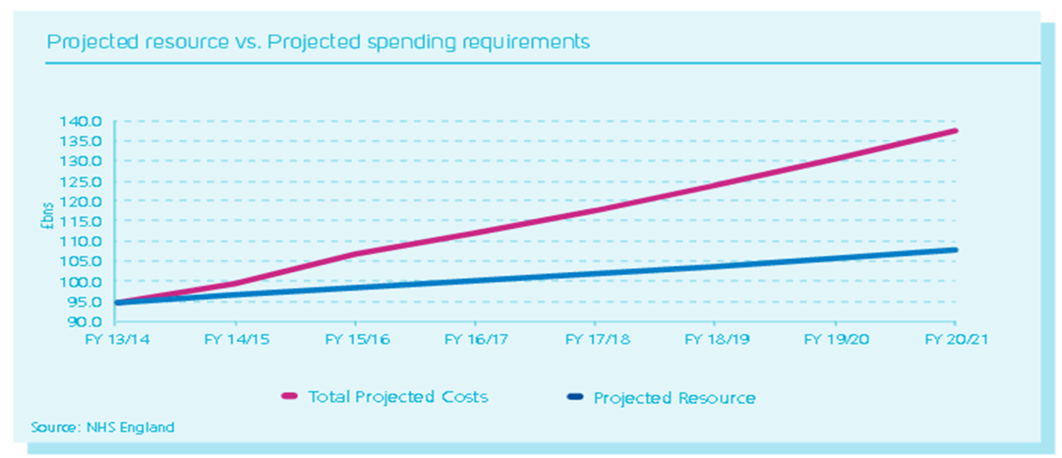

As a Calderdale system, the scale of the NHS system pressures identified in “A call to action” is significant. The Calderdale system needs to realise an approximate funding efficiency requirement of £80m between 2014/15 and 2018/19 across Calderdale CCG and providers.

The graph below shows how Calderdale CCG spent its resources in 2013/14. The CCG commissioned services to the value of £145.4m (55%) in acute settings and £11.8m (5%) in community health services.

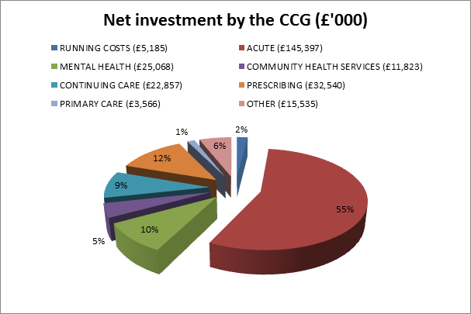

Appendix 2

Case Studies

Marie’s Story – Current


Marie is a 72 year old female with dementia lives home alone and receives home care twice daily. The care assistant from the home care service visits Thursday at 7pm and finds Marie to be more confused than is normal for her.
The care assistant rings 111 and is advised that a GP from local care will visit within the next 6 hours. GP visits and is concerned about Marie’s level of confusion and admits her to the hospital.
Marie is admitted to MAU, where she receives an abdominal x-ray, full blood screen and urinalysis. Marie is found to be constipated, prescribed an enema and laxatives.
Marie becomes increasingly confused due to change in environment and remains in hospital over 48 hours
Marie’s home care has been stopped and requires a restart which may take up to a week. Due to increase confusion and suspension of home care Marie’s discharge needs are to be reassessed which prolongs his stay in hospital.
Marie total length of stay was 10 days

Marie’s Story – Final

Marie is a 72 year old female with dementia, lives home alone and receives home care twice daily. The care assistant from the home care service visits Thursday at 7pm and finds Marie to be more confused than is normal for her.
The care assistant rings the Single Point of Access sharing her concerns. The SPA have access to the shared records and can see relevant clinical details
Based on their interpretation, the SPA moblise an appropriate member of the MDT to Marie’s home within 4 hours, where they further assess Marie’s condition. The MDT completes an assessment and urinalysis and considers Marie to be constipated (In exceptional circumstances they could have done a blood screen if thought necessary). The MDT administers an enema and prescribes laxatives. They also mobilise rapid response to provide additional support which is increased calls throughout the day and a night sitter for the following 2 nights. All the above information is uploaded onto Marie’s records in order that the GP is informed.
Further review by the MDT is carried out 24 hours later to ensure no further concerns and adds Marie’s details to the MDT patient list in order that Marie is monitored to prevent reoccurrence of severe constipation.
In Summary:
The problem has been managed by suitably trained community staff that in this example has not even needed to consult with the GP. Follow up to check on expected progress re: community Intermediate Care has been provided by the MDT and a hospital admission has been avoided

Scott’s Story – Current


Scott is 38 and lives in Hipperholme, he was diagnosed with diabetes in May 2012 after feeling very tired in the afternoons, even falling asleep at times. He is a stay at home dad to his 4 year old son.
Scott also developed thrush on his tongue. He did not have any other classic symptoms of type 1 diabetes such as excessive thirst, weight loss or passing more urine – he was just tired. His wife ordered him to see his GP where he was given some mouth drops for his oral thrush and sent on his way.
This did not clear up so he went back, this time an HbA1C blood test was arranged which came back raised and confirmed he was a diabetic, probably type 1, and may require insulin treatment. This was not a shock to Scott as both his parents had had type 2 diabetes, his mother managed with insulin and his father with oral medication - both of whom are no longer with us. Scott also had the most amazing sweet tooth and loved bread!
Scott’s GP arranged for him to attend Calderdale Royal Hospital (CRH) Diabetes Centre for assessment and likely insulin initiation. Each time Scott attended a hospital appointment, child care had to be arranged or his wife had to take time off work to look after their son.
The diabetes specialist nurse provided Scott with a glucose meter and advised him on his diet and how to adjust his insulin dose according to his blood sugar results. Some of their contacts were by phone and some in person at the CRH Diabetes Centre. Scott quickly became confident with his insulin regime. He contacted the specialist nurse when needed and attended an outpatient consultant diabetologist appointment three times in the first 6 months of diagnosis and then once or twice a year thereafter.

Scott’s Story – Future

Scott is 38 and lives in Hipperholme, he was diagnosed with diabetes in May 2012, after feeling very tired in the afternoons, even falling asleep. He is a stay at home dad to his 4 year old son.
Scott also developed thrush on his tongue. He did not have any other classic symptoms of diabetes such as excessive thirst or passing more urine – he was just tired. His wife ordered him to see his GP where he was given some mouth drops for his oral thrush and sent on his way.
This did not clear up so he went back, this time an HbA1C blood test was arranged which came back raised and confirmed he was a diabetic, probably type 1, and may require insulin treatment. This was not a shock to Scott as both his parents had had type 2 diabetes, his mother managed with insulin and his father with oral medication - both of whom are no longer with us. Scott also had the most amazing sweet tooth and loved bread!
Without delay Scott saw the specialist nurse at the GP surgery who sent him the Diabetes UK app directly to his phone and booked Scott onto the DAFNE course in a local community centre within one month. Scott joined the Diabetes Forum and was reading about diabetes for hours. The decision was made that he would follow a healthy, balanced diet - low in fat, sugar and salt and containing a high level of fresh fruit and vegetables, and he was given a glucose monitor, which very quickly became his best friend.
Scott initially recorded everything he ate on his phone app for counting nutritional info. Scott doesn’t note what he eats now unless it’s new food. He also checks his blood sugar levels before and after every meal.
Within 1 week his blood sugar levels were much improved and with the supervision of his specialist nurses he was adjusting the dose of his insulin according to what he ate, using the information he learnt on the DAFNE course.
Just over 3 months later Scott visited his GP surgery where he was seen by the visiting diabetologist from the hospital and GP specialist nurse. Further blood tests were carried out and his HbA1c had fallen to 41 mmol/ml. The consultant, nurse and Scott’s GP was delighted with Scott’s excellent results in such a short time
Scott continues to self-manage his condition and is confident with his insulin regime. Scott is a regular contributor to the patient question forum on the Diabetes UK website and has established a diabetes patient support group at his practice to support local people with diabetes.
In Summary: -
Scott never has to go to hospital to see a consultant; however he has access to the consultant closer to home. His GP is still senior coordinating clinician but most of the works is done by supportive community staff.

Megan’s story current



Megan is 14 years old and has suffered from psoriasis since she was 9 years old. She lives with her mum and three younger sisters in Todmorden and attends the local high school.

Megan has few friends due to her lack of self-confidence, this impacts on both her and her family’s lifestyles. Her behavior is unpredictable especially since becoming a teenager and her flare ups have become more frequent.

She struggles to sleep at night due to the itching and has a daily battle with her mum about attending school. When her psoriasis flares up, she doesn’t like attending school, especially participating in PE lessons and she is teased by the other children.

Her mum tells her to ignore the comments but they upset Megan and impact on her emotional well-being

Megan’s GP has referred her to Calderdale Hospital a few times over the last two years, on each occasion she has had to wait up to 12 weeks for an appointment due to turnover in staff. She sees a different person at the hospital which means she has to repeat her condition and problems on each visit. The appointments tend to be during the day which means missing school and her mum has to attend with her.

When Megan’s psoriasis flares up, her mum takes her to A&E, this involves getting her and her three sister’s ready and taking a bus to Halifax.

Megan uses ointments and steroid creams regularly and capsal coal tar shampoo (which dried her hair). Megan’s mum helps her to get rid of her psoriasis and has supported her on an exclusion diet they found on a website. This is difficult because she has to cook different meals for the family.

Megan avoids swimming/wearing shorts or short sleeved tops and doesn’t wear her hair back as the psoriasis is on her head.

Megan’s Story – Future



Megan’s mum contacts the single point of access via her GP in the evening to receive advice. The SPA assesses Megan’s needs and signpost/refer to the appropriate services.

In Megan case she is referred to the GP with Specialist Interest/Nurse for dermatology based at Todmorden Health Centre. The appointment is made out of school hours and she has a choice to attend either Todmorden Health Centre or the Children’s Centre in Todmorden.

The GP with Specialist Interest/Nurse produces a care plan as the expert in support management. An holistic assessment is provided offering advice and psychological support. This provides Megan and her mum with a plan should her condition exacerbate, rather than return to her GP or A&E. The service is accessible 7 days a week.

The development of a comprehensive care plan involves other professionals for example, healthy lifestyles, community pharmacist etc. Megan is instantly referred to the health lifestyle team to provide some support and provides Megan with an app to track various activities.

Megan is also referred to the Children and Young People’s Long Term Conditions support group which meets at the Todmorden Health Centre. Megan attends her first session at local venues and is relived to meet other people with similar problems. She becomes a regular at the support group and helps the nurse to manage some of the younger children.

Appendix 3
Outcome Measures
N.B: below provides an illustrative of the Outcome Measure Framework in development. Appendix 3 currently providers a flavor of outcomes that the commissioners are reviewing and will be be updated over the next couple of months .

Key Performance Indicators and Equality Considerations
The common higher-level contractual outcomes included in the KPI’s are:
- Patient experience and satisfaction with services
- Early detection and intervention, to support people to recover and stay well
- Supporting people to manage their condition and increasing patient involvement in decision making improved patient outcomes
- Reducing emergency admissions to hospital
- Delivery of co-ordinated and patient-centred care demonstrating joined-up working
- Effective information sharing, including use of technology

Patient Equality, Experience and Satisfaction
Outcome | Areas
Overall increase in patient experience and satisfaction by Friends and Family test and GP surveys | patients and carers reporting their care plan met their needs
 | patients dying in their preferred place of death
 | children reporting seamless transition to adult services
 | positive response rates to friends and family tests
 | patients reporting they were discharged at the appropriate time with the right support
Understanding and improving representation of local protected groups and their access, experience and outcomes. | Providers quarterly reporting on equality progress, representation, improvements and outcomes.
 | Collect equality monitoring data at the point of access to the service/s, including those who do not receive a service
 | SPA – time monitored access to interpreters, BSL and language, different communication methods in place
 | Systems to flag individual needs of patients and their carers to ensure best service first time
 | Information and advice, publicity and promotion – all to suit the diverse access needs of the community

Function 1 – Primary Prevention and Health Lifestyles
Aim: Ensure children, young people and adults, [families, communities and neighbourhoods] can access timely information to assist them their current physical and mental health status

How | Potential Indicator | Method of Measurement
Make Every Contact Count | Number of referrals to lifestyle services | Activity Report
 | Proportion of staff trained in Every Contact Counts | Activity Report
 | Long term reduction in the incidence of chronic disease | Activity Report
 | Increase in people reporting confidence to manage their own health and well-being | Activity Report

Phase 1 – look at Everyone Counts framework
Phase 2 – define the approach for the whole population

Function 2 – Early Intervention Services for People with a Long Term Condition
Aim: Provide support for individuals with long term conditions and over 75’s on a disease register so they can manage their physical and mental health and wellbeing more effectively
How | Potential Indicator | Method of Measurement
Patients diagnosed with a long term condition should receive [5 elements of good practice identified by John Taylor] | Proportion of individuals diagnosed with a long term condition/ over 75 and received all elements of good practice | Activity Report
 | Proportion of individuals with a long term condition on a disease register/ over 75 admitted as an emergency | Activity Report
 | Proportion of individuals with a long term condition on a disease register / over 75who attended A&E | Activity Report
 | Proportion of individuals diagnosed with a long term condition/ over 75 who felt able to manage their health and wellbeing more effectively | Patient Survey
 | Reduction in out-patient appointments | Activity Report

Function 3 - Multi-Disciplinary and multi and cross-agency working
Aim: Provide an integrated approach to the delivery of support and care for an individual’s physical, mental health and social care (closer to home), particularly where there are multiple diagnosis and agencies involved in the care of the indvidual
How | Potential Indicator | Method of Measurement
Multi-disciplinary/ multi agency working | Proportion of individuals with a long term condition on a disease register who have a named care worker | Activity Report  Patient Survey
 | Proportion of individuals with a long term condition on a disease register who have a car plan | Activity Report  Patient Survey
 | Proportion of individuals with a long term condition on a disease register who knew who to contact if they needed to discuss their needs | Activity Report  Patient Survey
 | How many times have you (patient with LTC) had to repeat your medical history | Patient Survey
 | Patient contacts in community based services | Activity Report
 | Number of patients with an agreed care plan | Activity Report
 | Increase of patients with home you have made follow-up contact within 2 weeks after setting a goal | Activity Report
Process – consider elements of good practice in MDT working defined for cancer pathways
Function 4 – Crisis Response and Single Point of Access
Aim: Provide an integrated service that provides rapid assessment and treatment for individuals physical and mental health needs in their own home
How | Potential Indicator | Method of Measurement
Response via SPA | Volume of calls to SPA | Activity Report
Response via SPA | Did the response following your call to SPA meet your needs | Patient Survey
Response via SPA | How many individuals still at home following assessment and intervention  - 24 hours  - 48 hours | Activity Report
 | Proportion of calls via SPA that required emergency admissions to hospital | Activity Report
 | Proportion of calls via SPA that required emergency admissions to long term residential care | Activity Report
Response via Crisis Response | Increase of utilisation of rapid response and crisis interventions | Activity Report
 | Patients still at home following assessment and intervention at:  24 hours - %  48 hours - % | Activity Report
 | Reduction in unplanned admissions to hospital | Activity Report
 | Reduction in unnecessary days in hospital | Activity Report

Function 5 – Specialist Support
AIM: ENSURE THE AVAILABILITY AND INPUT OF SPECIALIST PHYSICAL AND MENTAL HEALTH ADVICE TO SUPPORT CAE PLANNING FOR PATIENTS WITH COMPLEX OR DETERIORATING CONDITIONS
How | Potential Indicator | Method of Measurement
Provision closer to home | Volume of specialist clinical activity being undertaken in community settings | Activity Report
 | Patient experience of specialist care in community settings | Patient Survey
 | Increase training and support to primary and community practitioners | Activity Report

Function 6 – Supported Discharge
AIM: FACILITIES AND SUPPORT ARE ALWAYS AVAILABLE AND MAINTAIN INDIVIDUAL INDEPENDENCE
How | Potential Indicator | Method of Measurement
coordinated discharge plans | Proportion of patients who had their transfer of care from an acute setting delayed due to lack of facilities or support | Activity Report
 | How many individuals readmitted to hospital as an emergency admission <30 days; <91 days | Activity Report
 | Proportion of patient s who have a patient held management plan with agreed goals on arrival at home | Activity Report  Patient Survey
 | Patient experience of discharge process | Patient Survey

End

Royal College of Physicians Setting Higher Standards May 2011
ONS (2013) Population Mid-Year Estimates
ONS (2011) Census
DCLG (2010) Index of Multiple Deprivation 2010
It should be noted that a change in rank between 2007 and 2010 does not necessarily mean that there has been an absolute change in deprivation levels within that area – the indices measure deprivation relative to other areas.
ONS (2011) Census
ONS (2013) Population Mid-Year Estimates
ONS (2003, 2013) Live births and general fertility rates by local authority of usual residence of mother
DfE (2012) Early years foundation stage profile results in England (2011-12)
End Child Poverty, Poverty in Your Area (2012), available from http://www.endchildpoverty.org.uk/why-end-child-poverty/poverty-in-your-area [accessed 2.12.14]
ONS (2013) Population Mid-Year Estimates
Excluding academies
DfE (2013)
DfE (2013)
DfE (2012) Children Looked After by Local Authorities in England
DfE (2013) NEET data by local authority
PHE (2014) Local Health Profile: Calderdale
ONS (2013) Population Mid-Year Estimates
ONS (2011) Census
DWP (2014) Claimant Count (October 2014)
DCLG (2010) Index of Multiple Deprivation 2010
ONS (2014) Annual Survey of Hours and Earnings
ONS, 2012, Disability-Free Life Expectancy at birth (2009-2011)
ONS (2011) Census
ONS (2012) 2012-based Sub-National Population Projections

