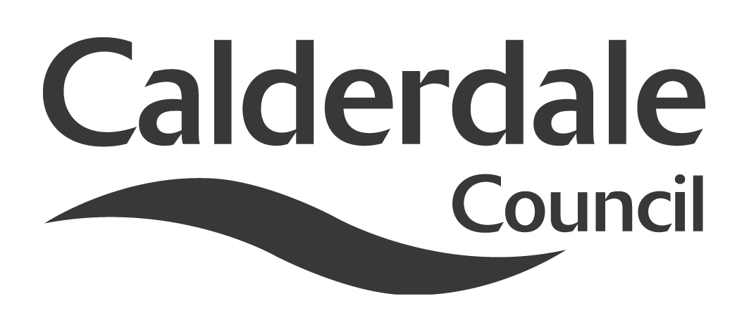

Report to Scrutiny Panel
Name of Scrutiny Panel | Adults, Health and Social Care Scrutiny Panel
Meeting Date | 27 January 2015
Subject | Better Care Fund – Section 75 Agreement
Wards Affected | All
Report of | Bev Maybury/Elaine James
Type of Item  (please tick✓ ) | Review existing policy
Type of Item  (please tick✓ ) | Development of new policy
Type of Item  (please tick✓ ) | Performance management (inc. financial)
Type of Item  (please tick✓ ) | Briefing (inc. potential areas for scrutiny)
Type of Item  (please tick✓ ) | Statutory consultation
Type of Item  (please tick✓ ) | Council request
Type of Item  (please tick✓ ) | Cabinet request | ✓
Type of Item  (please tick✓ ) | Member request for scrutiny (CCFA)

Why is it coming here?
The Better Care Fund is the key delivery mechanism through which the Calderdale Health & Well Being Board is delivering on the Care Act (2014) duty to integrate Adult Health and Social Care by April 2016. The Better Care Fund Section 75 Agreement will establish a legal architecture between the Council and Calderdale Clinical Commissioning Group (CCG) to govern our integrated commissioning for better health outcomes for people in Calderdale. The Section 75 Agreement is being proposed to act as a Framework under which the CCG will commission a range of health outcomes for children and adults.

Cabinet are due to consider the Section 75 Agreement in February 2015. The Leader of the Council has referred the Section 75 Agreement for pre-decision Scrutiny to Adults, Health & Social Care and Children & Young People’s Scrutiny Panels to seek the views of Members on the proposed Section 75 Agreement.

What are the key points?
NHS Calderdale CCG and Calderdale Council have agreed, in principle, to establish a pooled budget to commission services aimed at supporting people to remain independent and reducing demand for urgent and long term health and social care. The pooled budget will be called the Better Care Fund (BCF). From 1st April 2015 NHS Calderdale CCG and the Council will use Section 75 of the National Health Service Act (2006) to provide the legal framework for governance of integrated commissioning for health and well being outcomes for children and adults in Calderdale.

Possible courses of action
Scrutiny to note that Cabinet approval is being sought for the Council to enter into a Section 75 Agreement with NHS Calderdale Clinical Commissioning Group.

Contact Officer
Elaine James, Service Manager, Strategic Commissioning
Tele: 01422 3939167 E Mail: Elaine.James@calderdale.gov.uk

Anne Dray, Transition Programme Director, Calderdale CCG
Tele: 01422 281485 E Mail: anne.dray@calderdaleccg.nhs.uk

Should this report be exempt?
No

Report to Scrutiny Panel
- Background

To effectively commission together Calderdale Council and NHS Calderdale Clinical Commissioning Group need to have robust, fair, effective and legal mechanisms in place to make decisions about the money and responsibilities in relation to integrated commissioning budgets, including determining how much each partner contributes and how the commissioners shall share benefits and consequences of any failures.

As with any shared venture, it is critical that both parties agree the rules by which commissioning, contracting and procurement arrangement would operate and the contingency arrangements if plans did not succeed. These rules need to recognise the ongoing statutory responsibilities of each organisation and respect the mandate each has. They need to be acceptable to each organisation, and be explicit about where authority for decision making has moved from a single organisation to a joint process, with delegated authority. Section 75 of the National Health Service Act (2006) allows health commissioners, to enter into arrangements with local authorities to carry out activities with health benefits. Such arrangements are known as Section 75 Agreements and provide a legal basis from which Calderdale Council and NHS Calderdale Clinical Commissioning Group can integrate our approach towards commissioning services which will improve health and well being outcomes for children and adults in Calderdale.

The Council’s legal services are leading the work with NHS Calderdale CCG to draft the Section 75 Agreement. The working draft is appended to this report.

What a section 75 Agreement should Include:

- Aims and Objectives
- These will be taken from the documents both partners have already produced setting out our shared vision, ambition and plans to improve health and well being outcomes for children and adults in Calderdale which includes the Calderdale Health & Well Being Plan; NHS Calderdale CCG 5 Year Strategy; and the Calderdale Better Care Plan.

- Scope of the Pooled Budget (in terms of Commissioning Expenditure themes)
- This will be taken from the agreements both partners have already made, but details will need revising where necessary to support the delivery of our commissioning plans.
- This section will need to cover responsibilities and cross reference to ‘C below on budget values and details of spend areas, with current services being a useful aid to understanding, but NOT the primary definition.
- There will need to be a clear statement from both partners which will determine eligibility for funding, and user contributions, recognising the need to preserve the distinction between health and social care interventions for purposes of eligibility.

- Budgets – for 15/16 initially
- A schedule of budgets backed by brief explanations of purpose (as the Council and the CCG have already prepared for in year shadow financial monitoring)
- Explanation of budget reductions and other savings that need to be made, and how it is proposed to achieve (risk management of non delivery to be covered in section G)
- Principles underpinning budget setting, e.g. that the contributions are a sub-set of the Council or the CCG’s overall budgets, contingency provisions within the budget and organisational contingency provisions outside of budget
- Description of how budgets will be set in future years

- How strategic direction has been set and will be set in future
- The agreement should describe the role of the Health and Wellbeing Board, and the ways in which Health & Well Being Board partners in Calderdale and the public can influence strategic direction.
- The role of respective individual decision making within the Council and the CCG with reference to each scheme of delegated authority and standing orders.
- Length of the agreement and how and when it will be reviewed and if necessary refreshed by the Health & Well Being Board.

- How operational decisions will be made
- It sets out which organisation will hold the budget on behalf of both (or who holds which part of the budget if both parties hold part each).
- The detail of the role of the Better Care Programme Board and Better Care Operational Commissioning Group which have been constituted between the Council and the CCG as decision making bodies which have been establish to run any budgets pooled under the Section 75 Agreement and how they will interact with existing mechanisms within each organisation.
- It also sets out how we will comply with our statutory and locally given obligations about how we make decisions, including transparency and public involvement.
- It makes clear how decisions that are outside of the authority are delegated to the above bodies will be made
- It makes clear how we will resolve differences if we don’t achieve consensus, recognising the risks of a potential failure to be able to agree on decisions.
- It makes clear how cases for change will be developed and tested - this covers the nature of business cases for change, and how both parties shall engage users, staff, councillors and clinicians in developing proposals in a reasonable time.

- Operational Budget Management
- It sets out financial reporting arrangements e.g. monthly monitoring reports to the Executive Programme Board.
- It sets out policies and procedures to be used in each organisation – including reference to Standing Financial Instructions and audit arrangements – both internal and external audit.
- Statutory Accounts requirements – to allow compliance with each organisation’s annual accounting timetable and legal requirements.

- Benefit and risk share arrangements
- It sets out how any under spends or overspends in the budget will be treated
- It sets out where statutory responsibility ultimately lies, if there is legal action, insurance or indemnity implications on either or both parties
- It sets out maintenance of a joint Risk Register which forms part of the Health & Well Being Board Better Care Plan

- Approach to procurement and contracting
- It sets out that both parties shall comply with procurement requirements of the organisation which acts as the lead (host) commissioner for better care schemes
- It sets out that the contract form for better care schemes shall be determined by which ever partner acts as lead (host) commissioner
- It sets out who will manage contracts on behalf of both organisations

- Performance & Quality performance monitoring
- It sets out an integrated performance framework, including the key performance indicators that will enable the Council and the CCG to demonstrate success against the Better Care Plan Metrics of: Avoidable Admissions to hospital; Avoidable Admission to Care Homes; Effectiveness of Reablement Services; Delayed Transfer of Care from hospital; and Quality of People’s Experience of Services.
- It sets out how safeguarding and clinical quality issues will be monitored and addressed.

- Information Governance
- It sets out information sharing governance details which are necessary to support integrated commissioning.

- How we expect staff to work together
- It sets out our approach to organisational development to make this happen.

Implications for Both Organisations

The establishment of a Section 75 Agreement with real risk sharing requires joint decision making processes which changes current authorities, as some decisions currently reserved for members and officers of a single organisation become matters for joint decision making. There is therefore some loss of direct control of the budgets and responsibilities within the pooled budget implicit and inevitable in establishing a shared venture with shared risk. On the other hand each organisation acquires a share of responsibility for matters over which it might have previously had influence but no control.

The establishment of integrated commissioning also involves the adoption of different working practices and a requirement to follow two sets of regulations in some instances for example, in how we procure and contract for services.

Insofar as these changes represent risks, the loss of direct control is mitigated by the influence gained over a wider area of responsibility and changes in working practices should see the adoption of best practice and therefore represent an improvement.

Decisions Required in Advance of Signing a Formal Agreement

In the course of planning for 2015/16 and future years there will be a number of decisions that will need to be made before we are likely to have developed and agreed a formal agreement. These include:

- Approval of financial plans and business plans
- Approval of agreed changes to investment and or service delivery in 2015/16
- Approval of any procurements or other contractual changes for services within the scope of the planned pooled budget

In addition to the above commissioning decisions, the Council shall also need to determine short and long term arrangements for the delivery of our plans, building on the programme management arrangements we have put in place through the Better Care Programme Board.

- Main issues for Scrutiny

Scrutiny to note that Cabinet approval is being sought for the Council to enter into a Section 75 Agreement with NHS Calderdale Clinical Commissioning Group which will provide the legal framework for governance of integrated commissioning for health and well being outcomes for children and adults in Calderdale.

- Consultation

The following organisations have been consulted on for our better care plans through our Health & Wellbeing Board: Calderdale Healthwatch; the Calderdale Voluntary Sector Local Infrastructure Organisation (North Bank Forum); the Calderdale Housing & Registered Social Landlords Forum (Together Housing Group).

- Further action and timescales

The Section 75 Agreement is subject to approval by Calderdale Council’s Cabinet and NHS Calderdale CCG’s Governing Body during February 2015. It is anticipated that it shall be presented for final approval to the Health & Well Being Board in March 2015.

- Conclusions

The Section 75 Agreement provides an important vehicle for delivery of the Health & Well Being Board and Calderdale Council’s Cabinet strategic plans for 2014/15 and beyond. Good progress is being made in a number of areas; including governance, communications and risk; towards implementing integrated commissioning for improved health and social care outcomes for local people through the BCF.

- Appendices

The Better Care Fund Section 75 Agreement is appended as Appendix 1.

- Documents available for inspection at:

For further information on this report please contact:
- Elaine James, Service Manager (Strategic Commissioning)
- Telephone: 01422 393917
- E mail: Elaine.James@calderdale.gov.uk

The documents used in the preparation of this report are available for inspection at:
Adults, Health and Social Care
1 Park Road
Halifax
HX1 2TU

