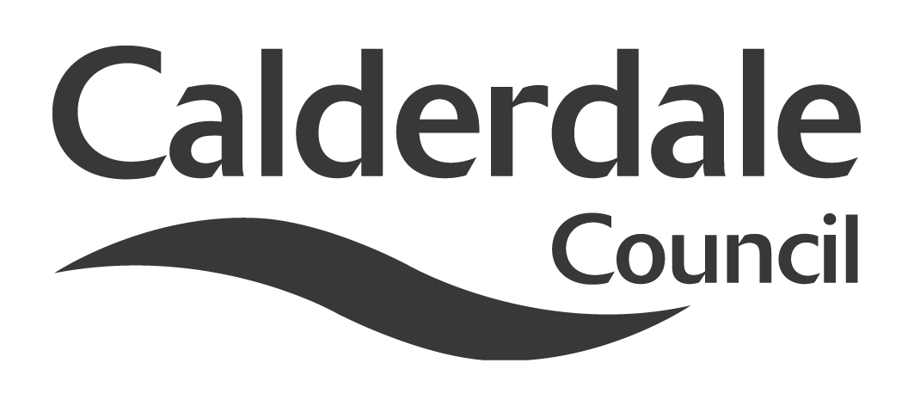
5

Report to Adults Health and Social Care Scrutiny Panel
Meeting Date | 27 January, 2015
Subject | General Fund Revenue Budget 2015/16 to 2017/18- Proposals for Consultation
Wards Affected | All
Report of | Head of Democratic and Partnership Services
Type of Item  (please tick✓ ) | Review existing policy
Type of Item  (please tick✓ ) | Development of new policy | ✓
Type of Item  (please tick✓ ) | Performance management (inc. financial)
Type of Item  (please tick✓ ) | Briefing (inc. potential areas for scrutiny)
Type of Item  (please tick✓ ) | Statutory consultation
Type of Item  (please tick✓ ) | Council request
Type of Item  (please tick✓ ) | Cabinet request
Type of Item  (please tick✓ ) | Member request for scrutiny (CCFA)

Why is it coming here?
Cabinet considered the 2015/16 - 2017/18 budget when it met on 12 January 2015 and adopted some budget proposals for consultation. As well as consulting the general public, Cabinet are required to consult Scrutiny Panels on changes to the policy and budget framework. Any comments or recommendations by the Scrutiny Panel will be considered by Cabinet on 9 February 2015. Copies of the Council budget proposals have been circulated to all Members. The detailed proposals for each service and equality impact assessments are available on the Council’s internet pages and those relevant to this Panel are included as Appendix 1 and Appendix 2.

What are the key points?
The budget proposals are set in the context of the continued significant pressures on local authority budgets, and taking into account budget decisions already taken in previous years which have yet to be fully implemented.

Possible courses of action
The Scrutiny Panel may choose to make recommendations to Cabinet concerning the draft proposals on the Revenue Budget 2015/16 to 2017/18

Contact Officer
Mike Lodge
Senior Scrutiny Support Officer
mike.lodge@calderdale.gov.uk
01422 393249

Should this report be exempt?
No

Report to Scrutiny Panel
- Main issues for Scrutiny

1.1 This report is an opportunity for Scrutiny Panels to comment on Cabinet’s budget proposals. Scrutiny Panels may consider budget proposals under Article 6.3 of the Constitution, which states that Scrutiny Panels may “assist the Council and the Cabinet in the development of its budget and policy framework by in-depth analysis of policy issues”

1.2 The Cabinet will consider the views of Scrutiny Panels and others on 9 February 2015.

1.3 Scrutiny Panels may wish to consider the budget proposals within the context of issues they have examined during the year, previous recommendations they may have made to Cabinet or Council, and emerging issues and new challenges.

1.4 Issues may also have arisen in budget monitoring reports considered by Scrutiny Panels during the year.

1.5 This is not the only opportunity that Members will have to comment on budget proposals. As well as discussions within political groups, the budget will be decided by full Council on 23 February 2015. Discussions at Scrutiny Panels can focus on those areas that are of particular concerns to the Panel. There are other opportunities in the budget process for members to pursue ward issues or political aspirations.

1.6 Scrutiny Panel meetings are held in public, so they are an opportunity for the public to contribute to budget discussions.

1.7 A detailed summary of the discussion at Scrutiny Panel will be prepared and reported to Cabinet. The summary will also be sent to the Leader of the Council
as soon as it has been prepared to give him the maximum opportunity to consider the views of the Scrutiny Panel.

1.8 The Improvement and Development Agency (IDeA) sets out the following scrutiny checklist in their local leadership academy – scrutiny of finance member workbook

- Do the proposed spending plans fit with the council’s overall aims, objectives and priorities?
- Is it clear how outcomes/outputs will be measured?
- What opportunities are there to generate income for the council (e.g. from fees, charges etc)?
- Have targets been established? Are these targets acceptable and how will they be monitored by members?
- Has the budget been reviewed thoroughly by members or “rolled over” from the previous year, i.e. more or less the same commitments with some allowance for inflation of costs?

1.9 When Use of Resources Scrutiny Panel considered the long term financial future of the Council on 24 October 2012 they adopted a report that included:

Immediate resource and finance issues and addressing the long term are part and parcel of the same thing. If we do not start to address the longer term issues now, then the problem will be exacerbated. So the budget process we are about to begin should bring about a balanced budget for 2013/14 and subsequent years. But the decisions we take next February should contribute to the longer term challenges as well. In recent years, Scrutiny Panels have undertaken a “line by line” examination of Cabinet budget proposals. Whilst this has produced some useful discussion, Scrutiny Panels should consider the overall strategic thrust of the budget proposal and their impact on the longer term issues.

Scrutiny Panels may wish to question Cabinet Members and senior officers about the longer term implications of the Cabinet budget proposals, as well as the more immediate impact.

- Appendices

Appendix 1 – Cabinet Budget Proposals for Consultation 2015/16 to 2017/18

Appendix 2 – Budget Savings Options 2015-18: Budget Equality Impact Assessment

- Documents available for inspection at:

Town Hall, Halifax, HX1 1UJ

