Calderdale M B C
13

Wards affected: All

Cabinet

17th November 2014

Review of Neighbourhood Working in Calderdale

Report of the Director for Communities

- Issue

1.1 Calderdale is a collection of towns and villages, each with their own unique character and identity. Therefore, it is important that how we deliver our services as a local authority respects and responds to the character and challenges of these areas, giving local people a voice and integrating seamlessly with other service providers to deliver results on the ground for communities.

1.2 Neighbourhood Services play a crucial role in responding to local issues, supporting the delivery of Council-wide outcomes and responding to specific challenges within the borough. It is proposed that neighbourhood services are further redesigned in order to improve service delivery, and to ensure financial sustainability into the future. This will involve working in, and with, local communities using a ‘hub and spoke’ approach.

- Need for a decision

2.1 The model for delivering neighbourhood working in Calderdale is a matter of considerable interest and importance to local people and our partners. Presenting this report to Cabinet ensures that changes are open and transparent, and that partners and stakeholders are aware of the Council’s intentions.

- Recommendation

3.1 It is recommended that Cabinet:

- endorse the principles and approach set out in this report to create two integrated, area-based teams and a district-wide hub in order to provide more cost-effective neighbourhood-based services for local communities;

- agree that the indicative structure within the report, together with the geographical areas to be covered by each of the two teams, should be discussed with staff and stakeholders, including the Communities Scrutiny Panel;

- agree that the Director for Communities should then implement the new structure, using the Council’s policies and procedures to ensure no staff are involuntarily displaced.

- Background

4.1 Local people often think of themselves as living in a town or village, rather than in ‘Calderdale’, and they also expect “the Council” rather than a particular service to deal with the issues they experience.

4.2 We now need to reflect this reality in the way the Council engages with local communities and delivers neighbourhood services across the Borough.

4.3 There is an opportunity to bring together three services within the Communities Directorate (Neighbourhoods) using the following principles:

- Integrating services to provide a more seamless customer experience and more effective delivery
- Streamlining management and improving efficiency
- Retaining a core, essential capacity across the whole Borough
- Minimising the impact on front line staff and, in particular, maintaining our capacity to keep the Borough clean and green.

4.4 It is proposed to bring together Community Safety, Neighbourhood Management and Safer, Cleaner, Greener into two fully integrated teams, each servicing a number of natural communities based around the towns and villages of Calderdale.

4.5 The teams will work closely with local people and voluntary organisations to support community initiatives and will provide a tailored service to meet the different needs of different communities.

4.6 A third team will provide Borough-wide services that cannot be delivered through the local teams – either because it does not make financial sense (economies of scale) or the functions are strategic (e.g. CCTV and Emergency Planning).

4.7 The suggested new approach is based on a Hub and Spoke concept, where the ‘Hubs’ are the 6 main towns – Halifax, Brighouse, Sowerby Bridge, Elland, Todmorden and Hebden Bridge – and the ‘Spokes’ are the natural communities surrounding them (villages and neighbourhoods).

4.8 The two teams will need to each have an area focus based around a number of these ‘hubs’ and ‘spokes’. However, there are a number of ways of designating these areas, for example using Parliamentary constituencies or existing operational areas used by the Council or other agencies; therefore it is suggested that the boundaries for each team should be determined following consultation with staff, stakeholders and the Communities Scrutiny Panel.

4.9 The diagram below illustrates the general concept of the ‘hub and spoke’ approach – showing some of the ‘spokes’ around the ‘hubs’ of Brighouse and Halifax:

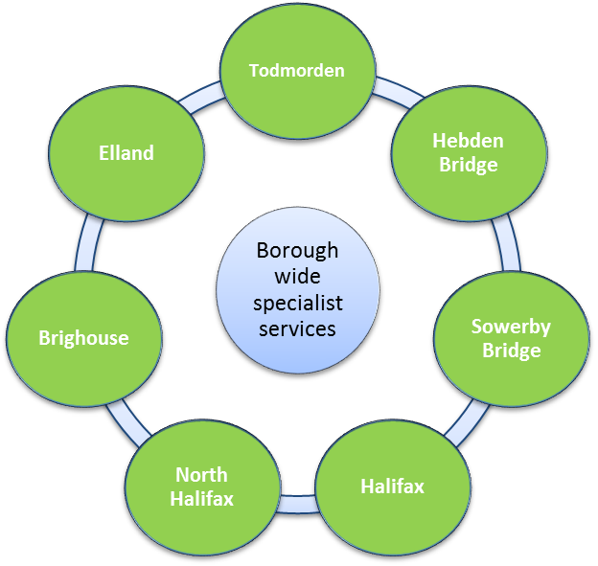
Towns

2 neighbourhood teams based in market towns and natural communities around Halifax but working through outreach in a range of community managed or partner buildings in neighbourhoods
Rastrick
Hove Edge
etc
Lightcliffe
Park
etc
Siddal
Boothtown
Neighbourhoods and villages
Bradshaw
Shelf
Ovenden
etc

Current and proposed structures

5.1 Currently the three service areas are configured as follows:

Safer, Cleaner, Greener Service
Neighbourhood
Management
Community Safety
and Resilience

Countryside Service & Forestry Team
Technical Support (including Play Areas)
4 Area Teams - grounds maintenance and street cleaning
Community Cohesion & Equality
4 Area Teams * (Ward Forums / engagement etc.)
Emergency Planning and Resilience
Anti Social Behaviour Team
CCTV & Town Centre Wardens

Staying Well Project / Neighbourhood Schemes **
* In Halifax North and East the service is delivered by North Halifax Partnership through a grant.
** This work is funded through the CCG and AH&SC but managed by Communities

5.2 The proposed structure will see the creation of three integrated teams as follows:

Neighbourhood Team 1
(clean & green, Ward forums, community support etc)

Neighbourhood Team 2
(clean & green, Ward forums, community support etc)

Borough-wide Hub – safety, resilience, cohesion etc

Staying Well project / AHSC funded staff

5.3 Expanded indicative structures for each of the three teams are attached at Appendix 1.

Options considered

6.1 There is an option to do nothing; however, this will mean an opportunity to improve service delivery in local communities is missed, and the service will have to continue to deal with structural overspends on an ‘ad hoc’ basis, rather than addressing the underlying causes.

6.2 The second option is to proceed with the approach outlined in this report. The benefits of this are:

The best use of scarce resources to deliver core neighbourhood functions through a joined up and integrated service provided across all the towns and villages of Calderdale, whilst reflecting the individual character and needs of each locality
  - Protection of front line street cleaning, parks and grounds maintenance services

  - Delivery of a financially sustainable Neighbourhoods Service, whilst offering the flexibility to add other services to the model in future

  - Ensuring each Ward is serviced by a dedicated and integrated team - with named contacts for local Councillors and residents - which would link closely with the new Police operating model

  - Allowing the current community engagement infrastructure of Ward Forums to continue, and build upon the established multi-agency Safer, Cleaner, Greener meetings as a way to address complex local issues.

6.3 There are other options, which will be explored through discussion with staff and stakeholders.

Consultation

7.1 This report is asking for Cabinet’s approval to progress a new structure, and this will involve engagement of staff and stakeholders in the process. As there are no anticipated job losses, there is no need for statutory consultation but the involvement and cooperation of staff will be central to the success of the new service delivery model.

7.2 The timeline for the process is envisaged as follows:
- 17th November 2014 : Cabinet - authority to progress new delivery model through Future Workforce Programme
- November 2014 - January 2015 consultation with staff and Communities Scrutiny Panel
- April 2015 : Implementation of new structure.

Financial implications

8.1 Delivery of the model set out in this report will ensure that neighbourhood services are able to be delivered within available resources, and can continue to meet the needs of local communities throughout the Borough.

Equality and Diversity

9.1 An initial Equality Impact Assessment is underway and will be used within the consultation process.

Contribution to delivering population outcomes

10.1 The Neighbourhoods Service contributes to a number of outcomes, including keeping communities safe, improving the environment and providing opportunities for civic and community engagement.

Corporate implications

11.1 These are services which are highly visible in local communities and give local people a sense of place. As such, they are pivotal in forming people’s judgements on the Council’s efficiency, effectiveness and, ultimately, its credibility and reputation.

Conclusion

12.1 There is an opportunity to reinvigorate the Council’s delivery of important local services by bringing them closer to local communities, using a ‘hub and spoke’ approach. This can be done in a way that provides a more seamless service to local people, that is also more efficient, and which retains a front line presence in local neighbourhoods.

For further information on this report contact:

Andrew Pitts, Head of Neighbourhoods
Tel 01422 392600
Andrew.pitts@calderdale.gov.uk

Documents used in preparation of this report:

Service files

Documents are available for inspection at:

Westgate House, Halifax

Area 1 Manager
Table below includes staff from North Halifax Partnership
Senior Neighbourhood Manager
Area 2 Manager
Senior Neighbourhood Manager
Neighbourhood Support Senior Officers x 4
Ward Officers x 2
Community Wardens x 4
Admin Assistant
Apprentice

Front line Supervisors x 4
Rangers x 2
Front line operatives x 46
Apprentice x 2

Countryside Officers x 2
Admin Assistant
Forestry Manager
Forestry Inspection Officer
Forestry Team Operatives 3 .8

Neighbourhood Support Senior Officers x 5
Neighbourhood Officers x 2
Community Worker x 2
Community Wardens x 3

Countryside Officers x2
Work Team x 2
Apprentice
Admin Assistant
Nursery Manager
Staying Well Manager
Staying Well Officers
Staying Well Admin

Emergency Planning
2 Officers
.5 Public Health
ASB
2 Officers
1 Police Staff
Countryside
Conservation Officer
Education & Promotion Officer

Business Hub
11 Officers

Service Development Officer Lettings Assistant
Systems Information Officer Policy Officer .6
Senior Technical Officer Technical Officer
Admin Asst x .4 Support Officer
Volunteer Co-ordinator .8 Town Twinning Office
Equalities Officer .6r .5

Cohesion Team
1 Officer
2 Police Officers
Play Officer
Play Operative
Front line Supervisors x 3
Front line operatives x 46
Apprentice x 2

Neighbourhood Schemes Co-ordinator
Neighbourhood Schemes Officers

District Hub Manager
Neighbourhood Support Senior Officer
Neighbourhood Support Senior Officer
Countryside Manager
CCTV
CCTV Manager
2 Halifax Town Centre Wardens
Workshop
Foreman
Apprentice

