Section 75 Partnership Framework Agreement – Schedule 7
Individual Scheme Specification

BCF Scheme Reference | S7PO3
Scheme name | IT Systems Development to implement the Care Act
Lead Commissioner (CMBC/CCG) | Calderdale MBC
Fund Manager (Senior Responsible Officer) | Stacey Leonard
Commencement of particular service | Ongoing
£ Value in 2015/16 | £200,000
Contract or in house | In House
Provider | Partnership working with:  - Calderdale and Huddersfield Foundation Trust  - Calderdale Clinical Commissioning Group  - South West Yorkshire Partnership Foundation Trust
Contract term | N/A

1.0 Introduction
Outline of scheme ( what is it we are actually doing?)
Development of the Calderdale MBC IT systems (primarily the Client Information system CIS) to meet the requirements of the Care Act.
The Care Act (2014) received Royal Assent in 2014. From April 2015 adult social care (ASC) will have a new legal framework putting the wellbeing of individuals at the heart of care and support services. The Act replaces more than a dozen pieces of legislation with a single modern law. The Care Act sets out key proposals for reforming the way in which adult social care is funded. As a result much of the discussion and analysis of the Act has been in relation to the proposed Care Cap, which limits the lifetime costs an individual has to pay for their care, and the accompanying infrastructure required to manage the cap. Work is underway led by the Council’s Business Change and Performance Management team to finalise local modeling of the potential financial impact of the proposed changes in Calderdale. The Care Act shall also impact upon the duties and functions provided by the Council’s Adults, Health & Social Care Directorate in conjunction with other Council Services including Housing and Income Services. Processes and practices will need to be reviewed to ensure that they are not only compliant with the new legislation but will enable us to deliver the changes required.
The AHSC Care Act (2014) Readiness Programme Board provides the architecture for oversight and governance of implementation of the new duties resulting from the Care Act. The Programme is subject to a detailed, clause by clause impact and risk assessment. The Programme Board has agreed a detailed Implementation Programme which is supported by an Operational Implementation Working Group and a series of Task & Finish Groups on specific areas of change.

Timelines for Implementation of the Care Act (2014)
The majority of the new legislation will come into effect in April 2015. The requirements related to the capped charging and extended means test will come into effect a year later in April 2016.

TABLE 10 – CARE ACT – IMPLEMENTATION PROGRAMME

Key Requirements & Calderdale Implementation Programme Impact Assessment & Progress Rating | Time scale
Duties on information and advice (including advice on paying for care | April 2015
Duties on prevention and wellbeing | April 2015
Duty on market shaping & provider failure | April 2015
National minimum threshold for eligibility | April 2015
Assessments (including carers assessments) | April 2015
Personal budgets and care and support plans | April 2015
Safeguarding | April 2015
New charging framework | April 2015
Universal Deferred Payment Agreements | April 2015
Extended means test | April 2016
Capped charging system | April 2016
Care Accounts | April 2016

Also describe the:
- Evidence base
New Duties under the care Act are described in full in the following documentation.
https://www.gov.uk/government/uploads/system/uploads/attachment_data/file/315993/Care-Act-Guidance.pdf
- Aims and Outcomes of the scheme
Development of CIS to cover the new duties under the Care Act:
- Care Cap and care Accounts
- Deferred Payments
- Additional Safeguarding duties
- Carers Assessment and support
- New assessment process
- Implementation of National Eligibility Criteria.

- Population/service users to whom the scheme will relate
People using social care services now and in the future, including carers and self-funders.
- Council or CCG functions which are the subject of the scheme including where appropriate the delegation of such functions for the commissioning of the relevant service
- Any plans or agreed actions to change the services
- Other schemes with interdependencies
This scheme has interdependencies with the following BCF Schemes:
- S1PO1, S1PO2, S3PO4.
- Duration and exit strategy
- Information sharing and communication

2.0 Governance (show which committee scheme is reported to/insert standard diagram of relevant CCCG/CMBC oversight committee)
Governance reporting for this scheme is made to the Calderdale BCF Operational Commissioning Group and escalated as necessary.

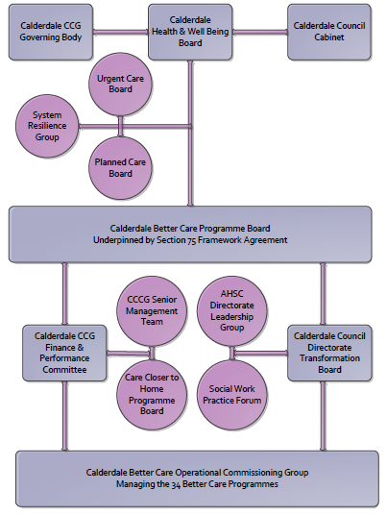

3. Finance
- Contributions to the fund are from CCCG or CMBC?
- 15/16 funding £200,000

4.0 Impact of scheme
Assurance and monitoring arrangements (common wording across all schemes? Or at least for CCCG and CMBC schemes?)
- Performance (KPIs – BCF and other local?)
- Monitoring of progress to be measured against the development project plan.
- High level measures:
  - Percentage of development complete and live
  - Percentage of modules on plan and forecast to meet go live target
- Baseline figures
- Reference: BCPM CIS Development plan
- Target activity (monthly/quarterly/annual)
- Phasing of change

