Section 75 Partnership Framework Agreement – Schedule 7
Individual Scheme Specification

BCF Scheme Reference | S7PO2
Scheme name | IT Records Correlation and Synchronisation
Lead Commissioner (CMBC/CCG) | Calderdale MBC
Fund Manager (Senior Responsible Officer) | Stacey Leonard
Commencement of particular service | Ongoing
£ Value in 2015/16 | £0
Contract or in house | In House
Provider | Partnership working with:  - Calderdale and Huddersfield Foundation Trust  - Calderdale Clinical Commissioning Group  - South West Yorkshire Partnership Foundation Trust
Contract term | N/A

1.0 Introduction
Outline of scheme (what is it we are actually doing?)
No funding for this scheme in 2015/16 as part of the S75 agreement, therefore not applicable.
Also describe the:
- Evidence base
- Aims and Outcomes of the scheme
- Population/service users to whom the scheme will relate
- Council or CCG functions which are the subject of the scheme including where appropriate the delegation of such functions for the commissioning of the relevant service
- Any plans or agreed actions to change the services
- Other schemes with interdependencies
- Duration and exit strategy
- Information sharing and communication

2.0 Governance (show which committee scheme is reported to/insert standard diagram of relevant CCCG/CMBC oversight committee)
Despite no funding allocated to this scheme, Governance reporting will be made to the Calderdale BCF Operational Commissioning Group and escalated as necessary.

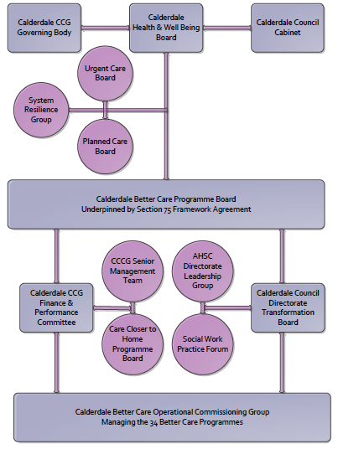

3. Finance
- Contributions to the fund are from CCCG or CMBC?
- 15/16 funding £0
- Recurrent /non recurrent
- Full year effect if part year in 15/16 £0
- Arrangements for managing over and underspends (xref to main framework but may have different arrangements for different schemes?)
- Financial governance arrangements, audit (may be standard for CCCG or CMBC)
- VAT

4.0 Impact of scheme
Assurance and monitoring arrangements (common wording across all schemes? Or at least for CCCG and CMBC schemes?)
- Performance (KPIs – BCF and other local?)
- Baseline figures
- Target activity (monthly/quarterly/annual)
- Phasing of change

5.0 Overarching framework agreement
Sections xxxxxxxx of the overarching Framework Partnership Agreement relating to the Commissioning of Health and Social care Services are applicable to this scheme unless specifically overwritten by the sections above.

