Section 75 Partnership Framework Agreement – Schedule 7
Individual Scheme Specification

BCF Scheme Reference | S7PO1
Scheme name | NHS Number – Coordination and project management
Lead Commissioner (CMBC/CCG) | Calderdale MBC
Fund Manager (Senior Responsible Officer) | Stacey Leonard
Commencement of particular service | Ongoing
£ Value in 2015/16 | £65,810
Contract or in house | In House
Provider | Partnership working with:  - Calderdale and Huddersfield Foundation Trust  - Calderdale Clinical Commissioning Group  - South West Yorkshire Partnership Foundation Trust
Contract term | N/A

1.0 Introduction
Outline of scheme ( what is it we are actually doing?)
Funding for the post of Commissioning Manager responsible for co-ordination of the implementation of the use of the NHS Number as the unique identifier for all common clients, BCF scheme monitoring and performance analysis to determine impact of the BCF Programme.
Funding for Management Information support.
Also describe the:
- Evidence base
The Better Care Fund National Condition around the NHS Number states:
Better data sharing between health and social care, based on the NHS number
The safe, secure sharing of data in the best interests of people who use care and support is essential to the provision of safe, seamless care. The use of the NHS number as a primary identifier is an important element of this, as is progress towards systems and processes that allow the safe and timely sharing of information. It is also vital that the right cultures, behaviours and leadership are demonstrated locally, fostering a culture of secure, lawful and appropriate sharing of data to support better care.
Local areas should:
• confirm that they are using the NHS Number as the primary identifier for health and care services, and if they are not, when they plan to;
• confirm that they are pursuing open APIs (i.e. systems that speak to each other); and
• ensure they have the appropriate Information Governance controls in place for information sharing in line with Caldicott 2, and if not, when they plan for it to be in place.
NHS England has already produced guidance that relates to both of these areas. (It is recognised that progress on this issue will require the resolution of some Information Governance issues by DH).

- Aims and Outcomes of the scheme
Use of the NHS Number:
- All active users on Calderdale MBC CIS/CASS systems have a current valid NHS Number
- Processes are in place to populate the NHS Number in the Calderdale MBC CIS/CASS systems via a batch process on a monthly basis, via the NHS MACS service
- Calderdale MBC achieves governance accreditation is achieved (NHS IG Toolkit) by April 2015 to facilitate a real time solution to the NHS capture and population within its CIS/CASS systems
BCF Scheme monitoring
- Establishment of a robust monitoring and escalation programme for each of the BCF schemes across the Local Authority and the CCG.
- Evaluate the impact of the BCF schemes on the wider Calderdale population.

- Population/service users to whom the scheme will relate
- Current active users and future users of Calderdale MBC CIS/CASS systems
- Users of the BCF schemes

- Council or CCG functions which are the subject of the scheme including where appropriate the delegation of such functions for the commissioning of the relevant service
- Any plans or agreed actions to change the services
- Other schemes with interdependencies
- Duration and exit strategy
- Information sharing and communication

2.0 Governance (show which committee scheme is reported to/insert standard diagram of relevant CCCG/CMBC oversight committee)
Governance reporting for this scheme is made to the Calderdale BCF Operational Commissioning Group and escalated as necessary.

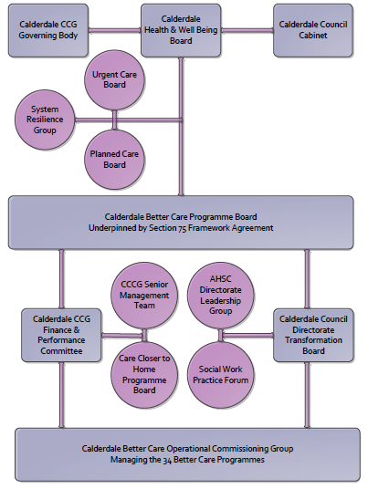

3. Finance
- Contributions to the fund are from CCCG or CMBC?
- 15/16 funding £65,810
- Full year effect if part year in 15/16 £65,810

4.0 Impact of scheme
Assurance and monitoring arrangements (common wording across all schemes? Or at least for CCCG and CMBC schemes?)
- Performance (KPIs – BCF and other local?)
- Baseline figures
- Target activity (monthly/quarterly/annual)
- Phasing of change

