Section 75 Partnership Framework Agreement – Schedule 6

Individual Scheme Specification

BCF Scheme Reference | S6PO5
Scheme name | Assistive Technology - Telehealth and Telecare
Lead Commissioner (CMBC/CCG) | NHS Calderdale Clinical Commissioning Group
Fund Manager (Senior Responsible Officer) | Rhona Radley
Commencement of particular service | 1st April 2013
£ Value in 2015/16 | £500,000
Contract or in house | Single Award Contract
Provider | Tunstall Healthcare Ltd
Contract term | Pilot termination date – 31st March 2016

1.0 Introduction

Outline of scheme

There are 3 strands to this project: Telecare and Telehealth in Quest for Quality care homes; and ‘COPD at Home’ (‘Telehealth 24’). The project was initiated due to the impact that the ageing population and the increasing number of people with long term conditions is likely to have on health and social care services. Data showed high rates of A&E attendances from residents of care homes, typically for urinary tract infections, respiratory infections, falls and fractures.
Telehealthcare is being used as an enabler to providing integrated, anticipatory and sustainable health and care services.

COPD at Home (‘Telehealth 24’)

Up to 24 people with COPD (within their own home) can be provided with a Tunstall ‘mymedic’ telemonitoring system. The Specialist Respiratory Nurses refer patients for it once they have assessed that the patient would be suitable to be monitored on it. The mymedic takes vital signs readings of the patient (Monday – Friday) which the Specialist Respiratory Nurses are able view remotely. The nurses can therefore monitor the readings and any changes can be noticed at an earlier stage, enabling earlier intervention. The nurses review the patient’s suitability for the mymedic every 6 weeks. The aims of the COPD at Home are to:

• Improve self-management
• Enable early intervention
• Prevent avoidable GP call-outs; and avoidable hospital admissions/ attendances
• Improve medication compliance
• Prevent future complications for those who haven’t yet started to access extensive healthcare
• Support the Respiratory Specialist nurses’ caseload

Telehealth and Telecare in the Quest for Quality Care Homes:
There are 24 Calderdale care homes participating in the ‘Quest for Quality in Care Homes’ project. As part of the project, Telecare and Telehealth is provided within these care homes.
Reasons for project initiating:

- Variation in practice across care homes
- High rates of A&E attendances and hospital admissions from care homes
- High rates of falls/ Urinary Tract Infections, Fractured Neck of Femurs etc
- To standardise practice; up-skill staff

Telecare – wireless sensors are placed around the care home to detect risks earlier (eg door sensors, Wireless Nursecall buzzer systems, enuresis sensors etc). The activation of these sensors alerts care home staff, enabling earlier intervention. Care home staff put in the referrals for sensors that they think would benefit residents.

Telehealth – 50 multi-user myclinic2 telemonitoring systems installed across the Quest care homes to monitor the vital signs of residents on a daily basis. The Quest Matrons risk stratify the residents to put onto the monitoring system and care home staff are encouraged to support the vital signs readings of the residents. The Quest Matrons monitor the readings remotely, enabling changes to be identified, and intervention to happen sooner.

The use of Telecare and Telehealth within the Quest care homes acts as an enabler to the following overall aims of the Quest project:

- Reduce unplanned demand on GPs
- Improve self-management, independence, confidence and dignity
- Improve quality of care
- Reduce avoidable attendances, admissions and readmissions to hospital
- Improve medicines optimisation through regular reviews, modifications and clinical interventions both in and out of hours
- Improve end of life care
- Enable early intervention
- Improve medication compliance
- Support the care home staff

2.0 Governance (show which committee scheme is reported to/insert standard diagram of relevant CCCG/CMBC oversight committee)

This Scheme is performance managed by the CCG’s QIPP Monitoring Group which reports into the CCG’s Finance and Performance Committee. Members of the CCG’s QIPP Monitoring Group are also members of the BCF Operational Commissioning Group and BCG Programme Board where actions to mitigate the likelihood and impact of risks to delivery of BCF objectives and outcomes are overseen and schemes are performance managed.

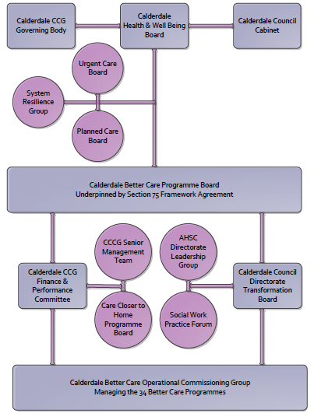

3. Finance
- Contributions to the fund are from CCCG
- 15/16 funding £500k
- Full year effect if part year in 15/16 – N/A

4.0 Impact of scheme
- Performance (KPIs – BCF and other local?)
- Baseline figures
- Target activity (monthly/quarterly/annual)
- Phasing of change

Headline BCF Metric for this scheme
- Reduction in non-elective (NEL) (general + acute only)

Supplementary Operational Metrics are:

Numbers of installations of Telehealth 24 – COPD at home

Numbers of individuals in receipt of telecare equipment

Numbers of individuals in receipt of telehealth equipment

b) Baseline activity

Telehealth 24 – COPD at Home - 53 installs up until 31.10.14. Case studies are submitted to CCG which demonstrate the quality/ benefits impact on patients.

Telecare in care homes – 756 pieces of equipment deployed across the Quest care homes to date

Telehealth in care homes – reporting still in development as telehealth in care homes was deployed when the MDT was mobilised.

c) Target activity (monthly/quarterly/annual)

Increase in the numbers of individuals receiving Telehealth 24, COPD at home, Telecare in Care Homes and Telehealth in Care homes

d) Phasing of change

The scheme is fully up and running and in place for the whole of 2015/16

