Section 75 Partnership Framework Agreement – Schedule 6

Individual Scheme Specification

BCF Scheme Reference | S6PO4
Scheme name | Quest for Quality in Care Homes – MDT
Lead Commissioner (CMBC/CCG) | NHS Calderdale Clinical Commissioning Group
Fund Manager (Senior Responsible Officer) | Rhona Radley
Commencement of particular service | 1st March 2014
£ Value in 2015/16 | £694,000
Contract or in house | Single Award Contract
Provider | Calderdale and Huddersfield NHS Foundation Trust
Contract term | Pilot 1st March 2014 to 30th April 2016

- Introduction

Outline of scheme

The Quest for Quality in Care Homes project is across 24 Calderdale care homes and is an investment in an integrated social and clinical approach to support anticipatory care planning. The main aim of this service is to provide and support the delivery of standardised, high quality, evidence-based, and safe patient-centred care for residents in the care homes involved in this project.

NHS Calderdale CCG has commissioned CHFT to provide an integrated professional and clinical Multi-Disciplinary Team (MDT). The MDT supports GPs and care home staff – advising care home staff on prevention and proactive management of residents to ensure the needs of residents are met and that care standards are applied consistently across all care homes. The MDT model includes dedicated Community Matrons; Consultant Geriatrician; pharmacy; clinical psychologist; palliative care representative and links to other areas such as tissue viability. The MDT works with the key stakeholders including; care homes, the local authority and primary care staff to ensure that residents are proactively managed within the care home setting, working to reduce avoidable unplanned intervention. The team also works with secondary care staff to support the appropriate early discharge of care home residents who have had a hospital admission.

The aims of the Quest project are to:
- Reduce variation in practice across care homes
- To standardise practice; up-skill staff
- Reduce unplanned demand on GPs
- Improve self-management, independence, confidence and dignity
- Improve quality of care
- Reduce avoidable attendances, admissions and readmissions to hospital
- Improve medicines optimisation through regular reviews, modifications and clinical interventions both in and out of hours
- Improve end of life care
- Enable early intervention
- Support the care home staff
- Governance (show which committee scheme is reported to/insert standard diagram of relevant CCCG/CMBC oversight committee)

This Scheme is performance managed by the CCG’s QIPP Monitoring Group which reports into the CCG’s Finance and Performance Committee. Members of the CCG’s QIPP Monitoring Group are also members of the BCF Operational Commissioning Group and BCG Programme Board where actions to mitigate the likelihood and impact of risks to delivery of BCF objectives and outcomes are overseen and schemes are performance managed.

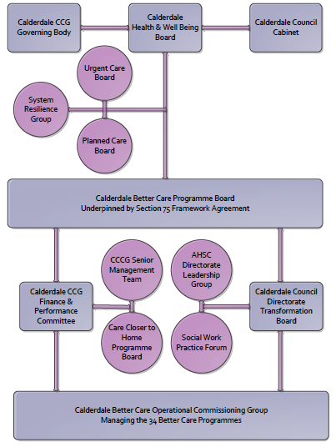

3. Finance

- Contributions to the fund are from CCCG
- 15/16 funding £694,000
- Full year effect if part year in 15/16 – N/A

4.0 Impact of scheme

- Performance (KPIs – BCF and other local?)
- Baseline figures
- Target activity (monthly/quarterly/annual)
- Phasing of change

A population segmentation and impact exercise was carried out following the NHSE tool supplied in the 'How to Guides'. It should be noted that each scheme within BCF will not in isolation provide the impact on the headline metric detailed here. It is the combination of these schemes, the Qipp Programme and the interdependencies across the services which will provide the whole improvement. Each of the schemes that form part of the BCF plan for Calderdale has a number of additional measures that will be routinely collected to evaluate the impact of the scheme on the Calderdale population.

Headline BCF Metric for this scheme
- Reduction in non-elective (NEL) (general + acute only)

Supplementary Operational Metrics are:

Referrals to the Quest for Quality Service

b) Baseline figures

Quest for Quality Referrals and Caseload

- 1195 referrals to the Quest for Quality service

 | Phase 1 only |  |  | Phase 1 and Phase 2 implementation
Referral Age Band | Apr-14 | May-14 | Jun-14 | Jul-14 | Aug-14 | Sep-14 | Oct-14 | Total | Percentage
Under 60 | 0 | 0 | 1 | 0 | 5 | 7 | 13 | 26 | 2%
60 to 69 | 0 | 5 | 4 | 9 | 9 | 8 | 15 | 50 | 4%
70 to 79 | 0 | 12 | 16 | 30 | 33 | 44 | 29 | 164 | 14%
80 to 89 | 0 | 45 | 67 | 106 | 83 | 99 | 101 | 501 | 42%
90 to 99 | 1 | 59 | 60 | 68 | 88 | 81 | 66 | 423 | 35%
Over 99 | 0 | 2 | 4 | 2 | 10 | 7 | 6 | 31 | 3%
Total | 1 | 123 | 152 | 215 | 228 | 246 | 230 | 1195 | 100%

Hospital Admissions
- 90 admissions to hospital from Quest for Quality Care Homes during October 2014. This is 26% lower than in October 2013 (121 admissions).
- Between April and October 2014, there have been a total of 612 admissions to hospital, which is 25% lower than the same period in 2013 (813).
- 60 admissions to hospital have been reported as avoided by the Quest for Quality service to present.

NB A full report and dashboard is received by the CCG as part of the Quest Contract group monthly meeting. The above information is a snapshot from these reports. The reports also include case studies showing the quality impact on the residents. The CCG is currently in the process of quality assuring finances against the data.

c) Target activity (monthly/quarterly/annual)

increase in numbers of avoided admissions over the 14/15 baseline

Increase in number of people referred per month by age group

d)Phasing of change

The scheme is fully up and running and in place for the whole of 2015/16

