Section 75 Partnership Framework Agreement – Schedule 6
Individual Scheme Specification

BCF Scheme Reference | S6PO3
Scheme name | Hospice
Lead Commissioner (CMBC/CCG) | Calderdale Clinical Commissioning Group
Fund Manager (Senior Responsible Officer) | Rhona Radley
Commencement of particular service | 1st April 2015
£ Value in 2015/16 | £460,000
Contract or in house | Single Award Contract
Provider | Overgate Hospice
Contract term | Grants terms are on an annual basis . Date term: 1 April 2014 to 31st March 2015

- Introduction
Calderdale CCG commission a Palliative and End of Life Care service from Overgate Hospice. The level of funding equates to 17% of the total hospice budget. In 2014-15 the CCG have increased their level of funding to reflect similar with the national average of 30% funding.
Overgate Hospice is a Charity providing specialist palliative care for the people of Calderdale with a life limiting illness. It is the only adult Hospice in Calderdale and has been operating services from the current building for nearly 33 years.
Overgate is an independent and local charity with a mission to ensure patients and those close to them live with the best possible quality of life. This is provided with the highest standard of compassionate and evidence-based specialist palliative and end of life care for adults in Calderdale who have active, progressive, life-limiting conditions.
The care is centred on the patient. They respect individuality and their rights to privacy and dignity and care for the whole person – their physical, emotional, spiritual, social needs and goals. This includes support for their families and carers through the illness and into bereavement.
They care for people with the advanced stages of all life-limiting conditions, including cancer, heart failure, lung disease, kidney disease and neurological diseases.
The key areas the core grant funding supports in relation to the above are:
- Specialist palliative care
- In-patient unit – acute beds
- In-patient unit – respite beds
- Day hospice
- Carers’ support group
- Pre-bereavement counselling
- 24/7 specialist palliative care advice service
The CCG have been working with Overgate Hospice to align the 5-year Strategy with the Overgate Hospice 5-year plan. The biggest change recognised for Overgate that they will develop further over the next five years is the work they do outside the main hospice building based in Elland. The hospice does not provide care in isolation. They are looking at how they can link with Doctors and Nurses in the local hospital and the community, with other clinical professionals and social care providers to name just a few, to ensure patients, their families and carers receive the best and most appropriate care to meet their needs.
Overgate recognise the need to share their expertise, knowledge and skills so more people can benefit from hospice type care in the community.
How much they can deliver is dependent on the level of funding received, however, they recognise they still have a role in influencing, training and educating local health and social care professionals to ensure local services improve to meet the growing demand.
The objective is for the Hospice to be open and outward looking towards the potential of new partnerships and collaborations that may strengthen what they can deliver and/or improve local end of life care services within the community.
The objectives for this work are to seek and explore ways in which the hospice can reach more people in Calderdale.
They will:
- Review local health needs to gain a greater understanding of local demographics.
- Extend the role of Day Hospice so they can support more patients with living with life limiting illnesses, for example respiratory, heart and neurological conditions in addition to cancer.
- Explore how they can develop specialist palliative care services to better meet the needs of dementia patients, their families and carers.
- Develop a hospice at home service.
- Explore the provision of a more comprehensive 7 day a week service at the hospice and within the community (to include out of hours admissions).
- Strengthen the provision of services available within the Patient and Family Support Team.
- Increase their role in Carer Support.
- Explore whether there is a need to provide satellite hospice services and how this could be achieved.
- Ensure they have objective information about their activity to improve service delivery and demonstrate they meet regulatory, professional bodies and commissioning requirements.

- Governance (show which committee scheme is reported to/insert standard diagram of relevant CCCG/CMBC oversight committee)

This Scheme is performance managed by the CCG’s QIPP Monitoring Group which reports into the CCG’s Finance and Performance Committee. Members of the CCG’s QIPP Monitoring Group are also members of the BCF Operational Commissioning Group and BCG Programme Board where actions to mitigate the likelihood and impact of risks to delivery of BCF objectives and outcomes are overseen and schemes are performance managed.

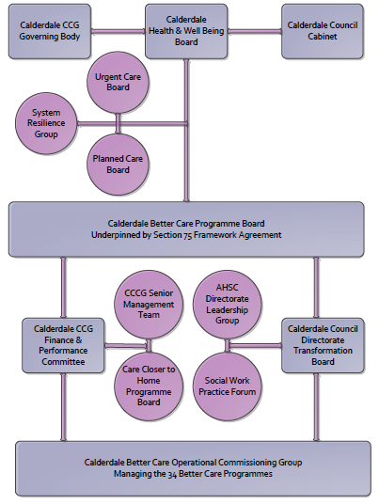
3. Finance
a) Contributions to the fund are from CCCG
b) 15/16 funding £460k
c) Full year effect if part year in 15/16 - N/A
4.0 Impact of scheme
a) Performance (KPIs – BCF and other local?)
b) Baseline figures
c) Target activity (monthly/quarterly/annual)
A population segmentation and impact exercise was carried out following the NHSE tool supplied in the 'How to Guides'. It should be noted that each scheme within BCF will not in isolation provide the impact on the headline metric detailed here. It is the combination of these schemes, the Qipp Programme and the interdependencies across the services which will provide the whole improvement. Each of the schemes that form part of the BCF plan for Calderdale has a number of additional measures that will be routinely collected to evaluate the impact of the scheme on the Calderdale population.
d) Phasing of change
Headline BCF Metric for this scheme
- Reduction in non-elective (NEL) (general + acute only)

Supplementary Operational Metrics are:
Increase in day hospital provision and the numbers of people supported by the service measured by the number of day hospice attendances per month

b) Baseline figures

Day Hospice Attendances 2012/13 and 2013/14
Apr | May | June | July | Aug | Sept | Oct | Nov | Dec | Jan | Feb | March
157 | 166 | 186 | 185 | 170 | 157 | 196 | 164 | 87 | 136 | 151 | 133
155 | 149 | 162 | 195 | 190 | 199 | 191 | 193 | 173 | 235 | 219 | 243

Monthly IPU admissions over the last two years
Activity from the Patient and Family Support Team is not yet captured on Systm one but will be later this year.
c) Target activity (monthly/quarterly/annual)
Increase in monthly IPU admissions compared to 2013/14 admissions
Increase in monthly Day Hospice attendances over the baseline of 2013/14 day hospice attendances
d) Phasing of change
The scheme is up and running and in place for the whole of 2015/16 but will be further developed during the year

