Section 75 Partnership Framework Agreement – Schedule 6

Individual Scheme Specification

BCF Scheme Reference | S6PO2
Scheme name | Palliative Out of Hours Service (End of Life)
Lead Commissioner (CMBC/CCG) | NHS Calderdale Clinical Commissioning Group
Fund Manager (Senior Responsible Officer) | Rhona Radley
Commencement of particular service | 1st March 2014 – 31st May 2016 (pilot)
£ Value in 2015/16 | £206,000
Contract or in house | Single Award Contract
Provider | Calderdale and Huddersfield NHS Foundation Trust
Contract term | 1st March 2014 – 31st May 2016 (pilot)

- Introduction

The service is provided by CHFT, Marie Curie and Overgate Hospice (the lead provider being CHFT) and consists of an End of Life Care Facilitator, and an Out of Hours Community Nursing Service.

The primary aim of the service is to safely and effectively care for people approaching end of life in their own home by improving the identification and coordination of care for patients approaching end of life, maximising the potential for patients to be cared for and die in their preferred place of choice. There are links to the long-term conditions and the Quest for Quality in Care Homes pathways in Calderdale.

The primary aim of the service is to reduce A&E attendances and admissions and safely and effectively care for people approaching the end of life in their own home, and improving the identification and coordination of care for patients approaching the end of life.

The service provides:
- Home nursing care
- Emotional support for patients and carers/ family;
- Advice
- Identification of people approaching the end of life and initiating discussions about preferences for end of life care
- Care planning: assessing needs and preferences, agreeing a care plan to reflect these and reviewing these regularly, delivering the plan during the day and out of hours and across all care settings
- Coordination of care: Liaising with GP’s, Care Homes and Community Teams to support existing services locally through MDT arrangements and monitoring of the End of Life Care register
- Health-led management of the last days of life
- Care after death
- Support for carers, both during a person’s illness and after their death

End of Life Care Facilitator:

The role of the facilitator is:

- to embed end of life tools, champion key quality standards across the pathway and coordinate training and education to meet local needs.
- improve the identification of people approaching the end of life, and the coordination of their care, as well as ensure that high standards are championed locally, professionals will be supported and education provided along with access to end of life care tools.
- To co-ordinate between existing in-hour services and the newly commissioned out of hours community nursing service.

Out of Hours Community Nursing Service:
- This is a dedicated nursing team which provides planned and crisis visits out of hours, as well as telephone support to patients and carers, and generalist palliative care advice and support to other professionals such as care home staff.

- Governance (show which committee scheme is reported to/insert standard diagram of relevant CCCG/CMBC oversight committee)

This Scheme is performance managed by the CCG’s QIPP Monitoring Group which reports into the CCG’s Finance and Performance Committee. Members of the CCG’s QIPP Monitoring Group are also members of the BCF Operational Commissioning Group and BCG Programme Board where actions to mitigate the likelihood and impact of risks to delivery of BCF objectives and outcomes are overseen and schemes are performance managed.

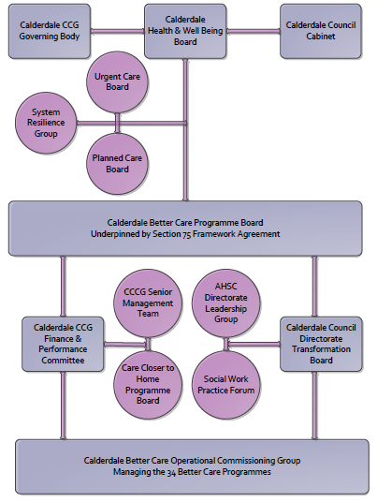

3. Finance
- Contributions to the fund are from CCCG
- 15/16 funding £206,000
- Funding is from 1st March 2014 – 31st May 2016 (pilot)
- Full year effect if part year in 15/16 - N/A

- Impact of scheme

a) Performance (KPIs – BCF and other local?)
b) Baseline figures
c) Target activity (monthly/quarterly/annual)
d) Phasing of change
A population segmentation and impact exercise was carried out following the NHSE tool supplied in the 'How to Guides'. It should be noted that each scheme within BCF will not in isolation provide the impact on the headline metric detailed here. It is the combination of these schemes, the Qipp Programme and the interdependencies across the services which will provide the whole improvement. Each of the schemes that form part of the BCF plan for Calderdale has a number of additional measures that will be routinely collected to evaluate the impact of the scheme on the Calderdale population.

Headline BCF Metric for this scheme
- Reduction in non-elective (NEL) (general + acute only)

Supplementary Operational Metrics are:

The primary aim of the service is to reduce A&E attendances and admissions and safely and effectively care for people approaching the end of life in their own home, and improve the identification and coordination of care for patients approaching the end of life.

Supporting indicators:

An increase in the number of people who are cared for in their preferred place of care
An increase in the number of people who die in their preferred place of death

b) Baseline figures

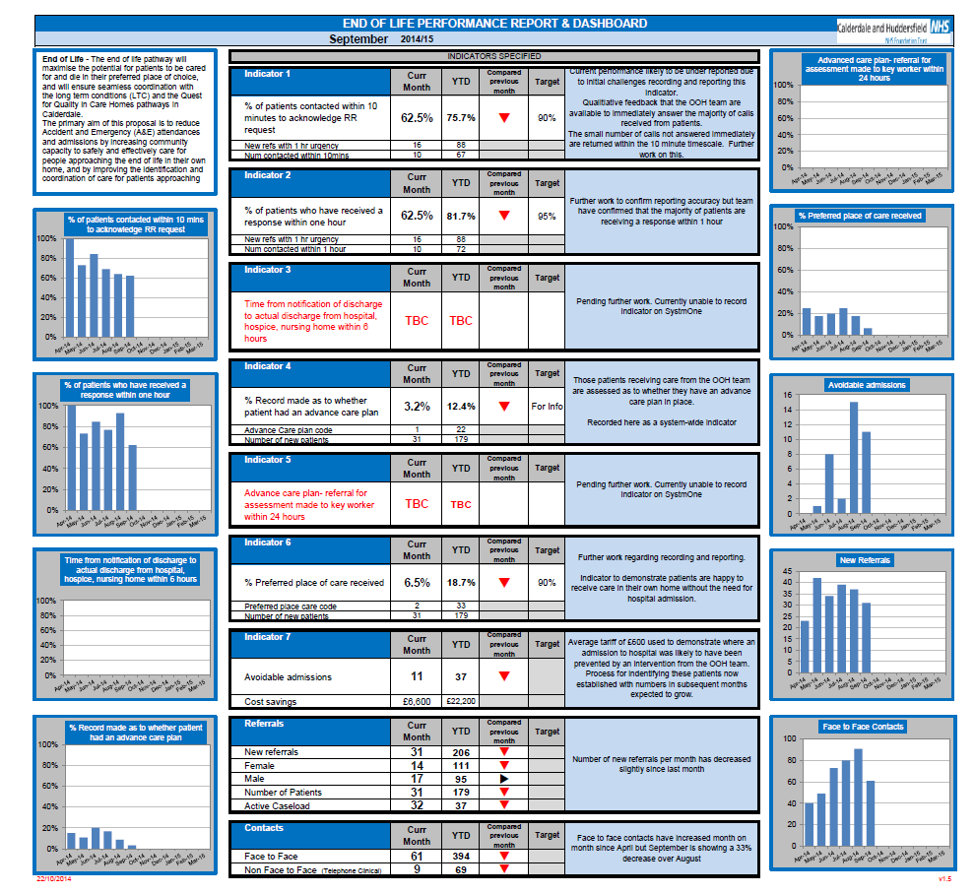

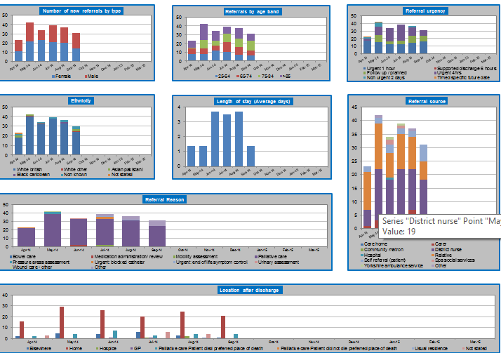

c) Target activity (monthly/quarterly/annual)

Reduction in avoidable admissions
An increase in the number of people who are cared for in their preferred place of care
An increase in the number of people who die in their preferred place of death

- Phasing of change

The scheme is fully up and running and in place for the whole of 2015/16

