Section 75 Partnership Framework Agreement – Schedule 6
Individual Scheme Specification
BCF Scheme Reference | S6PO1
Scheme name | End of Life Social Work
Lead Commissioner (CMBC/CCG) | Calderdale MBC
Fund Manager (Senior Responsible Officer) | Rob Mitchell
Commencement of particular service | Ongoing
£ Value in 2015/16 | £140,000
Contract or in house | In-House
Provider | Calderdale MBC
Contract term | Ongoing

1.0 Introduction
Outline of scheme (what is it we are actually doing?)
The End of Life Social Work Team to act as Allocated Lead Professional, coordinating the assessment and support through social work led, rather than clinically led, interventions for people who were within the last year of life. The team of five social workers are professionally accountable and work in a number of different settings to ensure that people are supported to make decisions around how they wished to die with dignity within a model that was truly positive in terms of risk-taking and upholds the fundamental rights of individuals to remain in control of how they ended their lives wherever possible in order to make choices and decisions that are right for them.
The team has challenge conventional ways of working through a remit to be innovative and develop new approaches which would will provide for a greater emphasis for adult social work shifting from a mind-set that sees eligible unmet needs as requiring paid support towards one that looked for solutions in people’s own resources and those of their family, an approach which would be more empowering for people who may feel that control is ebbing away as the end of their life.
The team have access to a budget of £30K which is held by the Carers Project as a small grant pot for use by the Team. The small grants enable the team to undertake creative support planning without needing to go through formal community care assessments.
One of the significant challenges that the team has faced is with regards to how a team of social workers is able to deliver the service without being clinicians. The team have dealt with this challenge head on and through an approach to integration, based on joint working, co-location, shared respect for professional viewpoints they have been able to gain the full respect of leading clinicians involved in palliative care. The team have created their own charter for how they work with people, defining their role clearly and ensuring that they work in genuine partnership with others. They have found that their role has evolved and are now heavily relied on by other health and social care professionals to take a lead role in ensuring that people’s rights are promoted and maintained wherever possible. This way of working in partnership has not only provided the End of Life Social Work Team with professional credibility with health partners in particular but it has also gone some considerable way to change the emphasis of palliative care across health and social care. The approach of the team has ensured that social care outcomes underpinned by the unwavering belief in the social model of ill health alongside and complimenting that of the medical model, has changed the way that professionals work together and how they provide support for people. Crucially, their approach to joint working has ensured that the person remains at the centre of decision making up until the end of their lives.
Below are two examples which are typical of the approach that the End of Life Social Work Team has developed towards their casework:
Mrs. A’s story...
Mrs. A. had cancer of the throat and Chronic Obstructive Pulmonary Disease (COPD). She needed long term support after a period of reablement following her discharge from hospital. A support plan for her and her family, during the final stages of her life, was set up. As Mrs. A’s daughter wanted to carry out most of the care just 2 calls per day were provided. The care provider was identified fairly quickly and there was a seamless transfer from the Reablement Team. A sitting service was also put in place to give the daughter some respite during the week – this was organised by the district nurses from Marie Curie. As well as the practical help, emotional help and support were provided to both Mrs. A and to her daughter. Mrs. A passed away, but in a peaceful, dignified, comfortable and pain free manner with her family around her. Her wish to die at home was made possible as a result of the very close and effective working of all the staff involved, coordinated by the social worker in the team.

Mrs B’s Story...
Mrs B was diagnosed with Lung Cancer in March 2014. Mrs B was a single mother with four children, the youngest being 18 months. Initially the referral came through from the hospital’s Palliative Clinical Nurse Specialist due to family dynamics and Mrs B struggling to accept her diagnosis. Mrs B’s daughter of 19 expressed her wish to become her sibling’s guardian and eventually apply through courts for a special guardianship order.
Mrs B begun having chemotherapy treatment but had several hospital admissions and hospice admissions due to side effects of the treatment. The End of Life Social Work Team worked closely with the palliative care nurses, district nurses during each hospital admission/discharge and also followed up when at home in the community.

2.0 Governance (show which committee scheme is reported to/insert standard diagram of relevant CCCG/CMBC oversight committee)
End of Life Social Work is managed through the CMBC Directorate Leadership Group (see below). The Planned Care Board also keeps an active watching brief on this area of work through the Closer to Home programme approach towards Advanced Care Planning.
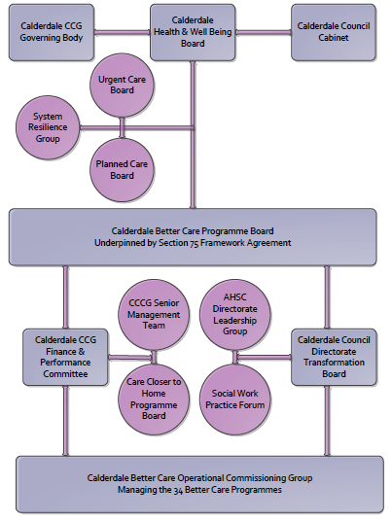
3. Finance
- Contributions to the BCF fund are from CCCG or CMBC? CCCG
- 15/16 funding - £140,000
- Full year effect if part year in 15/16 – N/A

4.0 Impact of scheme
Assurance and monitoring arrangements (common wording across all schemes? Or at least for CCCG and CMBC schemes?)
- Performance (KPIs – BCF and other local?)
- Baseline figures
- Target activity (monthly/quarterly/annual)
- Phasing of change
A population segmentation and impact exercise was carried out following the NHSE tool supplied in the 'How to Guides'. It should be noted that each scheme within BCF will not in isolation provide the impact on the headline metric detailed here. It is the combination of these schemes, the Qipp Programme and the interdependencies across the services which will provide the whole improvement. Each of the schemes that form part of the BCF plan for Calderdale has a number of additional measures that will be routinely collected to evaluate the impact of the scheme on the Calderdale population.
Headline BCF Metric for this scheme
- Reduction in non-elective (NEL) (general + acute only)

Supplementary Operational Metrics are:
- ASCOF 1ci Proportion of people using social care who receive self directed support
- ASCOF 1cii Proportion of people using social care who receive Direct Payments
- JWS2c Proportion of people who use services who have control over their daily life in Calderdale (ASCOF 1b)
- JWS3 Number of older people receiving formal community care assessments - provisional
- ASCOF 2ai Permanent admissions to residential care home, per 100,000 of the population (18-64)
- ASCOF 2aii Permanent admissions to residential care homes, per 100,000 of the population (65+)
- CA 1.4d The percentage of safeguarding alerts received that are dealt with in accordance with timescale requirements
- CA 1.4e The percentage of safeguarding referrals which are decisioned within timescales
- CA 1.4f The percentage of safeguareding referrals where the investigation is completed within 7 weeks of the referral decision being made

Baseline Performance:
In 2013/14, 298 cases were allocated to the End Of Life Social Work Team. The average length of support they provide someone with until end of life is 80 days. This compares to 174 cases in 2012/13, with an average length of support till end of life of 81 days. The success of the team in terms of establishing its unique role within the medically led model which is End of Life Care in Calderdale is evidenced in the 71% increase in referrals which the team has experienced during the last 12 months. The number of community care assessments completed has also increased by 86%from 128 in the first year (2012/13) to 238 during 2013/14. Demand continues to grow, and in the first quarter of 2014/15 the team has already completed 75 community care assessments.
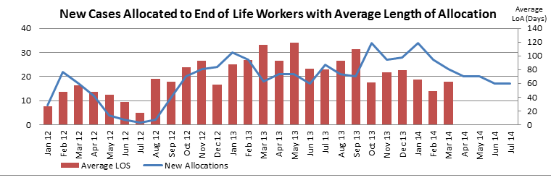
The impact of the team’s work is reflected in the results of the Annual Service User Survey 2013/14
- 92.4% of respondents said that care and support services brokered by the End of Life Social Work Team resulted in them having a better quality of life.
- 88.6% said that they had more control as a result of the support provided
- 82.3% said they felt more safe as a result of support

