Section 75 Partnership Framework Agreement – Schedule 5

Individual Scheme Specification

BCF Scheme Reference | S5PO4
Scheme name | Early Supported Discharge for Stroke
Lead Commissioner (CMBC/CCG) | Calderdale Clinical Commissioning Group
Fund Manager (Senior Responsible Officer) | Rhona Radley
Commencement of particular service | Needs date
£ Value in 2015/16 | £215,000
Contract or in house | Contract - Single Award Contract
Provider | Calderdale and Huddersfield NHS Foundation Trust
Contract term | Recurrent

- Introduction

Outline of scheme

The Early Supported Discharge (ESD) for Stroke service provides early supported intensive multi-disciplinary rehabilitation for patients returning home from hospital following a Stroke. It is recognised nationally as a key component to providing a high-quality stroke service.
The service aims to help patients to leave hospital more quickly and return to their own homes so to maximise independence as quickly as possible after their stroke. The service is for mild to moderate stroke patients (Barthel Score 10-17/20) and the team have the capacity to take a maximum of 12 patients at any one time.
The ESD staff in-reach onto the stroke wards (principally the Stroke Rehab Unit) to greet patients identified as meeting the criteria for Stroke ESD prior to discharge. This process is reliant on ward staff identifying which patients meet the criteria and referring them to the ESD team. These patients receive a minimum of 45 minutes of therapy daily of each therapy that is appropriate to patient need and tolerance.

The decision as to whether a patient meets the criteria for ESD and is appropriate to be discharged to the service is a multidisciplinary team decision. From August 2014 this process has been supported by a member of ESD staff visiting the CRH stroke unit 2 -3 times per week to liaise with the stroke unit staff. This process provides the opportunity for increased interaction and dialogue with ward staff with the aim of increasing the number of patients discharged to the service to 40% and above.

- Governance (show which committee scheme is reported to/insert standard diagram of relevant CCCG/CMBC oversight committee)

This Scheme is performance managed by the CCG’s QIPP Monitoring Group which reports into the CCG’s Finance and Performance Committee. Members of the CCG’s QIPP Monitoring Group are also members of the BCF Operational Commissioning Group and BCG Programme Board where actions to mitigate the likelihood and impact of risks to delivery of BCF objectives and outcomes are overseen and schemes are performance managed.

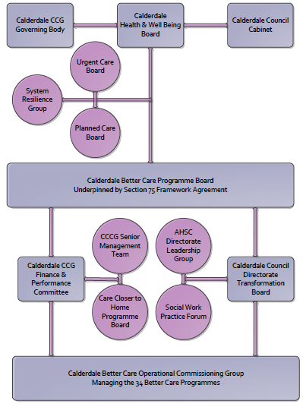

3. Finance
- Contributions to the fund are from CCCG or CMBC? CCCG
- 15/16 funding £215,000
- Full year effect if part year in 15/16 - N/A

4.0 Impact of scheme
Assurance and monitoring arrangements (common wording across all schemes? Or at least for CCCG and CMBC schemes?)

A population segmentation and impact exercise was carried out following the NHSE tool supplied in the 'How to Guides'. It should be noted that each scheme within BCF will not in isolation provide the impact on the headline metric detailed here. It is the combination of these schemes, the Qipp Programme and the interdependencies across the services which will provide the whole improvement. Each of the schemes that form part of the BCF plan for Calderdale has a number of additional measures that will be routinely collected to evaluate the impact of the scheme on the Calderdale population.

Headline BCF Metric for this scheme
Reduction in delayed transfers of care
Supplementary Operational Metrics are:

a) KPI Targets
Key BCF Indicator - Still at home 91 days after discharge (this scheme will contribute towards this target)

Supporting indicators:

The service has a discharge target of 40%.

In addition to the 40% discharge target, the provider has set an internal target of at least 90 Calderdale patients being discharged from CRH to Calderdale ESD in 2014/2015.

- Baseline figures

Performance/ outcome reporting (dashboard) for ESD for Stroke is currently in development.

- Target activity (monthly/quarterly/annual)

Summary of performance during 2014

The service has a discharge target of 40%. Performance/ outcome reporting (dashboard) for ESD for Stroke is currently in development.

In addition to the 40% discharge target, the provider has set an internal target of at least 90 Calderdale patients being discharged from CRH to Calderdale ESD in 2014/2015.

- Phasing of change

The scheme is fully up and running and in place for the whole of 2015/16.

