Section 75 Partnership Framework Agreement – Schedule 5
Individual Scheme Specification

BCF Scheme Reference | S5PO3
Scheme name | Complex Discharge Coordination
Lead Commissioner (CMBC/CCG) | Calderdale Clinical Commissioning Group
Fund Manager (Senior Responsible Officer) | Sarah Antemes
Commencement of particular service | 1st April 2015
£ Value in 2015/16 | £285,000
Contract or in house | In house
Provider | CCCG and CMBC
Contract term | 3 years

- Introduction
Delays in the assessment and eligibility process for Continuing Heath Care (CHC) and social care funding are leading to delays in discharge and unnecessary lengths of stay in hospital. These delays are leading to ‘bed blocking’ and causing pressure in the hospitals. Correct assessment processes are essential for correct identification of levels and types of funding and subsequent commissioning of appropriate levels of care/placements. Getting this process wrong has significant financial implications for the patient and their family and also for commissioners.
Attempts to improve processes by training nursing staff on hospital wards about the legalities of the National Framework for NHS Continuing Care and their responsibilities have not been successful in bringing about change. This is due in part to the high level of understanding about CHC that is required in order to carry out these processes successfully and also the high numbers of ward staff involved and the constant turnover of staff. Urgent care has been identified as a significant issue for Calderdale CCG.
In response to winter pressures and originally upported by urgent care monies, a pilot was started for a complex discharge team (CCG CHC nurses and social workers) to support the discharge process using an integrated approach.
Objectives
This process provides a clear pathway for assessments of eligibility, eliminates the need for unnecessary assessments, speeds up the discharge process and provides clarity for patients and families thereby avoiding unnecessary frustration and confusion, this in return will reduce the number of appeals for funding.

This proposal has already been tried with success as a pilot from 01/01/14 – 30/04/14. This service provides a model of integrated care that is sustainable and has already proved that it can deliver improved outcomes through a reduction in lengths of stay and delayed discharges. It is also in line with recommendations made by the Emergency Care Intensive Support Team (ECIST) who have been commissioned to review the urgent and emergency care pathway.
2. Governance
This Scheme is performance managed by the CCG’s QIPP Monitoring Group and the Urgent Care Board which reports into the CCG’s Finance and Performance Committee. Members of the CCG’s QIPP Monitoring Group are also members of the BCF Operational Commissioning Group and BCG Programme Board where actions to mitigate the likelihood and impact of risks to delivery of BCF objectives and outcomes are overseen and schemes are performance managed.

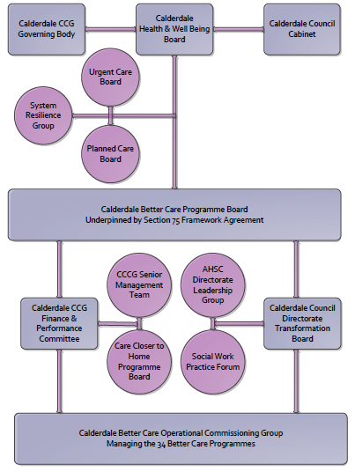

3. Finance
a, Contributions to the fund are from the CCG
b, 15/16 funding £285,000

- Impact of scheme
a, Performance – key indicators already in place are :
A population segmentation and impact exercise was carried out following the NHSE tool supplied in the 'How to Guides'. It should be noted that each scheme within BCF will not in isolation provide the impact on the headline metric detailed here. It is the combination of these schemes, the Qipp Programme and the interdependencies across the services which will provide the whole improvement. Each of the schemes that form part of the BCF plan for Calderdale has a number of additional measures that will be routinely collected to evaluate the impact of the scheme on the Calderdale population.
Headline BCF Metric for this scheme
Reduction in delayed transfers of care

i Percentage of occupied bed days due to delayed transfers of care
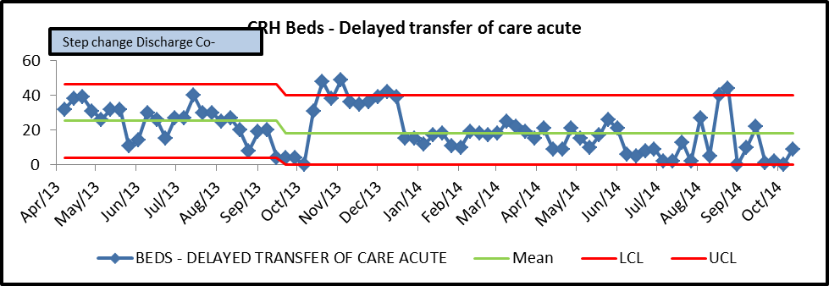

ii, Average days for assessment time (from referral to an outcome at panel).

b) Baseline figures to be taken from metrics for November/December 2014 figures
c) Target activity - Monthly Performance reports.
d) Phasing of change –
i, 15/16 Initial 3/12 consolidation of processes across wards 5s and 7s at Calderdale Royal Hospital, then roll out across other wards over next 6-9 months
ii, 16/17 Development of improved discharge pathway with Acute Trust and local authority

e) KPI Targets/Key BCF indicator
i Reduction in delays in discharge
ii Reduction in unnecessary use of hospital beds
iii Improved patient experience of discharge process
iv Clear discharge pathway supported by integration between hospital, CCCG and CMBC processes.

