Section 75 Partnership Framework Agreement – Schedule 5
Individual Scheme Specification

BCF Scheme Reference | S5PO2
Scheme name | Accident and Emergency Physician
Lead Commissioner (CMBC/CCG) | Calderdale Clinical Commissioning Group
Fund Manager (Senior Responsible Officer) | Rhona Radley
Commencement of particular service | TBC
£ Value in 2015/16 | £110,000
Contract or in house | Single Award Contract
Provider | Calderdale and Huddersfield Foundation Trust
Contract term

1.0 Introduction
From August 2012 an admission avoidance project has been undertaken in the A&E department at the Calderdale Royal Hospital with the aim to reduce emergency activity from A&E into Medical Specialities.

The purpose of the team is to review those patients that A&E clinicians feel may need to be admitted, to assess the patient’s needs and wherever appropriate prevent an admission.

This scheme involves a senior medical doctor working at the front door of A&E between the hours of 10am and 6pm Mondays to Fridays together with a Medical Assessment Unit (MAU) senior nurse.

The senior medical doctor’s grade and experience of working on MAU enables them to make decisions about discharging patients who would otherwise have been an admission to the hospital.

The Admissions Avoidance Team may refer patients to the Readmissions Virtual Ward and existing Community Services, and liaise with primary care and community teams to support the patients at home.

Community discharge matrons already work within the hospital supporting discharges for patients with more complex requirements and spend a great deal of time within MAU and A & E. These staff members will support the team and the team will act as a trio to prevent admissions

The main indicator used to measure the success of this scheme is the number of medical admissions (non-elective admissions) avoided. A review of the readmission rate for these patients is used as a balancing measure to ensure the scheme is provided in a safe and effective way.

The process behind this proposal is that patients still see an Emergency Doctor on presentation to the department. Only when a decision to admit/transfer to CDU does this admissions avoidance team intervene and look to prevent the admission for medical patients (i.e. there is no double counting of patients that ED doctors would not have admitted anyway)

The nurse will assist the Physician and ensure on-going continuity of care, pulling through results from diagnostic tests and providing holistic nursing care and ensuring blood results; x-rays etc are acted upon within a timely fashion. They will also risk assess the patient for readmission using the virtual ward screening tool for re-admission and refer those who meet the criteria to the virtual ward team for a follow up visit the next day .

The community matron will support where and when appropriate, fast track referrals to the single point of access, organising intervention where required and referring back to community teams if the individual is already known to district nurses and community matrons. The Community Matron will also liaise with the GP when appropriate and required.

2.0 Governance

This Scheme is performance managed by the CCG’s QIPP Monitoring Group which reports into the CCG’s Finance and Performance Committee. Members of the CCG’s QIPP Monitoring Group are also members of the BCF Operational Commissioning Group and BCG Programme Board where actions to mitigate the likelihood and impact of risks to delivery of BCF objectives and outcomes are overseen and schemes are performance managed.

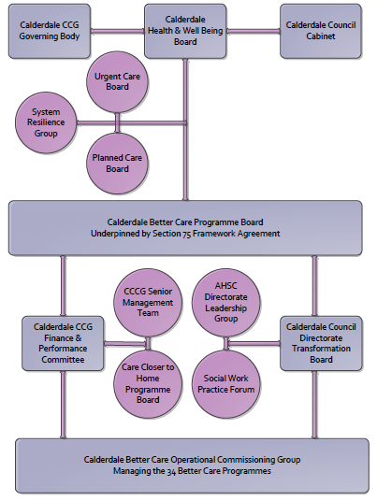

3. Finance
- Contributions to the fund are from CCCG
- 15/16 funding £110,000

4.0 Impact of scheme
a) Performance (KPIs – BCF and other local?)
b) Baseline figures
c) Target activity (monthly/quarterly/annual)
d) Phasing of change
A population segmentation and impact exercise was carried out following the NHSE tool supplied in the 'How to Guides'. It should be noted that each scheme within BCF will not in isolation provide the impact on the headline metric detailed here. It is the combination of these schemes, the Qipp Programme and the interdependencies across the services which will provide the whole improvement. Each of the schemes that form part of the BCF plan for Calderdale has a number of additional measures that will be routinely collected to evaluate the impact of the scheme on the Calderdale population.
Headline BCF Metric for this scheme
- Reduction in non-elective (NEL) (general + acute only)

Supplementary Operational Metrics are:
Assurance and monitoring arrangements are shown below:
- KPI Targets
Key BCF Indicator - Reduction in non - elective admissions (in this case reduction in admissions from A+E contributing to the overall 3.5% reduction target)
Supporting indicators:

b) Baseline figures

Main KPI for the Admission Avoidance Scheme across Calderdale and Greater Huddersfield
From which stream of non-recurrent monies is this scheme being funded? | Which pathway is this scheme impacting? | Scheme Name | Scheme Description | What organisation is the scheme targeted at? | Which area of improvement is the scheme targeted at? | Main KPI | Month | KPI Baseline | KPI Target

Operational Resilience | Non Elective | A&E physician service | Medical assessment in A&E to prevent admissions | Acute Trust | Implement / improve rapid assessment and treatment systems | Additional number of medical patients seen who avoided an acute admission at CRH & HRI hospitals | Nov | 52 | 52
 |  |  |  |  |  |  | Dec | 48 | 48
 |  |  |  |  |  |  | Jan | 36 | 36
 |  |  |  |  |  |  | Feb | 41 | 41
 |  |  |  |  |  |  | Mar | 43 | 43
 |  |  |  |  |  |  | Apr | 34 | 34

Admission Avoidance scheme monthly performance below

- Target activity (monthly/quarterly/annual)

d) Phasing of change
The scheme is fully up and running and in place for the whole of 2015/16

