Section 75 Partnership Framework Agreement – Schedule 5
Individual Scheme Specification

BCF Scheme Reference | S5PO1
Scheme name | Out of Hours Emergency Duty Urgent Assessment
Lead Commissioner (CMBC/CCG) | Calderdale MBC
Fund Manager (Senior Responsible Officer) | Rob Mitchell
Commencement of particular service | Ongoing
£ Value in 2015/16 | £366,000
Contract or in house | In house
Provider | CMBC
Contract term | Ongoing

1.0 Introduction
Outline of scheme (what is it we are actually doing?)
Section 114 of the Mental Health Act 1983 details the functions of Local Authorities in relation to the approval of AMHPs. The guidance in the Code of Practice states that Local Authorities should ensure that sufficient AMHPs are available to carry out their functions under the Act and that arrangements must be in place to provide a 24 hour service. The role of the AMHP includes but is not limited to participating in assessments with doctors to decide whether a person’s mental health care needs can be met in the community, or if the person meets the legal threshold for compulsory admission to hospital. There is no legal guidance about how many AMHPs are required to meet these obligations but the figure most commonly used as a guide line is one per ten thousand population, SWYPFT advise that for Calderdale this would equate to 20.4 full time equivalent AMHPs.

Community Care in 2013 undertook a review of AMHP cover nationally. Their finding was that 43% of Local Authorities were experiencing shortage of applications from AMHP and were unable to meet the recommended level of AMHP cover for their rota. BASW note that the average age for AMHPs is now 50+ and are strongly advocating that LAs have a coherent strategy in relation to numbers, retention, recruitment, pay, conditions and training for AMHP qualified staff. Community Care observes that contrary to the state of the market for AMHP a third of LAs have cut their budget for sustaining the talent pipeline of AMHPs in training. Further, demand for AMHP is growing with Mental Health Act Assessments during 2013 reaching their highest level nationally since the introduction of the Mental Health Act (1983).

2.0 Governance (show which committee scheme is reported to/insert standard diagram of relevant CCCG/CMBC oversight committee)
The Emergency Duty Team is managed through CMBC Children’s Services Directorate which integrates into the Better Care Programme through the BCF Operational Group. 7 day working is reported in on a partnership basis to Urgent Care Board which monitors the impact of the 7 Day Clinical Standards on AnE and transfers of care.

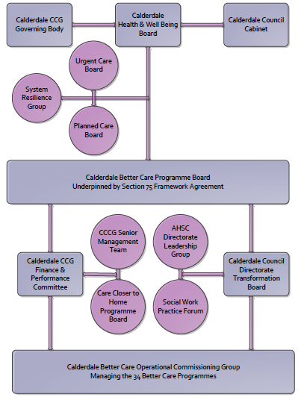

3. Finance
- Contributions to the fund are from CCCG or CMBC? - CCCG
- 15/16 funding - £366,000
- Full year effect if part year in 15/16 – N/A

4.0 Impact of scheme
Assurance and monitoring arrangements (common wording across all schemes? Or at least for CCCG and CMBC schemes?)
- Performance (KPIs – BCF and other local?)
- Baseline figures
- Target activity (monthly/quarterly/annual)
- Phasing of change
A population segmentation and impact exercise was carried out following the NHSE tool supplied in the 'How to Guides'. It should be noted that each scheme within BCF will not in isolation provide the impact on the headline metric detailed here. It is the combination of these schemes, the Qipp Programme and the interdependencies across the services which will provide the whole improvement. Each of the schemes that form part of the BCF plan for Calderdale has a number of additional measures that will be routinely collected to evaluate the impact of the scheme on the Calderdale population.

Headline BCF Metric for this scheme
- Reduction in non-elective (NEL) (general + acute only)

Supplementary Operational Metrics are:
- Mental Health Act Assessments under MHA 1983
- Assisting Police under Section 136 MHA 1983 (AMHP).
- Provide Appropriate Adults for Vulnerable Adults under PACE 1984.
- Advice to health staff / police regarding the MHA 1983, MCA 2005 and any other legislation that may have an impact on an individual.
- Responding to individuals who are distressed / suicidal when the Mental Health Crisis Service or the police determine that a Mental Health Act Assessment is required for consideration.

Baseline Performance

- There are currently 20 social workers who are approved AMHPs; 15 work in the CMHT (14.4FTE) and 5 are in EDT (4.5FTE); giving a total of 18.9 FTE. However not all CMHT staff will cover out of hours and their contacts do not require them to do so. There are 10.4FTE day staff available for the AMHP rota which equates to 51% of the recommended figure of 1 per 10,000 head of population.
- The 4.5FTE AMHP qualified staff in EDT enables the Council and SWYPFT to meet statutory responsibilities in relation to the AMHP rota by providing an additional capacity covering out of hours. Inclusion of EDT into the AMHP rota increases the level of cover up to 75% of recommended levels.
- An average of 25.8 assessments are undertaken per month by AMHPs (2013/14 figures received by the Mental Health Professional Lead).
- 17.2 full Mental Health Act Assessments are completed per month by AMHPs of which 50% (8.6 per month) are completed by EDT AMHPs.

