Section 75 Partnership Framework Agreement – Schedule 4
Individual Scheme Specification

BCF Scheme Reference | S4PO6
Scheme name | Community Support for Stroke Recovery
Lead Commissioner (CMBC/CCG) | Calderdale MBC
Fund Manager (Senior Responsible Officer) | Angela Gardner
Commencement of particular service | 01/04/2015
£ Value in 2015/16 | £145,000
Contract or in house | Single Award Contract & SLA with Upbeat (Council provider)
Provider | Currently 3 providers – Stroke Association, SCOPE and Upbeat. New specification being developed which will rationalise arrangements through a Procurement Exercise to be completed during 2014/15
Contract term | 5 Year Term Agreement on a 1+1+1+1+1 Basis

1.0 Introduction
Outline of scheme (what is it we are actually doing?)
Existing service provision around Community Stroke Services is currently delivered by Stroke Association, SCOPE and Upbeat and has been since 2011. There is currently a tendering process underway to seek a preferred provider to deliver Community Support for Stroke Recovery & Prevention to commence April 2015. The tender process will cover the services currently provided by the Stroke Association and SCOPE, the physical exercise element provided by Upbeat will continue to be delivered by them via a Service Level Agreement with the CMBC as this is an in-house provider.

Outcomes Based Commissioning

It is intended that this project will act as a catalyst for our change programme that will focus on the provision of support closer to home within community and primary care settings. A key element of approach includes primary care at the core of the service transformation and the need to build modern and sustainable models of provision in Calderdale.

It is the Council’s aspiration to work in partnership with Upbeat and a single partner or consortium to deliver on this initiative.

Core Objectives for the Service:
- Delaying and reducing the need for care and support and helping people to recover from episodes of ill health or following injury.

- Targeted community support for stroke recovery will build community and voluntary sector support for peer navigation and expert by experience programmes, developing skills and training opportunities.
- Information and advice available at the right time and in the right place to maximise the benefits to the individual, family and carers of people who have experienced a stroke.
- Facilitate service user involvement in service planning and design through ongoing development of focus groups and wider engagement with the local community.
- Support people to adjust their lifestyles to reduce the chances of having a stroke through education training and close working with GP Practices, health and social care professionals and voluntary organisations.

- Delaying and reducing the need for care and support through reducing the number of permanent admission to residential and nursing care homes.
  - Facilitate expert by experience involvement in early supported discharge from hospital back home for people who have experienced a stroke through peer mentoring, to secure better outcomes for people.

Evidence Base

The evidence base for Intermediate Care is well-developed in a number of key documents which are listed below:
- Prevention Package for Older People (2009)
- Intermediate Care - Halfway Home (2009)
- A vision for adult social care (2010)
- Transforming Community Services: Ambition, Action, Achievement - Transforming Rehabilitation Services (2010)
- Think Local, Act Personal (2010)
- SCIE Research Briefing (2011) Reablement: A Cost-Effective route to better outcomes http://www.scie.org.uk/publications/briefings/briefing36/
- Making it Real (2013)
- NHS Benchmarking (2013) http://www.nhsbenchmarking.nhs.uk/partnership-projects/National-Audit-of-Intermediate-Care/year-two.php
- Calderdale Adult Social Care Vision (2013)
- Calderdale Dementia Strategy Refresh (2013)
- Calderdale Adult Social Care Market Position Statement (2014)
- Calderdale Health & Well Being Board Better Care Plan (2014)

NICE guidance CMG45 (2012) ‘Services for the prevention of cardiovascular disease’ recommends that commissioners consider the following components of a high-quality service: http://publications.nice.org.uk/services-for-the-prevention-of-cardiovascular-disease-cmg45
- Population-wide and community-level approaches
- Assessing an individual's risk of cardiovascular disease, including commissioning the NHS Health Check programme and Making Every Contact Counts
- Behaviour change and lifestyle interventions
- Medical interventions

Department of Health/Public Health England Guidance NHS Health Check: Vascular Risk Assessment and Management, Best Practice Guidance (2013) http://www.healthcheck.nhs.uk/commissioners_and_healthcare_professionals/national_guidance/

Calderdale Baseline Position

Stroke is the third largest cause of death in England and 110,000 have a stroke each year. Stroke costs the NHS and the economy £7 billion a year in direct nursing costs, informal care and lost productivity. A third of people who have had a stroke are left with a long term disability.
In Calderdale there are currently 1123 people with a longstanding health condition caused by a stroke. This is expected to rise by 44% by 2030 to over 1600. Men are more likely to experience a stroke than women, and people from certain ethnic minorities are at greater risk with Indian, Bangladeshi, and Pakistani males and females all having a higher prevalence of ischaemic heart disease (IHD). Mortality from IHD is 50% higher high among Irish and Scottish people and those from south Asian groups, particularly Pakistanis and Bangladeshis than among the general population. The extent to which deprivation, adverse lifestyle factors, poorer access to healthcare, or other factors contribute to this high risk is not completely understood. For Indian, Bangladeshi and Pakistani groups, their varied but substantially raised prevalence of diabetes contributes to the raised risk of IHD.

The Calderdale Joint Strategic Needs Assessment (JSNA) shows that in Calderdale:

Stroke and transient ischaemic attacks (TIA)
- 2011/12 GP reported stroke and TIA prevalence in Calderdale was 1.9% (England 1.7%)
- Estimated prevalence 2.6%

Hypertension
- 2011/12 GP hypertension prevalence in Calderdale was 13.7%. This is comparable with an England prevalence of 13.6%
- Estimated prevalence 31.8%

The JSNA highlights that in Calderdale there is significantly more that could be done in primary and community care to prevent strokes. Calderdale ranks bottom quartile on completion of Primary Prevention prevalence checks and interventions in General Practice (see graph below).

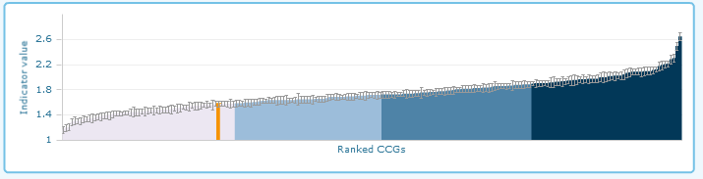

When adjusted for local socio-economic conditions more people than would be expected are experiencing strokes as shown below (Calderdale is the yellow dot). The JSNA shows there is a strong link between deprivation and cardiovascular diseases with the mortality rate for people under the age of 75 being twice as high the most deprived relative to the least deprived areas of Calderdale.

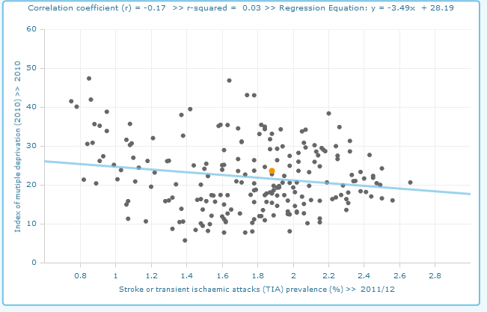

According to the NHS Information Centre Hospital Episode Statistics, the percentage of patients with stroke in Calderdale is below the England average at around 120 per 100,000 (compared to 127 per 100,000 in England). Yet according to National GP Profiles Calderdale’s stroke prevalence is above the England average (it was stated at the start of this document that sometimes GPs have patients from outside their locality and also that health care databases may use the same data in slightly different ways; these may account for the difference).

This patient cohort is also at high risk of admissions to care homes, 23% of all care home admissions during 2013/14 were referred to adult social care from the stroke rehab ward at CRH. (See Annex 2 maps for where people live in Calderdale who are admitted into hospital with conditions which place them at high risk of a stroke).

In general, practices with a higher number or percentage of older people registered also have higher stroke prevalence and vice versa. This would be expected and there do not seem to be any notable exceptions. All practices in Calderdale have a register of patients with stroke or TIA. However, not all practices refer new stroke patients for further investigation. Our data suggests that improvement is needed in the treatment of stroke patients on the same or next day as admission and improvements in the administration of brain scans to patients within 24 hours of stroke. Whilst wider transformation takes place through the West Yorkshire CCG review of stroke pathways, at a local level expanding peer and carer support and navigation services for survivors of stroke is a key priority for our Better Care Programme.

2.0 Governance (show which committee scheme is reported to/insert standard diagram of relevant CCCG/CMBC oversight committee)

Governance reporting for this scheme is made to the Calderdale BCF Operational Commissioning Group and escalated as necessary.

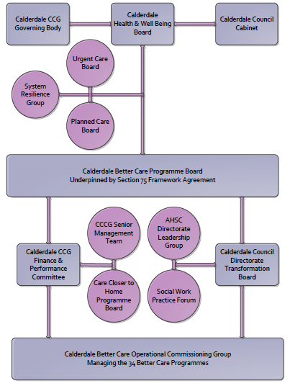

3. Finance
- Contributions to the fund are from CCCG or CMBC?
- 15/16 funding £145,000
- Full year effect if part year in 15/16 £ N/A

4.0 Impact of scheme
Assurance and monitoring arrangements (common wording across all schemes? Or at least for CCCG and CMBC schemes?)
A population segmentation and impact exercise was carried out following the NHSE tool supplied in the 'How to Guides'. It should be noted that each scheme within BCF will not in isolation provide the impact on the headline metric detailed here. It is the combination of these schemes, the Qipp Programme and the interdependencies across the services which will provide the whole improvement. Each of the schemes that form part of the BCF plan for Calderdale has a number of additional measures that will be routinely collected to evaluate the impact of the scheme on the Calderdale population.
Headline BCF Metric for this scheme
Reduction in permanent residential admissions
Supplementary Operational Metrics are:

Performance

- Monitoring Report on KPIs relating to this specific scheme reported as part of the overarching BCF Programme

- Routinely collected Outcome Measures monitored through the BCF Dash Board by the Better Care Programme Board

- Quarterly monitoring meetings with providers

The key outcomes we anticipate are:

- Improvement in the proportion of older people who recover their independence after illness or injury.
- Helping people to recover from episodes of ill health or following injury through improving the rates of people experiencing recovery from stroke.
- Reduced number of people who experience delays in their transfers of care from hospital, including those which are attributable to adult social care
- Proportion of older people (65 and over) who were still at home 91 days after discharge from hospital into reablement rehabilitation services
- Improved proportion of people who are fully independent when they complete their reablement programme.

Quarterly monitoring meetings with providers

http://www.calderdalejsna.org.uk/fileadmin/JSNA/PDFs_of_chapters/Cardiovascular_Disease_-_references_to_do.pdf
Hospital Episode Statistics NCHOD (released December 2012, next release December 2013) The NHS Information Centre for Health and Social Care https://indicators.ic.nhs.uk
National General Practice Profiles, National Public Health Profiles, http://fingertips.phe.org.uk/

