Section 75 Partnership Framework Agreement – Schedule 4
Individual Scheme Specification
BCF Scheme Reference | S4PO5
Scheme name | Reablement and Coordinated Support at Home
Lead Commissioner (CMBC/CCG) | Calderdale MBC
Fund Manager (Senior Responsible Officer) | Rachel Russell
Commencement of particular service | Ongoing
£ Value in 2015/16 | £2,541,550
Contract or in house | Partnership Agreement
Provider | - Support at Home is in provided in-house by the Council  - CHFT manage the reablement element of the scheme
Contract term | Ongoing
1.0 Introduction
The population is growing, in particular the population aged 75 years and over, which in Calderdale is expected to rise by 69% between 2009 and 2029. This is putting pressure on local health and social care services. For example,there has been an overall increase in the numbers of non-elective admissions with a short stay, and a sharp increase in the percentage of admissions without an overnight stay. This suggests that perhaps some of those being admitted at present could be supported to remain at home, or cared for in an intermediate care bed.
In addition, recent monitoring of the home care service in Calderdale has identified that the number of people receiving home care has increased, and that the level of dependency has also increased. If more people are effectively supported to retain or regain independence, home care can be targeted to enable those needing a higher level of support to remain in their own home rather than going into long-term care
The local and national evidence base for Reablement and Coordinated Support at Home is well-developed in a number of key documents which are listed below.
- Prevention Package for Older People (2009)
- Intermediate Care - Halfway Home (2009)
- A vision for adult social care (2010)
- Transforming Community Services: Ambition, Action, Achievement - Transforming Rehabilitation Services (2010)
- Think Personal, Act Local (2010)
- Making it Real (2013)
- Calderdale Adult Social Care Vision (2013)
- Calderdale Adult Social Care Market Position Statement (2014)
The published evidence demonstrates that most people have the potential to continuously improve with the right interventions at the right time (Homecare Re-ablement Prospective Longitudinal Study, Final Report (DOH 2010)). We are therefore planning to provide a period of recovery focused support at the point of a person’s contact with ongoing reablement or following a crisis intervention which places their confidence and their ability to remain living independently at home at risk (e.g. a hospital admission or an emergency respite stay.
Our approach towards Coordinated Support at Home is to work with couples and families within the local community providing information, advice, guidance and support. Support is person-centred and strengths-based meaning the individual remains central to all we do with clear emphasis on promoting independence and resilience. Support builds on freely available community resources and work with other agencies and organisations to make appropriate referrals and we seek to ensure proportionate interventions. The approach is outcome-based and helps certify that we are assisting people to achieve their identified goals.
Currently all Reablement and Coordinated Support at Home referrals are received into Gateway to Care for November 2013 are first screened by Support at Home social workers. In an analysis of 180 referrals to the team only 10% were determined to actually require a reablement intervention. As a result of the teams intervention 87% were resolved through low cost/no cost solutions by the team, and 20% needed no further support from any other service.

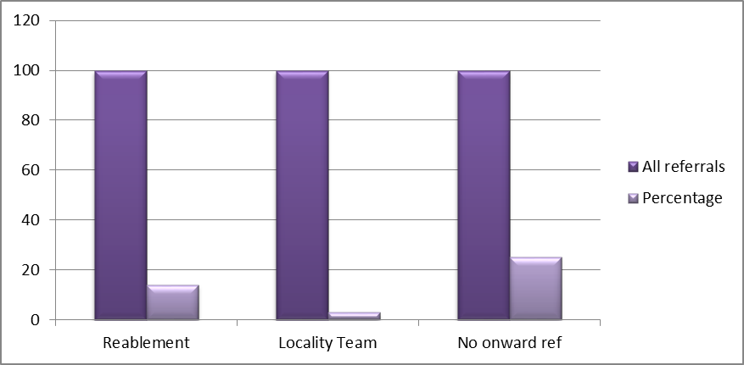

Demand for social care reablement has significantly increased following integration with the health intermediate care service into an integrated locality based support and independence model in January 2014.
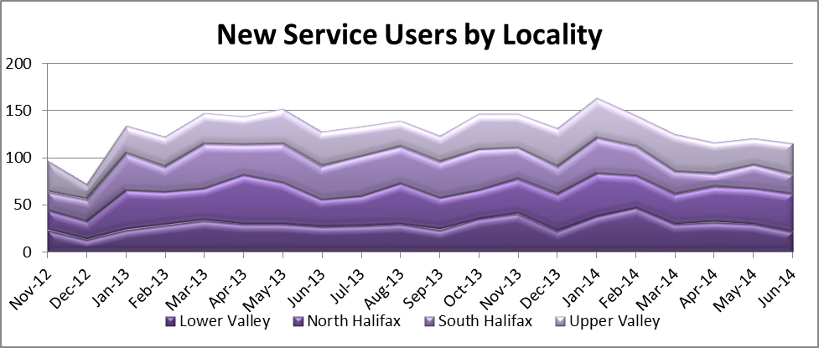
Calderdale is unusual in that the service is primarily used to support step down support rather than step up hospital admission avoidance. Only 26% of referrals are being generated through primary care or community health teams, 74% of referrals are for discharge support from the hospital.
Supporting Independence Team Referrals in 13/14, Clients Aged 75+. Referrals by per 1000 of linked GP Population. Where referral source is ‘Primary / Community’ Health’
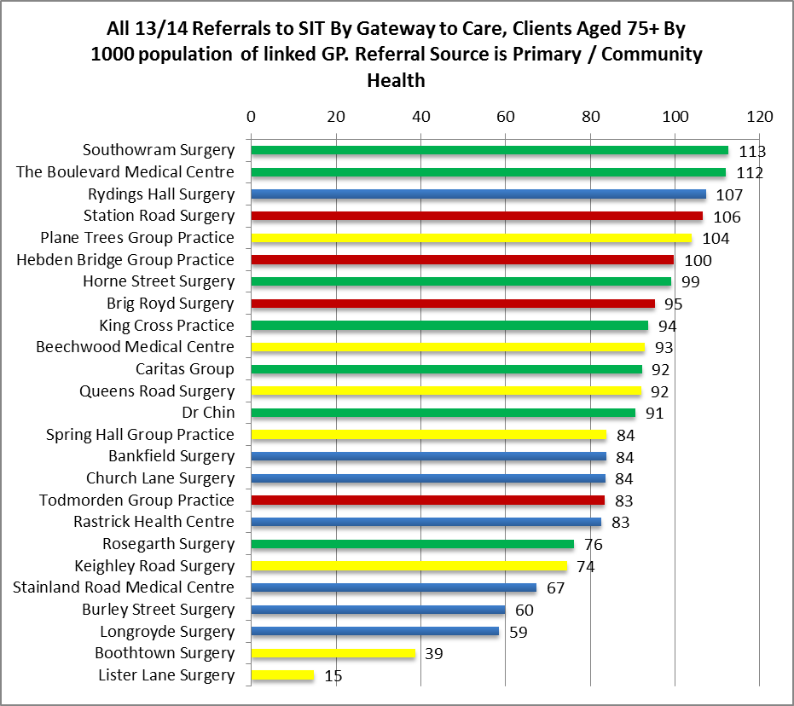
AHSC locality Summary
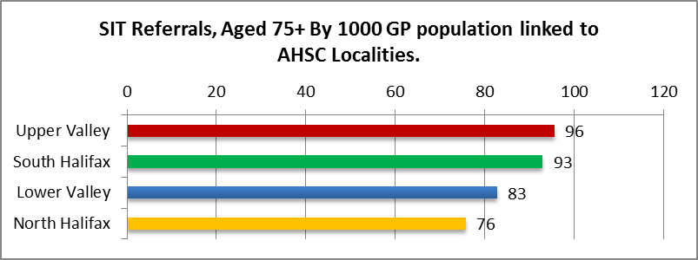

There is considerable potential for increased efficiencies from the reablemement approach. SCIE report in their literature review of the evidence base into reablement that national best practice results in up to 63%of people who are supported with a reablement intervention no longer needing any form of service after the intervention that 26% had a reduced requirement for home care hours. However the local service model is not yet achieving this level of performance with the year end result reporting at 38.2%.

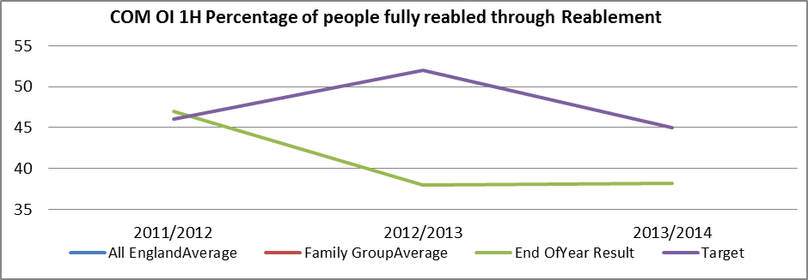
As a result outcomes against the Better Care Supplementary Metric benchmark as bottom quartile performance nationally and for the family group.

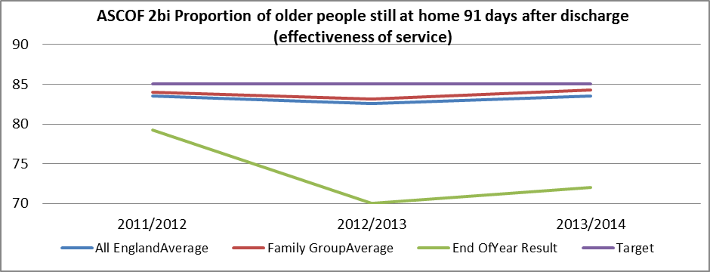
Polarity: High is good

Reporting Year | All England Average | Family Group Average | End Of Year Result | Target
2011/2012 | 83.5 | 84 | 79.2 | 85
2012/2013 | 82.6 | 83.1 | 70 | 85
2013/2014 | 83.5 | 84.3 | 72 | 85

2.0 Governance (show which committee scheme is reported to/insert standard diagram of relevant CCCG/CMBC oversight committee)

Governance reporting for this scheme is made to the Calderdale BCF Operational Commissioning Group and escalated as necessary.

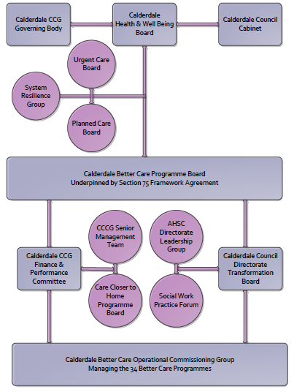
3. Finance
- Contributions to the fund are from CCCG or CMBC?
- 15/16 funding £2,541,550
- Full year effect if part year in 15/16 £
- Arrangements for managing over and underspends (xref to main framework but may have different arrangements for different schemes?)
- Financial governance arrangements, audit (may be standard for CCCG or CMBC)
- VAT

4.0 Impact of scheme
Assurance and monitoring arrangements (common wording across all schemes? Or at least for CCCG and CMBC schemes?)
A population segmentation and impact exercise was carried out following the NHSE tool supplied in the 'How to Guides'. It should be noted that each scheme within BCF will not in isolation provide the impact on the headline metric detailed here. It is the combination of these schemes, the Qipp Programme and the interdependencies across the services which will provide the whole improvement. Each of the schemes that form part of the BCF plan for Calderdale has a number of additional measures that will be routinely collected to evaluate the impact of the scheme on the Calderdale population.
Headline BCF Metric for this scheme
- Increased effectiveness of reablement
Supplementary Operational Metrics are:
- Reduced occupied hospital beds
- Reduced occupied long term care home beds
- Reduced emergency hospital admissions and re-admissions
- Improved communication and information flows, reduced duplication and improved efficiency
- Better co-ordination of services leading to a reduction in duplication and waste of resources
- More satisfied staff working in the system
- Reduced system financial and reputational risks
- Better value for money

- Performance (KPIs – BCF and other local?)
- Baseline figures
- Target activity (monthly/quarterly/annual)
- Phasing of change

