Section 75 Partnership Framework Agreement – Schedule 4
Individual Scheme Specification

BCF Scheme Reference | S4PO4
Scheme name | Intermediate Care Social Work
Lead Commissioner (CMBC/CCG) | Calderdale MBC
Fund Manager (Senior Responsible Officer) | Rob Mitchell
Commencement of particular service | Ongoing
£ Value in 2015/16 | £250,000
Contract or in house | In-house
Provider | N/A
Contract term | Ongoing

1.0 Introduction
Outline of scheme (what is it we are actually doing?)
The Intermediate Care Social Work Service acts as an allocated worker to all people who are accepted into reablement or an intermediate care or transitional bed. Operating alongside Gateway to Care Clinical Advisors who monitor flow through the Intermediate Care Beds and the CMBC Home Care Brokerage Service who liaise with home care providers on transfer of packages from reablement the team of five Social Workers and four Service Coordinators provide:
- Prompt access to responsive, personalised support which takes account of holistic needs including natural networks of support from family, friends and community.
- Advocacy, empowerment and support which ensures that the person is at the centre of and in control of decision making and is recognised as an expert in their own condition.
- Access to a person centred plan of support which focuses on promoting independence, recovery and reablement outcomes for the individual.
- Smooth and seamless return to on-going support arrangements that have been adapted to meet any change in their long term needs identified through holistic assessment.
- Where a person is within reablement the service provides the community care assessment for a Personal Budget and arranges for brokerage for a package of care.

The service also provides the assessment and case management where a person within an intermediate care or transitional bed is identified as needing a community care assessment for a Personal Budget or for an assessment for a permanent admission into 24 hour care.

2.0 Governance (show which committee scheme is reported to/insert standard diagram of relevant CCCG/CMBC oversight committee)
Intermediate Care Social Work is managed through the CMBC Directorate Leadership Group (see below). The Urgent Care Board also keeps an active watching brief on this area of work through the Discharges work stream in order to monitor impact of demand for intermediate care and flow through reablement and the intermediate care beds on transfer of care from hospital.

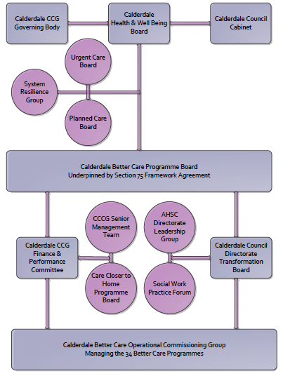

3. Finance
- Contributions to the fund are from CCCG or CMBC? CCCG
- 15/16 funding - £250,0000
- Full year effect if part year in 15/16 – N/A

4.0 Impact of scheme
Assurance and monitoring arrangements (common wording across all schemes? Or at least for CCCG and CMBC schemes?)
- Performance (KPIs – BCF and other local?)
- Baseline figures
- Target activity (monthly/quarterly/annual)
- Phasing of change
A population segmentation and impact exercise was carried out following the NHSE tool supplied in the 'How to Guides'. It should be noted that each scheme within BCF will not in isolation provide the impact on the headline metric detailed here. It is the combination of these schemes, the Qipp Programme and the interdependencies across the services which will provide the whole improvement. Each of the schemes that form part of the BCF plan for Calderdale has a number of additional measures that will be routinely collected to evaluate the impact of the scheme on the Calderdale population.
Headline BCF Metric for this scheme
- Reduction in permanent residential admissions
Supplementary Operational Metrics are:
- ASCOF 1ci Proportion of people using social care who receive self directed support
- ASCOF 1cii Proportion of people using social care who receive Direct Payments
- JWS2c Proportion of people who use services who have control over their daily life in Calderdale (ASCOF 1b)
- JWS3 Number of older people receiving formal community care assessments - provisional
- ASCOF 2ai Permanent admissions to residential care home, per 100,000 of the population (18-64)
- ASCOF 2aii Permanent admissions to residential care homes, per 100,000 of the population (65+)
- CA 1.4d The percentage of safeguarding alerts received that are dealt with in accordance with timescale requirements
- CA 1.4e The percentage of safeguarding referrals which are decisioned within timescales
- CA 1.4f The percentage of safeguareding referrals where the investigation is completed within 7 weeks of the referral decision being made

Baseline Performance:
