Section 75 Partnership Framework Agreement – Schedule 4
Individual Scheme Specification
BCF Scheme Reference | S4PO3
Scheme name | Intermediate Supported Care (Heatherstones)
Lead Commissioner (CMBC/CCG) | Calderdale MBC
Fund Manager (Senior Responsible Officer) | Rachel Russell
Commencement of particular service | TBC
£ Value in 2015/16 | £370,000
Contract or in house | Contract and In-house
Provider | Joint Venture between:  - CMBC (Housing, Adult Social Care)  - Connect Housing  - CHFT  - Upbeat
Contract term | 1 year
- Introduction
When people are ready to leave hospital, they are sometimes not confident or well enough to go back home, but they might not need the high level of care offered in hospital or a care home. The Heatherstones apartments will bridge this gap in current provision by giving people a safe and accessible place to recover before returning home, in maximum privacy. Care, support, and housing advice will be provided on site. Each individual admitted into the scheme will have a care plan to suit their needs and will aim to help them regain full confidence and independence. Through-out their stay, the person will receive regular review of their care plan, and where necessary adjustments made to ensure the goal of returning to a non-institutional home is maintained,

This has been a joint adventure e between CMBC (Housing, Adult Social Care), connect Housing and CHFT Heatherstones is a Calderdale and Huddersfield Foundation Trust (CHFT) owned site that has been empty since 2009 and sits within a primary housing area. The site currently consists of 13 x 2 bed terraced houses and 8 x 2 bed apartments.

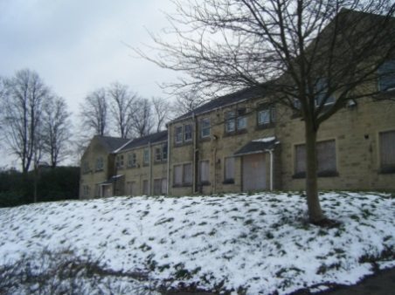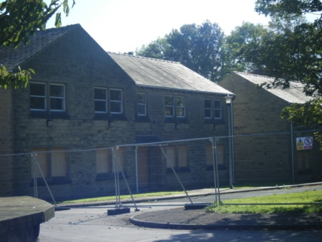

The vacant properties are located in Skircoat Green, overlooking the Heath. The proximity of the site to the town centre, transport links, Calderdale Royal Hospital and local amenities would make it an ideal sustainable location for a blend of ‘step forward’ units and affordable housing. This would support a number of strategic priorities for Calderdale Council.
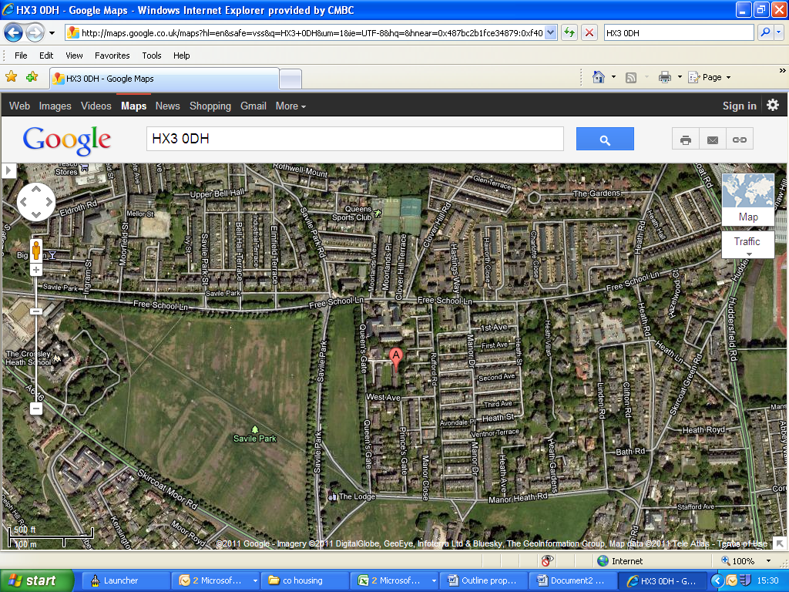

The Council have worked with CHFT to secure a Registered Provider (RP) of affordable housing – Connect Housing, who are in a position to offer assistance in bringing the properties back into use. Connect Housing have been identified as a preferred partner based on their status as a local Registered Provider, their capital offer and their immediate access to finance to purchase the site.

The CHFT are seeking a receipt of £1.2 million for the site. Connect Housing are in a position to offer a capital payment of £1.0 million. A £200,000 capital provision that has been transferred to the Council from the Clinical Commissioning Group with the intent to secure the Heatherstones site for the proposed use. This sum is therefore available to meet the £1.2 million asking price.

Connect Housing will take control of the site and refurbish the terraced housing into affordable housing for rent.

Connect Housing will also refurbish the apartments into ‘step forward’ accommodation, with one staff office/base. The Council’s preferred option is to refurbish the apartments into 14 individual units which would allow adults in the scheme maximum privacy whilst undergoing reablement and rebuilding their confidence.

Step forward accommodation would be an alternative to a short term placement in an intermediate care bed in a residential care home. The accommodation would consist of self-contained apartments comprising of a double bedroom, bathroom, living room/kitchen area, provided in a setting that supports ‘reablement’, promoting faster recovery and maximising independent living in a safe setting. In effect the proposed design would provide temporary convalescent accommodation for adults for up to 6 weeks.

Therapy, care and support would be provided on site to suit the needs of the individual, tapering from high level initially towards full independence prior to moving home.

The units would provide an extended option to the offer available through the intermediate tier service to those adults who are not very frail elderly and who aspire to remain living independently in the community.

All of this would contribute towards reducing the number of long term care placements and helping people to remain as independent as possible for as long as possible. This equates to approximately £27,000 per annum that will be saved for every person that the Council would have alternatively had to place in long term care.

- Comprehensive, holistic assessments including social care, environmental and well being which informs and supports reablement delivery for step up and step down support.
- Intermediate care and transitional beds to reduce long-term care needs whilst providing information to inform future planning of services and involves teams that are outside the direct scope of this redesign for various management/funding reasons.
- A dedicated community recovery service for people who have an 18 month period of recovery following stroke including peer networks and experts by experience.

The evidence base for this intermediate tier scheme is well-developed in a number of key documents which are listed below:
- Prevention Package for Older People (2009)
- Intermediate Care - Halfway Home (2009)
- A vision for adult social care (2010)
- Transforming Community Services: Ambition, Action, Achievement - Transforming Rehabilitation Services (2010)
- Think Local, Act Personal (2010)
- SCIE Research Briefing (2011) Reablement: A Cost-Effective route to better outcomes http://www.scie.org.uk/publications/briefings/briefing36/
- Making it Real (2013)
- NHS Benchmarking (2013) http://www.nhsbenchmarking.nhs.uk/partnership-projects/National-Audit-of-Intermediate-Care/year-two.php
- Calderdale Adult Social Care Vision (2013)
- Calderdale Dementia Strategy Refresh (2013)
- Calderdale Adult Social Care Market Position Statement (2014)
- Calderdale Health & Well Being Board Better Care Plan (2014)
- Information sharing and communication
2.0 Governance (show which committee scheme is reported to/insert standard diagram of relevant CCCG/CMBC oversight committee)
Governance reporting for this scheme is made to the Calderdale BCF Operational Commissioning Group and escalated as necessary.

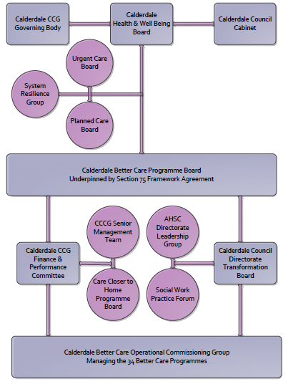
3. Finance
- Contributions to the fund are from CCCG or CMBC?
- 15/16 funding £370,000
- Full year effect if part year in 15/16 £
- Arrangements for managing over and underspends (xref to main framework but may have different arrangements for different schemes?)

4.0 Impact of scheme
Assurance and monitoring arrangements (common wording across all schemes? Or at least for CCCG and CMBC schemes?)
A population segmentation and impact exercise was carried out following the NHSE tool supplied in the 'How to Guides'. It should be noted that each scheme within BCF will not in isolation provide the impact on the headline metric detailed here. It is the combination of these schemes, the Qipp Programme and the interdependencies across the services which will provide the whole improvement. Each of the schemes that form part of the BCF plan for Calderdale has a number of additional measures that will be routinely collected to evaluate the impact of the scheme on the Calderdale population.

Headline BCF Metric for this scheme
- Increased effectiveness of reablement
Supplementary Operational Metrics are:
- Improvement in the proportion of older people who recover their independence after illness or injury.
- Helping people to recover from episodes of ill health or following injury through improving the rates of people experiencing recovery from stroke.
- Reduced number of people who experience delays in their transfers of care from hospital, including those which are attributable to adult social care
- Proportion of older people (65 and over) who were still at home 91 days after discharge from hospital into reablement rehabilitation services
- Improved proportion of people who are fully independent when they complete their reablement programme.

