Section 75 Partnership Framework Agreement – Schedule 4
Individual Scheme Specification

BCF Scheme Reference | S4PO2
Scheme name | Intermediate Care Nursing and Residential Beds – In the Community
Lead Commissioner (CMBC/CCG) | Calderdale Clinical Commissioning Group (CCCG)
Fund Manager (Senior Responsible Officer) | Rhona Radley
Commencement of particular service | 1st April 2013  30th September 2013
£ Value in 2015/16 | £800,000
Contract or in house | Contract
Provider | - Park View Nursing Home  - Brackenbed View Nursing Home  - Elmroyd Nursing Home  - Fearny Lee Residential Home
Contract term | Termination Date 30th March 2016 and 30th September 2016

1.0 Introduction
The purpose of the intermediate care service is to provide intermediate care beds (30 nursing and 20 residential) for adults who do not need to be in hospital, but who need a period of intensive rehabilitation before returning to their usual place of residence. The service has a strong rehabilitation focus, with individuals being supported to regain their optimal level of functional independence and to self-care wherever possible.

Delivery of specialist rehabilitation services to individuals will be undertaken by the Support and Independence Team (SIT) and provider care home staff.

The aims and objectives for the service are:
- To provide rehabilitation and assist the individual to achieve and maintain an optimum level of independence and health
- To ensure that individuals are cared for in an appropriate setting, with respect to personal privacy, dignity, independence and choice
- To provide a holistic care experience that addresses the physical, psychological, cultural and social needs not only of the individual but their carers, friends and relatives.
- To facilitate the return of individuals to their own homes or agreed onward placement.

The evidence base for Intermediate Care is well-developed in a number of key documents which are listed below:
- Prevention Package for Older People (2009)
- Intermediate Care - Halfway Home (2009)
- A vision for adult social care (2010)
- Transforming Community Services: Ambition, Action, Achievement - Transforming Rehabilitation Services (2010)
- Think Personal, Act Local (2010)

The service is available to any individual aged 18 or over who is registered with a GP practice in Calderdale and/or who lives in Calderdale who meets the referral criteria developed.

Where an individual has a keyworker in another service, for example, mental health, Gateway to Care will advise the SIT of this. The SIT worker should then contact that keyworker for a discussion about whether the individual would benefit from the service and if so, a joint assessment should be undertaken and a management plan agreed, indicating key responsibilities.
Calderdale CCG have developed a comprehensive specification for the nursing and residential intermediate care beds. This specification provides the following details:
- Purpose of the service
- Service Description including interpendencies
- Service Delivery
- Compliance of Quality and Safety
- Monitoring Arrangements
Calderdale CCG have recently reduced the number of residential beds and increased nursing beds. This decision was made in line with demand across the system. These contracts have been commissioned until 31st March 2016 and 30th September 2016.
N.B ‘The Support and Independence Team (SIT)’ refers to the integrated Support & Independence Team led by Calderdale & Huddersfield NHS Foundation Trust which provides early intervention and support to people struggling with independence, mobility or confidence following an accident, illness or injury, or deterioration in their condition. The SIT is responsible for delivering specialist rehabilitation/reablement to individuals in the intermediate care beds. This includes assessment, care planning, review and discharge planning. The SIT will also work with the care home providers to deliver delegated rehabilitation care during an individual’s stay)

2.0 Governance
This Scheme is performance managed by the CCG’s QIPP Monitoring Group which reports into the CCG’s Finance and Performance Committee. Members of the CCG’s QIPP Monitoring Group are also members of the BCF Operational Commissioning Group and BCG Programme Board where actions to mitigate the likelihood and impact of risks to delivery of BCF objectives and outcomes are overseen and schemes are performance managed.

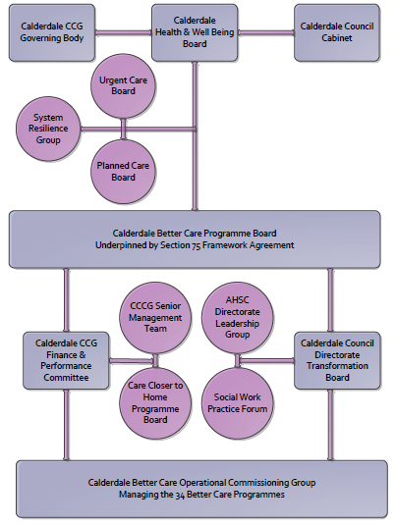

3. Finance
- Contributions to the fund are from CCCG
- 15/16 funding £800k

4.0 Impact of scheme
Assurance and monitoring arrangements (common wording across all schemes? Or at least for CCCG and CMBC schemes?)
a) Performance (KPIs – BCF and other local?)
b) Baseline figures
c) Target activity (monthly/quarterly/annual)
d) Phasing of change
A population segmentation and impact exercise was carried out following the NHSE tool supplied in the 'How to Guides'. It should be noted that each scheme within BCF will not in isolation provide the impact on the headline metric detailed here. It is the combination of these schemes, the Qipp Programme and the interdependencies across the services which will provide the whole improvement. Each of the schemes that form part of the BCF plan for Calderdale has a number of additional measures that will be routinely collected to evaluate the impact of the scheme on the Calderdale population.
Headline BCF Metric for this scheme
Reduction in permanent residential admissions
Supplementary Operational Metrics are:
Increased effectiveness of reablement
Reduction in delayed transfers of care
Reduction in non-elective (NEL) (general + acute only)
Assurance and monitoring arrangements are shown below:
a) KPI Targets
Key BCF Indicator – increase in the number of people still at home 91 days after discharge
Supporting indicators: - extract detail from list below
do we have any targets for each of these to add in to the KPIs or is it simply a reduction/increase on the 2014/15 levels?
b) Baseline figures




- Target activity (monthly/quarterly/annual)

% bed occupancy perhaps 80% rolling average

Number of people referred per month

Average length of stay
d) Phasing of change
The scheme is fully up and running and in place for the whole of 2015/16

