Section 75 Partnership Framework Agreement – Schedule 4
Individual Scheme Specification

BCF Scheme Reference | S4PO1
Scheme name | Residential Transitional Beds
Lead Commissioner (CMBC/CCG) | Calderdale MBC
Fund Manager (Senior Responsible Officer) | Rachel Russell
Commencement of particular service | 01/04/2105
£ Value in 2015/16 | £186,260
Contract or in house | Contract
Provider | Anchor Trust (Trinity Fold)
Contract term | Ongoing

1.0 Introduction
Transitional & Resettlement Support provides a supportive environment whilst individuals are able to continue their period of convalescence and recovery as arrangements for support at home and housing options are fully mobilised.
Numbers of beds are flexed up and down in response to seasonal demand in line with Urgent Care Partnership Surge Escalation Protocols. They are managed through Gateway to Care, as are the Intermediate Care Beds and, as they go live, the Heatherstones Units. This enables Gateway as the SPA to make good decisions on resource allocation to match presenting system demands and match the resource to the personalised support needs of individuals who require support
The function of the Transitional Resettlement Support includes:
- Agreeing with the person, their family and the Intermediate Care Social Worker a personalised support plan for their transitional support within a residential care setting. The support plan details how the person wants to achieve their outcome of independence and a return home.
- Providing personalised transitional support as detailed in the support plan. The support plan covers a period of up to 4 weeks within the residential care setting, however a person can return home prior the end of the 4 week period.
- With the individual and their family, proactively reviewing progress against the support plan The focus of the review is to build the person’s, and where necessary the families, confidence as they they are achieve their outcomes and are ready for a sustained return to independence at home.
- Liaising weekly with the allocated Intermediate Care Social Worker to update on progress and advise when the person is ready for a return home.
- Contributing to MDT discharge planning arrangements, being coordinated by the allocated Intermediate Care Social Worker.
- Agreeing with the person, their family and the Intermediate Care Social Worker resettlement, and a post discharge plan, which Is detailed within the community support plan.
- Providing personalised resettlement support as detailed in the support plan, for a period of up to 7 days.
- Contributing to meeting long term care and support needs for personal budget holders (or where appropriate self funders) who have sustained a return to independence at home through access to a range of follow on support services such as personal care or purposeful day activities.
The evidence base for Intermediate Care is well-developed in a number of key documents which are listed below:
- Prevention Package for Older People (2009)
- Intermediate Care - Halfway Home (2009)
- A vision for adult social care (2010)
- Transforming Community Services: Ambition, Action, Achievement - Transforming Rehabilitation Services (2010)
- Think Local, Act Personal (2010)
- SCIE Research Briefing (2011) Reablement: A Cost-Effective route to better outcomes http://www.scie.org.uk/publications/briefings/briefing36/
- Making it Real (2013)
- NHS Benchmarking (2013) http://www.nhsbenchmarking.nhs.uk/partnership-projects/National-Audit-of-Intermediate-Care/year-two.php
- Calderdale Adult Social Care Vision (2013)
- Calderdale Dementia Strategy Refresh (2013)
- Calderdale Adult Social Care Market Position Statement (2014)
- Calderdale Health & Well Being Board Better Care Plan (2014)

2.0 Governance (show which committee scheme is reported to/insert standard diagram of relevant CCCG/CMBC oversight committee)

Governance reporting for this scheme is made to the Calderdale BCF Operational Commissioning Group and escalated as necessary.

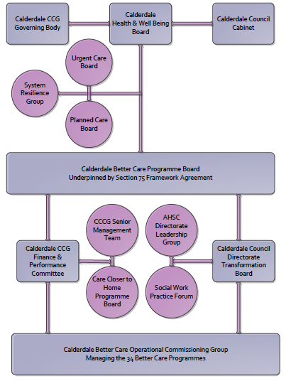

3. Finance
- Contributions to the fund are from CCCG or CMBC?
- 15/16 funding £186,260
- Full year effect if part year in 15/16 £
- Arrangements for managing over and underspends (xref to main framework but may have different arrangements for different schemes?)
- Financial governance arrangements, audit (may be standard for CCCG or CMBC)
- VAT

4.0 Impact of scheme
Assurance and monitoring arrangements (common wording across all schemes? Or at least for CCCG and CMBC schemes?)
A population segmentation and impact exercise was carried out following the NHSE tool supplied in the 'How to Guides'. It should be noted that each scheme within BCF will not in isolation provide the impact on the headline metric detailed here. It is the combination of these schemes, the Qipp Programme and the interdependencies across the services which will provide the whole improvement. Each of the schemes that form part of the BCF plan for Calderdale has a number of additional measures that will be routinely collected to evaluate the impact of the scheme on the Calderdale population.
Headline BCF Metric for this scheme
Reduction in delayed transfers of care
Supplementary Operational Metrics are:
- Improvement in the proportion of older people who recover their independence after illness or injury.
- Helping people to recover from episodes of ill health or following injury through improving the rates of people experiencing recovery from stroke.
- Reduced number of people who experience delays in their transfers of care from hospital, including those which are attributable to adult social care
- Proportion of older people (65 and over) who were still at home 91 days after discharge from hospital into reablement rehabilitation services
- Improved proportion of people who are fully independent when they complete their reablement programme.

