Section 75 Partnership Framework Agreement – Schedule 3
Individual Scheme Specification

BCF Scheme Reference | S3PO4
Scheme name | Care Act (214) new statutory duties – implementation and review costs
Lead Commissioner (CMBC/CCG) | Calderdale MBC
Fund Manager (Senior Responsible Officer) | Elaine James
Commencement of particular service | Ongoing
£ Value in 2015/16 | £542,000
Contract or in house | In-house
Provider | CMBC
Contract term | Ongoing

1.0 Introduction
Outline of scheme (what is it we are actually doing?)
The Care Act (2014) received Royal Assent in 2014. From April 2015 adult social care (ASC) will have a new legal framework putting the wellbeing of individuals at the heart of care and support services. The Act replaces more than a dozen pieces of legislation with a single modern law. The Care Act sets out key proposals for reforming the way in which adult social care is funded. As a result much of the discussion and analysis of the Act has been in relation to the proposed Care Cap, which limits the lifetime costs an individual has to pay for their care, and the accompanying infrastructure required to manage the cap. Work is underway led by the Council’s Business Change and Performance Management team to finalise local modeling of the potential financial impact of the proposed changes in Calderdale. The Care Act shall also impact upon the duties and functions provided by the Council’s Adults, Health & Social Care Directorate in conjunction with other Council Services including Housing and Income Services. Processes and practices will need to be reviewed to ensure that they are not only compliant with the new legislation but will enable us to deliver the changes required.
The AHSC Care Act (2014) Readiness Programme Board provides the architecture for oversight and governance of implementation of the new duties resulting from the Care Act. The Programme is subject to a detailed, clause by clause impact and risk assessment. The Programme Board has agreed a detailed Implementation Programme which is supported by an Operational Implementation Working Group and a series of Task & Finish Groups on specific areas of change.

Timelines for Implementation of the Care Act (2014)
The majority of the new legislation will come into effect in April 2015. The requirements related to the capped charging and extended means test will come into effect a year later in April 2016.

TABLE 10 – CARE ACT – IMPLEMENTATION PROGRAMME

Key Requirements & Calderdale Implementation Programme Impact Assessment & Progress Rating | Time scale
Duties on information and advice (including advice on paying for care | April 2015
Duties on prevention and wellbeing | April 2015
Duty on market shaping & provider failure | April 2015
National minimum threshold for eligibility | April 2015
Assessments (including carers assessments) | April 2015
Personal budgets and care and support plans | April 2015
Safeguarding | April 2015
New charging framework | April 2015
Universal Deferred Payment Agreements | April 2015
Extended means test | April 2016
Capped charging system | April 2016
Care Accounts | April 2016

2.0 Governance (show which committee scheme is reported to/insert standard diagram of relevant CCCG/CMBC oversight committee)
Governance oversight of the Care Act (2014) implementation programme takes place through the AHSC Transformation Board. The Board reports into the AHSC Directorate Leadership Group.
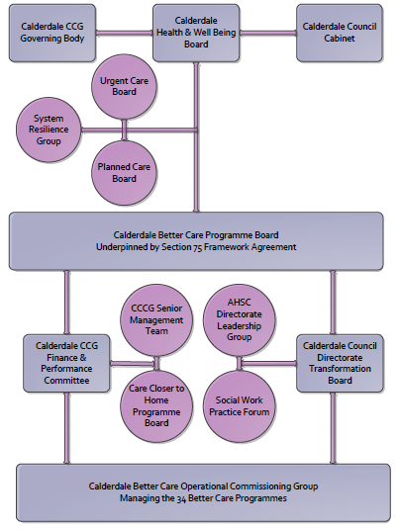

AHSC Transformation Board (Care Act (2014) Readiness Programme)
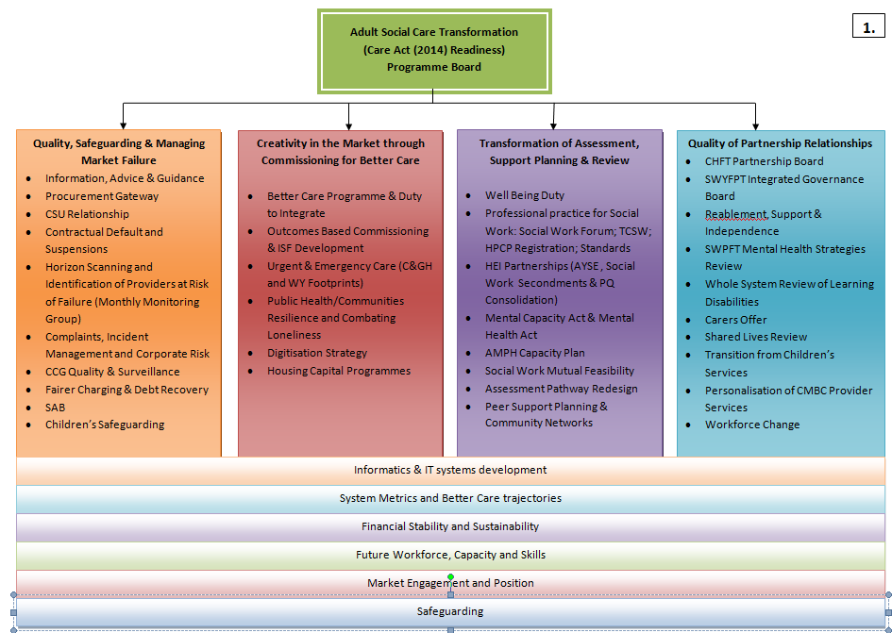
3. Finance
- Contributions to the fund are from CCCG or CMBC? CCCG
- 15/16 funding £542,000
- Full year effect if part year in 15/16 – N/A mandated level by Department of Health

4.0 Impact of scheme
Assurance and monitoring arrangements (common wording across all schemes? Or at least for CCCG and CMBC schemes?)
- Performance (KPIs – BCF and other local?)
- Baseline figures
- Target activity (monthly/quarterly/annual)
- Phasing of change

A population segmentation and impact exercise was carried out following the NHSE tool supplied in the 'How to Guides'. It should be noted that each scheme within BCF will not in isolation provide the impact on the headline metric detailed here. It is the combination of these schemes, the Qipp Programme and the interdependencies across the services which will provide the whole improvement. Each of the schemes that form part of the BCF plan for Calderdale has a number of additional measures that will be routinely collected to evaluate the impact of the scheme on the Calderdale population.

Headline BCF Metric for this scheme
- Reduction in permanent residential admissions

Supplementary Operational Metrics are:
- ASCOF 1ci Proportion of people using social care who receive self directed support
- ASCOF 1cii Proportion of people using social care who receive Direct Payments
- ASCOF 1e Proportion of adults with learning disabilities in paid employment
- ASCOF 1f Proportion of adults in contact with secondary mental health services in paid employment
- ASCOF 1g Proportion of people with learning disabilities who live in their own home or with their family
- JWS2c Proportion of people who use services who have control over their daily life in Calderdale (ASCOF 1b)
- JWS3 Number of older people receiving formal community care assessments - provisional
- ASCOF 2ai Permanent admissions to residential care home, per 100,000 of the population (18-64)
- ASCOF 2aii Permanent admissions to residential care homes, per 100,000 of the population (65+)
- ASCOF 2bi Proportion of older people still at home 91 days after discharge (effectiveness of service)
- Delayed transfers of care from hospitals per 100,000 population - all agencies
- ASCOF 2cii Delayed transfers of care from hospital per 100,000 population – adult social care
- CA 3.3a Number of people with a LD in out of area placements funded by the LA
- CA 4.1b Percentage of people fully reabled through reablement
- CA 4.2a Number of dedicated carers’ assessments undertaken
- CA 4.2b Joint carers’ assessments (undertaken at the same time as the service user assessment
- CA 4.1a People accepted into reablement
- JWS1 Number of emergency admissions for patients over 65 – Provisional
- CA 1.4d The percentage of safeguarding alerts received that are dealt with in accordance with timescale requirements
- CA 1.4e The percentage of safeguarding referrals which are decisioned within timescales
- CA 1.4f The percentage of safeguareding referrals where the investigation is completed within 7 weeks of the referral decision being made

Baseline Performance:
Polarity: High is good

ASCOF 1ci Proportion of people using social care who receive self directed support
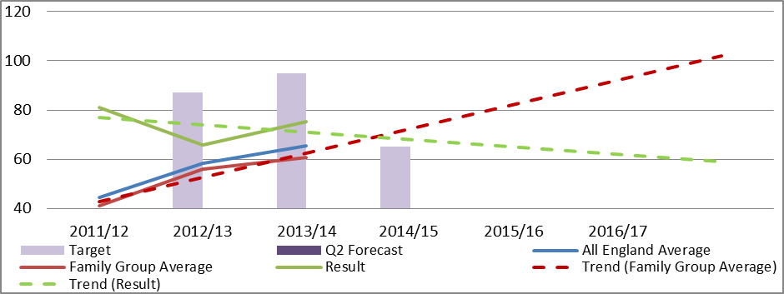
Polarity: High is good

ASCOF 1cii Proportion of people using social care who receive Direct Payments
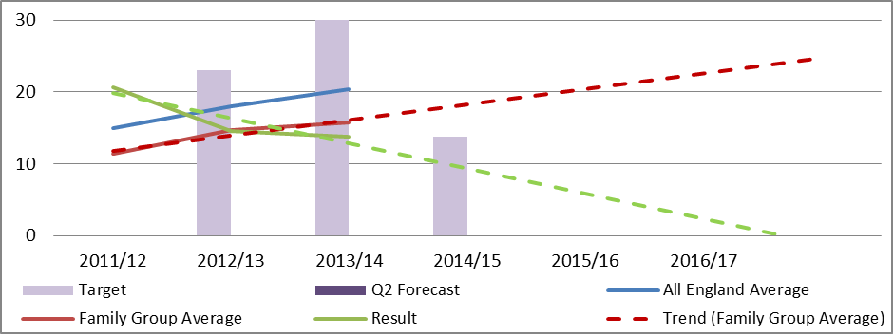
Polarity: High is good
JWS2c Proportion of people who use services who have control over their daily life in Calderdale (ASCOF 1b)
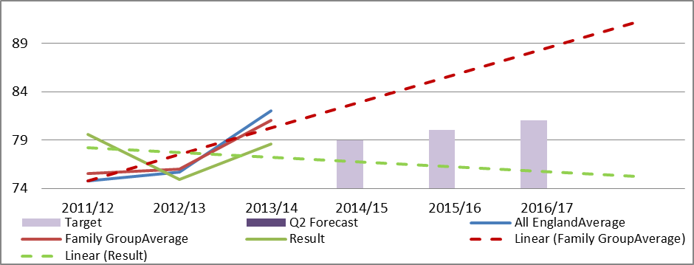
JWS3 Number of older people receiving formal community care assessments - provisional
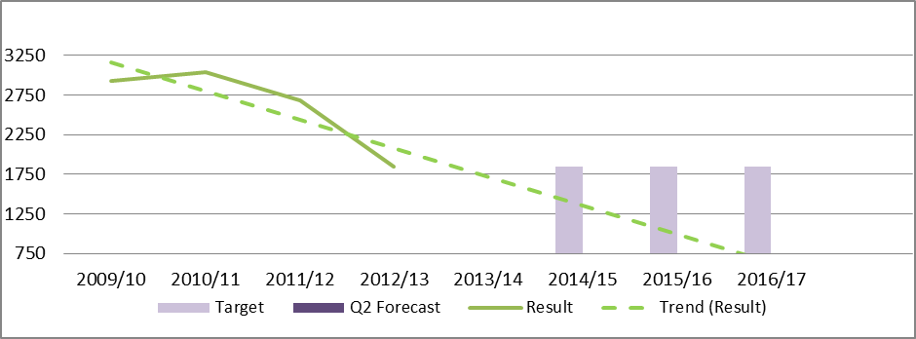Under
Polarity: Low is good

ASCOF 2ai Permanent admissions to residential care home, per 100,000 of the population (18-64)
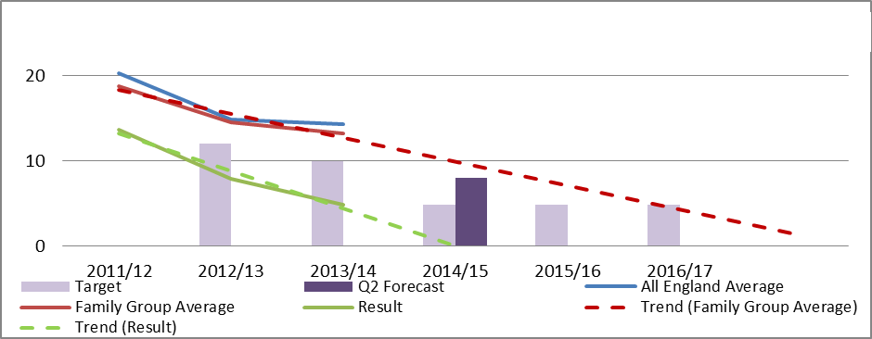
Polarity: Low is good

ASCOF 2aii Permanent admissions to residential care homes, per 100,000 of the population (65+)
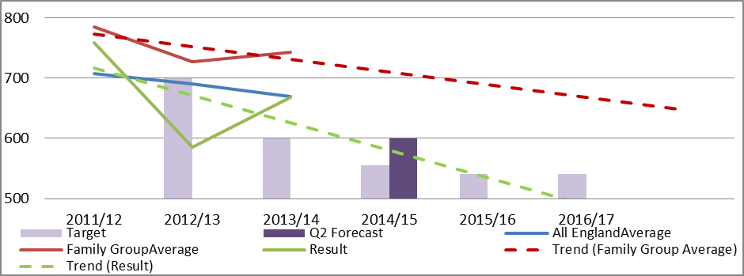
Polarity: High is good

ASCOF 1e Proportion of adults with learning disabilities in paid employment
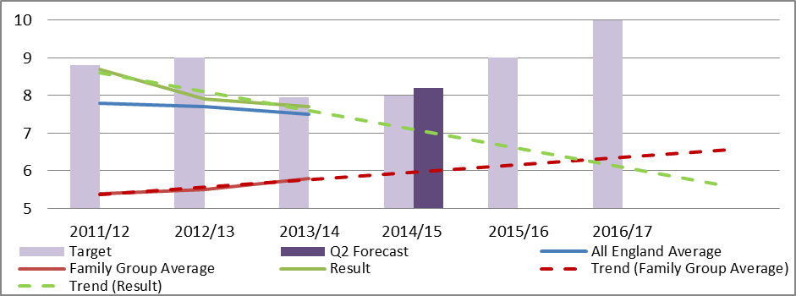
Polarity: High is good

ASCOF 1f Proportion of adults in contact with secondary mental health services in paid employment
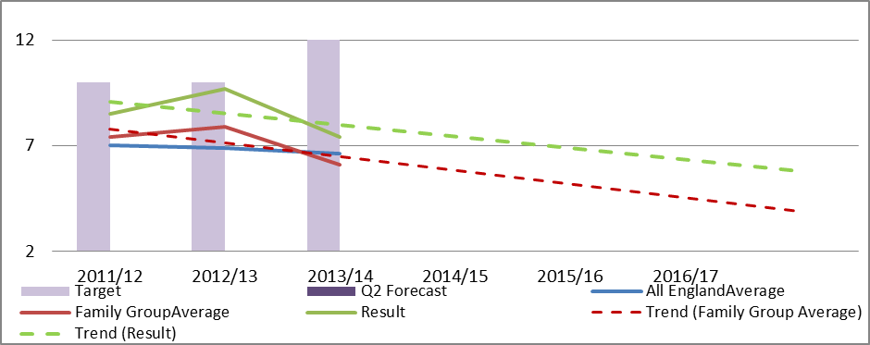
Polarity: High is good

ASCOF 1g Proportion of adults with learning disabilities who live in their own home or with their family.
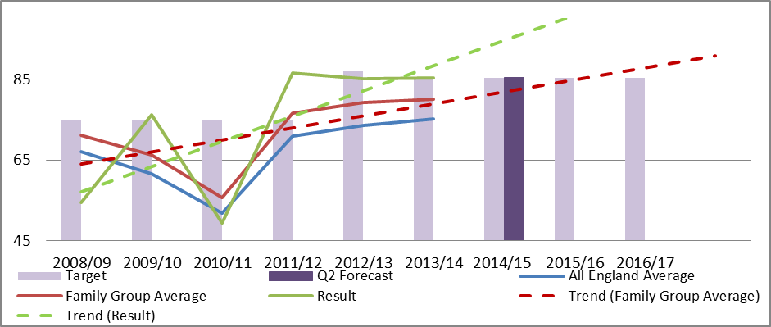
Polarity: High is good

ASCOF 2bi Proportion of older people still at home 91 days after discharge (effectiveness of service)
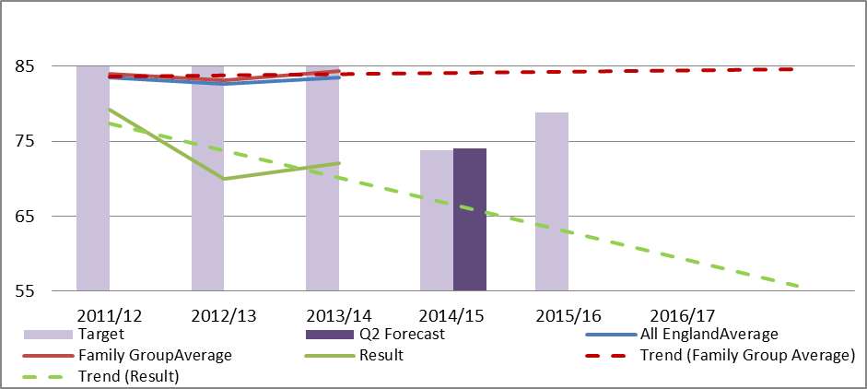
Polarity: Low is good

ASCOF 2ci Delayed transfers of care from hospital per 100,000 population – all agencies
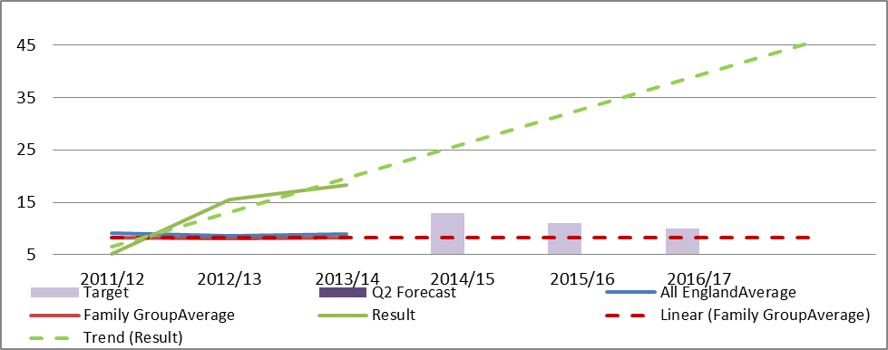
Polarity: Low is good

ASCOF 2cii Delayed transfers of care from hospital per 100,000 population – adult social care
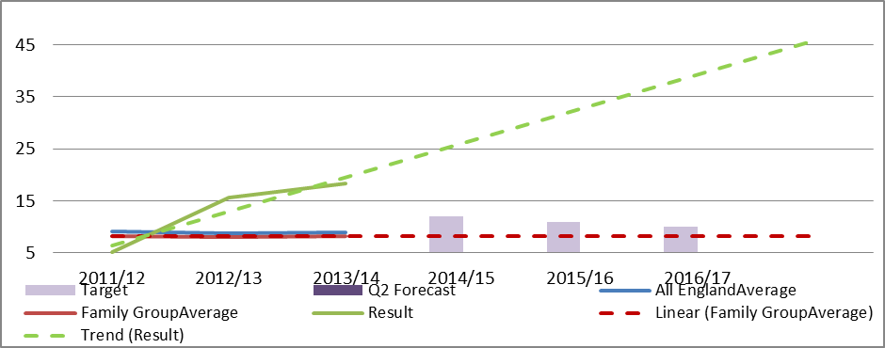
Polarity: Low is good

CA 3.3a Number of people with a LD in out of area placements funded by the LA
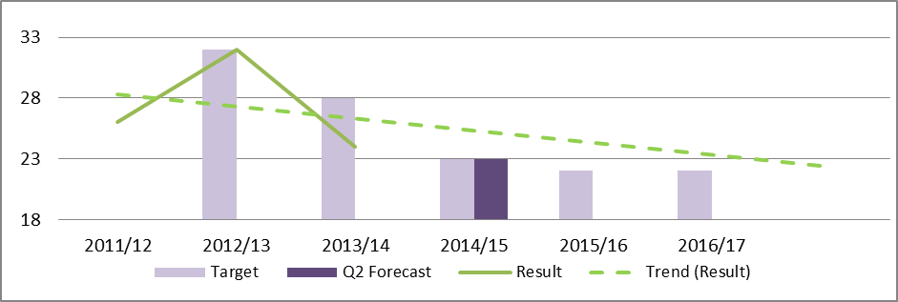
Polarity: High is good

CA 4.1b Percentage of people fully reabled through reablement
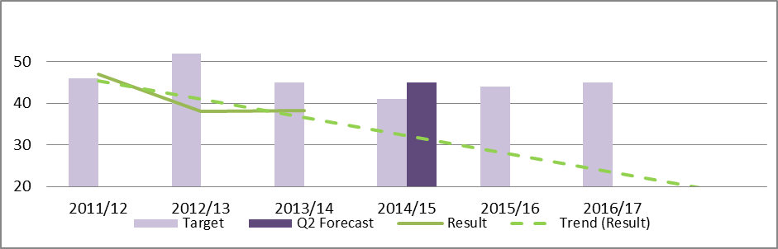
Polarity: High is good

CA 4.2a Number of dedicated carers’ assessments undertaken
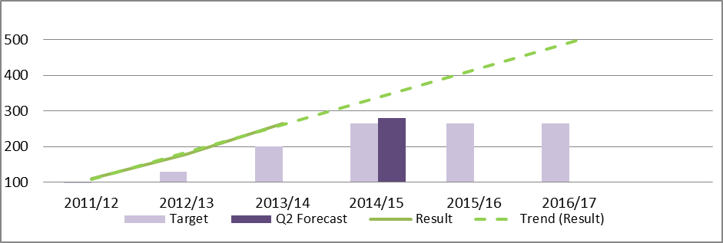
Polarity: High is good
CA 4.2b Joint carers’ assessments (undertaken at the same time as the service user assessment)
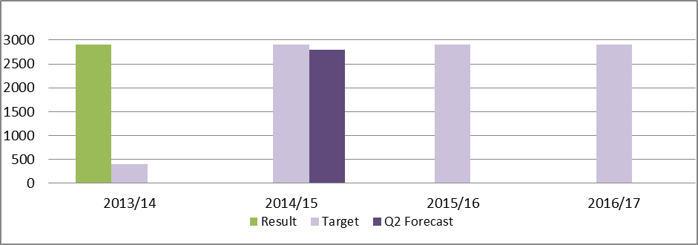
Polarity: High is good
CA 4.1a People accepted into reablement
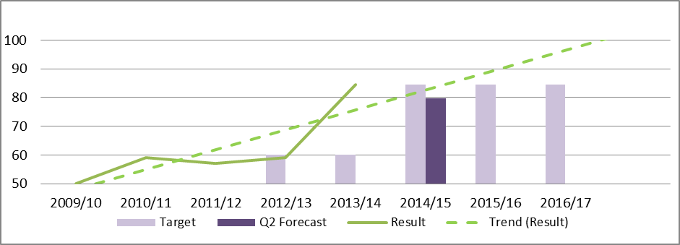
Polarity: Low is good

JWS1 Number of emergency admissions for patients over 65 - Provisional
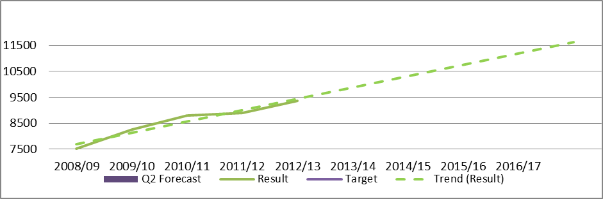
Polarity: High is good

CA 1.4d The percentage of safeguarding alerts received that are dealt with in accordance with timescale requirements
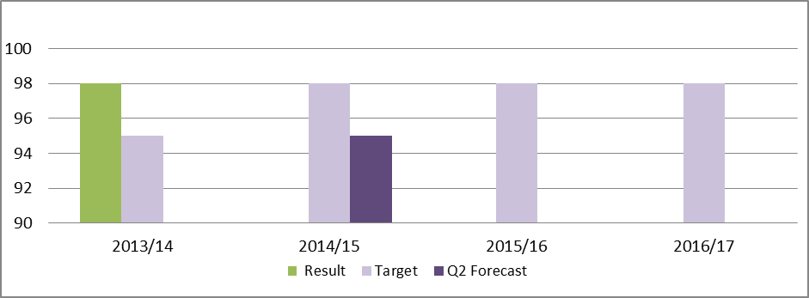
Polarity: High is good

CA 1.4e The percentage of referrals which are decisioned within timescales
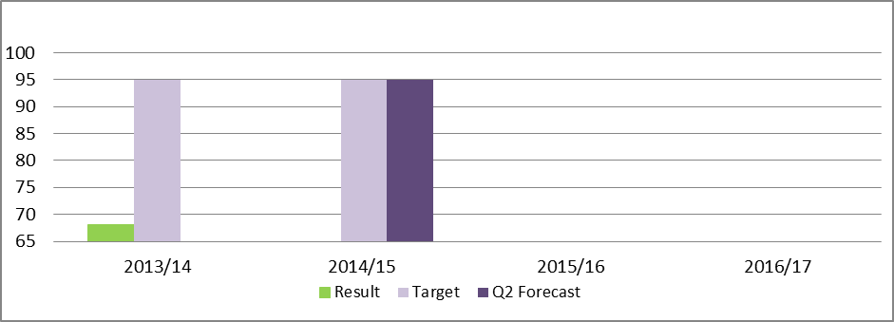

Polarity: High is good

CA 1.4f The percentage of referrals where the investigation is completed within 7 weeks of the referral decision being made
