Section 75 Partnership Framework Agreement – Schedule 3
Individual Scheme Specification

BCF Scheme Reference | S3PO3
Scheme name | Demographic Growth Pressures for Personal Budgets
Lead Commissioner (CMBC/CCG) | Calderdale MBC
Fund Manager (Senior Responsible Officer) | Elaine James
Commencement of particular service | Ongoing
£ Value in 2015/16 | £950,000
Contract or in house | In-house
Provider | CMBC
Contract term | Ongoing

1.0 Introduction
Outline of scheme (what is it we are actually doing?)
Protecting social care services in the Borough means ensuring that those in need within our local communities continue to receive the support they require, in a time of growing demand and budgetary pressures.

Whilst maintaining current eligibility criteria is one aspect of this, our primary focus is on developing new forms of person centred, coordinated support which help ensure that individuals remain healthy and well, and have maximum independence, with benefits to both themselves and their communities, and the local health and care economy as a whole.

By proactively intervening to support people at the earliest opportunity and ensuring that they are resilient, resourceful, are engaged in the management of their own wellbeing, and wherever possible enabled to stay within their own homes, our focus is on protecting and enhancing the quality of care by tackling the causes of ill-health and poor quality of life, rather than simply focussing on the supply of services.

2.0 Governance (show which committee scheme is reported to/insert standard diagram of relevant CCCG/CMBC oversight committee)
Oversight of the demand pressures on adult social care arising from demographic growth are being managed within the Care Act (2014) implementation programme which reports into the AHSC Transformation Board. The AHSC Transformation Board reports into the AHSC Directorate Leadership Group and on into the BCF Programme Board and System Resilience Group.
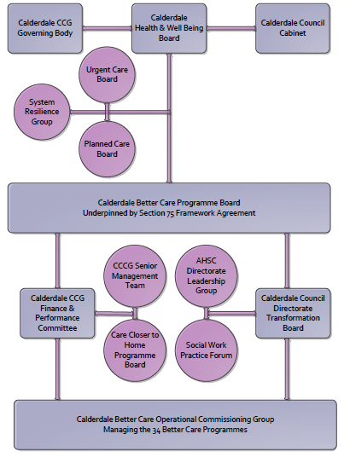

AHSC Transformation Board Architecture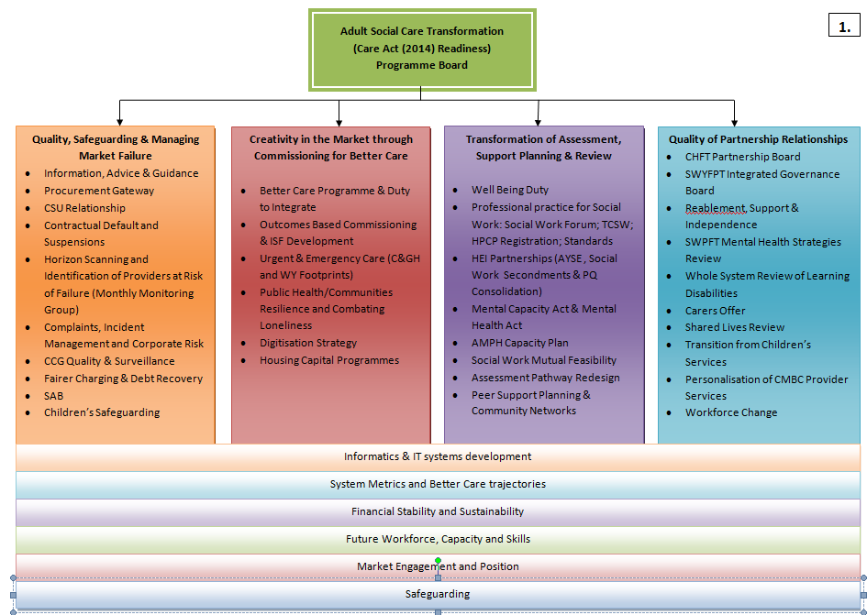
3. Finance
- Contributions to the fund are from CCCG or CMBC? CCCG
- 15/16 funding £950,000
- Full year effect if part year in 15/16 – N/A

4.0 Impact of scheme
Assurance and monitoring arrangements (common wording across all schemes? Or at least for CCCG and CMBC schemes?)
- Performance (KPIs – BCF and other local?)
- Baseline figures
- Target activity (monthly/quarterly/annual)
- Phasing of change
A population segmentation and impact exercise was carried out following the NHSE tool supplied in the 'How to Guides'. It should be noted that each scheme within BCF will not in isolation provide the impact on the headline metric detailed here. It is the combination of these schemes, the Qipp Programme and the interdependencies across the services which will provide the whole improvement. Each of the schemes that form part of the BCF plan for Calderdale has a number of additional measures that will be routinely collected to evaluate the impact of the scheme on the Calderdale population.

Headline BCF Metric for this scheme
Reduction in permanent residential admissions
Supplementary Operational Metrics are:
- ASCOF 1ci Proportion of people using social care who receive self directed support
- ASCOF 1cii Proportion of people using social care who receive Direct Payments
- ASCOF 1g Proportion of people with learning disabilities who live in their own home or with their family
- JWS3 Number of older people receiving formal community care assessments – provisional
- CA 4.2a Number of dedicated carers’ assessments undertaken
- CA 4.2b Joint carers’ assessments (undertaken at the same time as the service user assessment

Baseline Performance:
Polarity: High is good

ASCOF 1ci Proportion of people using social care who receive self directed support
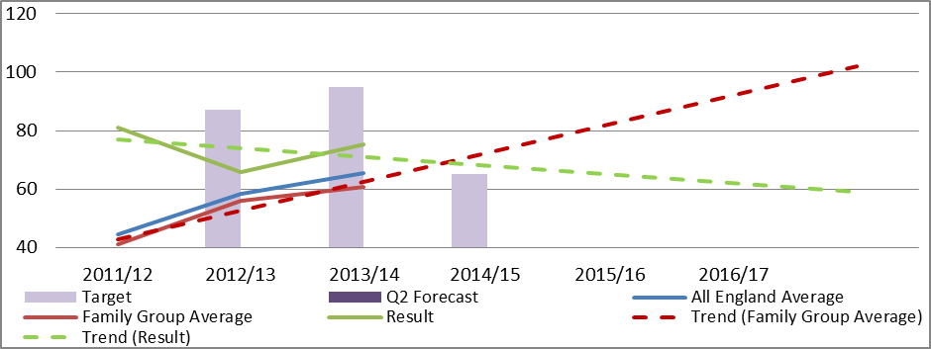
Polarity: High is good

ASCOF 1cii Proportion of people using social care who receive Direct Payments
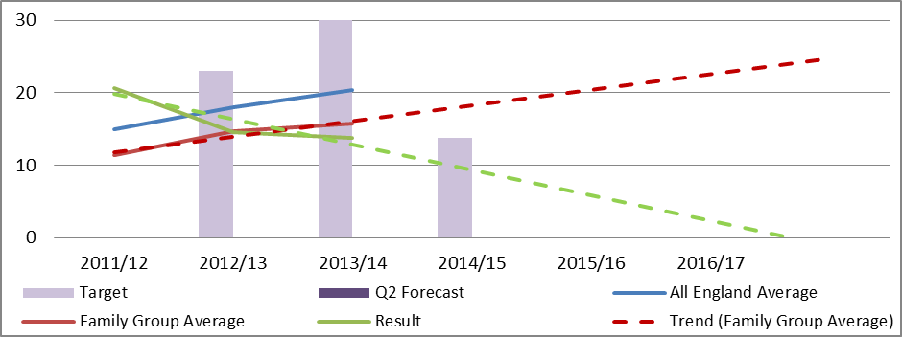
JWS3 Number of older people receiving formal community care assessments - provisional
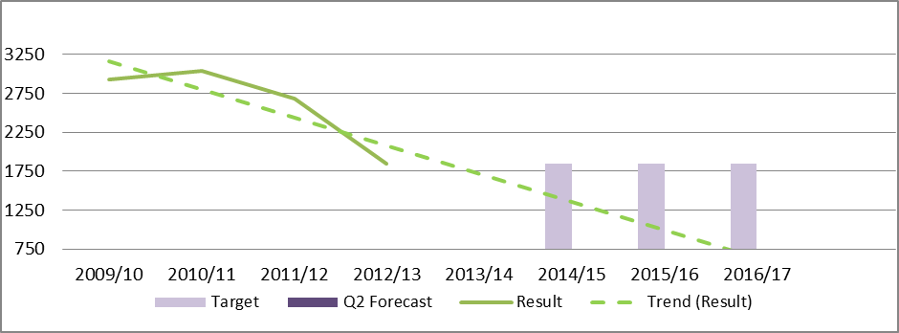Under
Polarity: High is good

ASCOF 1g Proportion of adults with learning disabilities who live in their own home or with their family.
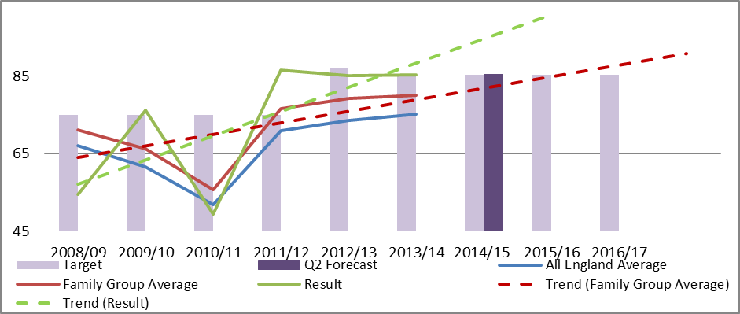
Polarity: High is good

CA 4.2a Number of dedicated carers’ assessments undertaken
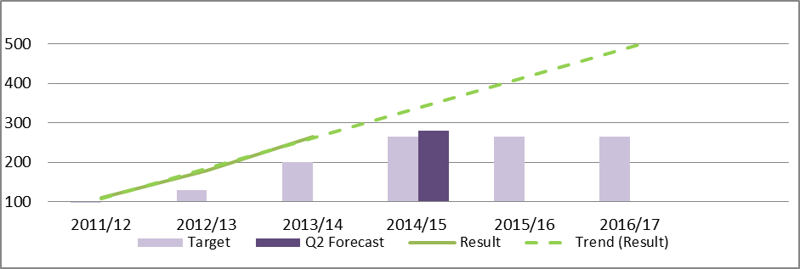
Polarity: High is good
CA 4.2b Joint carers’ assessments (undertaken at the same time as the service user assessment)
