Section 75 Partnership Framework Agreement – Schedule 3
Individual Scheme Specification

BCF Scheme Reference | S3PO2
Scheme name | Case Management: Social Work Assessments
Lead Commissioner (CMBC/CCG) | Calderdale MBC
Fund Manager (Senior Responsible Officer) | Rob Mitchell
Commencement of particular service | Ongoing
£ Value in 2015/16 | £657,810
Contract or in house | In-house
Provider | CMBC
Contract term | Ongoing

1.0 Introduction
Outline of scheme (what is it we are actually doing?)
Social work and the work of social workers will continue to evolve to ensure that it meets the challenge of the necessary changes and remains relevant and at the heart of the customer journey. However CIPF benchmarking indicates that Calderdale spends proportionally significantly lower than the family group average on qualified workers.
The social work profession and the values inherent in professional social work are crucial to the delivery of the new model. The status and professional standing of social work will underpin the delivery of the model with a Mutual as a new organisational form for delivery of a community social work approach. Social workers within the Community Social Work Mutual will be recognised as crucial members of the locality holistic team and their professional role and responsibility will be at the heart of multi-agency work and the interface between health and social care professionals and pathways. The Community Social Work Mutual will provide an opportunity for social workers to have a much greater say in their practice, work creatively, engage in community development and not just individual case work, and truly involve people who receive support in the running of services.
Social Workers will be professionally accountable and will be required to work in a number of different settings to ensure that people are supported to make decisions within a model that is truly positive in terms of risk-taking and upholds the fundamental rights of individuals to remain in control of their lives wherever possible in order to make choices and decisions that are right for them. Refocusing professional social work practice, based on values of anti-oppressive and anti-discriminatory practice, will ensure that customers receive the right level of professional support, protection from harm and strength to enable them to regain the balance of power away from the state.
The model will ensure that professional social work is proportionate in its response and that it works to build on existing and new networks of support that re-engage individuals with their community, family and friends wherever it is feasible. Whilst fully supporting individuals to make choices and regain control of their lives, social workers will be strong and skilled decision makers. They will signpost individuals, interpret eligibility, assess and manage risk, advocate for rights and be advanced practitioners in mental capacity and in safeguarding.
Demand for statutory assessment remains relatively high and work is continuing to slow down the conversations with people to secure better outcomes which optimise natural networks of support from family and community rather than making people dependent on statutory health and social care. The Community Social Work Practice Mutual will provide for a greater emphasis for adult social work shifting from a mind-set that sees eligible unmet needs as requiring paid support towards one that looks for solutions in people’s own resources and those of their community, an approach which is more empowering for people. The success of this approach is reflected in the trend towards reducing numbers of statutory assessments for a Personal Budget (see below) despite a 25% increase in the volume of demand for adult social care new referrals for social work assessment.
Under the Better Care Plan social workers will assume the role as named Allocated Lead Professional Worker for all adults who are assessed as needing 24 hour care and support within a residential or residential with nursing setting regardless of who is funding the placement, this will enable the Council to be better prepared to meet the Care Act (2014) new statutory duties in relation to self-funders. There are 1,500 care home beds available across the Borough operating in excess of an 85% occupancy rate. As of August 2014 45% of the available beds are filled by people placed by the Council and supported by a social worker. The indications are that there would need to be investment in an additional 40 social workers to fully meet the potential demand arising from the Care Act (2014).
2.0 Governance (show which committee scheme is reported to/insert standard diagram of relevant CCCG/CMBC oversight committee)
Oversight of the demand pressures for assessment on adult social care arising from demographic growth, new statutory entitlements for carers and self-funders which are being introduced under the Care Act (2014) from April 2015 and the 800 fold increase in Requests for Authorisation for Deprivation of Liberty Safeguards Best Interest assessments and reviews are being monitored and managed within the Care Act (2014) implementation programme which reports into the AHSC Transformation Board. The AHSC Transformation Board reports into the AHSC Directorate Leadership Group and on into the BCF Programme Board and System Resilience Group. The Social Work Forum has oversight of planning for workforce capacity and capability to respond to demand for assessment.
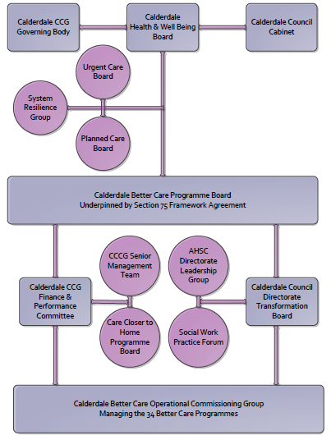

3. Finance
- Contributions to the fund are from CCCG or CMBC? CCCG
- 15/16 funding - £657,810
- Full year effect if part year in 15/16 – N/A

4.0 Impact of scheme
Assurance and monitoring arrangements (common wording across all schemes? Or at least for CCCG and CMBC schemes?)
- Performance (KPIs – BCF and other local?)
- Baseline figures
- Target activity (monthly/quarterly/annual)
- Phasing of change

A population segmentation and impact exercise was carried out following the NHSE tool supplied in the 'How to Guides'. It should be noted that each scheme within BCF will not in isolation provide the impact on the headline metric detailed here. It is the combination of these schemes, the Qipp Programme and the interdependencies across the services which will provide the whole improvement. Each of the schemes that form part of the BCF plan for Calderdale has a number of additional measures that will be routinely collected to evaluate the impact of the scheme on the Calderdale population.
Headline BCF Metric for this scheme
Reduction in permanent residential admissions
Supplementary Operational Metrics are:
- ASCOF 1ci Proportion of people using social care who receive self directed support
- ASCOF 1cii Proportion of people using social care who receive Direct Payments
- JWS2c Proportion of people who use services who have control over their daily life in Calderdale (ASCOF 1b)
- JWS3 Number of older people receiving formal community care assessments - provisional
- ASCOF 2ai Permanent admissions to residential care home, per 100,000 of the population (18-64)
- ASCOF 2aii Permanent admissions to residential care homes, per 100,000 of the population (65+)
- CA 1.4d The percentage of safeguarding alerts received that are dealt with in accordance with timescale requirements
- CA 1.4e The percentage of safeguarding referrals which are decisioned within timescales
- CA 1.4f The percentage of safeguareding referrals where the investigation is completed within 7 weeks of the referral decision being made

Baseline Performance:
Polarity: High is good

ASCOF 1ci Proportion of people using social care who receive self directed support
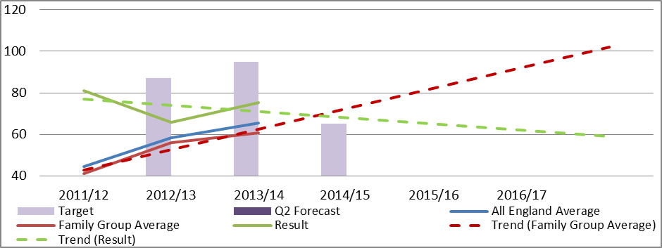
Polarity: High is good

ASCOF 1cii Proportion of people using social care who receive Direct Payments
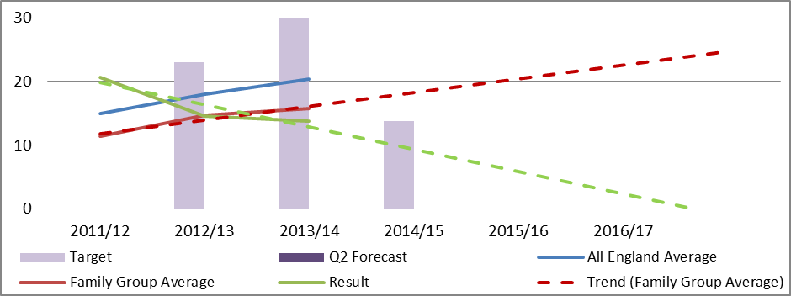
Polarity: High is good
JWS2c Proportion of people who use services who have control over their daily life in Calderdale (ASCOF 1b)
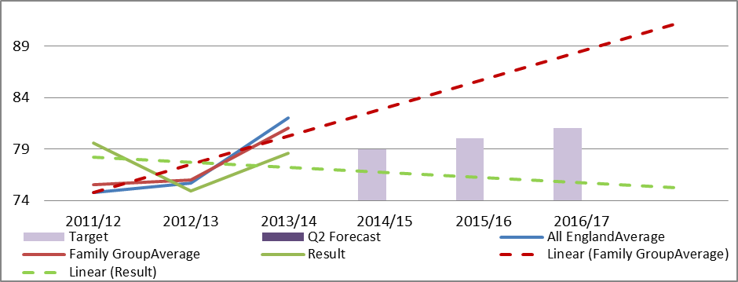
JWS3 Number of older people receiving formal community care assessments - provisional
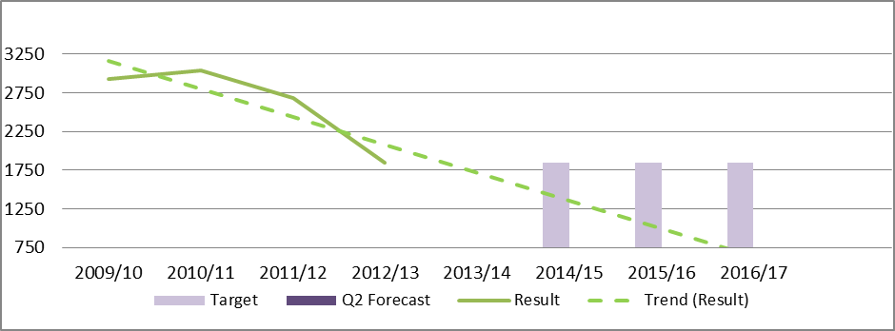Under
Polarity: Low is good

ASCOF 2ai Permanent admissions to residential care home, per 100,000 of the population (18-64)
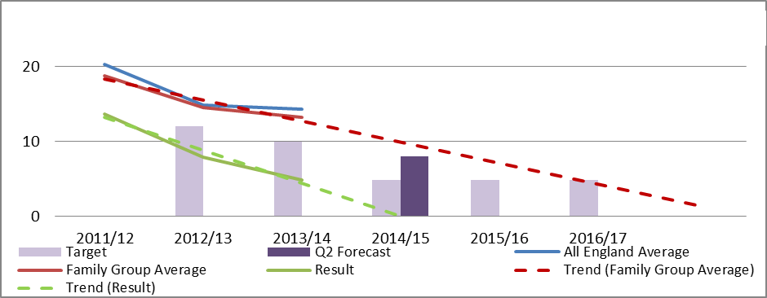
Polarity: Low is good

ASCOF 2aii Permanent admissions to residential care homes, per 100,000 of the population (65+)
