Section 75 Partnership Framework Agreement – Schedule 3
Individual Scheme Specification
BCF Scheme Reference | S3PO1
Scheme name | Case Management: Allocated Lead Professional Worker for 75+ in General Practice
Lead Commissioner (CMBC/CCG) | Calderdale Clinical Commissioning Group
Fund Manager (Senior Responsible Officer) | Debbie Robinson
Commencement of particular service | 01/04/15
£ Value in 2015/16 | £1,050,000
Contract or in house | Contract
Provider | General Practice.
Contract term | Existing contract due to end 31st March 2015

1.0 Introduction
Outline of scheme (what is it we are actually doing?)
This service seeks to address unwarranted variation in the management of patients aged 75 and over and subsequent reduce rates of non-elective admissions for this cohort of patients across Calderdale.
A key element of this service aims to increase confidence and self-reliance by promoting self-care techniques and giving health promotion advice (e.g. healthy eating, exercise advice). In addition to provide links to local organisations and support groups to help those patients who may be isolated and live alone.
This is a preventative intervention which intends to increase the effectiveness of primary care services (i.e. reduce emergency attendance and admission resulting from poor long term condition management) and support people to stay well, therefore reducing reliance on secondary care services.
Also describe the:
- Evidence base: In a recent Study undertaking by the Kings Fund, evidence suggests that a holistic approach to the care of elderly patients can be of great benefit to the patient and their carers.

- Aims and Outcomes of the scheme:
• All patients aged over 75 will have an annual health assessment
• To improve out of hospital care for patients
• Improve independence
• Reduction on 30 day readmission rates for this cohort of patients
• Reduction in admissions for patients aged 75 and over with ambulatory care sensitive conditions (ACS) and Conditions not requiring admission (CNRA).
- The service seeks to address variation in the management of the target cohort of patients and subsequent rates of non-elective admissions for ambulatory care sensitive (ACS) and Conditions not requiring admission (CNRA) across GP practices in Calderdale.

- Population/service users to whom the scheme will relate:
- All patients aged 75 and over registered with a general practice in Calderdale.

- Council or CCG functions which are the subject of the scheme including where appropriate the delegation of such functions for the commissioning of the relevant service

- Any plans or agreed actions to change the services

- Other schemes with interdependencies

- Duration and exit strategy
- Seven months. 1st September 2014 – 31st March 2014, a review of the pilot’s effectiveness will take pace to consider commissioning this service on a recurrent basis from the 1st April 2015.

- Information sharing and communication:
The provider is required to:-
• Actively gather patient/carer experience data
• review patient/carer experience data on a quarterly basis, make recommendations where appropriate and act on them
• make available to the CCG patient/care experience intelligence when requested
2.0 Governance (show which committee scheme is reported to/insert standard diagram of relevant CCCG/CMBC oversight committee)
This Scheme is performance managed by the CCG’s QIPP Monitoring Group which reports into the CCG’s Finance and Performance Committee. Members of the CCG’s QIPP Monitoring Group are also members of the BCF Operational Commissioning Group and BCG Programme Board where actions to mitigate the likelihood and impact of risks to delivery of BCF objectives and outcomes are overseen and schemes are performance managed.

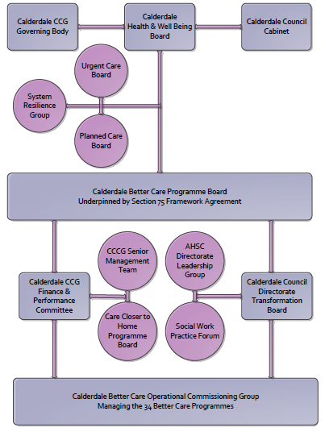

3. Finance
- Contributions to the fund are from CCCG or CMBC? The total budget for this service is £1,079,625. The resource to fund the service is covered in the CCGs financial plan for 2014/15.
- 15/16 funding £see G
- Full year effect if part year in 15/16 £
- Arrangements for managing over and underspends (xref to main framework but may have different arrangements for different schemes?)
- Financial governance arrangements, audit (may be standard for CCCG or CMBC)
- VAT

4.0 Impact of scheme
Assurance and monitoring arrangements (common wording across all schemes? Or at least for CCCG and CMBC schemes?)

A population segmentation and impact exercise was carried out following the NHSE tool supplied in the 'How to Guides'. It should be noted that each scheme within BCF will not in isolation provide the impact on the headline metric detailed here. It is the combination of these schemes, the Qipp Programme and the interdependencies across the services which will provide the whole improvement. Each of the schemes that form part of the BCF plan for Calderdale has a number of additional measures that will be routinely collected to evaluate the impact of the scheme on the Calderdale population.
Headline BCF Metric for this scheme
- Reduction in non-elective (NEL) (general + acute only)

Supplementary Operational Metrics are:

Description | Measure
The number of patients aged 75 and over who have been invited for an annual health assessment | Evidence will be required that a minimum of 3 invitations will have been offered. Appropriate exception reporting for patients who have declined, not responded or are except from invitation based on clinical judgement.
The Number of patients who have received a holistic health assessment | Practices are to record attendance/review in patient record to demonstrate % done against 75 and over register size
The number of patients aged 75 or over with yearly flu vaccinations | Overall % achievement Flu seasonal vaccination program based on World Health Organisation Targets 2014/15
Number of holistic care plans in place and shared with the patient and or carer | Practices will need to record an entry in the patient’s record following assessment that demonstrates an agreed care plan is in place, where appropriate.
Post discharge review of patient discharge summary/discharge letter | Practices will need to identify patients 75 or over who have been discharged from secondary care and the % of these patients that have received a review within 3 days of receipt of the discharge summary, where it was deemed that a follow up or review is indicated.

