Section 75 Partnership Framework Agreement – Schedule 2
Individual Scheme Specification

BCF Scheme Reference | S2PO8
Scheme name | Preventative Home Support (CQC Registered Home Care)
Lead Commissioner (CMBC/CCG) | Calderdale MBC
Fund Manager (Senior Responsible Officer) | Elaine James
Commencement of particular service | 01/04/15
£ Value in 2015/16 | £500,000
Contract or in house | Contract
Provider | New outcomes based specification being implemented from 01.10.2014 for 3 Strategic Personalised Care & Support Partners operating within co-terminus boundaries with the locality reablement teams within the Support & Independence Teams. Providers are: TLC in Lower Valley; Mears Care in Central Halifax; North West in Upper Valley.
Contract term | 5 year term

1.0 Introduction
Outline of scheme (what is it we are actually doing?)
The Service is delivered across three Locality Areas with one Provider delivering all the care and support services commissioned by the Council in that Locality Area. Collaborative working with other organisations is encouraged.
The Service must be:
- Registered and regulated by the Care Quality Commission
- Meet personal outcomes for individuals receiving the service
- Maximise their independence
- Are reliable and consistent
- Are safe and sustainable
- Are delivered with dignity and respect
- Allow continuity of Care worker
- Are flexible and empower the Individual to exercise choice and control over all aspects of how their care and support is delivered
The Service Model is for the provider to work in partnership with Individuals, their families, carers and the Council’s social work teams to achieve measurable maintenance and change outcomes. This will require each party to share information about:
- Processes and services.
- Diagnosis and prognosis of ill health conditions where available.
- What approaches work best for the Individual as an expert in their own condition.
- The assets and resources that are available in an Individual’s natural support network and in their local community.
Some examples of the ways in which people wish to be supported by this service are listed below. This list is neither exhaustive nor needed in all cases, and will depend on how the Individual wishes to meet their agreed outcomes. It is also important to emphasise that the list below is not prescriptive and should not preclude imaginative and alternative solutions which may better suit an Individual.
Personal care
- Assisting to get up or go to bed.
- Washing, bathing, hair care, shaving, denture and mouth care.
- Hand and fingernail care, foot care, (excluding any aspect of nail care which requires a state registered chiropodist or podiatrist, surgical or cosmetic procedures).
- Assisting with skin care such as moisturising very dry skin.
- Dressing and undressing.
- Assisting with transfers from or to bed / chair / toilet.
- Assistance to use the toilet, including necessary cleaning and safe disposal of waste.
- Emptying or changing catheter or stoma bags.
- Moving and handling including using hoists and other equipment.
- Assistance with eating and drinking, including associated kitchen cleaning and hygiene.
Safe and well support
- Cleaning.
- Food or drink preparation.
- Dealing with correspondence.
- Assisting with taking medication
- Making beds and changing linen.
- Washing, drying and ironing.
- Disposing of household and personal rubbish.
- Cleaning areas used by pets subject to risk assessment.
- Assisting with the consequences of household emergencies, including liaison with local contractors.
- Lighting fires, boilers etc, subject to health and safety guidance.
- Assisting to access other services such as laundrette, gardening, shopping, home decoration, household odd jobs, etc.
- Assisting to maintain family and social relationships
- Connecting the Individual into community facilities and groups which match their interests e.g. to the local library
- Helping the Individual to handle their own money, including accompanying to the shop or to collect their own pension.
- Shopping, collecting pensions, benefits or prescriptions, paying bills or other simple errands on behalf of the Individual

2.0 Governance (show which committee scheme is reported to/insert standard diagram of relevant CCCG/CMBC oversight committee)
Oversight of the demand pressures on adult social care for packages of home care are being managed within the Care Act (2014) implementation programme which reports into the AHSC Transformation Board. The AHSC Transformation Board reports into the AHSC Directorate Leadership Group and on into the BCF Programme Board and System Resilience Group. The Urgent Care Board also keeps an active watching brief on this area of work through the Discharges work stream in order to monitor impact of demand and flow on into home care on transfer of care from hospital.
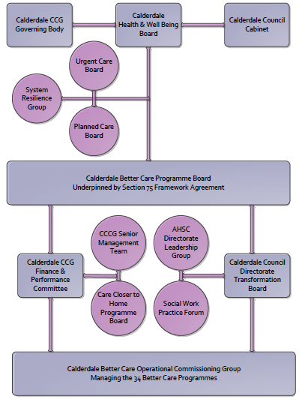

3. Finance
- Contributions to the fund are from CCCG or CMBC? CCCG
- 15/16 funding £500,000
- Full year effect if part year in 15/16 - N/A

4.0 Impact of scheme
Assurance and monitoring arrangements (common wording across all schemes? Or at least for CCCG and CMBC schemes?)
A population segmentation and impact exercise was carried out following the NHSE tool supplied in the 'How to Guides'. It should be noted that each scheme within BCF will not in isolation provide the impact on the headline metric detailed here. It is the combination of these schemes, the Qipp Programme and the interdependencies across the services which will provide the whole improvement. Each of the schemes that form part of the BCF plan for Calderdale has a number of additional measures that will be routinely collected to evaluate the impact of the scheme on the Calderdale population.
BCF Metric for this scheme
- Reduction in non-elective (NEL) (general + acute only)

Supplementary Operational Metrics are:
- Demand for new packages of home care (CQC registered domiciliary care) is continuous with 20 new referrals into brokerage per week from the reablement service within locality Support and Independence Teams.

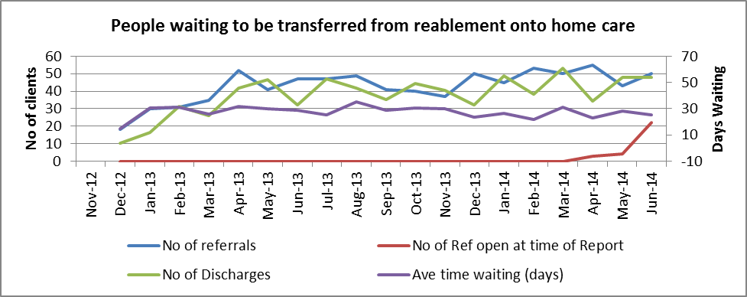

As of August 2014 887 people were receiving 9,57 hours per week of home care across the Borough at an average cost of £14 per hour. The average size of a package of care has increase slightly over the last year.

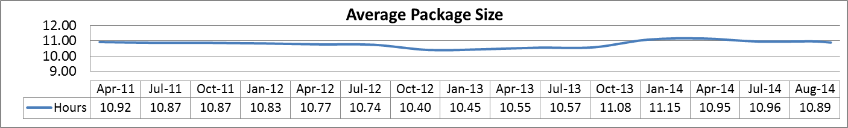

295 receive less than 5hours a week support. A sample audit of 30 of these cases showed that in the type of support provided for this cohort is in low level preventative support. 915 people who received home care support in the last year were within the Moderate Band under Fair Access to Care Service.





