Section 75 Partnership Framework Agreement – Schedule 2
Individual Scheme Specification

BCF Scheme Reference | S2PO7
Scheme name | Disabled Facilities Grants for Adaptations
Lead Commissioner (CMBC/CCG) | Calderdale MBC
Fund Manager (Senior Responsible Officer) | Helen Rhodes
Commencement of particular service | 01/04/15
£ Value in 2015/16 | £1,090,000 capital
Contract or in house | Contract
Provider | Supply chain of 200+ housing aids and adaptation providers
Contract term | N/A

Around 350-400 people with disabilities are referred to the Agency for assistance with major adaptations or relocation. Around 40-50 of these referrals will be from children’s services, the rest are adults.
Needs can be quite complex and may involve more than one resident with disabilities although commonly are due to age related disability with customers unable to get in or out of a bath or safely use a staircase.
The agency administrates mandatory Disabled Facilities Grants for adults and children, as well as providing alternative ways of meeting the access needs by discretionary grants and loans, assistance to households to relocate, and minor adaptations (see Handyperson Service) as appropriate. A further 500 pieces of lifting equipment are serviced and repaired annually.
During the survey and casework process, checks are made to ensure that the home is safe, hazard free, warm and affordable. If customers have needs which are not being met or finances are difficult, suitable referrals are made so that wider needs are met alongside the adaptations.
Agency staff talk to customers about the best way of meeting the needs for an accessible home environment prior to assisting with design and procurement of actual works or practical assistance with finding an alternative home. Around 40-50 households each year move to more suitable accommodation.
Around 300 households complete works funded for with mandatory Disabled Facilities Grants. Referrals from OTAS and Childrens Services are recorded along with key dates and personal information.
The aims outcomes of the scheme are
- Better managed independent living as a result of adaptations/minor repairs or planned house move

- Enhancing quality of life for people with disabilities
- Delaying and reducing the need for care and support
- Reduced admissions to residential care

- Reduced number of injuries due to falls
- Reduced emergency admissions to hospital
- Reduced re-admissions within 30 days of discharge from hospital
- Reduced hip fractures in over 65s
- Reduced visits to GP

Improvements to the processes for assessing needs are planned. Currently assessment of needs from occupational therapy is carried out largely in isolation from all other housing and financial needs. Arrangements for bring this area of assessment into the holistic needs assessment will make much more sense to the customers, be far more efficient and ultimately provide a better outcome for the customer.
The scheme is interdependent with S2P05 and S2P06 as well as wider housing services such as the Home Improvement Service.

2.0 Governance (show which committee scheme is reported to/insert standard diagram of relevant CCCG/CMBC oversight committee)

Governance reporting for this scheme is made to the Calderdale BCF Operational Commissioning Group and escalated as necessary.

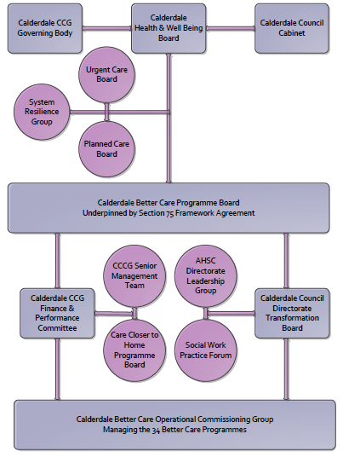

3. Finance
- Contributions to the fund are from CCCG or CMBC? CMBC
- 15/16 funding £1,090,000 capital
- Recurrent / Full year effect if part year in 15/16 £N/A
- Arrangements for managing over and underspends (xref to main framework but may have different arrangements for different schemes?)
- Financial governance arrangements, audit (may be standard for CCCG or CMBC) CMBC
- VAT Yes

4.0 Impact of scheme
Assurance and monitoring arrangements (common wording across all schemes? Or at least for CCCG and CMBC schemes?)
A population segmentation and impact exercise was carried out following the NHSE tool supplied in the 'How to Guides'. It should be noted that each scheme within BCF will not in isolation provide the impact on the headline metric detailed here. It is the combination of these schemes, the Qipp Programme and the interdependencies across the services which will provide the whole improvement. Each of the schemes that form part of the BCF plan for Calderdale has a number of additional measures that will be routinely collected to evaluate the impact of the scheme on the Calderdale population.
Headline BCF Metric for this scheme
- Reduction in non-elective (NEL) (general + acute only)

Supplementary Operational Metrics are:
Along with S2P05 and S2P06, EN04.8.a Number of people assisted to improve independence in their homes
Along with S2P05 and S2P06, EN04.8.b Average time of waiting for adaptations
- Baseline figures 2013/14
- EN04.8.a 2,185
- EN04.8.b 12 weeks

- Target activity (monthly/quarterly/annual)
EN04.8.a annual target 2,000
EN04.8.b annual target 11 weeks

.

