Section 75 Partnership Framework Agreement – Schedule 2
Individual Scheme Specification
BCF Scheme Reference | S2PO4
Scheme name | Community Equipment (inc Loan Stores)
Lead Commissioner (CMBC/CCG) | Calderdale MBC
Fund Manager (Senior Responsible Officer) | Rachel Russell
Commencement of particular service | 01/04/15
£ Value in 2015/16 | £577,560
Contract or in house | Contract
Provider | TBC – currently out of contract
Contract term | Single Award Contract

- Introduction
Aids to daily living, often referred to as equipment, play a vital role in enabling people to sustain their independence as they age in place, or experience disability. Provision of equipment enables people to regain confidence and skills, reducing and delaying their dependency on other forms of long term care and support. ICES play an integral role in preventing hospital admission, and preventing the delaying hospital discharge.
There are 12,000 piece of community equipment currently in use across Calderdale. The model for ICES follows the personalisation agenda, and where appropriate people are provided with an equipment solution at the point of contact at Gateway to Care. However, where the person’s situation is more complex a referral is made through to the current Occupational Therapy Assessment Service. Currently Gateway to Care refers 2,300 – 3,000 people for assessment for the provision of equipment.
The role of the ICES is to logistically co-ordinate the delivery and installation of equipment and minor adaptations (predominately grab rails and key safes). Equipment is requested by occupational therapists based in OTAS, hospital, and community based professionals. As an integrated community equipment stores, they are involved in the logistal provision of health equipment.
Currently, a new service level specification is being developed to provide a more integrated approach to the assessment and provision of equipment and minor adaptations. The new service will include, the current Accessible Homes Agency, Integrated Community Equipment Stores, Support at Home Team and Occupational Therapy.

- Governance (show which committee scheme is reported to/insert standard diagram of relevant CCCG/CMBC oversight committee)
Governance reporting for this scheme is made to the Calderdale BCF Operational Commissioning Group and escalated as necessary.

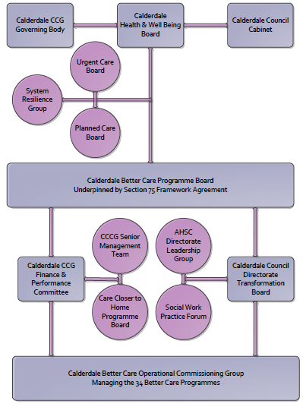

3. Finance
- Contributions to the fund are from CCCG or CMBC?
- 15/16 funding £
- Full year effect if part year in 15/16 £ £577,560
- Arrangements for managing over and underspends (xref to main framework but may have different arrangements for different schemes?)
- Financial governance arrangements, audit (may be standard for CCCG or CMBC)
- VAT

4.0 Impact of scheme
A population segmentation and impact exercise was carried out following the NHSE tool supplied in the 'How to Guides'. It should be noted that each scheme within BCF will not in isolation provide the impact on the headline metric detailed here. It is the combination of these schemes, the Qipp Programme and the interdependencies across the services which will provide the whole improvement. Each of the schemes that form part of the BCF plan for Calderdale has a number of additional measures that will be routinely collected to evaluate the impact of the scheme on the Calderdale population.

Headline BCF Metric for this scheme
- Reduction in non-elective (NEL) (general + acute only)

Supplementary Operational Metrics are:
- People provided with equipment are supported and enabled to sustain independent living within their own home.
- Provision of equipment enables people to regain confidence and skills, reducing and delaying their dependency on other forms of long term care and support.
- Delay in hospital discharge
- People remaining at home after 91 days

