Section 75 Partnership Framework Agreement – Schedule 2
Individual Scheme Specification

BCF Scheme Reference | S2PO3
Scheme name | Carers Offer
Lead Commissioner (CMBC/CCG) | Calderdale MBC
Fund Manager (Senior Responsible Officer) | Karen Midgley
Commencement of particular service | 01/04/15
£ Value in 2015/16 | £835,000
Contract or in house | Contract with CMBC
Provider | Range of providers- current re-tender for Carer’s Project Contract
Contract term | Range of contracts awarded by CMBC

1.0 Introduction

£835,000 has been identified in 2015/16 for carer-specific support and meeting the costs of the new carer entitlement to eligibility for carers introduced by the Care Act (2014) from April 2015. This equates to 5% of the Better Care fund.

There are 1,205 carers registered with their GP and 1,900 registered with the Calderdale Carers Project. 361 carers provide over 35 hours care a week, this group is anticipated as a priority in terms of developing a local carers offer. During 2013/14 adult social care considered 2907 carers support needs alongside the assessment of support for the person. 264 of these resulted in completion of a dedicated Carers Assessment.

Part of our carers offer is coordinated through the Calderdale Carers Project who provide information, advice, monthly support groups around Calderdale including one for Asian women, case-working, benefits advice, counselling, training, activities, emergency back-up plans, carers needs assessments, carers need fund payments, targeted support fund payments, end of life care payments and specific support for young adult carers (aged 18-25). 7 day support to carers is provided through Weekend Care service. 227 people accessed carer respite services during 2013/14, the support offer includes 3 respite beds in care homes and the Calderdale Carers Sitting Service which provides home based day and night respite for carers. A further specialist respite service is provided for adults with a learning disability. A specialist service supports carers 199 carers receive dedicated support to address the negative impact their caring duties have had on their mental health, 20% of this cohort are of BMEA ethnicity. Emergency backup for carers is provided by Calderdale Urgent Home Support Service which provides CQC registered crisis emergency support when carers are in crisis to stabilise the home situation and support for the cared for person for a period of up to 2 weeks.
Also describe the:
- Evidence base
Carers UK and the University of Leeds estimate that unpaid carers save the government in the region £119 billion per year. Timely and appropriate support for carers ensures that they remain in good physical and mental health and are able to carry on caring with limited need for funded support. Money targeted and maintaining the resilience of carers can save significant amounts of money within the health and social care economy.

- Aims and Outcomes of the scheme
The carers support schemes aim to support carers to maintain good health and well-being in order that they can maintain their caring responsibilities. This support will be offered in a range of including the following:
- Information and advice will be easily accessible in a range of formats from advice on the web to individual consultations.
- Social and leisure support is widely available and well promoted.
- A range of carers support groups will continue to be available
- Counselling
- Specialist support for Young Adult carers
- Case working
- Carers Emergency back up plans
- Expert by experience- Looking After me Courses
- Carers Personal budgets
- Respite/ short stay offer for cared for person
- Daytime support including weekend care.

- Population/service users to whom the scheme will relate
There are 1,205 carers registered with their GP and 1,900 registered with the Calderdale Carers Project. 361 carers provide over 35 hours care a week, this group is anticipated as a priority in terms of developing a local carers offer. During 2013/14 adult social care considered 2907 carers support needs alongside the assessment of support for the person. 264 of these resulted in completion of a dedicated Carers Assessment.
Census data estimates that around 10% of the population with have some level of caring responsibility, so in Calderdale there could be over 20,000 carers. It is anticipated that The Care Act will raise awareness and demand.

- Council or CCG functions which are the subject of the scheme including where appropriate the delegation of such functions for the commissioning of the relevant service
The provision of carers assessments is supported by Calderdale Carers project- where appropriate carers access support from the project to complete the forms

- Any plans or agreed actions to change the services

Strengthening the local Carer’s offer is essential to ensure compliance with the Care Act and this should support an:
- Increase in the number of carers registered with their GP.
- Increase in the number of carers receiving dedicated Carers Assessments.
- Increase in the number of carers who have an Emergency Back up Plan in place to support them and the person they care for in the event of an emergency.

Projected increase in the number of dedicated Carer’s Assessments

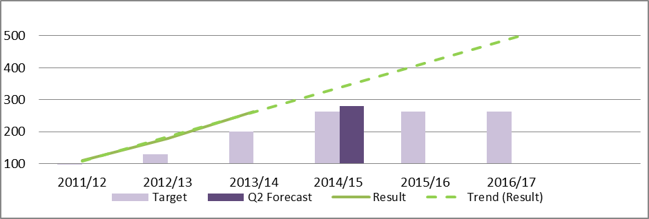

- Other schemes with interdependencies
Most functions of the CCG/LA are interdependent with the offer of carers support. The Care Act work scheme under BCF will be interdependent in relation to the development ofan enhanced offer for carers.

- Duration and exit strategy
This is an ongoing commitment

- Information sharing and communication
Calderdale has a current Carers Strategy 2012-2015 and there is an established Carer’s Strategy group meeting quarterly to oversee the implementation of The Carer’s Strategy and local support available to carers.

2.0 Governance (show which committee scheme is reported to/insert standard diagram of relevant CCCG/CMBC oversight committee)
Governance reporting for this scheme is made to the Calderdale BCF Operational Commissioning Group and escalated as necessary.

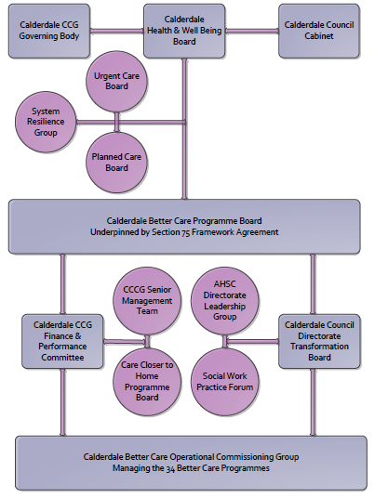

3. Finance
- Contributions to the fund are from CCCG or CMBC
The fund has contributions from both agencies
- 15/16 funding £835,000
- Full year effect if part year in 15/16 £
- Arrangements for managing over and underspends (xref to main framework but may have different arrangements for different schemes?)
This budget is used to fulfil existing contracts so will not incur over or under spends.
- Financial governance arrangements, audit (may be standard for CCCG or CMBC)
Council budget monitoring
- VAT

4.0 Impact of scheme
Assurance and monitoring arrangements (common wording across all schemes? Or at least for CCCG and CMBC schemes?)
A population segmentation and impact exercise was carried out following the NHSE tool supplied in the 'How to Guides'. It should be noted that each scheme within BCF will not in isolation provide the impact on the headline metric detailed here. It is the combination of these schemes, the Qipp Programme and the interdependencies across the services which will provide the whole improvement. Each of the schemes that form part of the BCF plan for Calderdale has a number of additional measures that will be routinely collected to evaluate the impact of the scheme on the Calderdale population.

Headline BCF Metric for this scheme
- Reduction in non-elective (NEL) (general + acute only)

Supplementary Operational Metrics are:
- Performance (KPIs – BCF and other local?)
PI- number of carers assessments provided
- Baseline figure

- Target activity (monthly/quarterly/annual) as above
- Phasing of change – support will be required to support the increased administration and support required as take up of Carers Assessments increases.

