Section 75 Partnership Framework Agreement – Schedule 2

Individual Scheme Specification

BCF Scheme Reference | S2PO1
Scheme name | Virtual Ward
Lead Commissioner (CMBC/CCG) | Calderdale Clinical Commissioning Group
Fund Manager (Senior Responsible Officer) | Rhona Radley
Commencement of particular service | Commenced 1 December 2011 per wording below but shows as 2013 on graph below
£ Value in 2015/16 | £ 250,000
Contract or in house | Contract with CMBC
Provider | Calderdale and Huddersfield NHS Foundation Trust
Contract term | Link to Community Services contract with CHFT

- Introduction

Outline of scheme

Commenced 1 December 2011.

The aim of the Virtual Ward is to prevent unnecessary hospital readmissions and contribute to the delivery of safe, patient-centred care closer to home. Using a predictive scoring tool (LACE-Tool), patients (adults) identified as being at increased risk of readmission are admitted onto the Virtual Ward caseload. This includes all acute medical admissions who have had a previous stay in hospital within 30 days as well as high scoring patients over the age of 60. These patients are then proactively case managed in an attempt to reduce the risk of readmission by working in partnership with the patient, GP, Community Pharmacy, social services, secondary care services and voluntary organisations to ensure the patient receives the right health care, at the right time, in the right place. The service also identifies potential needs, providing people with support to prevent them from returning to hospital wherever possible.

Themes of readmission are listed below. These areas are focussed on by the Virtual Ward:
- Patient acutely unwell and required admission.
- Weekend/Out of hours (i.e. when patients readmit because usual community services are unavailable).
- Lack of/incorrect equipment.
- Medication issues.
- Discharged home too early.
- Communication issues (communication between primary and secondary services failing).
- Social reasons (i.e. lack of home care, inappropriate housing etc).
- Patient non-compliance.
- Other.

- Governance (show which committee scheme is reported to/insert standard diagram of relevant CCCG/CMBC oversight committee)
This Scheme is performance managed by the CCG’s QIPP Monitoring Group which reports into the CCG’s Finance and Performance Committee. Members of the CCG’s QIPP Monitoring Group are also members of the BCF Operational Commissioning Group and BCG Programme Board where actions to mitigate the likelihood and impact of risks to delivery of BCF objectives and outcomes are overseen and schemes are performance managed.

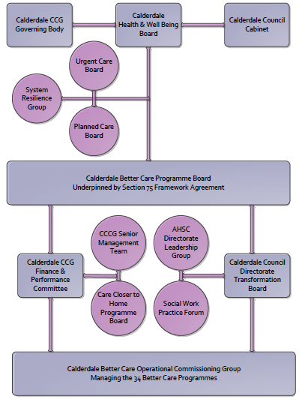

3. Finance
- Contributions to the fund are from CCCG or CMBC? CCCG
- 15/16 funding £250k
- Full year effect if part year in 15/16 - N/A

4. Impact of scheme

Assurance and monitoring arrangements (common wording across all schemes? Or at least for CCCG and CMBC schemes?)
- Performance (KPIs – BCF and other local?)
- Baseline figures
- Target activity (monthly/quarterly/annual)
- Phasing of change
A population segmentation and impact exercise was carried out following the NHSE tool supplied in the 'How to Guides'. It should be noted that each scheme within BCF will not in isolation provide the impact on the headline metric detailed here. It is the combination of these schemes, the Qipp Programme and the interdependencies across the services which will provide the whole improvement. Each of the schemes that form part of the BCF plan for Calderdale has a number of additional measures that will be routinely collected to evaluate the impact of the scheme on the Calderdale population.
Headline BCF Metric for this scheme
- Reduction in non-elective (NEL) (general + acute only)

Supplementary Operational Metrics are:

Using the Dr Foster method of clinical benchmarking for risks of readmission to hospital, Calderdale and Huddersfield NHS Foundation Trust has improved since the implementation of the virtual ward service. This is demonstrated in the following graphs:
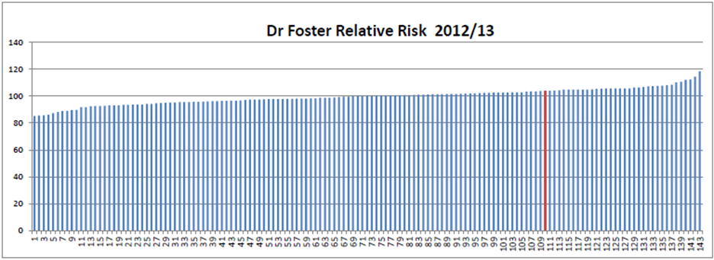

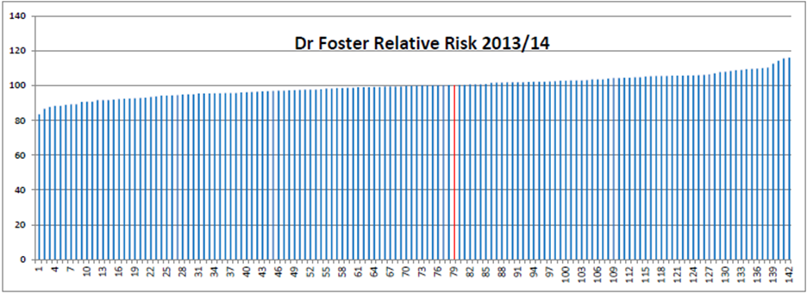

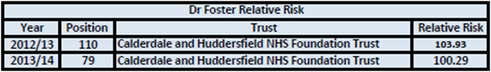

CHFT Readmissions data shown below:

CHFT Readmissions – Acute/ Medical:

CHFT Readmissions – Acute/ Medical

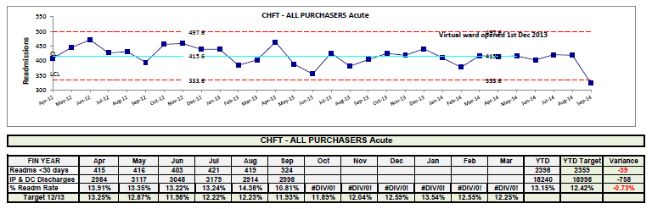

c)Targets

d)Phasing of scheme

the scheme is fully up and running and in place for the whole of 2015/16

