Section 75 Partnership Framework Agreement – Schedule 1
Individual Scheme Specification

BCF Scheme Reference | S1PO4
Scheme name | - Self Care Hub and  - LD Hub
Lead Commissioner (CMBC/CCG) | CMBC
Fund Manager (Senior Responsible Officer) | - Self Care Hub – Stacey Leonard  - LD Hub – Karen Midgley
Commencement of particular service | - Self-Care Hub subject to procurement exercise during 2014/15  - LD Hub – contract award due September 2014
£ Value in 2015/16 | £164,000
Contract or in house | In House
Provider | CMBC
Contract term | Self Care Hub – TBC  LD Hub – TBC

1.0 Introduction
Outline of scheme ( what is it we are actually doing?)
Self-Care Hub – LTC
The Self Care hub will be a web based tool where people can be supported to better manage their long term condition to be self-sufficient and resourceful to confidently manage their needs and reduce dependency on the care system, through a virtual online assistant, be signposted to self-care options to make positive life style changes and learn essential skills along the way.
A typical user story involves a very personal, goal-orientated journey through the Self Care Hub, supporting someone to track their own progress through dealing with a variety of long-term conditions; seamlessly and securely traversing different touch points (clinical and non-clinical systems) whilst maintaining a constant, familiar and safe user experience within the Self Care Hub. This allows for both lateral and vertical movement within the health care system.
The tool will be Open Source and compliant with current NHSE IT system procurement code of practice, to allow for potential future integration with the local provider Health Information Systems, if appropriate.
LD Hub
The CaLDer Hub is proposed as a network of people with learning disability, their families and carers working as volunteers The work is aligned to that delivered by the statutory services at Tier 1 in the model shown in figure 1.(attached)
The Hub will offer people with LD and their families’ access to knowledge, skills and contacts with existing professionals and voluntary groups to support them to live as independent a life in the community as is their wish, whilst offering support to access statutory services that can meet the needs of their LD.
Figure 1

Self-Care Hub Aims
The aims of the
- Enable people to gather valuable insights into their long term condition and wider health and wellbeing as they progress through the self-care hub self-assessment tools with the aid of a virtual assistant. .
- Provide tailored support through a ‘customer check out area’ that will allow, for example, appointments to be scheduled with a Health trainer or a downloadable app.
- Provide insights to inform the system about people’s individual preferences and what type of support would be suitable for them and for future visits similar to the Amazon business model. www.amazon.co.uk
- Provide clear referral points to local services to enable people to be referred at point of access, including integrated links to existing services and directories such as connect to support
- Have a virtual assistant that will interact with the individual, to identify their key health issues due to the impact of their long term condition(s) and guide them towards the right support for their needs.
- So give easy access to self-care resources ie both information and tools to equip individuals with the necessary skills and knowledge to better self-manage their long term conditions.
- Support health care professionals through providing a suite of self-care tools and resources to help their patients answer the above 6 questions. This helps a more efficient use of clinical time as individuals are engaged in their own assessment and self-management with problem solving support from clinical teams as needed.
- Focus on supporting the management of conditions which are of high prevalence in the local area such as diabetes, cardiovascular disease, chronic pain, emotional health and respiratory disease.
- Collect information on the health and social care needs of this section of the population and the choices people are making to meet these needs that will be used to inform future commissioning decisions.

LD Hub Aims
The CaLDer Hub will support primary care, social care, people with learning disabilities, their families and carers in a community hub and spoke provision that reaches all areas within Calderdale in order, to provide a tier 1 (community based) response to finding solutions to the barriers to good health and help people to stay healthy and independent in their local communities. The CaLDer Hub will also support people with learning disabilities and their family carers to access social opportunities and develop community networks within Calderdale.

To provide the Learning Disability population of Calderdale with a supportive network of support workers and volunteers who support the needs of the population which will typically fall into 6 broad categories:
- Information
- Advice
- Referral
- Networking
- Organising volunteer activities
- Establishing new areas of delivery

- To support all users and carers in finding appropriate services to meet their needs by providing signposting and support to ‘navigate’ through statutory services
- To support professionals at Tier 1 in education and planning for people with LD using their services:
i.e. support to GP’s, dentists, educators, police, libraries etc to understand specific needs of people with Learning Disability coming into contact with their services and support the individual to find where ‘LD friendly ‘ services are located such as user friend cafes and social groups
- To provide a network of people with learning disabilities and family carers as volunteers offering advice, support and information to other people with learning disabilities and their family carers. The Hub will gather the knowledge, skills and contacts of existing workers in a variety of statutory and 3rd sector providers into one place. The Hub can provide a reference point for anyone wishing access LD community services and informal support.
- To provide clear information for the existing LD website and develop a regular newsletter for people with learning disabilities and their carers, giving up to date details of services, events and voluntary opportunities
- To provide a single number contact for all service users and carers for the Hub , which will link to the service provided by Gateway to care
- Provide regular meeting places across all areas of Calderdale where users and carers can meet in community provision such as cafes, pubs, restaurants and leisure centres. This will benefit the service users and carers and also help to create more Learning Disability friendly places where people’s needs are understood.
- To improve and facilitate communications between individuals, families and support services
- To promote a positive image of LD locally
- To support the work of the Learning Disability Partnership Board, including the organisation of 2 monthly Partnership Board meetings. The Hub will also need to support the co-chair and to work in partnership with the LDPB chair to facilitate the meetings
- To actively generate and support the production of more ‘easy read’ versions of key documents and to work with the LDPB to identify key documents that require translation
- To gather data as requested to help statutory services to plan and develop existing service provision in higher Tiers in this model (figure1)

Self-Care Hub – LTC
The self-care hub aims to support local people with long term conditions / vulnerabilities to be self sufficient and resourceful to confidently manage needs and thus reduce dependency on the care system as well as improve their functioning holistically.
So they
- Increase their sense of control and resilience in their lives by effectively self managing their condition / vulnerabilities, problem solving, and making informed choices including their support.
- Be active partners with care providers in the assessment of health needs, their chosen priorities and in decision making.
- Look at health & wellbeing i.e. wider than disease management
- Receive consistency of culture, information and support about self-care that is timely
- Live as active participants in the or local communities with the least restrictions

LD Hub Objectives
- To ensure equitable access to healthcare and community services for people with a learning disability across Calderdale.
- To advise and support healthcare services to make reasonable adjustments for this population to meet statutory duties e.g. currently under Equal Access (DH 2009) and DDA (1995) and from April 2011 in accordance with the new public sector Equality duty of the Equality Act 2010.
- To strengthen and expand health promotion activities available for people with a learning disability including innovative person centred approaches to programmes.
- To ensure that Health Action Plans are recognised and used by health and social care professionals, support providers, family carers and people with a learning disability
- To engage with individuals, families and carers in consultation exercises and events and support the completion of national returns such as the Learning Disability Self-Assessment Survey
- To work with the Commissioners on the integration programme between health and social care services to collectively put the individual at the heart of all care planning.
- To support people with learning disabilities to have more choice and control. Supporting people to access personalised support options and to take an active role in the development of The Hub and other local services.
- Ensure people with Learning Disability have access to information about their health that is appropriate and targeted to the relevant groups.

- Population/service users to whom the scheme will relate

Self-Care Hub – LTC
People aged 65 and over with a limiting long-term illness, by age, projected to 2030
 | 2014 | 2015 | 2020 |  | 2025 | 2030
People aged 65-74 whose day-to-day activities are limited a little | 4,675 | 4,812 | 5,156 | 5,225 |  | 5,912
People aged 75-84 whose day-to-day activities are limited a little | 3,575 | 3,672 | 4,187 | 5,250 |  | 5,669
People aged 85 and over whose day-to-day activities are limited a little | 1,298 | 1,326 | 1,523 | 1,834 |  | 2,257
Total population aged 65 and over with a limiting long term illness whose day-to-day activities are limited a little | 9,547 | 9,810 | 10,866 | 12,308 |  | 13,837
People aged 65-74 whose day-to-day activities are limited a lot | 3,174 | 3,267 | 3,501 | 3,548 |  | 4,014
People aged 75-84 whose day-to-day activities are limited a lot | 3,124 | 3,208 | 3,658 | 4,587 |  | 4,953
People aged 85 and over whose day-to-day activities are limited a lot | 1,925 | 1,966 | 2,259 | 2,719 |  | 3,347
Total population aged 65 and over with a limiting long term illness whose day-to-day activities are limited a lot | 8,222 | 8,442 | 9,418 | 10,854 |  | 12,314

LD Hub
Population of people with a learning disability living in Calderdale
Table produced from www.poppi.org.uk version 9.0
People predicted to have a learning disability, by age in Calderdale
 | 2014 | 2015 | 2020 | 2025 | 2030
People aged 18-24 predicted to have a learning disability | 433 | 433 | 402 | 395 | 432
People aged 25-34 predicted to have a learning disability | 630 | 632 | 655 | 655 | 623
People aged 35-44 predicted to have a learning disability | 675 | 668 | 655 | 684 | 709
People aged 45-54 predicted to have a learning disability | 730 | 742 | 724 | 664 | 657
People aged 55-64 predicted to have a learning disability | 577 | 581 | 650 | 698 | 678
People aged 65-74 predicted to have a learning disability | 438 | 451 | 490 | 493 | 557
People aged 75-84 predicted to have a learning disability | 222 | 229 | 262 | 331 | 357
People aged 85 and over predicted to have a learning disability | 87 | 90 | 104 | 126 | 157
Total population aged 18 and over predicted to have a learning disability | 3,792 | 3,827 | 3,942 | 4,046 | 4,170

Age range | % in 2011 | % in 2021
15-19 | 2.77 | 2.67
20-24 | 2.69 | 2.71
25-29 | 2.49 | 2.49
30-34 | 2.49 | 2.49
35-39 | 2.45 | 2.46
40-44 | 2.45 | 2.47
45-49 | 2.28 | 2.31
50-54 | 2.37 | 2.39
55-59 | 2.33 | 2.32
60-64 | 2.2 | 2.22
65-69 | 2.01 | 2.02
70-74 | 2.34 | 2.33
75-79 | 2.07 | 2.08
80+ | 1.89 | 1.93

- Council or CCG functions which are the subject of the scheme including where appropriate the delegation of such functions for the commissioning of the relevant service
- Any plans or agreed actions to change the services
  - Not Applicable a both new services
- Other schemes with interdependencies
Care Closer to Home - CCG

- Duration and exit strategy
- Information sharing and communication

2.0 Governance (show which committee scheme is reported to/insert standard diagram of relevant CCCG/CMBC oversight committee)
Governance reporting for this scheme is made to the Calderdale BCF Operational Commissioning Group and escalated as necessary.

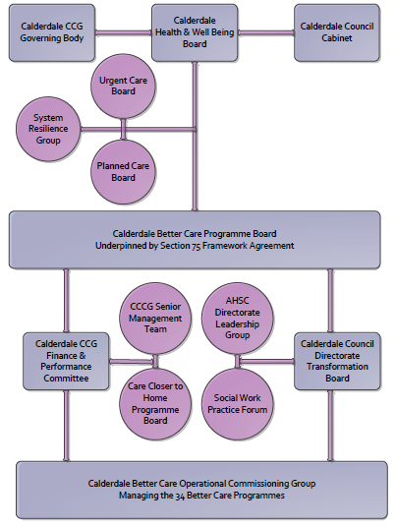

3. Finance
- Contributions to the fund are from CCCG or CMBC?
- 15/16 funding £164,000

4.0 Impact of scheme
Assurance and monitoring arrangements (common wording across all schemes? Or at least for CCCG and CMBC schemes?)
A population segmentation and impact exercise was carried out following the NHSE tool supplied in the 'How to Guides'. It should be noted that each scheme within BCF will not in isolation provide the impact on the headline metric detailed here. It is the combination of these schemes, the Qipp Programme and the interdependencies across the services which will provide the whole improvement. Each of the schemes that form part of the BCF plan for Calderdale has a number of additional measures that will be routinely collected to evaluate the impact of the scheme on the Calderdale population.

Headline BCF Metric for this scheme
Reduction in non-elective (NEL) (general + acute only)
Supplementary Operational Metrics are:
- Number of users in a given month (Local)
- Percentage increase in users in previous quarter (Local)
- Self reported satisfaction with the service (to be advised, Local)
- ASCOF 1A - Social care-related quality of life
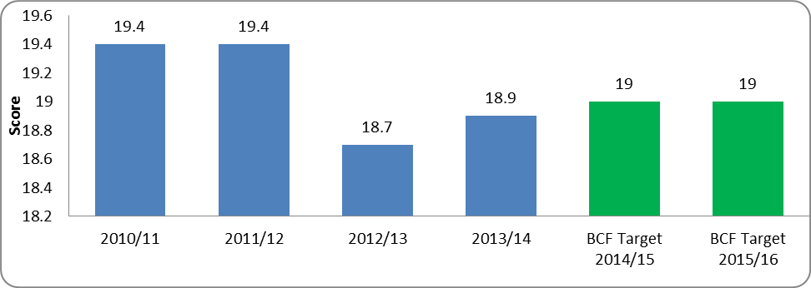
- ASCOF 1E - Proportion of adults with learning disabilities in paid employment
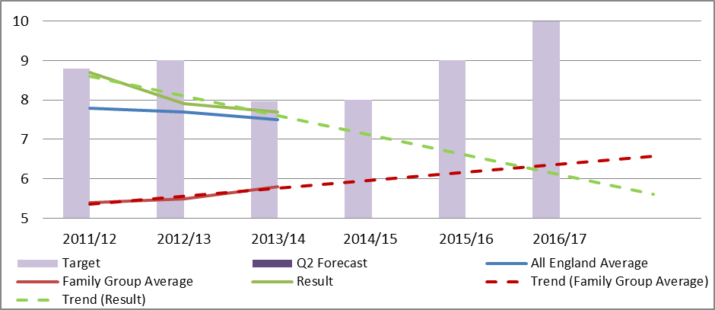
- ASCOF 2C(1) - Delayed transfers of care from hospital per 100,000 population
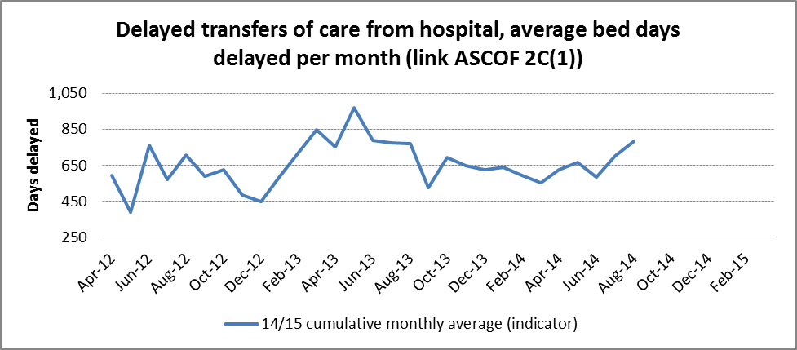
- ASCOF 3D(1) - Proportion of people who use services who find it easy to find information about services
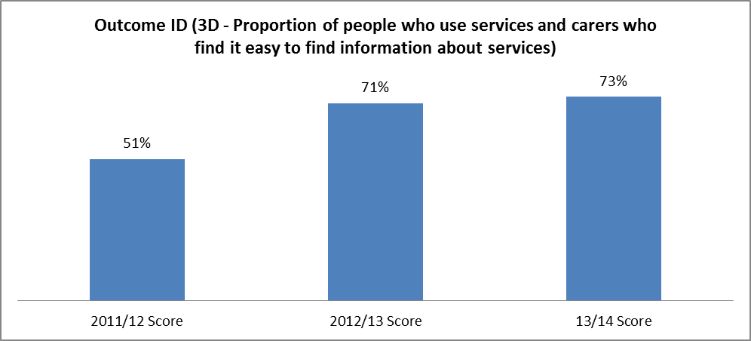
- ASCOF 4B - Proportion of people who use services who say that those services have made them feel safe and secure
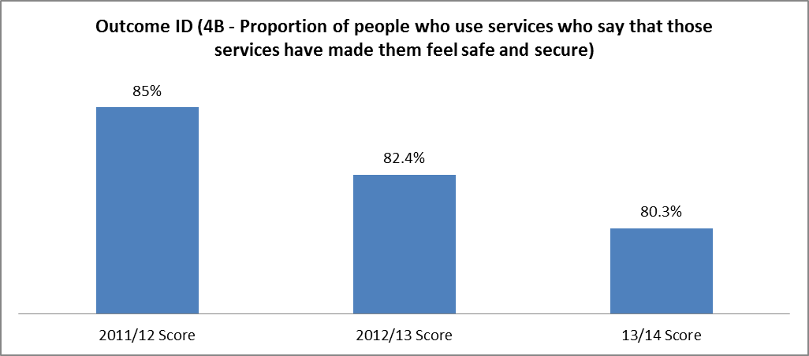

- Baseline figures
To be established for both hubs

- Target activity (monthly/quarterly/annual)
Indicator | Monitoring Frequency
Number of users in a given month (Local) - Monthly | Monthly
Percentage increase in users in previous quarter (Local) | Quarterly
Self reported satisfaction with the service (to be advised, Local) | Annual
ASCOF 1A - Social care-related quality of life - Annual | Annual
ASCOF 1E - Proportion of adults with learning disabilities in paid employment | Quarterly
ASCOF 2C(1) - Delayed transfers of care from hospital per 100,000 population | Monthly

