Section 75 Partnership Framework Agreement – Schedule 1
Individual Scheme Specification

BCF Scheme Reference | S1P03
Scheme name | Self-Care Assistive Technology for Independent Living
Lead Commissioner (CMBC/CCG) | Calderdale Metropolitan Borough Council
Fund Manager (Senior Responsible Officer) | Stacey Leonard
Commencement of particular service | November 2010
£ Value in 2015/16 | £135,000
Contract or in house | Contract In House CMBC
Provider | Currently in excess of 20 providers within the supply chain
Contract term | Linked to the Community Services Contract for CHFT

1.0 Introduction
Outline of scheme (what is it we are actually doing?)
Assistive Technology (Telecare/telehealth) - Remote monitoring devices to promote wellbeing and safety monitoring devices to prevent/avoid hospital admission and increasing use of traditional social care, and therefore promote long-term independence. Telecare has been defined by the Department of Health as a service that uses ‘a combination of alarms, sensors and other equipment to help people live independently. This is done by monitoring activity changes over time and will raise a call for help in emergency situations, such as a fall, fire or a flood ’ (Department of Health 2009).
In recent years assistive technology (AT) has been provided in a traditional capacity to people across the full spectrum of social care needs. AT currently sits pre-FACSs assessment and is therefore termed a universal preventative service. The fund allocated for SP1 PO3 will be used to continue to procure the current AT services offered by the council and research and pilot a small number of further innovative schemes focusing on maximising a person’s independence within their community which additionally may have an impact on preventing hospital admission.
Also describe the:
- Evidence base
Population of older people aged 65 years and over in Calderdale is predicted to increase by 42% by 2030. Older people living with a limiting long term illness whose daily activities are affected by their illness accounts for over 9,500 older people currently. Similar numbers of people are predicted to have a fall with rates of falls increasing with age and frailty, with a significant number requiring hospital admission. The vast majority of over 75s in Calderdale live alone with this group specifically being most likely to require hospital admission following a fall.
An overview report for the Department of Health in 2006 by the Evidence Working Group of the Telecare Policy Collaborative reported:
• Telecare helped West Lothian achieve the lowest proportion of delayed hospital discharges of older people in Scotland and reduced the average stay in private care homes from 36 to 18 months’
• The ‘Safe at Home’ scheme in Northampton ‘suggested that telecare helped people (with dementia) to keep living independently in their own homes for longer’
• Data from Birmingham’s community alarm service ‘showed that a substantial return on investment in the form of reduced hospitalisation costs and reduced residential care could be achieved over a ten year period
• Evidence from a telecare scheme for frail older people in North West Surrey ‘shows that telecare focused on safety and security could reduce the number of people entering residential care by 11% in the fifth year after implementation or perhaps 25% in year 20
Source: Think Local, Act Personal
Analysis of 131 telecare users in North Yorkshire in September 2008 identified what the traditional care package would have been if telecare had not been available and this showed that telecare provided a saving per person of between £1,756 and £12,246, with an average annual saving of £3,600 per person.
Source: North Yorkshire County Council – Innovation, Choice and Control: Telecare North Yorkshire
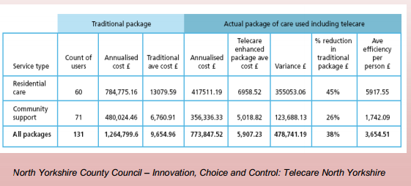

Data to support evidence base:
Tables produced from www.poppi.org.uk version 9.0
Population aged 65 and over, projected to 2030 (Calderdale)
 | 2014 | 2015 | 2020 | 2025 | 2030
People aged 65-69 | 12,100 | 12,300 | 11,200 | 12,500 | 14,200
People aged 70-74 | 8,300 | 8,700 | 11,300 | 10,300 | 11,600
People aged 75-79 | 6,500 | 6,700 | 7,600 | 10,000 | 9,200
People aged 80-84 | 4,600 | 4,700 | 5,400 | 6,300 | 8,400
People aged 85-89 | 2,900 | 2,900 | 3,200 | 3,900 | 4,600
People aged 90 and over | 1,700 | 1,800 | 2,100 | 2,600 | 3,400
Total population 65 and over | 36,100 | 37,100 | 40,800 | 45,600 | 51,400

People aged 65 and over with a limiting long-term illness, by age, projected to 2030
 | 2014 | 2015 | 2020 |  | 2025 | 2030
People aged 65-74 whose day-to-day activities are limited a little | 4,675 | 4,812 | 5,156 | 5,225 |  | 5,912
People aged 75-84 whose day-to-day activities are limited a little | 3,575 | 3,672 | 4,187 | 5,250 |  | 5,669
People aged 85 and over whose day-to-day activities are limited a little | 1,298 | 1,326 | 1,523 | 1,834 |  | 2,257
Total population aged 65 and over with a limiting long term illness whose day-to-day activities are limited a little | 9,547 | 9,810 | 10,866 | 12,308 |  | 13,837
People aged 65-74 whose day-to-day activities are limited a lot | 3,174 | 3,267 | 3,501 | 3,548 |  | 4,014
People aged 75-84 whose day-to-day activities are limited a lot | 3,124 | 3,208 | 3,658 | 4,587 |  | 4,953
People aged 85 and over whose day-to-day activities are limited a lot | 1,925 | 1,966 | 2,259 | 2,719 |  | 3,347
Total population aged 65 and over with a limiting long term illness whose day-to-day activities are limited a lot | 8,222 | 8,442 | 9,418 | 10,854 |  | 12,314

Rates for people who report at least one fall during the last 12 months are as follows:
Age range | % males | % females
65-69 | 18 | 23
70-74 | 20 | 27
75-79 | 19 | 27
80-84 | 31 | 34
85+ | 43 | 43

Rates for admissions to hospital as a result of unintentional falls are as follows:
Age range | %
65-69 | 0.52
70-74 | 0.92
75+ | 3.68

Rates for people living alone are as follows:
Age range | % males | % females
65-74 | 20 | 30
75+ | 34 | 61

- Aims and Outcomes of the scheme
- To maximise a person’s independence and quality of life, providing a high quality 24/7 monitoring service, sensitive to diverse needs of the community;
- Provide carers with support and peace of mind;
- Reduce the need for residential/nursing admissions by maintaining people as independent as possible in their own community;
- Reduce emergency admissions to hospital via the 24/7 minotaur and response service;
- Keep people who use the devices feeling safe
- Reduce falls in the home
- Support hospital discharge
- Support people at end of life

- Population/service users to whom the scheme will relate
  - Older people recently discharged from hospital
  - People living in extra care/warden controlled accommodation
  - People with a history of falls, or who have a health condition that is more likely to result in falls
  - People with early stages of dementia
  - People needing reassurance to continue living in the community

- Council or CCG functions which are the subject of the scheme including where appropriate the delegation of such functions for the commissioning of the relevant service
  - xxx
- Any plans or agreed actions to change the services
  - New assistive technologies will be brought on stream as the market develops and devices are upgraded by the providers.
- Other schemes with interdependencies
  - S6 PO1 – End of Life Social Work Assessment
  - S6 PO3 – Assistive technology, telecare and telehealth
  - S4 PO3 – Heatherstones
  - S4 PO5 – Reablement and Coordinated support at home
- Duration and exit strategy
  - xxx
- Information sharing and communication
  - xxx

2.0 Governance (show which committee scheme is reported to/insert standard diagram of relevant CCCG/CMBC oversight committee)
Governance reporting for this scheme is made to the Calderdale BCF Operational Commissioning Group and escalated as necessary.

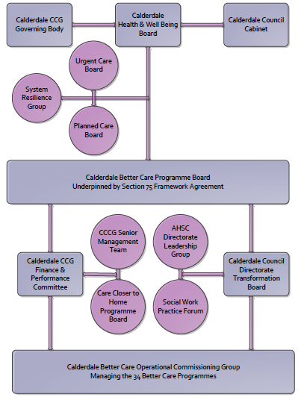

3. Finance
- Contributions to the fund are from CCCG or CMBC?
- 15/16 funding £135,000
- Full year effect if part year in 15/16 £135,000
- Arrangements for managing over and underspends (xref to main framework but may have different arrangements for different schemes?)
- Financial governance arrangements, audit (may be standard for CCCG or CMBC)
- VAT

4.0 Impact of scheme
Assurance and monitoring arrangements (common wording across all schemes? Or at least for CCCG and CMBC schemes?)
A population segmentation and impact exercise was carried out following the NHSE tool supplied in the 'How to Guides'. It should be noted that each scheme within BCF will not in isolation provide the impact on the headline metric detailed here. It is the combination of these schemes, the Qipp Programme and the interdependencies across the services which will provide the whole improvement. Each of the schemes that form part of the BCF plan for Calderdale has a number of additional measures that will be routinely collected to evaluate the impact of the scheme on the Calderdale population.

Headline BCF Metric for this scheme
Reduction in non-elective (NEL) (general + acute only)
Supplementary Operational Metrics are:

  - ASCOF 2B(2) - Proportion of older people (65 and over) who were still at home 91 days after discharge from hospital into reablement/rehabilitation services (offered the service)
  - ASCOF 2A(2) - Permanent admissions of older people (aged 65 and over) to residential and nursing care homes, per 100,000 population
  - Key BCF Indicator - Reduction in non- elective admissions (NEL) (in this case reduction in admissions and readmissions contributing to the overall 3.5% reduction target).
  - ASCOF 4B - Proportion of people who use services who say that those services have made them feel safe and secure
  - ASCOF 2C(2) - Delayed transfers of care from hospital which are attributable to adult social care per 100,000 population
  - Support people at end of life – Number of cases managed by the EoL team where assistive technology was utilised (New, local)

- Baseline figures
  - ASCOF 2B(2) - Proportion of older people (65 and over) who were still at home 91 days after discharge from hospital into reablement/rehabilitation services (offered the service)
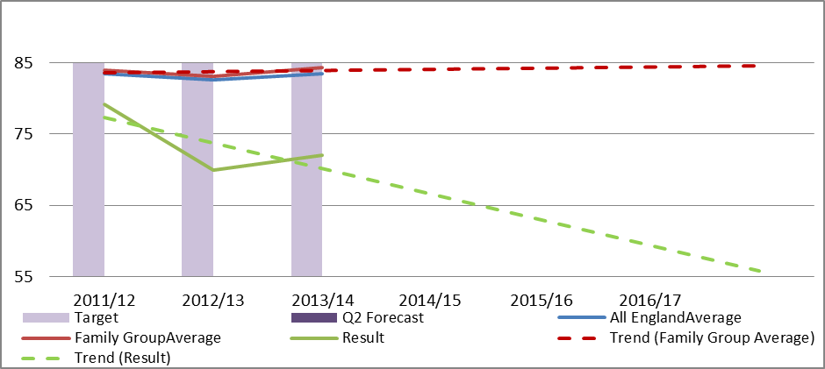
  - ASCOF 2A(2) - Permanent admissions of older people (aged 65 and over) to residential and nursing care homes, per 100,000 population
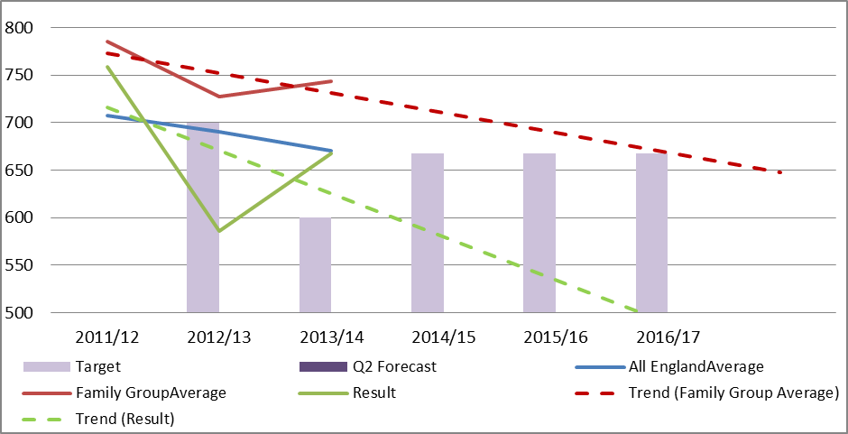
  - Key BCF Indicator - Reduction in non- elective admissions (NEL) (in this case reduction in admissions and readmissions contributing to the overall 3.5% reduction target).

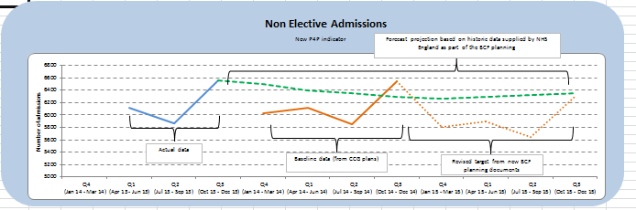
  - ASCOF 4B - Proportion of people who use services who say that those services have made them feel safe and secure
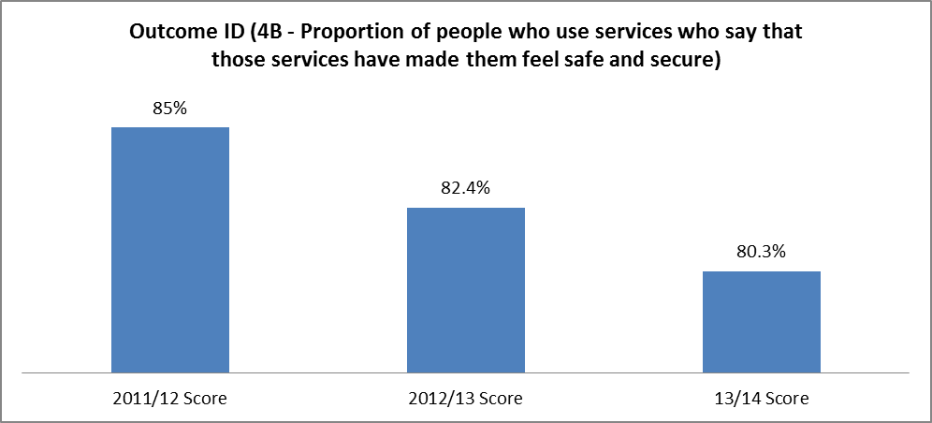
  - ASCOF 2C(2) - Delayed transfers of care from hospital which are attributable to adult social care per 100,000 population
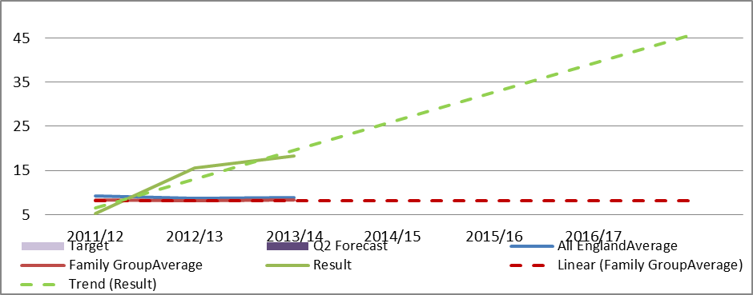
  - Support people at end of life – Number of cases managed by the EoL team where assistive technology was utilised (New, local)

- Target activity (monthly/quarterly/annual)
Indicator | Monitoring Frequency
ASCOF 2B(2) - Proportion of older people (65 and over) who were still at home 91 days after discharge from hospital into reablement/rehabilitation services (offered the service) | Quarterly, 3 month delay in reporting.
ASCOF 2A(2) - Permanent admissions of older people (aged 65 and over) to residential and nursing care homes, per 100,000 population - | Monthly
Key BCF Indicator - Reduction in non- elective admissions (NEL) (in this case reduction in admissions and readmissions contributing to the overall 3.5% reduction target). | Monthly
ASCOF 4B - Proportion of people who use services who say that those services have made them feel safe and secure | Annual
ASCOF 2C(2) - Delayed transfers of care from hospital which are attributable to adult social care per 100,000 population | Monthly
Support people at end of life – Number of cases managed by the EoL team where assistive technology was utilised (New, local) | Quarterly

