Section 75 Partnership Framework Agreement – Schedule 1
Individual Scheme Specification

BCF Scheme Reference | S1P02
Scheme name | Weekend Single Point of Access to Intermediate Care (Gateway to Care)
Lead Commissioner (CMBC/CCG) | Calderdale Metropolitan Borough Council
Fund Manager (Senior Responsible Officer) | Elaine James
Commencement of particular service | November 2010
£ Value in 2015/16 | £ 98,910
Contract or in house | Contract with CHFT & In House CMBC
Provider | Joint Venture – CMBC and CHFT
Contract term | Linked to the Community Services Contract for CHFT

1.0 Introduction
Outline of scheme (what is it we are actually doing?)
Gateway to Care in an integrated Single Point of Access to the health intermediate tier and adult social care based within Adult Social Care. This programme will extend Gateway to a 7 day service covering weekends.

The team provide internet, telephone and face to face information, advice and guidance and act as a case work team holding complex cases for up to 24 hours whilst services are brokered and arranged which keep people independent, safe and avoid an emergency admission into hospital or a care home. Gateway coordinates access to a range of resources including:

- Further face to face assessment for Support at Home
- Neighbourhood Schemes and Staying Well Community Support Services
- The Gateway Food Bank
- Minor adjustments to packages of home care
- Occupational therapy assessment for aids/adaptation
- Telecare assessment for assistive technology
- Housing technical instructor assessment for minor/major home adaptation or relocation
- Housing related support for adults of all ages
- The Calderdale Urgent Home Support Service which provides CQC registered domiciliary support for people in crisis for up to 7 days
- Eligibility for the Crisis Intervention Team, Intermediate Care Beds, Heatherstones Rehabilitation Units and Transitional Beds
- Social Care Duty and screening for all adult safeguarding alerts
- Information in relation to home of choice for people considering a 24 hour care admission

During 2013/14 the team responded to 77,000 contacts. Access to Gateway to Care is through telephone, email, fax and in person. All telephony, IT systems and building running costs are the responsibility of Adult Social Care. The leadership and management of both the social care and health functions of Gateway to Care to the team is provided through a team manager and 1.2 team leader (social workers ASC funded). The deputy manager (CCG funded) provides management across both social care and health, having delegated responsibility and decision making throughout the team while providing clinical management and working knowledge of SystemOne.

The call numbers and complexity of calls to Gateway to care have increased over time increasing from nearly 61,000 in 2012/13 to over 71,000 in 2013/14 which is an increase of over 16%. Contacts from email and faxes has also shown an increase emails increasing over the year by 50% and faxes requiring action are around 240 each month (no data for 2012/13)

The SCA’s and Clinical Advisors screen and triage referrals for Support and Independence Team. Each referral is duel entered onto SystmOne and CIS.

The Clinical Advisors are required to evidence their clinical involvement on the relevant IT system using either / both the council IT system CIS and the health system SystmOne even in cases where there is no onward referral required . The charts below show data extracted from SystemOne and CIS for the clinical advisors.

Gateway provides a one stop shop single number point of contact for General Practice to support all health and social care access issues excluding mental health.

2.0 Governance (show which committee scheme is reported to/insert standard diagram of relevant CCCG/CMBC oversight committee)
Gateway to Care is managed through the CMBC Directorate Leadership Group (see below). 7 day working is reported in on a partnership basis to Urgent Care Board.
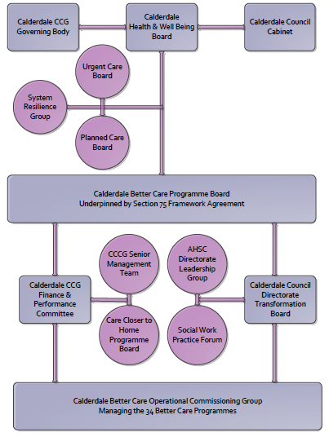

3. Finance
- Contributions to the fund are from CCCG or CMBC? CCCG
- 15/16 funding £98,910
- Full year effect if part year in 15/16 – N/A

4.0 Impact of scheme
Assurance and monitoring arrangements (common wording across all schemes? Or at least for CCCG and CMBC schemes?)
- Performance (KPIs – BCF and other local?)
- Baseline figures
- Target activity (monthly/quarterly/annual)
- Phasing of change
A population segmentation and impact exercise was carried out following the NHSE tool supplied in the 'How to Guides'. It should be noted that each scheme within BCF will not in isolation provide the impact on the headline metric detailed here. It is the combination of these schemes, the Qipp Programme and the interdependencies across the services which will provide the whole improvement. Each of the schemes that form part of the BCF plan for Calderdale has a number of additional measures that will be routinely collected to evaluate the impact of the scheme on the Calderdale population.
Headline BCF Metric for this scheme
- Reduction in non-elective (NEL) (general + acute only)

Supplementary Operational Metrics for Gateway to Care are:
- Number of Gateway Contacts (Calls Received; Calls Made; Emails Requiring Action).
- All Referrals made to Gate way to Care, plus Non Referred Contacts in 13/14, by Clients aged 75+ with link to GP Practice per 1,000 of GP population.
- All Referrals made to Gate way to Care, plus Non Referred Contacts in 13/14, by Clients aged 75+ with link to GP Practice per 1,000 of GP population.
- All Referrals made to Gate way to Care, plus Non Referred Contacts in 13/14, by Clients aged 75+ with link to GP Practice per 1,000 of GP population where source is primary/community health care worker.
- Number of health interventions made by the Clinical Advisors.
- Number of social care interventions made by the Clinical Advisors.
- Referrals to Support & Independence Locality Teams.
NOT YET OPERATIONAL SO NO BASELINE

