
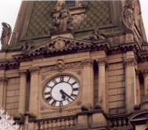


A

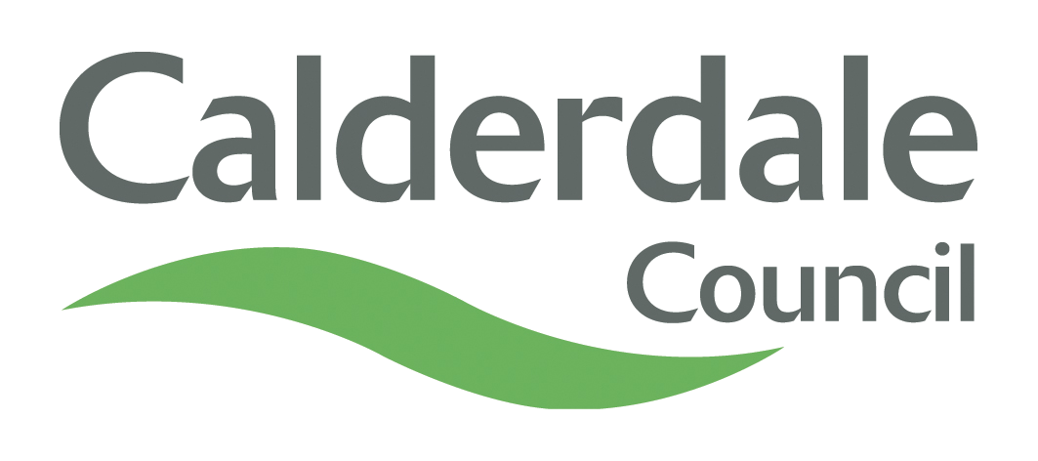
Appendix B
INTERNAL AUDIT REPORT

Economy and Environment – Highways and Planning

WINTER SERVICE CONTRACT

DATE OF REPORT: 11th FEBRUARY 2014

Overall Opinion - Weak

WINTER SERVICE CONTRACT

EXECUTIVE SUMMARY CONTENTS

Section |  | Page
- Introduction  - Audit Opinion  - Scope of the Review  - Main Findings  - Main Risks  - Recommendations Summary |  | 3  3  3  4  5  6
- Action Plan  Key Dates and Distribution |  | 6
Date Draft Report Issued | 3rd February 2014 | Auditor | Audit Technician
Date Report Issued | 11th February 2014 | Distribution | To: Head of Planning and Highways  cc: Highway Network Manager
Date Reminder Issued | 6th March 2014 | Distribution
Date Response Received | 7th March 2014 | Distribution
Date of Follow-Up | Not due – to be carried out November 2014 | Distribution

EXECUTIVE SUMMARY

- INTRODUCTION

1.1. The programmed audit was undertaken as part of the Member approved Internal Audit Plan for the financial year 2013/14.

1.2. The overall objectives of the audit were as follows:

  - To evaluate the systems in operation with regard to financial procedures and recommend improvements where necessary.
  - To ensure that system controls are operating effectively and that a sound control environment exists contributing towards the council achieving its corporate objectives.
  - To ensure that Council policies are being met and instructions issued to comply with Section 151 Standards are adhered to.
  - To check a sample of transactions to ensure they are correct and procedures have been complied with.
  - To ensure that assets are safeguarded.

- AUDIT OPINION
2.1. The strength of the control environment relating to Winter Service Contract at the time of the audit was weak. The conclusions which led to the Audit Opinion were as follows:
Area of Audit | Opinion
Previous Audit Recommendations | N/A
Contract Issues | Weak
Contractor Compliance | Weak
Contract Payments | Sound

2.2. The table above is a summary of the conclusions arrived at in the findings section of the audit report and is based on evidence obtained during the review.

- SCOPE OF THE REVIEW
  - To contribute towards the Council meeting the requirements of The Accounts and Audit Regulations (England) 2011, which,
- Requires authorities to ensure that the financial management is adequate and effective, that there are sound systems of internal control which facilitate the effective exercise of the Council’s functions and which include arrangements for the management of risk.
- Requires authorities to undertake an adequate and effective internal audit of its accounting records and of its system of internal control in accordance with proper practices in relation to internal control.
  - That being the case, the scope of the review took into account the following:
      - Contract Issues:
- To ensure that Contracts Procedure Rules and procurement legislation had been complied with.
- To ensure that clear concise and appropriate contract conditions were in place.
      - Contractor Compliance:
- To ensure the following contract conditions were complied with;
- Drivers and other workers provided by a contractor were suitably qualified.
- Contractors had appropriate insurance.
- Vehicles in use for the contract were road worthy.
- To obtain evidence that contractor monitoring was being undertaken.
      - Contract Payment:
- To ensure that payment claims were dealt with in a timely manner.
- To ensure that contractors were paid at the correct rate as per the tender schedule.

4. MAIN FINDINGS

  - The main findings which lead to the Audit Opinion of weak were as follows:
- The contract was mistakenly misclassified as works at the tender stage and the contract used was a works contract. The documentation had been taken from another contract with minimal changes having been made, as throughout the documentation reference is made to Highways Maintenance and Minor Works instead of the Winter Service.
- Other issues with the contract were identified as:
- Contractors had been sent a parent company guarantee to sign instead of a contract agreement.
- The contract states that payments are to be paid every four weeks but the winter service contractors are operating and being paid on a weekly basis.
- The conditions of contract provide details of a price fluctuation clause, however it was unclear as to when or if the variation of price would apply.
- The conditions of contract did not specify the Council’s Health & Safety Manager requirements that all drivers should hold the City & Guilds qualification in Winter Services Activities and complied with the rules of the Working Time Directive.
- It was established that the team who operate the contract had no input into the contract terms and conditions.
- The Winter Service Contract commenced in October 2012. It was established that the contract documentation was not sent to Legal Services for action until March 2013. No recommendation was made in this report as one had been made in the Economy & Environment Directorate report issued in September 2013.
- No evidence was provided that checks had been made to ensure:
- all drivers held the City & Guilds qualification in Winter Services Activities and complied with the rules of the Working Time Directive. Verbal assurance was given that checks had been made. However, there are no records held at Highways Service to verify.
- contractor compliance with insurance requirements.
- contractor’s vehicles had a valid MOT if applicable to the vehicle or had been tested for roadworthiness.
- Checks on payments made proved satisfactory.

5. MAIN RISKS
5.1 The main risks identified from the audit findings were as follows:

- Contract does not meet the specific health and safety and insurance requirements of the Service. Issues may therefore arise in enforcing the requirements.
- Potential for challenge from other contractors given that the incorrect contract type was used.
- Reputational Damage and potential indefensible insurance claims if the Council cannot verify checks have been carried out.
6. RECOMMENDATIONS SUMMARY
6.1 The Action Plan, which shows the recommendations made to management along with the management response received is detailed at 7.1.
7. ACTION PLANS

7.1 Action Plan and Management Response to Recommendations made in Internal Audit Report Issued 11th February 2014

Rec  No. | Report Recommendations | Management Response/Proposed Action Plan | Name of Responsible Officer | Proposed Date of Action
1. | Management must ensure that when the next contract is drawn up that:  - Stakeholders are consulted to ensure that the contract meets the appropriate key requirements and is fit for purpose.  - The contract is reviewed to ensure that the issues identified above and any other issues with the contract are addressed in the next contract. | Agreed.  Notes will be left on file to ensure compliance with this requirement. | D Newton | At next re-let of contract.
2. | Management must ensure that evidence is provided by the contractor that verifies that winter service drivers hold the relevant qualifications and comply with the Working Time Directive in accordance with the Council’s Health and Safety Manager’s requirements. | Whilst this evidence has been inspected, no copies are kept. In future copies will be maintained. | D Newton/ J Cole | October 2014 at the beginning of the next winter season.
3. | Management must ensure that copies of insurance documentation for each contractor are provided and held by the service. | Agreed | D Newton/ J Cole | October 2014 at the beginning of the next winter season.
4. | Management must ensure that all winter service vehicles have had a MOT or other appropriate check prior to the each winter season and evidence is held by the Service. | Agreed | D Newton/ J Cole | October 2014 at the beginning of the next winter season.

