
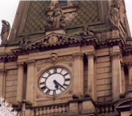


A

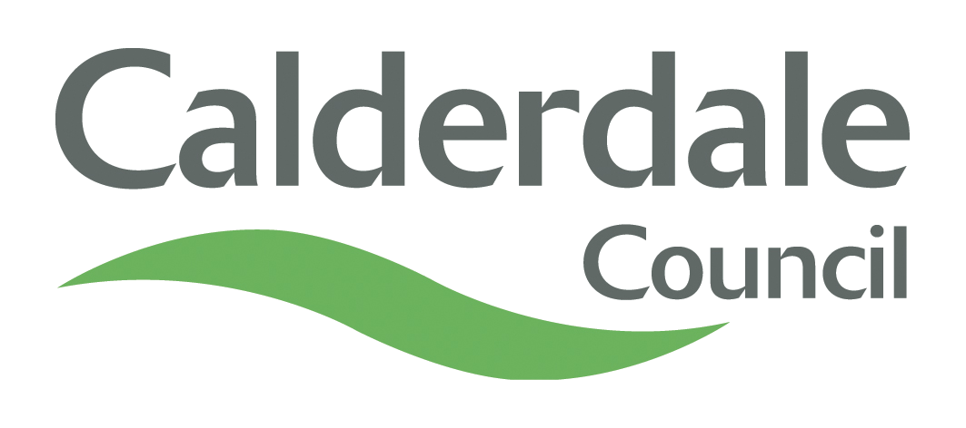
Appendix A
INTERNAL AUDIT REPORT

CHIEF EXECUTIVE’S OFFICE – FINANCE SERVICES

PAYMENT OF SCHOOLS BUDGET SHARE

DATE OF REPORT: 26th June 2013

Overall Opinion - Sound

PAYMENT OF SCHOOLS BUDGET SHARE

EXECUTIVE SUMMARY CONTENTS

Section |  | Page
- Introduction  - Audit Opinion  - Scope of the Review  - Main Findings  - Main Risks  - Recommendations Summary |  | 3  3  3  4  5  5
Key Dates and Distribution

Date Report Issued | 26/6/13 | Auditor | Audit Technician
Date Response Received | n/a | Distribution | Assistant Head of Finance (Internal Audit, Risk Management, LMS & Insurance)
Date Follow-up Issued | n/a | Distribution
Date Follow-up Returned | n/a | Distribution

EXECUTIVE SUMMARY

- INTRODUCTION

1.1. The programmed audit was undertaken as part of the Member approved Internal Audit Plan for the financial year 2013/14.

1.2. The overall objectives of the audit were as follows:

  - To evaluate the systems in operation with regard to financial procedures and recommend improvements where necessary.
  - To ensure that system controls are operating effectively and that a sound control environment exists contributing towards the Council achieving its corporate objectives.
  - To ensure that Council policies are being met and instructions issued to comply with Section 151 Standards are adhered to.
  - To check a sample of transactions to ensure they are correct and procedures have been complied with.
  - To ensure that assets are safeguarded.
- AUDIT OPINION
2.1. The control environment and audit opinion for the Payment of School Budget Share is Sound.
The conclusions which led to the Audit Opinion were as follows:
Area of Audit | Conclusion
Previous Audit Recommendations | Sound
Formula Allocations | Sound
Adjustments to Allocations | Sound
Payments to Schools | Sound
VAT Re-imbursements | Sound
Financial Ledger Reconciliation | Sound
Walkthrough Testing | Sound

2.2. The table above is a summary of the conclusions arrived at in the findings section of the audit report and is based on evidence obtained during the review.

- SCOPE OF THE REVIEW
  - To contribute towards the Council meeting the requirements of The Accounts and Audit Regulations (England) 2011, which,
- Requires authorities to ensure that the financial management is adequate and effective, that there are sound systems of internal control which facilitate the effective exercise of the Council’s functions and which include arrangements for the management of risk.
- Requires authorities to undertake an adequate and effective internal audit of its accounting records and of its system of internal control in accordance with proper practices in relation to internal control.
  - That being the case, the scope of the review took into account the following:
- The internal controls in place for ensuring that formula allocations to schools are correct.
- The arrangements in place for making adjustments to formula allocation during the financial year.
- The controls surrounding the transfer of funds to schools.
- The calculation and payment of VAT reimbursements to schools.
- The arrangements for reconciliation to the financial ledger.
- MAIN FINDINGS

  - The previous report on the payment of school budget share was issued in August 2012 and gave an audit opinion of Sound. There were no weaknesses identified in the systems of control and therefore no recommendations were required.
  - The school budget allocations for 2013/14 were compared to the total budget available and found to agree. Allocations to individual schools were also checked and no issues were raised. There are robust internal controls in place for ensuring that school allocations are correct.
  - The arrangements for making adjustments to school allocations during the year were found to be sound with good internal control through independent check and thorough reconciliation procedures.
  - All adjustments to the allocations during the year were checked and found to be correct and supported by appropriate documentation.
  - There are sound controls in the system for making payment of school budget share. BACS payment summaries are checked before funds are transferred to schools and there is an independent check of payment summaries received from the bank which ensures that the monthly transfer of funds has been correctly processed for all schools. The audit trail was found to be sound with good evidence that checks are in place through certification of documents.
  - There is a monthly control checklist in place which is an excellent control for ensuring that the required procedures are followed.
  - Sample checking of school budget share payments revealed no discrepancies.
  - The arrangements for reimbursing schools for VAT incurred were found to be very good, with all required controls in operation. There is a sound audit trail and good levels of internal check.
  - Sample testing of VAT reimbursements found no discrepancies and all expected controls were found to be in place.
  - There are internal checks in place and regular reconciliations to the financial ledger which ensures that payments to schools are accounted for correctly.
  - Audit checks confirmed that payments were made in a timely manner so that schools did not have cash flow problems which may result from late payment.
  - There is up-to-date detailed system documentation which accurately describes the procedures and controls in place.
- MAIN RISKS
5.1 As already stated, it is considered that the control environment is sound with good arrangements in place in all areas. The financial risk to the Council could be significant if controls were poor due to the high levels of payments involved. However, the audit indicated that there are no residual risks due to the strong systems of control in place.
6. RECOMMENDATIONS SUMMARY
6.1 There were no recommendations in the report and therefore an action plan was not required.

