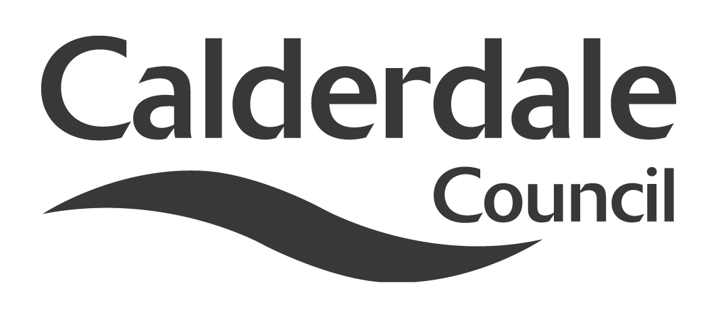
5

Report to Scrutiny Panel
Name of Scrutiny Panel | Children and Young People Scrutiny Panel
Meeting Date | 05 March 2014
Subject | Schools’ minor capital works possible funding and\or prudential borrowing scheme
Wards Affected | All
Report of | Director, Children and Young People’s Services
Type of Item  (please tick✓ ) | Review existing policy
Type of Item  (please tick✓ ) | Development of new policy | √
Type of Item  (please tick✓ ) | Performance management (inc. financial)
Type of Item  (please tick✓ ) | Briefing (inc. potential areas for scrutiny)
Type of Item  (please tick✓ ) | Statutory consultation
Type of Item  (please tick✓ ) | Council request
Type of Item  (please tick✓ ) | Cabinet request
Type of Item  (please tick✓ ) | Member request for scrutiny (CCFA)

Why is it coming here?
As requested at the Scrutiny Panel meeting of 29th January, 2014

What are the key points?
The attached report has been prepared for the Capital Programme Working Party “to consider whether to introduce a minor capital works programme supported through the re-introduction of a prudential borrowing scheme for schools, or a small grant regime or by using both funding mechanisms as appropriate.`

Possible courses of action
The Panel may wish to make recommendations to Cabinet on the contents of the attached report.

Contact Officer
Stuart Smith, Director, Children & Young People’s Service 01422 392500

Should this report be exempt?
No

Report to Scrutiny Panel
- Background

At its meeting held on 29 January 2014, the Children and Young People’s Scrutiny Panel discussed an item on “school capital programme - outcome of feasibility studies”.

The Cabinet Member with responsibility for Children & Young People’s Services and Lead Member for Children’s Services advised that a paper was due to be submitted to the Capital Programme Working Party on 12th March 2014. It was felt that it would be helpful for the report to come to this panel at its next meeting on 5th March.

Therefore, the panel agreed that:

The Director, Children and Young People be requested to submit a report on Schools Prudential Borrowing to the 5th March 2014 Meeting of this Panel.
- Main issues for Scrutiny

See attached report

- Further action and timescales

The attached report will be presented to the Capital Programme Working Party on 12 March 2014, where recommendations may be made to Cabinet.

- Appendices

Report to Capital Programme Working Party, “Schools’ Minor Capital Works Possible Funding And\Or Prudential Borrowing Scheme”.

- Documents available for inspection at

Halifax Town Hall, Crossley Street, Halifax, HX1 1UJ

